Work To Be Done
Created: 04/2019 by the National FFA Organization

Retiring Address Video Summary: There is always work to be done in life. In his retiring address, 2017-18 National FFA Western Region Vice President Bryce Cluff discusses how we can become better leaders through work, understanding and love.

Student Learning Objectives:
After completing these activities, students will …
- Develop ways to become a better leader.
- Identify areas of personal growth on which to focus.
- Demonstrate leadership through action.

Time Required: 45 minutes
Resources: “Work To Be Done, Bryce Cluff retiring address,” https://vimeo.com/297419693

Equipment and Supplies Needed:
- A copy of the “Work” worksheet for each student
- Internet access to play the video in real time or embed it in a PowerPoint ahead of time

This quick lesson plan would work well as:
- A leadership lesson.
- A personal growth lesson.

Student Activity Sheets:
Direct access to student activity sheets without lesson plan or answer key for easy upload to learning management systems or printing for classwork.
https://ffa.box.com/s/thx1vuqlyaauweodd26l1ouch6r669ks (Word)
https://ffa.box.com/s/kdyi9al1jmolyyuf2wupmzyi9vinmc19 (Non-Designed)
https://ffa.box.com/s/eaxdxyajz8m84eb0eqco1469eqnbge1w (PDF)
These activities are aligned to the following standards:
FFA Precept
- FFA.PL-A.Action: Assume responsibility and take the necessary steps to achieve the desired results, no matter what the goal or task at hand.
- FFA.PL-C.Vision: Visualize the future and how to get there.
- FFA.PL-E.Awareness: Understand personal vision, mission and goals.
- FFA.PG-J.Mental Growth: Embrace cognitive and intellectual development relative to reasoning, thinking and coping.
- FFA.CS-N.Decision Making: Analyze a situation and execute an appropriate course of action.
Common Core – Math Practices
- CCSS.MP1: Make sense of problems and persevere in solving them.
- CCSS.MP5: Use appropriate tools strategically.
- CCSS.MP6: Attend to precision.
AFNR Career Ready Practices
- CRP.02: Apply appropriate academic and technical skills. Career-ready individuals readily access and use the knowledge and skills acquired through experience and education to be more productive.
- CRP.04: Communicate clearly, effectively, and with reason. Career-ready individuals communicate thoughts, ideas and action plans with clarity, whether using written, verbal and/or visual methods.
- CRP.06: Demonstrate creativity and innovation. Career-ready individuals regularly think of ideas that solve problems in new and different ways, and they contribute those ideas in a useful and productive manner to improve their organization.
- CRP.08: Utilize critical thinking to make sense of problems and persevere in solving them. Career-ready individuals readily recognize problems in the workplace, understand the nature of the problem, and devise effective plans to solve the problem.
Partnership for 21st Century Skills
- Communication
- Critical Thinking and Problem Solving
- Flexibility and Adaptability
- Initiative and Self-Direction
- Leadership and Responsibility
Lesson Plan:
- Bell Ringer: How is your day going? Use complete sentences and record your answers on the worksheet titled “Work.”

- Introduction: Why is it important to check on people from time to time? Have students answer this on the worksheet and then share with the class.

The word “work” may have different meanings to different people. However, people often forget that we have our own work that needs to be done to improve ourselves and our leadership ability. Today, we will watch a retiring address from the 91st National FFA Convention & Expo. In his retiring address, 2017-18 National FFA Western Region Vice President Bryce Cluff describes the work that needs to be done by each of us.

- Activity: Each student needs a copy of the worksheet “Work.” Students will watch the retiring address of 2017-18 National FFA Western Region Vice President Bryce Cluff and complete the activities. The video URL is https://vimeo.com/297419693.

- Follow-up: Have students share how they are going to build up their community and each other, and then discuss how these acts will help to develop leadership.

- Leveling Up: Have students develop and implement a plan (who, what, when, how) for “random acts of kindness” day (February 17) at your school or have the class or FFA chapter plan its own “random acts of kindness day” for your school. Have students include faculty, staff, administration and other students in their plan. If this date is too far in the future or has already passed, have each student plan and implement a random act of kindness for someone at home. Have students journal about how their acts of kindness were received.

- Exit Ticket: On a blank sheet of paper, create a word cloud of key words that come to mind when you think about a “great leader.” The larger the word in the word cloud the more important it is. Keep this word cloud in a place you can reference and reflect on each day. Example of a word cloud:



Work
Aligned to the following standards:
FFA.PL-A; FFA.PL-C; FFA.PL-E; FFA.PG-J; FFA.CS-N; MP1; MP5; MP6; CRP.02; CRP.04; CRP.06; CRP.08
Directions:
Fill in the blanks and answer the questions below while watching “Work To Be Done,” the retiring address of 2017-18 National FFA Western Region Vice President Bryce Cluff, available at https://vimeo.com/297419693.

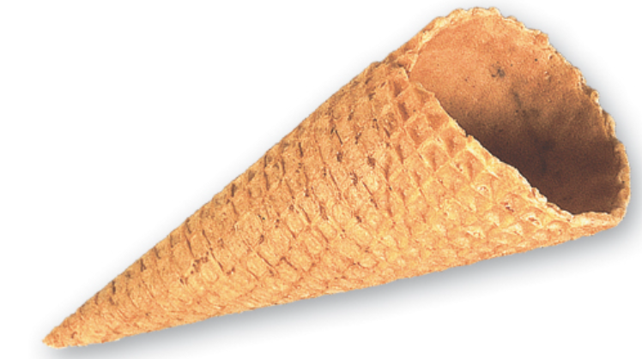


Bell Ringer: How is your day going?
(Use complete sentences in your answer.)
Why is it important to check in on people or simply ask how their day is going?
What did Bryce do to try to make Jackie’s day better?
According to Bryce, there is ______________ to be done!
Explain what Bryce means by this statement.
Where did Bryce go that ended up having a large impact on him?

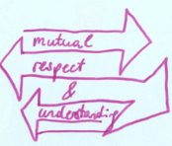


According to Bryce, what do people need? ______________
How can we all show this quality to another person to make that person’s life better?

According to Bryce, at our core we all have one simple need. What is that?

- To feel accomplished
- To feel successful
- To feel validated
There is _______________________ to be done.
What does this mean?
Identify two ways you can increase love and understanding in your community by being a positive influence.

Identify two ways you can build someone up this week.

How will you put Bryce’s words into action to become a better leader?


KEY: Work
Aligned to the following standards:
FFA.PL-A; FFA.PL-C; FFA.PL-E; FFA.PG-J; FFA.CS-N; MP1; MP5; MP6; CRP.02; CRP.04; CRP.06; CRP.08
Directions:
Fill in the blanks and answer the questions below while watching “Work To Be Done,” the retiring address of 2017-18 National FFA Western Region Vice President Bryce Cluff, available at https://vimeo.com/297419693.
Bell Ringer: How is your day going?
(Use complete sentences in your answer.)

Answers will vary.
Why is it important to check in on people or simply ask how their day is going?
Asking shows that you care and can really make a person’s day better.
What did Bryce do to try to make Jackie’s day better?
He gave her ice cream and listened.
According to Bryce, there is WORK to be done!
Explain what Bryce means by this statement.
When it comes to our work as a leader, we are always on the clock to assist others.
Where did Bryce go that ended up having a large impact on him?

St. Thomas, USVI

According to Bryce, what do people need? LOVE
How can we all show this quality to another person to make that person’s life better?
Answers will vary. Example: by showing acceptance of another person’s day-to-day lifestyle (ex. vegan). By saying, “Not saying I get that, but I’ve got you.”
According to Bryce, at our core we all have one simple need. What is that?

- To feel accomplished
- To feel successful
- To feel validated
There is UNDERSTANDING to be done.
What does this mean?
Answers will vary.
Identify two ways you can increase love and understanding in your community by being a positive influence.
Answers will vary. Example: help at a soup kitchen.

Identify two ways you can build someone up this week.
Answers will vary. Example: giving encouraging words on the football field.

How will you put Bryce’s words into action to become a better leader?
Answers will vary.

