Work
Aligned to the following standards:
FFA.PL-A; FFA.PL-C; FFA.PL-E; FFA.PG-J; FFA.CS-N; MP1; MP5; MP6; CRP.02; CRP.04; CRP.06; CRP.08
Directions:
Fill in the blanks and answer the questions below while watching “Work To Be Done,” the retiring address of 2017-18 National FFA Western Region Vice President Bryce Cluff, available at https://vimeo.com/297419693.

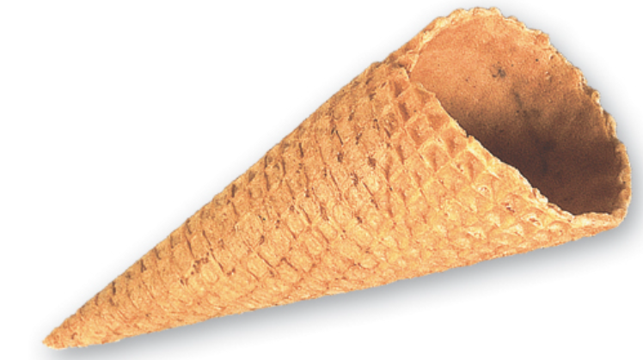


Bell Ringer: How is your day going?
(Use complete sentences in your answer.)
Why is it important to check in on people or simply ask how their day is going?
What did Bryce do to try to make Jackie’s day better?
According to Bryce, there is ______________ to be done!
Explain what Bryce means by this statement.
Where did Bryce go that ended up having a large impact on him?

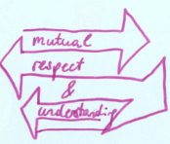


According to Bryce, what do people need? ______________
How can we all show this quality to another person to make that person’s life better?

According to Bryce, at our core we all have one simple need. What is that?

- To feel accomplished
- To feel successful
- To feel validated
There is _______________________ to be done.
What does this mean?
Identify two ways you can increase love and understanding in your community by being a positive influence.

Identify two ways you can build someone up this week.

How will you put Bryce’s words into action to become a better leader?


