Building Solutions: Innovation
Created: 10/2015 by the National FFA Organization

Student Learning Objectives
After completing these activities students will…
- Understand how innovation is important to the advancement of agriculture
- Describe cause and effect relationships
- Report on an agricultural innovation of their choosing

Time Required: 60 minutes
Resources: FFA.org
Elanco ENOUGH Report – https://ffa.box.com/s/6csd0xsjwgzv3khdw4iqxus1c4ioxpec
Equipment and Supplies Needed:
- A copy of the “Building Solutions: Innovation” worksheet for each student.
- Internet access to view the Elanco ENOUGH Report and to research other innovations.

This quick lesson plan would work well as:

- Full class period – Agribusiness, Animal Science or Ag Leadership Curriculum
- Stand alone lesson
- Supplemental activity for development of CDE and SAE applications

These activities are aligned to the following standards:

AFNR Performance Element
- CS.01. Analyze how issues, trends, technologies and public policies impact systems in the Agriculture, Food & Natural Resources Career Cluster
- CS.02. Evaluate the nature and scope of the Agriculture, Food & Natural Resources Career Cluster and the role of agriculture, food and natural resources (AFNR) in society and the economy.
FFA Precept
- FFA.PG-J.Mental Growth: Embrace cognitive and intellectual development relative to reasoning, thinking and coping.
- FFA.CS-N.Decision Making: Analyze a situation and execute an appropriate course of action.
Common Career Technical Core
- AG1 Analyze how issues, trends, technologies and public policies impact systems in the Agriculture, Food & Natural Resources Career Cluster.
NASDCTEc
- AGC10.04 Envision emerging technology and globalization and project its influence on widespread markets to demonstrate an understanding of technologies and trends that will impact the AFNR industry.
Common Core- Reading: Informational Text
- CCSS.ELA-Literacy.RI.9-10.1 Cite strong and thorough textual evidence to support analysis of what the text says explicitly as well as inferences drawn from the text.
Common Core- Writing
- CCSS.ELA-Literacy.W.9-10.2
Write informative/explanatory texts to examine and convey complex ideas, concepts, and information clearly and accurately through the effective selection, organization, and analysis of content.
Common Core- Math Practices
- CCSS.MP1: Make sense of problems and persevere in solving them.
- CCSS.MP3: Construct viable arguments and critique the reasoning of others.
- CCSS.MP6: Attend to precision.

AFNR Career Ready Practices
- CRP.02. Apply appropriate academic and technical skills. Career-ready individuals readily access and use the knowledge and skills acquired through experience and education
to be more productive.
- CRP.04. Communicate clearly, effectively, and with reason. Career-ready individuals communicate thoughts, ideas and action plans with clarity, whether using written, verbal and/or visual methods.
Partnership for 21st Century Skills
- Information, Communications, and Technology Literacy
- Global Awareness
- Think Creatively

Lesson Plan:
- Introduction:

To advocate for agriculture, we must share WHY our industry is a positive leading influence in the quality of human life. We must also share HOW we make these advancements without compromising food safety and the environment.

An innovation by definition is a new method, idea, or product. In the context of this exercise innovation is primarily efficiency, or incrementally improving on already existing practices. This is an important concept in agriculture.

Part 2 of this activity also gives students the chance to discover and share any of hundreds of agricultural innovations that are in development. Allowing students to discover unique innovations allows them to focus on an area of interest, but to also be empowered and inspired by what they find.

Consider how these discovered innovations can be used to advance your FFA members in career development events (CDE), their supervised agricultural experience (SAE), or agriscience contests.

- Activity: Each student needs a copy of the handout “Building Solutions: Innovation”

  - All students should read through pages 12-15 of the Elanco ENOUGH Report found at https://ffa.box.com/s/6csd0xsjwgzv3khdw4iqxus1c4ioxpec

  - Students should complete Part 1 of the “Building Solutions: Innovation” worksheet based on what they learned from the report. (individually or partners)

  - Part 2 of the worksheet can be assigned as homework or also be completed during a class period.
Students will need access to a computer or library for Part 2.

- Follow-up:
  - Building Solutions: Innovation is lesson one of a three lesson series.
  - The ENOUGH report is written to be understood by a wide audience. Have students explore other parts of the report and share with others.
  - Teachers, students, and others can join the ENOUGH movement by the visiting ENOUGH website at https://www.enoughmovement.com/ . Individuals that join can receive a T-shirt and further resources for a limited time.

Building Solutions: Innovation
Aligned to the following standards: CS.01, CS.02, FFA.PG-J., FFA.CS-N., AG1, AGC10.04, CCSS-ELA-Literacy.RI.9-10.1, CCSS.MP1, CCSS.MP3, CCSS.MP6, CRP.02, CRP.04
Part 1
Directions:
Read through pages 12-15 of the Elanco ENOUGH Report found at: https://ffa.box.com/s/6csd0xsjwgzv3khdw4iqxus1c4ioxpec

Innovation: The _________, __________ and __________ that help farmers produce more food more sustainably; innovations that, in many cases, are already __________, ___________, ___________ and ___________.

Innovations that have improved food production:

1. | 4. | 7.
2. | 5. | 8.
3. | 6. | 9.

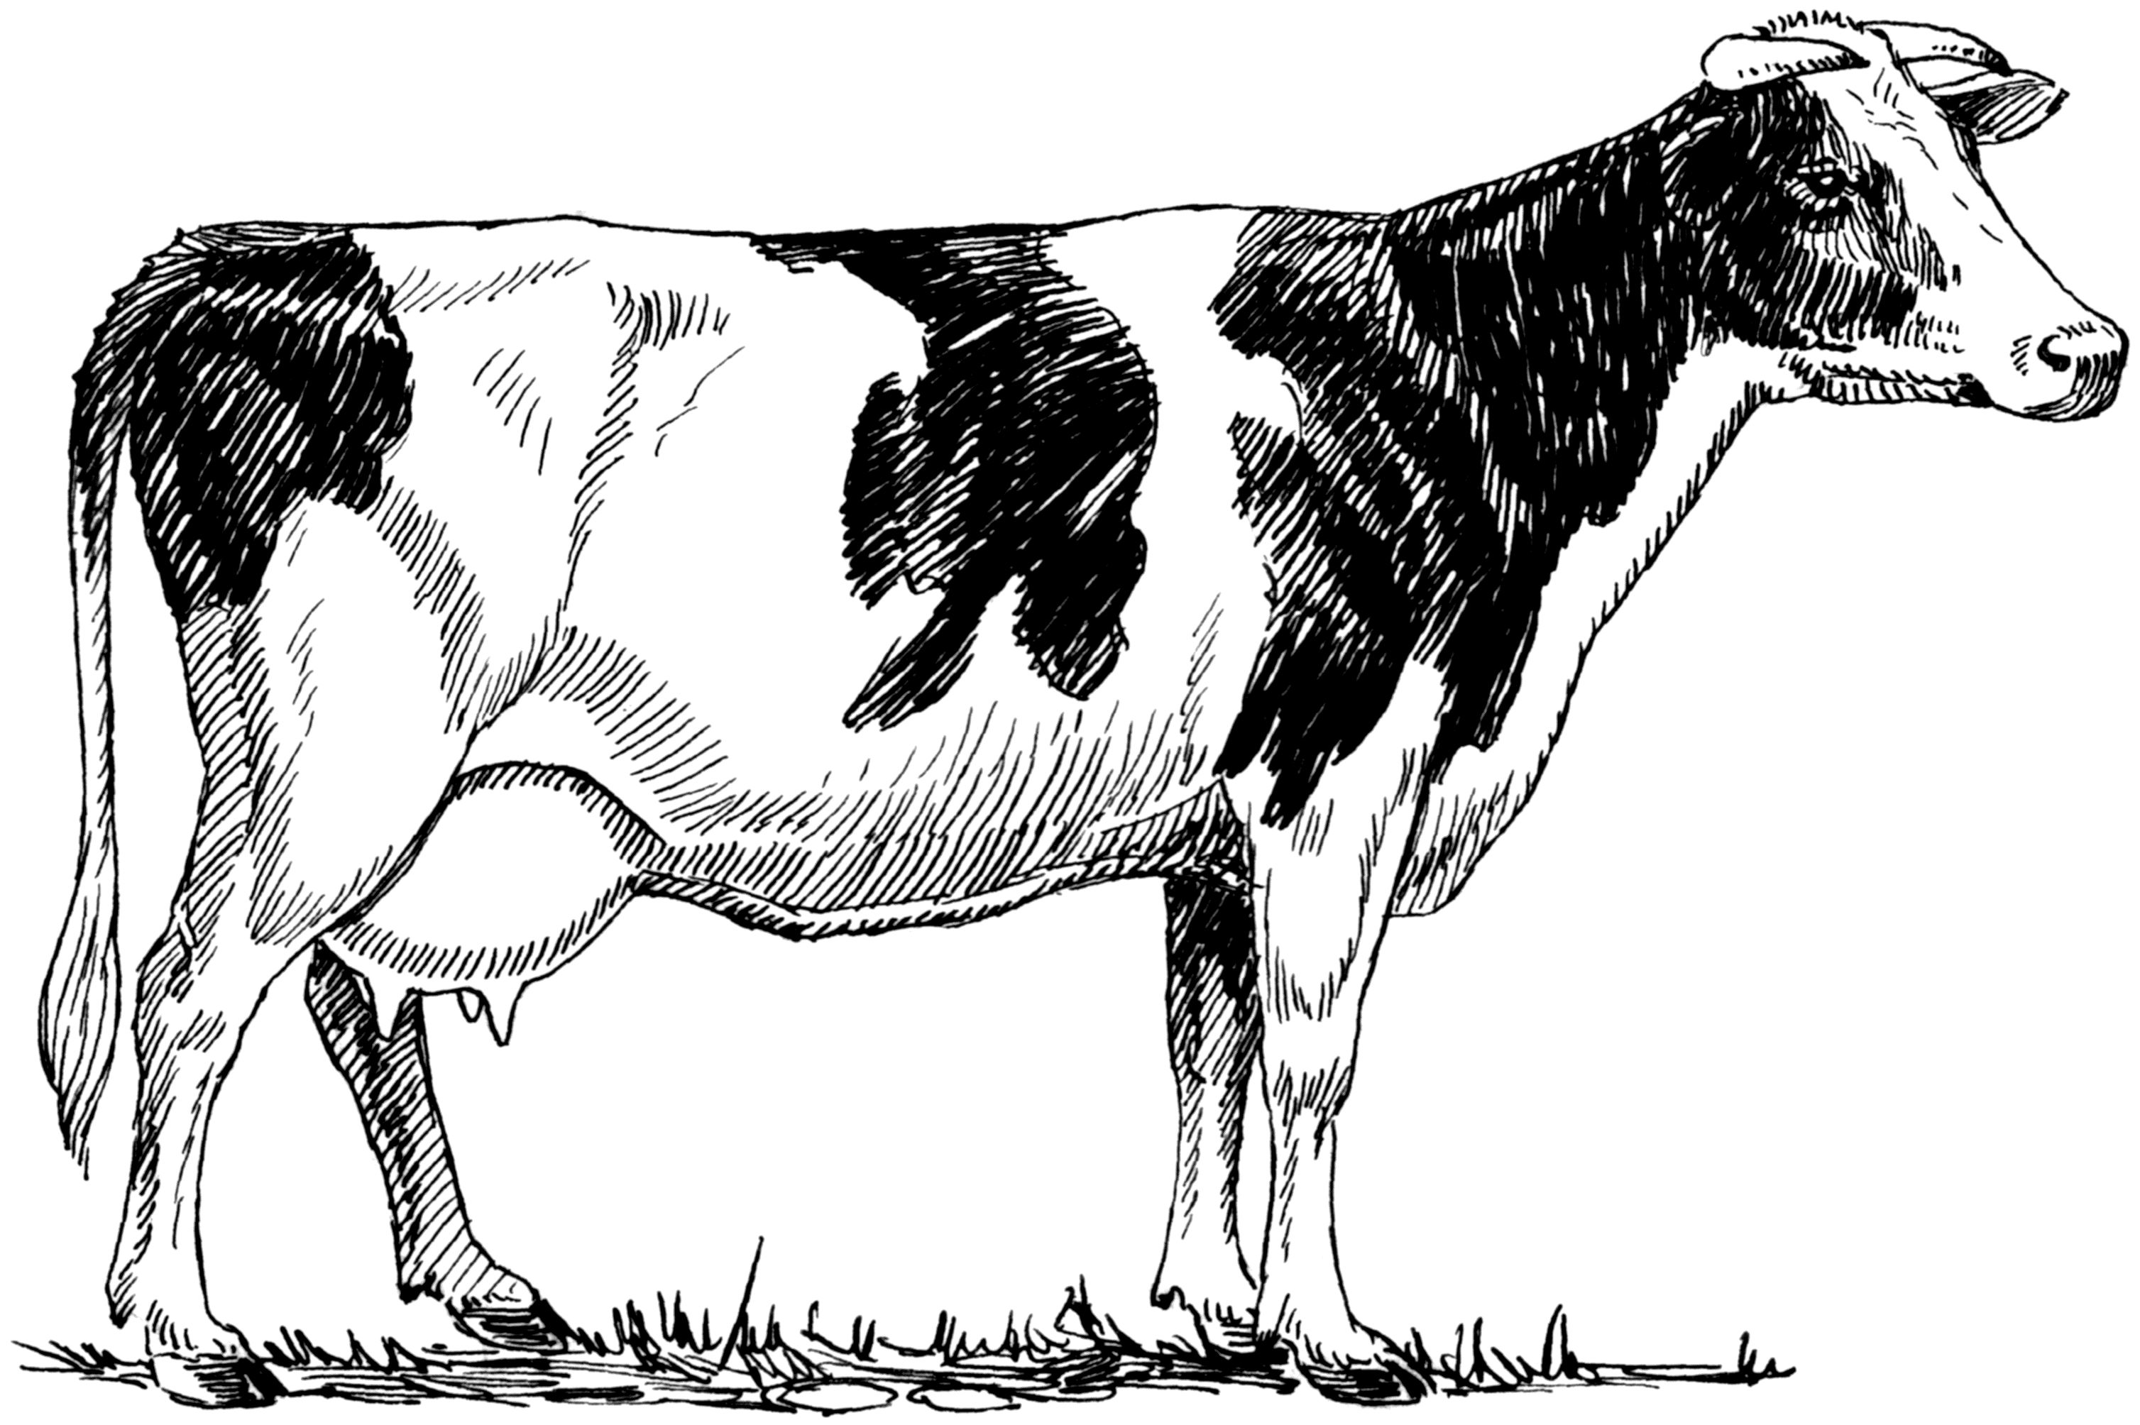
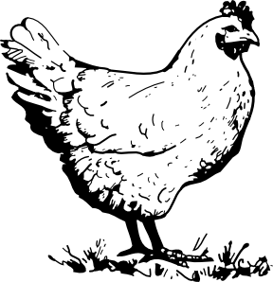

Egg Production Dairy Production

Using innovation, not adding hens, would save: Using Innovation, not adding cows, would save:

___% or ___________ tons of feed per year ___% or ___________ tons of feed per year

___% or ___________ acres of land per year ___% or ___________ acres of farmland per year

___% or ___________ gallons of water per year ___% or ___________ gallons of water per year

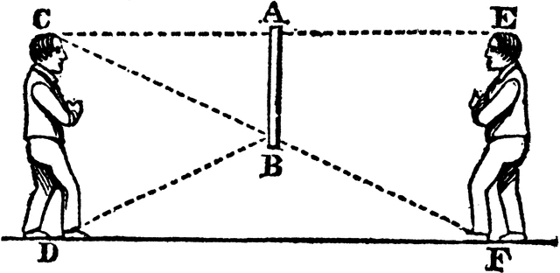 Reflection

Is innovation always looked upon favorably by consumers? Why might they be hesitant to accept innovation?

Aligned to the following standards: CS.01, CS.02, FFA.PG-J., FFA.CS-N., AG1, AGC10.04, CCSS-ELA-Literacy.RI.9-10.1, CCSS.MP1, CCSS.MP3, CCSS.MP6, CRP.02, CRP.04
Building Solutions: Innovation
Part 2
DIRECTIONS:
Find information on an agricultural innovation of your choice. Choose an innovation in an area that you are interested in, such as animal science, agronomy, forestry, technology or agribusiness.

Answer the following questions to build your understanding and potential of the innovation you chose.

Presentation Points
1. If you had 5 minutes to describe and explain your chosen agricultural innovation to your class, what would be your top five talking points? List these points below and write a few sentences to describe them.

2. How will this innovation advance agriculture? How will it help use resources (natural/financial/human) more effectively? Will it help increase production?

3. Is this innovation being used effectively? Describe how it is being used.

4. How could this innovation be advanced in the future? What ideas do you have to improve this innovation? Could you use these ideas as a starting point for upcoming career development events (CDE) or your SAE?

