Building a Responsible Textile Supply Chain
Created: 01/2021 by the National FFA Organization

Description of lesson: The textile industry plays a large role in the economy, and with that role comes a responsibility to maintain sustainability standards throughout the production process. This lesson explores the sustainability that is maintained throughout the production process.
Student Learning Objectives:
After completing these activities, students will …
- Describe sustainability.
- Identify how sustainability is involved in the textile industry.
- Develop an understanding of the cotton-to-clothing process.
- Discuss the value chain and the cotton to textile production process.

Time Required: 90 minutes
Resources/References:
- Article: Building a Responsible Textile Supply Chain, https://www.ffa.org/ffa-new-horizons/building-a-responsible-textile-supply-chain/
- Website: Dictionary, dictionary.com
- Website: Crop to Campus, https://croptocampus.com/

Equipment and Supplies Needed:
- A copy of the “Building a Responsible Textile Supply Chain” worksheet for each student
- Internet access to play the video in real time or embed it in a PowerPoint ahead of time

Student Activity Sheets:
Direct access to student activity sheets without lesson plan or answer key for easy upload to learning management systems or printing for classwork.

https://ffa.box.com/s/mzycnta86mtejt6lgpcaszozgpsjv3z4 (Word)
https://ffa.box.com/s/f81armb69g7dnr0srz44y6jlbldsp80a (PDF)

Cross-Curricular Connections:
Science | Technology | Social Studies
Describe sustainability and its use in the textile industry. | Identify the tools utilized in the textile industry. | Identify the inventor of the cotton gin.

These activities are aligned to the following standards:
AFNR Performance Element
- CS.01. Analyze how issues, trends, technologies and public policies impact systems in the Agriculture, Food & Natural Resources Career Cluster.
- CS.04. Demonstrate stewardship of natural resources in AFNR activities.
- CS.06. Analyze the interaction among AFNR systems in the production, processing and management of food, fiber and fuel and the sustainable use of natural resources.
FFA Precept
- FFA.PL-A.Action: Assume responsibility and take the necessary steps to achieve the desired results, no matter what the goal or task at hand.
- FFA.PL-C.Vision: Visualize the future and how to get there.
- FFA.PL-E.Awareness: Understand personal vision, mission and goals.
- FFA.PL-F.Continuous Improvement: Accept responsibility for learning and personal growth.
- FFA.PG-I.Professional Growth: Assume responsibility for attaining and improving upon the skills needed for career success.
- FFA.PG-J.Mental Growth: Embrace cognitive and intellectual development relative to reasoning, thinking and coping.
- FFA.CS-N.Decision Making: Analyze a situation and execute an appropriate course of action.
Common Career Technical Core
- AG1 Analyze how issues, trends, technologies and public policies impact systems in the Agriculture, Food & Natural Resources Career Cluster.
- AG4 Demonstrate stewardship of natural resources in AFNR activities.
- AG6 Analyze the interaction among AFNR systems in the production, processing and management of food, fiber and fuel and the sustainable use of natural resources.
Common Core – Reading: Informational Text
- CCSS.ELA-Literacy.RI.9-10.4 Determine the meaning of words and phrases as they are used in a text, including figurative, connotative, and technical meanings; analyze the cumulative impact of specific word choices on meaning and tone (e.g., how the language of a court opinion differs from that of a newspaper).
Common Core – Speaking and Listening
- CCSS.ELA-Literacy.SL.9-10.2 Integrate multiple sources of information presented in diverse media or formats (e.g., visually, quantitatively, orally) evaluating the credibility and accuracy of each source.
Green/Sustainability Knowledge and Skill Statements
- AFNR Career Cluster, Statement 3 Communicate the impact of green and sustainability principles on agriculture, food and natural resource systems.
- AFNR Career Cluster, Statement 7 Demonstrate an understanding of green and sustainability trends that are impacting processes and markets in AFNR.
AFNR Career Ready Practices
- CRP.02. Apply appropriate academic and technical skills. Career-ready individuals readily access and use the knowledge and skills acquired through experience and education to be more productive.
- CRP.04. Communicate clearly, effectively, and with reason. Career-ready individuals communicate thoughts, ideas and action plans with clarity, whether using written, verbal and/or visual methods.
- CRP.05. Consider the environmental, social and economic impact of decisions. Career-ready individuals understand the interrelated nature of their actions and regularly make decisions that positively impact and/or mitigate negative impact on other people, organizations and the environment.
- CRP.07. Employ valid and reliable research strategies. Career-ready individuals are discerning in accepting and using new information to make decisions, change practices or inform strategies.
- CRP.08. Utilize critical thinking to make sense of problems and persevere in solving them. Career-ready individuals readily recognize problems in the workplace, understand the nature of the problem, and devise effective plans to solve the problem.
- CRP.11. Use technology to enhance productivity. Career-ready individuals find and maximize the productive value of existing and new technology to accomplish workplace takes and solve workplace problems.
Partnership for 21st Century Skills
- Critical Thinking and Problem Solving
- Initiative and Self-Direction
- Flexibility and Adaptability
- Leadership and Responsibility
- Think Creatively

Lesson Plan:
- Bell Ringer: What connection is there between agriculture and the clothing that you wear everyday?

- Introduction: The textile industry plays a large role in the economy. With such a large role, comes a responsibility to maintain sustainability standards throughout the production process. Today we are going to learn about the sustainability that is maintained throughout the textile production process.

- Activity: Each student needs a copy of the worksheet “Building a Responsible Textile Supply Chain.”
  - Part 1: Have students read the article “Building a Responsible Textile Supply” (https://www.ffa.org/ffa-new-horizons/building-a-responsible-textile-supply-chain/) and then complete the worksheet to learn about the textile industry and the sustainability needs.
  - Part 2: The textile industry plays a very large role in the economy. Follow the steps below to learn more about this important industry. Students will begin by looking at the tag in their shirt and writing down the material that was used to make it. Students should include the name of the material and the percentage (Ex. 100% cotton). Next, students will find two more articles of clothing and record the material in the space provided (Ex. two more shirts). Have students highlight the materials the items have in common (Ex. rayon). In purple, students should circle the materials that are synthetic (Ex. polyester). In red, students should circle the materials that are NOT synthetic (Ex. cotton). Lastly, students will answer the following questions: Why is cotton such a common material used for clothing? Why might synthetic materials be used? Have students share their thoughts with the class. Virtual learning: For virtual learning, have students share through a discussion board and respond to each other.
  - Part 3: Have students watch the Crop to Campus video series developed by Hanes to learn how cotton goes from the field to a T-shirt. Students will answer questions about each video as well as critical thinking questions to extend their learning from the series. Lastly, have students think about the process for turning cotton into shirts. Using the space provided, students will develop a flow chart that depicts the process. Each step in the process should include a label of what is happening (Ex. sewing), a brief description and an image. If needed, students can revisit the Crop to Campus videos to ensure they have all the steps in the process. Students should use the steps that were highlighted in their worksheet and also consider the smaller steps that were discussed in the videos (Ex. cleaning the cotton, using the cotton gin, etc.).
  - Part 4: There are many steps in the production of a cotton T-shirt. In the agriculture industry, we have an Agriculture, Food and Natural Resources (AFNR) Value Chain that outlines the industry from start to finish. Using the provided chart of the AFNR Value Chain, have students read the descriptions and draw a line from each step of the T-shirt production process listed next to the correct step in the value chain. Students will then have the opportunity to develop their own promotional shirt about the cotton-to-shirt process they have learned about. To conclude the lesson, students will complete the following statement: What I have learned about the textile industry is …”

- Follow-up: Have students share their final thoughts and shirts with the class. For virtual learning, have students create a poster or Flipgrid with their shirt and final statement.

- Optional — Extended Learning Opportunities (Not factored into time requirement):
  - Have students develop a one-minute elevator speech to share the role of sustainability throughout the textile industry.
  - Have students explore more about sustainability in agriculture through the Sustainability in Agriculture lesson series – Valent USA where students can learn more about sustainability through the development of a new trail mix.

- Exit Ticket: What role does sustainability and agriculture play in the textile industry?

Building a Responsible Textile Supply Chain
Aligned to the following standards:
CS.01; CS.04; CS.06; FFA.PL-A; FFA.PL-C; FFA.PL-E; FFA.PL-F; FFA.PG-I; FFA.PG-J; FFA.CS-N; AG1: AG4; AG6; CCSS.ELA.RI.9-10.4; CCSS.ELA.SL.9-10.2; AFNR Career Cluster, Statement 3; AFNR Career Cluster, Statement 7; CRP.02; CRP.04; CRP.05; CRP.07; CRP.08; CRP.11
Part 1
Directions:
Read the article “Building a Responsible Textile Supply” found at https://www.ffa.org/ffa-new-horizons/building-a-responsible-textile-supply-chain/. Complete the following activities to learn more.

Now that we have defined sustainability, how would you explain sustainability to a friend or family member?
Using a dictionary or dictionary.com, define sustainability.



What role does sustainability play in the agriculture industry?

What is a “textile”?


_____________________ practices are just one piece of the puzzle.
_________________ want to know what they are contributing to.
So farmers know how their ______________ are being used.
There is an expectation that brands are doing their part in ______________________ ______________________.

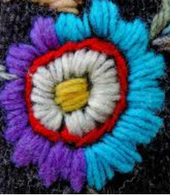
Describe textile exchange here and complete the bubbles below:

In your own words, identify how a consumer like you can impact textile sustainability.
In your own words, describe why the standards mentioned in the article are so important.
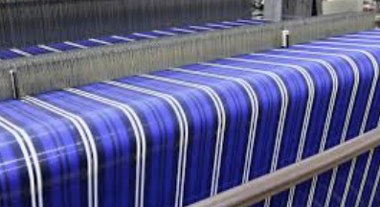
Some examples of requirement standards:
No _________ farming.

________________ grazing.
Use of ________________ content.
________________ protections.

Part 2
Directions:
The textile industry plays a very large role in the economy. Today, we are going to continue to learn about the industry. Follow the steps below to learn more about this important industry.
Find two more articles of clothing and record their material(s) below. Write the clothing item on the line and the material(s) below. (Ex. two more shirts)
Item 2: ______________________
Item 3: ______________________
Look at the tag on your shirt, and write down the material that was used to make it. Include the name of the material and the percentage. (Ex. 100% cotton)
Why is cotton such a common material used for clothing? Why might synthetic materials be used?
In red, circle the materials that are NOT synthetic.
(Ex. cotton)
In purple, circle the materials that are synthetic.
(Ex. polyester)
In green, highlight the materials the items have in common.
(Ex. rayon)

Part 3
Directions:
Follow the steps below to further explore the textile industry from field to shirt. Using the Crop to Campus website from Hanes and complete the following activities.
Watch Crop to Campus Episode 1 and answer the following questions.

- What school do the students attend? __________________________________________________

- What connection does the textiles industry have with the agriculture industry?

- Why do you think Hanes is inviting these students to follow their production process?
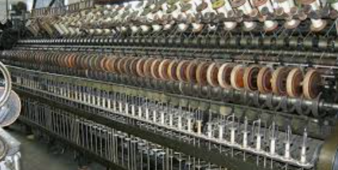


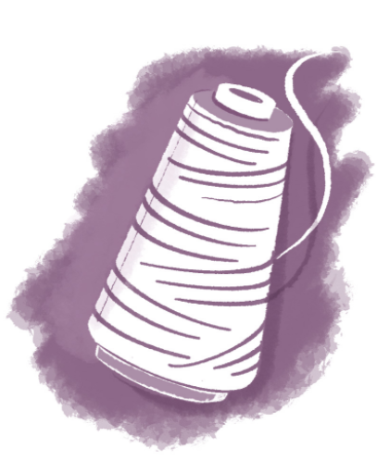

Watch Crop to Campus Episode 2. What is the first step to producing a cotton shirt? C_________________ P______________________

- What role do farmers play in producing a sustainable product? Give examples.
1
Watch Crop to Campus Episode 4. What is the next step in the production process?
K_______________________, C________________________ and S_____________, D____________________.

- To what country does Hanes send their yarn for this step?
_____________________________
- What did you find most surprising about this step of production?
3
Use your research skills and history knowledge to answer this question: Who invented the cotton gin?

_______________________
Watch Crop to Campus Episode 3. Once cotton leaves the farm and is cleaned, what is the next step? S___________________________g

- Describe the way that cotton is turned into yarn.

- What did you find most surprising about this step of production?

- How does Hanes ensure they are being sustainable during this step in the process? Why is this so important?
2
Is cotton grown in your state? Circle your answer.
Yes No

Why/why not?
Watch Crop to Campus Episode 5.

- What does Hanes do to support their community?

- What are two programs provided by Hanes to support their employees?
(1)

(2)

- How is water quality maintained at the facility? Why is water quality important?

4
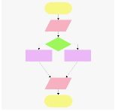

Example of what a flow chart can look like:
Think about the process you just learned for turning cotton into shirts. Use the space below to develop a flow chart that depicts the process. Each step in the process should include a label of what is happening (Ex. sewing), a brief description and an image. If needed, revisit the Crop to Campus videos to ensure you have all the steps in the process.
Watch Crop to Campus Episode 7.

- What did the students say was the most important thing companies need to do for the future generations? Be T______________________.
- What do you think about the production process of a T-shirt now that you have seen the entire process?

- What would you tell someone about the textile industry now that you have been behind-the-scenes for each step of the T-shirt production process?

5
Why do you think these programs are important?
Part 4
Directions:
There are many steps in the production of a cotton T-shirt. In the agriculture industry, we have an Agriculture, Food and Natural Resources (AFNR) Value Chain that outlines the industry from start to finish. Using the chart of the AFNR Value Chain below, read the descriptions and draw a line from each step of the T-shirt production process (listed below) to the correct step in the value chain.
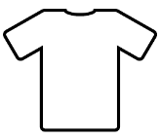
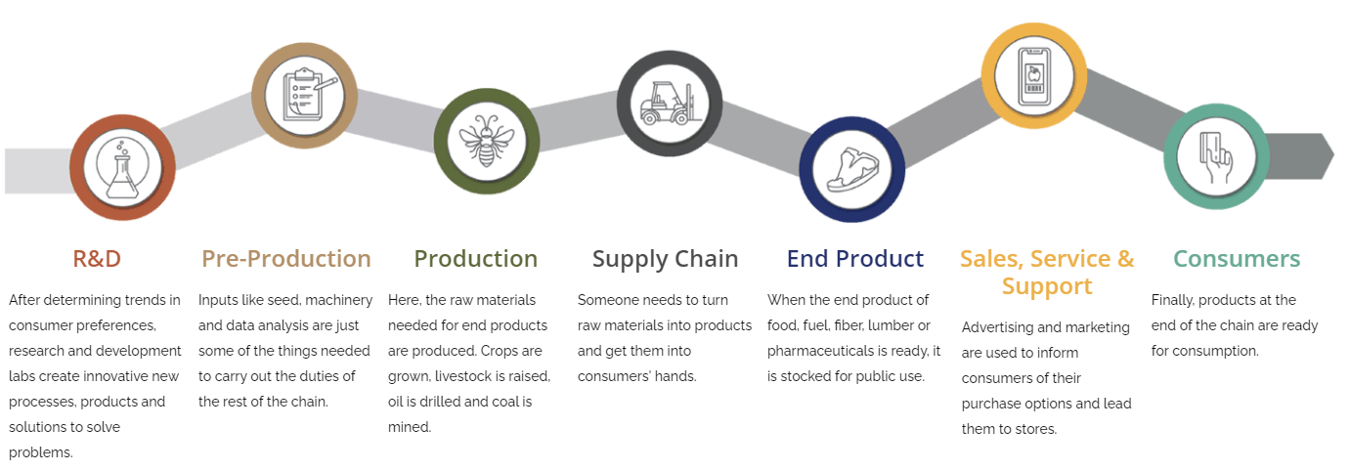
Think about the production process and what you have learned and then design a new T-shirt that could be used to share the story of farm-to-product for cotton shirts.
Front
Back
Complete the following statement: What I have learned about the textile industry is …”
Dyeing the Yarn Cotton Production Cleaning the Cotton Sewing Cutting Spinning

Knitting Purchasing the Cotton Seed Shirts Delivered to Suppliers Buying a New Shirt
Key: Building a Responsible Textile Supply Chain
Aligned to the following standards:
CS.01; CS.04; CS.06; FFA.PL-A; FFA.PL-C; FFA.PL-E; FFA.PL-F; FFA.PG-I; FFA.PG-J; FFA.CS-N; AG1: AG4; AG6; CCSS.ELA.RI.9-10.4; CCSS.ELA.SL.9-10.2; AFNR Career Cluster, Statement 3; AFNR Career Cluster, Statement 7; CRP.02; CRP.04; CRP.05; CRP.07; CRP.08; CRP.11
Part 1
Directions:
Read the article “Building a Responsible Textile Supply” and complete the following activities to learn more.

Now that we have defined sustainability, how would you explain sustainability to a friend or family member? Answers will vary.
Using the dictionary or dictionary.com, define sustainability. Avoiding the depletion of natural resources to maintain balance

What role does sustainability play in the agriculture industry? Sustainability is important to ensure the future of the industry as well as sustainably produced products.

What is a “textile”? Cloth or woven fabric used to make clothing and other products

Farming
practices are just one piece of the puzzle.
Consumers want to know what they are contributing to.
So farmers know how their products are being used.
There is an expectation that brands are doing their part in sourcing sustainably.

Describe textile exchange here and complete the bubbles below: Facilitates round-table discussions among those in the supply chain.

Some examples of requirement standards:
Use of recycled content
Environmental protections
Rotational grazing

In your own words, identify how a consumer like you can impact textile sustainability. Answers will vary.
In your own words, describe why the standards mentioned in the article are so important. Answers will vary.
No-till farming

Part 2
Directions:
The textile industry plays a very large role in the economy. Today, we are going to continue to learn about the industry. Follow the steps below to learn more about this important industry.
Find two more articles of clothing and record their material(s) below. Write the clothing item on the line and the material(s) below. (Ex. two more shirts) Answers will vary.

Answers will vary.
Item 2: ______________________
Item 3: ______________________
Look at the tag on your shirt and write down the material that was used to make it. Include the name of the material and the percentage. (Ex. 100% cotton) Answers will vary.
Why is cotton such a common material used for clothing? Why might synthetic materials be used? Answers will vary.
In red, circle the materials that are NOT synthetic. (Ex. cotton)
In purple, circle the materials that are synthetic.
(Ex. polyester)
In green, highlight the materials the items have in common.
(Ex. rayon)

Part 3
Directions:
Follow the steps below to further explore the textile industry from field to shirt. Using the Crop to Campus website from Hanes, complete the following activities.
Watch Crop to Campus Episode 1 and answer the following questions.

- What school do the students attend? North Carolina State University

- What connection does the textiles industry have with the agriculture industry?
Many of the materials needed, such as cotton, are grown and produced through the agriculture industry.

- Why do you think Hanes is inviting these students to follow their production process? Answers will vary.
Use your research skills and history knowledge to answer this question: Who invented the cotton gin?
Eli Whitney
Watch Crop to Campus Episode 4. What is the next step in the production process?
Knitting, Cutting and Sewing, Dyeing

- To what country does Hanes send their yarn for this step? El Salvador
- What did you find most surprising about this step of production?
Answers will vary.
3
Watch Crop to Campus Episode 3. Once cotton leaves the farm and is cleaned, what is the next step? Spinning

- Describe the way that cotton is turned into yarn.
Cotton is transported to a facility where the spinning machine spins the cotton into yarn.

- What did you find most surprising about this step of production? Answers will vary.

- How does Hanes ensure they are being sustainable during this step in the process? Why is this so important? There is zero waste. Everything is utilized and reused. This is important to ensure waste is being avoided.
2
Is cotton grown in your state? Circle your answer.
Answers will vary.
Yes No

Why/why not?
Answers will vary.
Watch Crop to Campus Episode 2. What is the first step to producing a cotton shirt? Cotton Production

- What role do farmers play in producing a sustainable product? Give examples. Farmers play a large role in ensuring the production process is sustainable. Examples include using little water/irrigation, using less fuel and diesel due to new technology, etc.
1
Watch Crop to Campus Episode 7.

- What did the students say was the most important thing companies need to do for the future generations? Be Transparent
- What do you think about the production process of a T-shirt now that you have seen the entire process? Answers will vary.

- What would you tell someone about the textile industry now that you have been behind-the-scenes for each step of the T-shirt production process? Answers will vary.

5
Watch Crop to Campus Episode 5.

- What does Hanes do to support their community?
Employees get paid time off to contribute to the community through different acts of community service multiple times per year. Also, the Hanes manufacturing facilities are the largest employers in the area.

- What are two programs provided by Hanes to support their employees?
- Education for their positions and to move up in the company

- A future mom program

- How is water quality maintained at the facility? Why is water quality important? They put good bacteria into the water so the water that goes into the river is cleaner than the water that was first removed. Water quality is important to ensure a healthy environment and to maintain the natural resources in the area.

4

Think about the process you just learned for turning cotton into shirts. Use the space below to develop a flow chart that depicts the process. Each step in the process should include a label of what is happening (Ex. sewing), a brief description and an image. If needed, revisit the Crop to Campus videos to ensure you have all the steps in the process. Answers will vary.

Part 4
Directions:
There are many steps in the production of a cotton T-shirt. In the agriculture industry, we have an Agriculture, Food and Natural Resources (AFNR) Value Chain that outlines the industry from start to finish. Using the chart of the AFNR Value Chain below, read the descriptions and draw a line from each step of the T-shirt production process (listed below) to the correct step in the value chain.
Dyeing the Yarn Cotton Production Cleaning the Cotton Sewing Cutting Spinning

Knitting Purchasing the Cotton Seed Shirts Delivered to Suppliers Buying a New Shirt
Complete the following statement: What I have learned about the textile industry is …” Answers will vary.
Think about the production process and what you have learned and then design a new T-shirt that could be used to share the story of farm-to-product for cotton shirts. Answers will vary.
Front
Back

