Sensational Soy
Created: 03/2024 by the National FFA Organization
Description of Lesson: Oil seeds and the oil they produce for the agriculture industry play a significant role in the products we have come to utilize and consume every day. Students will discover the importance of oil seeds by learning about business, manufacturing and food science related to this crucial piece of the Agriculture, Food and Natural Resources Value Chain.
Student Learning Objectives:
After completing these activities, students will …
- Describe soybeans and their role in the economy.
- Identify the impact of soybeans and soy oil on our daily lives.
- Read and explain information depicted in graphs and charts.
- Develop a reel/video to confer information about soy to others.

Suggested Grade Level:
Grades 9 and 10 (This lesson is written so instructors can scale up or down based on class needs.)

Suggested Time: 180 minutes (*Time requirements may vary based upon student understanding and class schedule.)
Resources/References:
- Website: NC Soybeans Producers Association, https://ncsoy.org/media-resources/uses-of-soybeans/
- Video: Different Uses for Soybeans – The Henry Ford’s Innovation Nation, https://youtu.be/kS6e797W4iA
- Website: U.S. Soy, https://ussoy.org/
- Video: Bunge, Our Business, https://vimeo.com/215249665

Related Resources:
- Bunge Lesson 2: It’s All About Relationships, https://ffa.box.com/s/mr0uown1leh95iakh6xe790l4l4hpmhn
- Bunge Lesson 3: What Happens to the Soybeans, https://ffa.box.com/s/bw3adubadatvepzigvknvtib3jo8dvtd
- Bunge Lesson 4: https://ffa.box.com/s/4pn8ep0gpbot9cqo0slciw2pxd21y473
- Fueling the World One By-Product at a Time, https://ffa.box.com/s/o4wfqem2sr8nx2i3rj2vapcb21mqw1si

Equipment and Supplies Needed:
- A copy of the “Sensational Soy” worksheet for each student
- Internet access to play the video in real time or embed it in a PowerPoint ahead of time
- One small Ziploc bag per student
- One tablespoon cornstarch per student
- One tablespoon water per student
- 1/8 teaspoon soybean oil per student
- Two to three drops food coloring of choice per student
- One-tablespoon measuring spoon
- 1/8-teaspoon measuring spoon
- Microwave
- Eye droppers or pipettes

Vocabulary:
- Soybean
- Soybean meal
- Soybean oil
- Biofuel
- Biodiesel
Cross-Curricular Connections:
Science | English/Language Arts | Technology | Mathematics
- Create soy plastic.  - Read a food label to identify the inclusion of soybean oil in the product. | - Read and synthesize an article about soy. | - Use technology to record a video/reel. | - Read graphs and charts to learn new information.

Virtual Instruction Ideas:
Upload all content into a learning management system for students to collaborate and complete assignments.

Student Activity Sheets:
Direct access to student activity sheets without lesson plan or answer key for easy upload to a learning management system or printing for classwork.

https://ffa.box.com/s/kruwzot56euz4vb30qwghidjbzbqrt7t (Word)
https://ffa.box.com/s/o7ge28b1wbbmode15w6tbh454yim9qyf (Non-Designed)
https://ffa.box.com/s/udqy9db7zo6gc6hp8r45dyww0z4me7o7 (PDF)
https://docs.google.com/document/d/1ccXpNEXJp779-N0QUDkoFQhTMCzTZCFDqZVzku3CiTc/copy (Google)

These Activities Are Aligned to the Following Standards:
FFA Precept
- FFA.PL-A.Action: Assume responsibility and take the necessary steps to achieve the desired results, no matter what the goal or task at hand.
- FFA.PL-E.Awareness: Understand personal vision, mission and goals.
- FFA.PL-F.Continuous Improvement: Accept responsibility for learning and personal growth.
- FFA.PG-I.Professional Growth: Assume responsibility for attaining and improving upon the skills needed for career success.
- FFA.CS-M.Communication: Effectively interact with others in personal and professional settings.
- FFA.CS-N.Decision Making: Analyze a situation and execute an appropriate course of action.
Common Core – Reading: Informational Text
- CCSS.ELA-Literacy.RI.9-10.2 Determine a central idea of a text and analyze its development over the course of the text, including how it emerges and is shaped and refined by specific details; provide an objective summary of the text.
- CCSS.ELA-Literacy.RI.9-10.4 Determine the meaning of words and phrases as they are used in a text, including figurative, connotative, and technical meanings; analyze the cumulative impact of specific word choices on meaning and tone (e.g., how the language of a court opinion differs from that of a newspaper).
Common Core – Speaking and Listening
- CCSS.ELA-Literacy.SL.9-10.2 Integrate multiple sources of information presented in diverse media or formats (e.g., visually, quantitatively, orally) evaluating the credibility and accuracy of each source.
- CCSS.ELA-Literacy.SL.9-10.4 Present information, findings, and supporting evidence clearly, concisely, and logically such that listeners can follow the line of reasoning and the organization, development, substance, and style are appropriate to purpose, audience, and task.
Common Core – Literacy in Science & Technical Subjects: Writing
- CCSS.ELA-Literacy.WHST.9.10.4 Produce clear and coherent writing in which the development, organization, and style are appropriate to task, purpose, and audience.
AFNR Career Ready Practices
- CRP.02. Apply appropriate academic and technical skills. Career-ready individuals readily access and use the knowledge and skills acquired through experience and education to be more productive.
- CRP.04. Communicate clearly, effectively, and with reason. Career-ready individuals communicate thoughts, ideas and action plans with clarity, whether using written, verbal and/or visual methods.
- CRP.05. Consider the environmental, social and economic impact of decisions. Career-ready individuals understand the interrelated nature of their actions and regularly make decisions that positively impact and/or mitigate negative impact on other people, organizations and the environment.
- CRP.07. Employ valid and reliable research strategies. Career-ready individuals are discerning in accepting and using new information to make decisions, change practices or inform strategies.
- CRP.08. Utilize critical thinking to make sense of problems and persevere in solving them. Career-ready individuals readily recognize problems in the workplace, understand the nature of the problem, and
devise effective plans to solve the problem.
- CRP.11. Use technology to enhance productivity. Career-ready individuals find and maximize the productive value of existing and new technology to accomplish workplace tasks and solve workplace problems.
Partnership for 21st Century Skills
- Communication
- Critical Thinking and Problem Solving
- Global Awareness
- Flexibility and Adaptability
- Initiative and Self-direction
- Leadership and Responsibility
- Think Creatively

Lesson Plan:
- Bell Ringer: Hand out the worksheet “Sensational Soy” to each student. Students will complete the first box labeled “Bell Ringer.”

- Introduction: Discuss with students what they circled and why. All of these products contain soy and soybean oil from soybeans! Today, we are going to explore soybeans and the role they play in our economy.

- Activity:
  - Part 1:
    - To better understand where soybean oil comes from, students will identify the parts an purpose of the different parts of the soybean, using the NC Soybeans Producers Association website, https://ncsoy.org/media-resources/uses-of-soybeans/.

    - Students will then learn about Henry Ford and his work with soybeans to gain a larger view of how soybeans and soybean oil have been used throughout history and how they impact us now. Students will watch a video (https://youtu.be/kS6e797W4iA) and summarize the use of soy by Henry Ford.

    - Next, students will have the opportunity to make soy plastic. Use the ingredients and directions included on the student worksheet to guide this activity. Have students share their thoughts on the conclusion questions with the class, specifically soybean oil and its role in product development and their everyday lives.

  - Part 2:
    - Now that we have a better understanding of soybeans, let’s take a closer look at soybean oil. Soybean oil is a crucial staple in the agriculture industry, but it also plays a large role in what we do every day. Use the U.S. Soy website, https://ussoy.org/, to learn about the various uses and benefits of soybean oil: Food and Lifestyle, Animal Nutrition, Sustainability, Innovation and Around the World. For the Around the World section, students will select an article and summarize the content and impact. Have students think-pair-share with two neighbors about what they learned about each part of the soybean oil industry.

    - Next, students will analyze two graphs/charts to better understand the supply and demand for soybeans/soybean oil. Have students share their thoughts on what they learn and the impact these numbers have on the current industry.

    - We now have a high-level view of the industry, so let’s look at a company called Bunge that works to take the soybean to product! Show the video “Bunge, Our Business,” https://vimeo.com/215249665, to students so they can see everything they learned come full circle from an industry leader.

  - Part 3: Students will develop a 90- to 120-second video/reel that explains and depicts the importance of soybeans and soybean oil in our everyday lives. (Based on your class, determine if partners, groups or individual work will provide the greatest learning potential for this activity.) Students will need to include specific examples to make their points. Students can use the provided space to plan their video/reel. A rubric is provided to help guide students. Spend time in class watching each video/reel to gain a greater understanding of the industry.

- Follow-up: If available, have someone from the soybean and/or soybean oil industry serve as a guest speaker to continue conversations on the economic and daily importance of the soybean and soybean oil industry.

- Exit Ticket: Summarize the importance of the soybean oil industry in one sentence that a grandparent, sibling or community member unassociated with the industry would understand.

Sensational Soy
Aligned to the following standards:
FFA.PL-A; FFA.PL-E; FFA.PL-F; FFA.PG-I; FFA.CS-M; FFA.CS-N; CCSS.RI.9-10.2; CCSS.RI.9-10.4; CCSS.SL.9-10.2; CCSS.SL.9-10.4; CCSS.WHST.9.10.4; CRP.02; CRP.04; CRP.05; CRP.07; CRP.08; CRP.11
Part 1
Directions:
Bell Ringer: Circle the products below to identify what you have used and/or consumed.
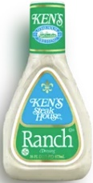


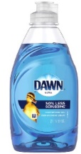




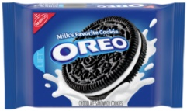

- How many items did you circle? _____/7
- What do you think each of these products have in common?

Directions: To better understand where soybean oil comes from, let’s take a look at the soybean. Use the NC Soybeans Producers Association website: https://ncsoy.org/media-resources/uses-of-soybeans/.
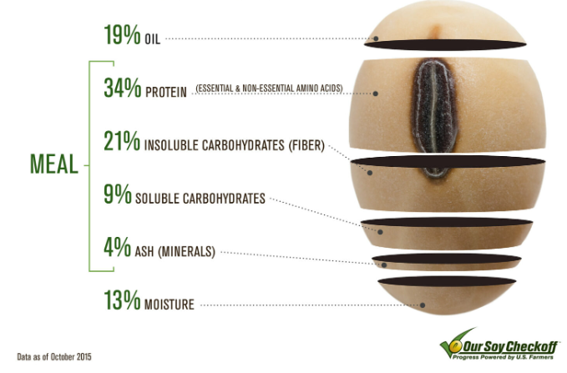
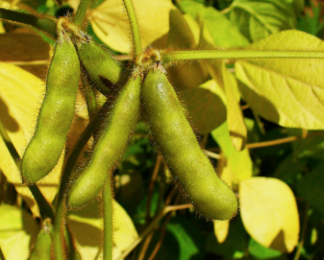
How much oil comes from the soybean seed? _________%
- What are some uses for soybean oil?
- ________________________________________________________________
- ________________________________________________________________
How much meal comes from the soybean seed? _________%
- What is one of the largest uses of soybean meal?

How much moisture does the soybean contain? __________%
Pods that hold the growing soybean.

- Who is Henry Ford? _____________________________________
- Watch the video available at https://youtu.be/kS6e797W4iA, and summarize the use of soy by Henry Ford.

- What do you think would have changed if the war had not interrupted Henry Ford’s work? Give an example that would impact you today.
Identify three products that contain soybean oil that you use or are impacted by regularly.

- ___________________________________
- ___________________________________
- ___________________________________

Directions: Let’s put Henry Ford’s research into action on a smaller scale.
- Supplies Needed:
  - 1 small Ziploc bag
  - 1 tablespoon cornstarch
  - 1 tablespoon water
  - 1/8 teaspoon soybean oil
  - 2-3 drops food coloring of choice
  - Microwave
  - Eye dropper or pipette
  - 1-tablespoon measuring spoon
  - 1/8-teaspoon measuring spoon
- Directions:
- Open the Ziploc bag.
- Add cornstarch, water, soybean oil and food coloring.
- Remove all the air from the bag and zip it closed.
- Using your hands, mix the ingredients until thoroughly mixed.
- If the mixture is dry, add a small amount of water.
- Open one inch of the zipper on the baggie to serve as a vent.
- Place the vented bag in the microwave for 20 to 30 seconds.
- Carefully remove bag from microwave. Use caution to avoid burning your hands.
- Once cool, open the bag away from your face in case there is more steam contained in the bag.
- Answer the questions below.
Answer the following questions based on what you just made.

- What did you make? _______________________________________________
- Describe your creation.

- How do you think this compares to what Henry Ford created?

- How can soybean oil impact the way we live every day?

- Imagine soybean oil did not exist. What would be the impact on the world and/or your life? Give at least one specific example.

Part 2
Directions: Now that we have a better understanding of soybeans, let’s take an even closer look. Soybeans are a crucial staple in the agriculture industry, but they also play a large role in what we do every day. Use the U.S. Soy website, https://ussoy.org/, to learn about the various uses and benefits of soybean oil.
Food and Lifestyle
- How does soy impact you through the food you eat and the lifestyle you live?

- Identify a food or lifestyle item that is currently in your bag, in your current space or that you interacted with today.

______________________________________________________
- Watch the following video: https://youtu.be/LYjkZXbjHWE. Why is soybean oil considered healthy?

- Find a food label that includes soybean oil and attach it here.
Animal Nutrition
- Describe the role that soy plays in the world of animals.

- List two animals that benefit from soy production.
(1)

(2)

- How does the impact of soy on animals impact you?

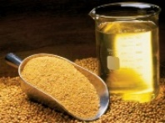
Sustainability
- How is sustainability being considered when thinking about soybean production?
Around the World
- Select an article about soy. Based on what you have read, describe the impact and role of soy.
Innovation
- What types of innovations exist that utilize soy? Give one specific example.

Soybean oil is one of the main products of soybeans. Use the USDA chart below to learn about soybean oil supply and demand.

- According to the chart, is soybean oil production increasing or decreasing? (Circle the correct response.)

- Roughly, how much soybean oil was produced in 2021-22? _____________________ million pounds

- How much soybean oil was used for food and other uses in 2021-22? ______________________ million pounds

- How much has soybean oil production increased in total from 2017-18 to 2021-22?
________________________ million pounds

- Which type of oil is utilized the most for biofuels in the U.S. in 2021-22? ____________________ at ________%

- In one to three, sentences describe the data displayed in the charts above.

- Identify three more products that contain soybean oil that you use or are impacted by regularly.

- ______________________________________________
- ______________________________________________
- ______________________________________________

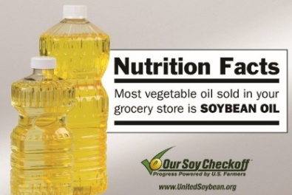
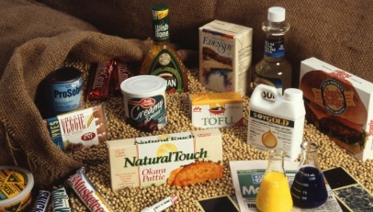
Part 3
Directions:
Develop a 90- to 120-second video/reel that explains and depicts the importance of soybeans and soybean oil in our everyday lives. Be sure to use examples. Use the space below to plan your video/reel.

Area | 4 Points | 3 Points | 2 Points | 1 Point
Content | All content is accurate. There are no factual errors. | Most of the content is accurate, but there is one piece of information that seems inaccurate. | The content is generally accurate, but one piece of information is clearly inaccurate. | Content is confusing or contains more than one factual error.
Clarity and Creativity | The video is easy to understand, and all elements are clearly written or spoken. Creativity was used. | The video is easy to understand, and most elements are clearly written or spoken. Some creativity was used. | The video is hard to understand with very quiet speaking or very hard to read writing. Little creativity was used. | The video is hard to understand, and one cannot follow the thought process. No creativity was used.
Narration and Preparedness | The video is clearly rehearsed and presented with no mistakes.  Student spoke slowly and clearly. | One mistake is heard in the video. | Two mistakes are heard in the video. | Three or more mistakes are heard in the video.  Student spoke very fast and was unclear.
Time | Video was 90 to 120 seconds in length. |  |  | Student was either under or over the allotted time frame.

KEY: Sensational Soy
Aligned to the following standards:
FFA.PL-A; FFA.PL-E; FFA.PL-F; FFA.PG-I; FFA.CS-M; FFA.CS-N; CCSS.RI.9-10.2; CCSS.RI.9-10.4; CCSS.SL.9-10.2; CCSS.SL.9-10.4; CCSS.WHST.9.10.4; CRP.02; CRP.04; CRP.05; CRP.07; CRP.08; CRP.11
Part 1
Directions:
Bell Ringer: Circle the products below to identify what you have used and/or consumed.
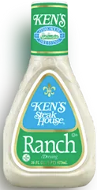
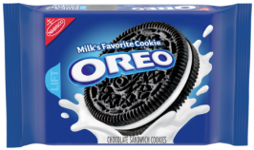
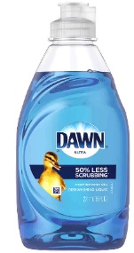

- How many items did you circle? _____/7 Answers will vary.
- What do you think each of these products have in common?
Soybean oil

Directions: To better understand where soybean oil comes from, let’s take a look at the soybean. Use the NC Soybeans Producers Association website: https://ncsoy.org/media-resources/uses-of-soybeans/.
How much oil comes from the soybean seed? 19%
- What are some uses for soybean oil? Answers will vary, but examples are feed, fuel, etc.
- ________________________________________________________________
- ________________________________________________________________
How much meal comes from the soybean seed? 68%
- What is one of the largest uses of soybean meal?
Animal feed
How much moisture does the soybean contain? 13%

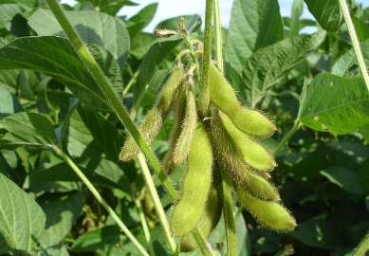
Pods that hold the growing soybean.

- Who is Henry Ford? Inventor of the Model T Ford and the assembly line
- Watch the video available at https://youtu.be/kS6e797W4iA, and summarize the use of soy by Henry Ford.
Henry Ford worked with soy to develop a soy-based plastic to be used in automobiles. The plastic he developed was strong and durable, as shown when he used his axe in a demonstration.

- What do you think would have changed if the war had not interrupted Henry Ford’s work? Give an example that would impact you today. Answers will vary.
Identify three products that contain soybean oil that you use or are impacted by regularly. Answers will vary.

- ___________________________________
- ___________________________________
- ___________________________________

Directions: Let’s put Henry Ford’s research into action on a smaller scale.
- Supplies Needed:
  - 1 small Ziploc bag
  - 1 tablespoon cornstarch
  - 1 tablespoon water
  - 1/8 teaspoon soybean oil
  - 2-3 drops food coloring of choice
  - Microwave
  - Eye dropper or pipette
  - 1-tablespoon measuring spoon
  - 1/8-teaspoon measuring spoon
- Directions:
- Open the Ziploc bag.
- Add the cornstarch, water, soybean oil and food coloring.
- Remove all the air from the bag and zip closed.
- Using your hands, mix the ingredients until thoroughly mixed.
- If the mixture is dry, add a small amount of water.
- Open one inch of the zipper on the baggie to serve as a vent.
- Place the vented bag in the microwave for 20 to 30 seconds.
- Carefully remove bag from microwave. Use caution to avoid burning your hands.
- Once cool, open the bag away from your face in case there is more steam contained in the bag.
- Answer the questions below.

Answer the following questions based on what you just made.

- What did you make? Soybean plastic
- Describe your creation.
Answers will vary.

- How do you think this compares to what Henry Ford created?
Answers will vary.

- How can soybean oil impact the way we live every day?
Answers will vary.
- Imagine soybean oil did not exist. What would be the impact on the world and/or your life? Give at least one specific example.
Answers will vary.
Part 2
Directions: Now that we have a better understanding of soybeans, let’s take an even closer look. Soybeans are a crucial staple in the agriculture industry, but they also play a large role in what we do every day. Use the U.S. Soy website, https://ussoy.org/, to learn about the various uses and benefits of soybean oil.
Food and Lifestyle
- How does soy impact you through the food you eat and the lifestyle you live? Answers will vary.

- Identify a food or lifestyle item that is currently in your bag, in your current space or that you interacted with today. Answers will vary.

______________________________________________________
- Watch the following video: https://youtu.be/LYjkZXbjHWE. Why is soybean oil considered healthy? Soybean oil contains healthy fats and is free of trans fats when in oil form.

- Find a food label that includes soybean oil and attach it here. Answers will vary.
Animal Nutrition
- Describe the role that soy plays in the world of animals. Soybean meal is heavily utilized as a feed source for livestock.

- List two animals that benefit from soy production.
- Chickens, fish, cattle, swine

(2)

- How does the impact of soy on animals impact you? Answers will vary. Example: Animals that are being used for food production need to be fed in the most nutritious way to ensure they are healthy and have a good life. Healthy animals equals healthy end products for consumption.

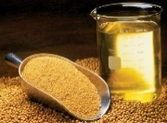
Sustainability
- How is sustainability being considered when thinking about soybean production? Innovations in farming practices are being used to create more sustainable and functional crops that will keep the soil in top health.
Around the World
- Select an article about soy. Based on what you have read, describe the impact and role of soy . Answers will vary.
Innovation
- What types of innovations exist that utilize soy? Give one specific example. Examples will vary. Example: Using soy to address challenges the economy is facing is important for moving forward. A specific example would be the use of soy in tires for automobiles.

Soybean oil is one of the main products of soybeans. Use the USDA chart below to learn about soybean oil supply and demand.

- According to the chart, is soybean oil production increasing or decreasing? (Circle the correct response.)

- Roughly, how much soybean oil was produced in 2021-22? ≈27,000 million pounds

- How much soybean oil was used for food and other uses in 2021-22? ≈25,000-26,000 million pounds

- How much has soybean oil production increased in total from 2017-18 to 2021-22?
≈3,000 million pounds

- Which type of oil is utilized the most for biofuels in the U.S. in 2021-22? Soybean oil at 46%

- In one to three sentences, describe the data displayed in the charts above.

Answers will vary. Example: The production of soybean oil is steadily increasing to meet the growing demand for biofuel, food and other, and exports. It is important to note that soybean oil is the heavily utilized vegetable oil, fat and grease utilized for production of U.S. biofuels in 2021-22.

Identify three other products that contain soybean oil that you use or are impacted by regularly. Answers will vary.

- ______________________________________________
- ______________________________________________
- ______________________________________________

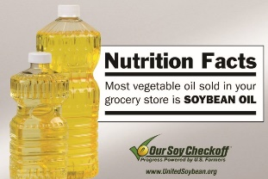
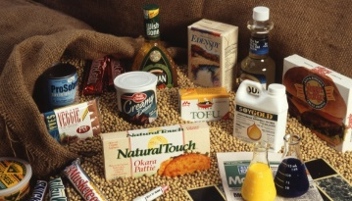
Part 3
Directions:
Develop a 90- to 120-second video/reel that explains and depicts the importance of soybeans and soybean oil in our everyday lives. Be sure to use examples. Use the space below to plan your video/reel.
Answers will vary.

Area | 4 Points | 3 Points | 2 Points | 1 Point
Content | All content is accurate. There are no factual errors. | Most of the content is accurate, but there is one piece of information that seems inaccurate. | The content is generally accurate, but one piece of information is clearly inaccurate. | Content is confusing or contains more than one factual error.
Clarity and Creativity | The video is easy to understand, and all elements are clearly written or spoken. Creativity was used. | The video is easy to understand, and most elements are clearly written or spoken. Some creativity was used. | The video is hard to understand with very quiet speaking or very hard to read writing. Little creativity was used. | The video is hard to understand, and one cannot follow the thought process. No creativity was used.
Narration and Preparedness | The video is clearly rehearsed and presented with no mistakes.  Student spoke slowly and clearly. | One mistake is heard in the video. | Two mistakes are heard in the video. | Three or more mistakes are heard in the video.  Student spoke very fast and was unclear.
Time | Video was 90 to 120 seconds in length. |  |  | Student was either under or over the allotted time frame.

