Moving Agriculture Forward
Directions:
Watch the video “Ingredient Production and Transportation in Agriculture with CSX and Darling,” https://vimeo.com/460290610, and complete the following activities.


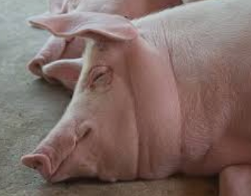
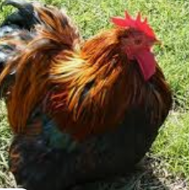
- How are these companies directly impacted by agriculture?
  - CSX: ____________________________________________________________________________________________________________________________________________________________________________
  - Darling Ingredients Inc.: ____________________________________________________________________________________________________________________________________________________________________________
In your own words, describe the overall role each company plays in our economy.

CSX:

Darling Ingredients Inc.:
- How has the coronavirus pandemic impacted each company?
  - CSX: ____________________________________________________________________________________________________________________________________________________________________________
  - Darling Ingredients Inc.: ____________________________________________________________________________________________________________________________________________________________________________
Unscramble the letters below to reveal a word that has been used by CSX and Darling Ingredients to describe each company’s employees.

L E E A T I S S N

___ ___ ___ ___ ___ ___ ___ ___ ___
3. What would you say to an FFA member or classmate about obtaining a career in an industry that is considered essential?


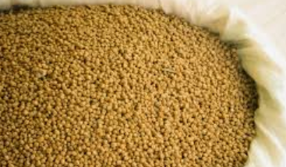
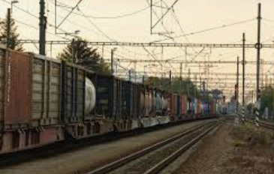
Based on the Darling Ingredients Inc. video, respond to the following two items.

- What year was Darling Ingredients Inc. developed? ________

- Summarize the Darling Ingredients Inc. video in one sentence.

4. What is eco-friendly fertilizer according to Darling Ingredients Inc.?
5. What are the trends in government regarding fertilizer recommendations?
Based on the CSX video, provide the following information.

- ________ miles
- ________ states
- ________ railroaders
- ________ bushels of corn
- ________ bushels of soybeans
- ________ bushels of wheat
- ________ tons of finished phosphate
- ________ of the business can be attributed to agriculture.

- What technology changes can we expect in the coming years?

  - CSX: ____________________________________________________________________________________________________________________________________________________________________________
  - Darling Ingredients Inc.: ____________________________________________________________________________________________________________________________________________________________________________
7. What can a student do now to prepare for a career with companies such as Darling Ingredients Inc. and CSX?
What are you currently doing or participating in that helps you to build these types of skills?
List two specific, new (that you are not already doing) ways you can enhance these skills.
KEY: Moving Agriculture Forward
Directions:
Watch the video “Ingredient Production and Transportation in Agriculture with CSX and Darling,” https://vimeo.com/460290610, and complete the following activities.
- How are these companies directly impacted by agriculture?
  - CSX: Hauls agricultural products from those that grow/raise them
  - Darling Ingredients Inc.: Recycles products/by-products and develops products for use (rendering)
In your own words, describe the overall role each company plays in our economy.

CSX: Makes transportation of agricultural products possible through railway systems, which allows products to be produced in the midwest and utilized in the east

Darling Ingredients Inc.: Takes otherwise unusable products from animal processing facilities and makes them into products that can be used; without this company, there would be a lot of waste.
- How has the coronavirus pandemic impacted each company?
- CSX: With the drop in the demand for food service, transportation needs dropped.
- Darling Ingredients Inc.: With the decrease in animal harvesting capabilities, productivity dropped slightly. However, when the industry faced swine that were too large to go to processing facilities, the company was able to step in and help with the extermination of the swine. The business had the best quarter due to this need.
Unscramble the letters below to reveal a word that has been used by CSX and Darling Ingredients to describe each company’s employees.

L E E A T I S S N

E S S E N T I A L
3. What would you say to an FFA member or classmate about obtaining a career in an industry that is considered essential? You must love what you do.

Based on the Darling Ingredients Inc. video, respond to the following two items.

- What year was Darling Ingredients Inc. developed? 1882

- Summarize the Darling Ingredients Inc. video in one sentence. Darling Ingredients Inc. is a rendering company that takes animal by-products and makes them into products useable for the agricultural industry.

4. What is eco-friendly fertilizer according to Darling Ingredients Inc.? Animal-based by-products are used to develop organic fertilizers.
5. What are the trends in government regarding fertilizer recommendations? The company must follow the current, required USDA guidelines to be labeled organic. However, the company must also look at the requirements demanded by different states like CA, OR, WA and on a state-by-state basis.
Based on the CSX video, provide the following information.

- 200,000 miles
- 23 states
- 19,000 railroaders
- 380,000,000 bushels of corn
- 100,000,000 bushels of soybeans
- 100,000,000 bushels of wheat
- 5,000,000 tons of finished phosphate
- 15% of the business can be attributed to agriculture.

- What technology changes can we expect in the coming years?

  - CSX: Automation throughout the industry
  - Darling Ingredients Inc.: Technology to make animal feed and pet food safer; new developments in biofuel and renewable energy resources in production
7. What can a student do now to prepare for a career with companies such as Darling Ingredients Inc. and CSX? Agriculture courses will help. Additionally, taking a wide variety of classes is beneficial as well as taking advantage of new experiences. The industry needs people that are skilled with their hands.
What are you currently doing or participating in that helps you to build these types of skills? Answers will vary.
List two specific, new (that you are not already doing) ways you can enhance these skills. Answers will vary.

