Career Profile
Directions:
Utilize AgExplorer located at https://agexplorer.ffa.org/ to research your chosen career. You will use the information to complete a social media profile for your career of choice.
Cover Photo: (Setting/Location of Career)

Profile Picture

Career Focus Area:
Name of Career:
Interests/Groups: (What professional organizations are useful for me?)

Friends: (Who would I work with? What careers are related?)

Basic Information: (Where do I work? What companies could I work for/with?)

Career Profile, Continued

Status Update: (Why is this career the coolest?)
Schooling: (What education is needed for this career?)

About: (What do I do? What are my responsibilities?)

Aligned to the following standards:
CS.05; FFA.PL-A; FFA.PL-C; FFA.PL-E; FFA.PL-F; FFA.PG-I; FFA.PG-J; FFA.CS-M; FFA.CS-N; AG5; AGC09.02; CCSS.EI.9-10.4; CCSS.W.9-10.2; CCSS.SL.9-10.1; CCSS.WHST.9.10.4; CRP.02; CRP.04; CRP.07; CRP.08; CRP.10; CRP.11

EXAMPLE: Career Profile
Cover Photo: (Setting)
Q1`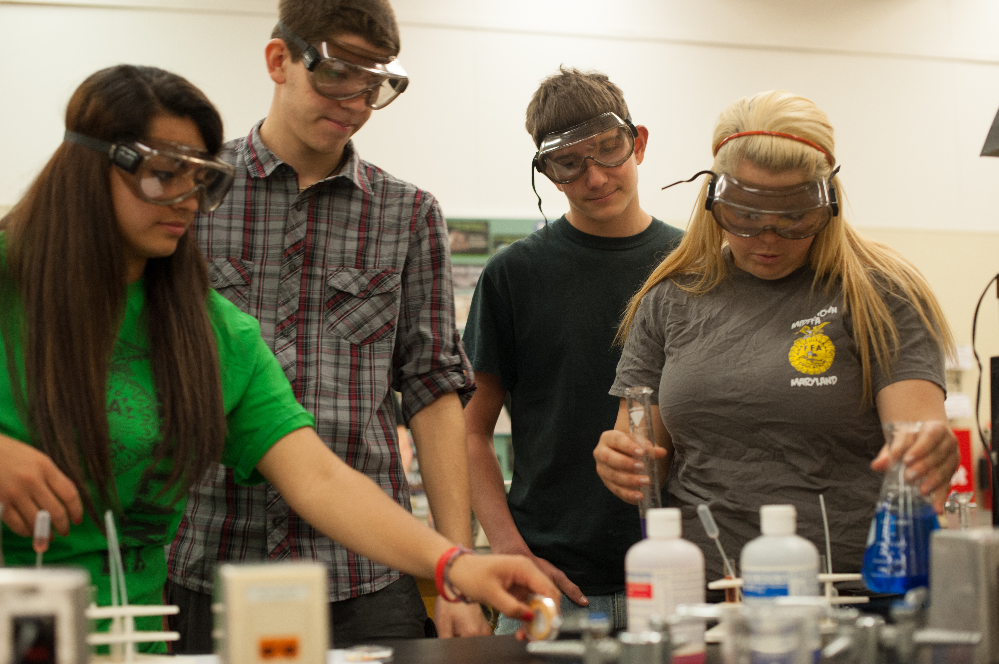

Profile Picture
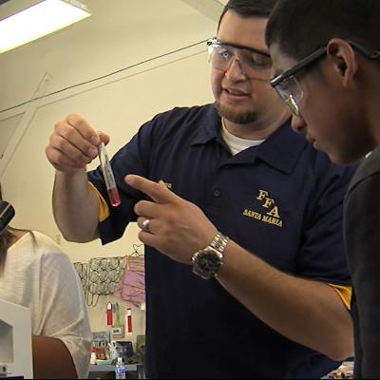

Name of Career: Agriculture Science Teacher - Secondary
Career Focus Area: Agricultural Education
Friends: (Who would I work with? What careers are related to me?)

Middle school and high school students
School administration
Extension agents
Guidance counselors
Parents
Postsecondary Educator: College/University Professor
Extension Faculty
College Recruiter
Agricultural Literacy and Advocacy Specialist
Advisor: Government/Stakeholder Relations
Agricultural Lobbyist

Interests/Groups: (What professional organizations are useful for me?)
- National Association of Agricultural Educators
- American Association for Agriculture Education
- National FFA Alumni Association

Basic Information: (Where do I work? What companies could I work with?)

Schools- rural, suburban or urban setting

Agriculture communications-journalist, advocacy

Agricultural education-younger students

Farm Bureau, Extension, National FFA Organization

EXAMPLE: Career Profile, Continued

Status Update: (Why is your career the coolest?)

I get to work with the future agriculturalists every day!

Schooling: (What education is needed for this career?)

Bachelor’s degree (4-year-degree) in agricultural education or other agriculturally related field plus the appropriate state teaching licensure.

About: (What do I do? What are my responsibilities?)

I teach students about all aspects of agriculture (Animals, plants, mechanics, etc.).

I am an advisor for the FFA which is the largest youth organization in the world.

I get to inspire and develop future leaders every day.

I create lesson plans and supervise the school lab and student SAEs. I stay informed about agriculture and agricultural literacy.

Aligned to the following standards:
CS.05; FFA.PL-A; FFA.PL-C; FFA.PL-E; FFA.PL-F; FFA.PG-I; FFA.PG-J; FFA.CS-M; FFA.CS-N; AG5; AGC09.02; CCSS.EI.9-10.4; CCSS.W.9-10.2; CCSS.SL.9-10.1; CCSS.WHST.9.10.4; CRP.02; CRP.04; CRP.07; CRP.08; CRP.10; CRP.11

