Sales Representative
Role Overview:
Sales representatives in Plant Systems promote and sell crop protection products and seeds. They work with farmers, retailers and distributors to offer solutions that boost productivity and sustainability.

Key Responsibilities:
- Build and maintain customer relationships in their territory.
- Meet sales targets and promote new products.
- Provide technical product recommendations to farmers.
- Track competitor activity and market trends.
- Collaborate with sales and marketing teams on strategies.

Essential Skills:
- Communication and interpersonal skills
- Agronomy and product knowledge
- Sales and negotiation techniques
- Goal orientation and independence

Career Path:
May lead to positions such as territory sales manager, regional sales director or product manager

Agronomic Service Representative
Role Overview:
Agronomic service representatives (ASRs) provide expert field support and technical guidance. They ensure that products are applied correctly and help diagnose agronomic issues.

Key Responsibilities:
  - Deliver training and agronomic insights to sales teams and customers.
  - Conduct field trials and product demonstrations.
  - Investigate crop issues and offer science-based solutions.
  - Gather and analyze field data to improve product strategies.

Essential Skills:
  - Agronomic and scientific expertise
  - Field data analysis and diagnostics
  - Communication and presentation skills
  - Collaboration and problem-solving

Career Path:
Progression to technical manager, research agronomist or agronomy lead roles

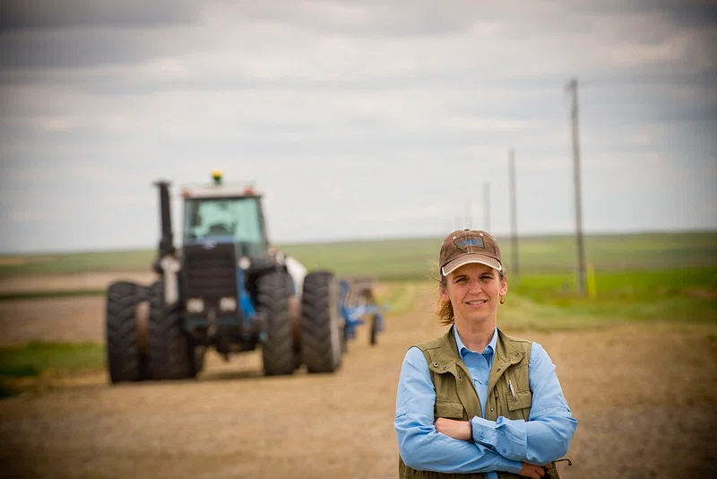
Customer Service Specialist
Role Overview:
Customer service specialists support clients by managing orders, resolving issues and providing information. They ensure customer satisfaction and operational efficiency.

Key Responsibilities:
  - Process orders and track shipments.
  - Communicate with customers via phone, email and chat.
  - Resolve service issues quickly and professionally.
  - Collaborate with sales and logistics teams.

Essential Skills:
  - Empathy and active listening
  - Strong organization and multitasking
  - Customer service systems and communication tools
  - Detail-oriented problem solving

Career Path:
Can lead to roles in customer service management, sales support or supply chain coordination



