Career, Trade School, College and/or Member Signing Day
Recognizing accomplishments and successes is a wonderful way to bring members closer and recognize hard work. As a way to do this, try an official Signing Day during National FFA Week! Signing days are typically used when students have made a decision or are becoming a part of something new that will advance them personally or in their career. Use the following to celebrate students committing to colleges, careers, joining the FFA, Greenhand ceremonies, just to name a few examples!
- Have the student fill this out prior to the event:
Student Name: ___________________________________

Where they are headed (i.e., workforce, trade school, college or new FFA member)

Student quote about the accomplishment and/or why they are excited.

What led the student to this accomplishment?


- Planning:
  - Start by discussing the event with students and explaining its importance.
  - Gain access to a larger table with chairs and decorate with balloons or special backdrop (this is where the “signing” will take place).
  - Find a large area (shop, large classroom, gymnasium) where the signing table can be set, along with space for attendees to gather and watch.
  - Invite other students from the chapter, agricultural class or school assembly to attend and watch the event.
  - Create a poster for each student that includes their picture, background, future plans, etc. so that attendees at the signing event can view them while they are waiting for the event to start.
  - Find someone to take pictures.
  - Invite future employers or someone to recognize each student specifically (can be a guidance counselor, principal, coach, etc.).
  - Gain permission and time for the presentation from administration.
  - Consider something that can be handed to each student. Examples: a hat with the trade school logo, a company hat or shirt, etc. If this is a member signing day, consider giving students a piece of official dress or a pin if these are new Greenhand members.
  - Print signing certificates for each student.
  - Consider snacks and water/lemonade for a reception after the signing ceremony. Be sure to determine the location and decorations.
  - Invite administration, advisory board, parents, etc.
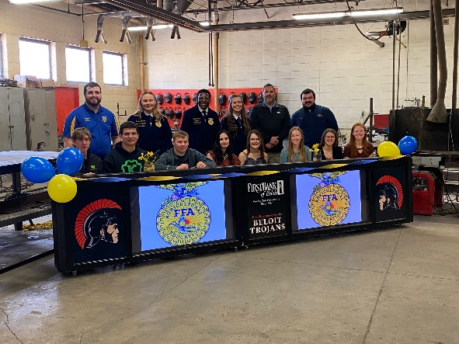

- Set Up:
  - Set up or hang a plain backdrop or one with school logos.
  - Cover the table with a tablecloth.
  - Ensure that future employers or the person recognizing each student specifically has arrived (can be a guidance counselor, principal, coach, etc.).
  - Ensure there is an item for each student to be handed.
  - Ensure there is a certificate to sign for each student.
  - Set up the reception area with snacks, tablecloths, decorations, etc.

- Run of Show
  - Welcome:
    - “Welcome to the [insert school name/FFA Chapter] Career and Trade School Signing Day. We are excited to recognize and celebrate these students on their success in school and choosing their path. Please join me in congratulating each student as they officially sign.”
  - Student Presentation
    - Call each student up one at a time and have the student sit behind the table. Have the student’s representative come up as well. Announce students’ names, where they are going, and the quote the student shared in the form. Have the representative present students with their signing certificate. Or, you can have multiple students sign at once and then have them individually tell the crowd about their future plans.
    - While the student is signing have the photographer take pictures. After signing, the student can stand with the representative and do an exchange of the item (ex. Hold the shirt up to the student, etc.). Be sure lots of pictures are taken of the exchange.
    - Announce “Congratulations to [Student name] on his/her/their commitment to [career/trade school name, joining FFA]. We are excited to see you continue to excel!”
  - Conclusion
    - “As we send these students onto their next big step in life, may we remember the important role they will play and the impact they will make.”
  - After the Signing Ceremony
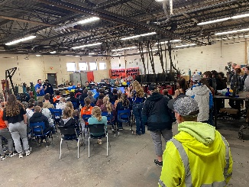

    - Invite guests and students to join you for a celebratory reception.

Certificate of Intent
The [Insert School Name] congratulates

_______________________________________________________________________
[Student Name on Line]

For making the decision to commit to [insert commitment].

[Insert logo of company, school, chapter]

Congratulations on your commitment to continue on your path to success!

________________________________________________________________
Student Signature

_________________________ _________________________ Principal Guidance Counselor

