In the Forest
Aligned to the following standards:
NRS.02; PL-A.; PG-J.; CS-M; AG-NR2; AGPE01.03; CS.06; CCSS.RI.9-10.3; CCSS.SL.9-10.1; CCSS.RST.9-10.1; CCSS.RST.9-10.2; CCSS.RST.9-10.4; CCSS.RST.9-10.8; CCSS.RST.9-10.9; CCSS.RST.11-12.1; CCSS.RST.11-12.8; CCSS.WHST.9.10.2; CCSS.WHST.9.10.7; CCSS.WHST.9.10.8; CCSS.WHST.9.10.9; HS-ESS3-1; HS-LS2-6; AFNR Career Cluster-Plant Systems Pathway, Statement 1; CRP.02; CRP.04; CRP.06; CRP.07; CRP.08
Directions:
Answer the questions below as you watch the video “National Forest SAE | Cayla Miller,” available at https://vimeo.com/377457887.

What is Cayla’s SAE?

What two areas of agriculture are connected to her SAE?

What is the process of electroshocking trout?
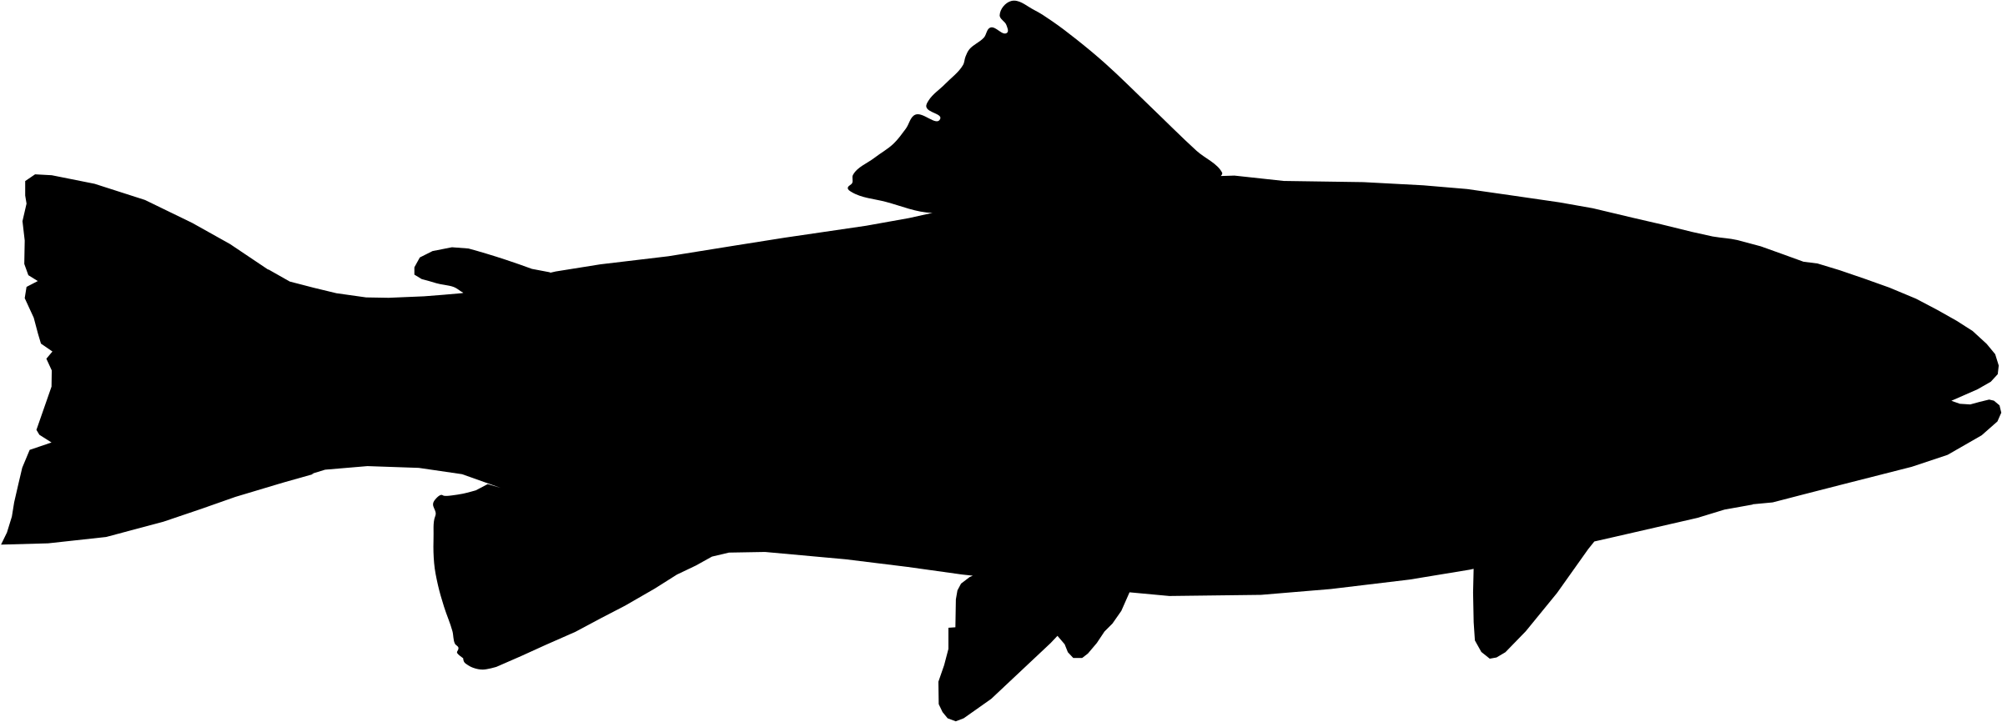

Describe the tasks that Cayla has to complete as part of her job.


Why does she need to check the pH levels?

What is the Youth Conservation Corp?


What is Cayla’s favorite SAE memory?
What did she learn from her SAE?

Forest Ecosystems
Aligned to the following standards:
NRS.02; PL-A.; PG-J.; CS-M; AG-NR2; AGPE01.03; CS.06; CCSS.RI.9-10.3; CCSS.SL.9-10.1; CCSS.RST.9-10.1; CCSS.RST.9-10.2; CCSS.RST.9-10.4; CCSS.RST.9-10.8; CCSS.RST.9-10.9; CCSS.RST.11-12.1; CCSS.RST.11-12.8; CCSS.WHST.9.10.2; CCSS.WHST.9.10.7; CCSS.WHST.9.10.8; CCSS.WHST.9.10.9; HS-ESS3-1; HS-LS2-6; AFNR Career Cluster-Plant Systems Pathway, Statement 1; CRP.02; CRP.04; CRP.06; CRP.07; CRP.08
Directions:
Complete the following activities to learn about forest ecosystems.

- There are three types of forest ecosystems: tropical, temperate and boreal. Complete the table below to compare and contrast these ecosystems. (Suggested resource: The Forest Biome, https://ucmp.berkeley.edu/exhibits/biomes/forests.php)

 | Tropical Forest | Temperate Forest | Boreal Forest
Average Temperature
Precipitation
Soil Quality
Canopy
Flora
Fauna
Further Subdivisions of This Group

- The organisms in an ecosystem depend on each other for survival. They are broadly categorized by their role within the ecosystem, and there is some variance between the three types of forest ecosystems. Complete the table below to learn about the interdependence of organisms within each type of forest. (Suggested Resources: Tropical Forest, https://sciencing.com/about-6325114-information-forest-ecosystem.html; Temperate Forest, https://sciencing.com/food-chains-deciduous-forest-7449795.html; Boreal Forest, https://sciencestruck.com/taiga-biome-food-chain)

 | Tropical Forest | Temperate Forest | Boreal Forest
Producers
Consumers
Decomposers

- Forests are divided into layers, and each of these layers is slightly different depending on the type of forest. Use the table below to define the layers of the three forest types. (Suggested Resources: Tropical Forest, https://education.nationalgeographic.org/resource/rain-forest/; Temperate Forest, https://jakesnatureblog.com/2018/05/31/temperate-forest-layers-5-main-layers/)

Tropical Forest | Temperate Forest | Boreal Forest
Emergent Layer: | Canopy Layer: | A boreal forest has much less diversity so there is only a tree layer and ground layer, and neither layer has a broad range of plant or animal life.
Canopy Layer: | Small Tree/Sapling Layer:
Understory Layer: | Shrub Layer:
Forest Floor Layer: | Herb Layer:
 | Ground Layer:

- Using the information gathered in Questions 1 through 3, draw a diagram in the space below that shows how the various components of a forest interact. Your diagram can be for either a tropical forest or a temperate forest. (Suggested Resources: Concept, Structure, Components of Ecosystem, http://www.brainkart.com/article/Concept,-Structure,-Components-of-Ecosystem_7434/; Forest Ecosystems, https://climate-woodlands.extension.org/forest-ecosystems/; Explain the Vertical and Horizontal Ecological Structures of British Woodland, https://myforestjourney.home.blog/2020/01/12/fspwe-1-1-explain-the-horizontal-ecological-structures-of-british-woodland/; Conduct a Google Image search for forest ecosystem diagrams)
  - Your diagram should contain these components:
    - Include and label each layer of your chosen forest ecosystem.
    - Draw the producers, consumers and decomposers.
    - Use arrows or some other symbol to indicate how the producers, consumers and decomposers interact.
    - Draw and color in examples of the flora and fauna of your chosen forest ecosystem.

