Chapter Goals Activity 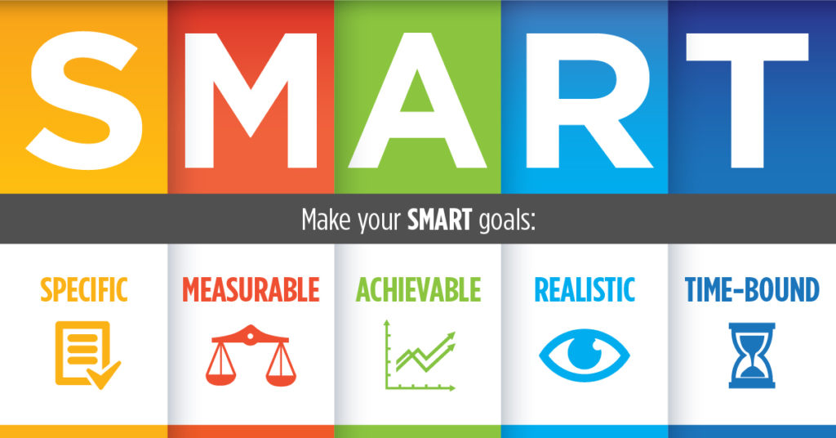
Goals can be the foundation to help guide us as a team toward what we want to achieve this year. SMART stands for Specific, Measurable, Attainable, Realistic, Time-Bound. Our goals should be something that challenges us, but also something that is realistic for us to achieve. Remember to also set a timeline (due date) that we want to achieve it by! Not all goals are going to be met, but all goals should have the potential to be met. CTI
When making our SMART goals for this year, make sure to follow the format below:
WHAT: What are we trying to achieve? WHY: Why is this goal important?
WHO: Who is going to be in charge of achieving the goal?
WHEN: When will this goal be achieved by? HOW: How are we going to achieve this goal?
SMART Goal 1

GOAL 2

SMART Goal 2

SMART Goal 3

