Chapter SWOT Analysis 
Where are we strong? Where can we grow?

Weaknesses

Strengths

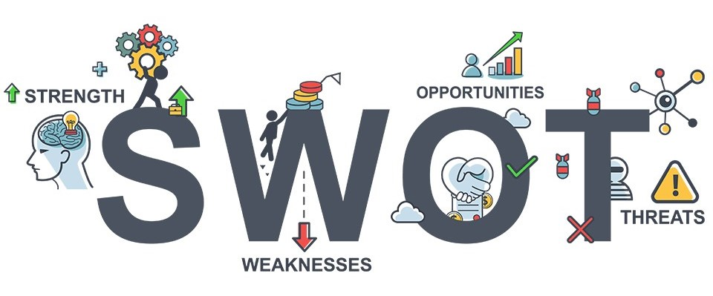

Threats

Opportunities

