All About the Vine
Aligned to the following standards:
PS.03; PL-A.; PG-J.; CS-M.; AG-PL3; AGPB01.03; CCSS.RI.9-10.1; CCSS.SL.9-10.4; CCSS.RST.9.10.4; CCSS.WHST.9.10.4; CCSS.WHST.9.10.7; WHST.9.10.9; CRP.02; CRP.04; CRP.07; CRP.08
Directions:
Answer the questions below as you watch the video “Grapevine Wreaths SAE | Chloe Jones,” available at https://vimeo.com/377181367.

What does Chloe do in the summer and in the winter to create her grapevine wreaths?
How does Chloe’s SAE impact her community?



What daily tasks is she responsible for?


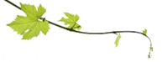
What things must be considered when decorating the wreath?

How do you make a grapevine wreath?

How has Chloe’s SAE grown?

What did she have to learn so she could grow her SAE?

Do You Have Any Grapes?
Aligned to the following standards:
PS.03; PL-A.; PG-J.; CS-M.; AG-PL3; AGPB01.03; CCSS.RI.9-10.1; CCSS.SL.9-10.4; CCSS.RST.9.10.4; CCSS.WHST.9.10.4; CCSS.WHST.9.10.7; WHST.9.10.9; CRP.02; CRP.04; CRP.07; CRP.08
Directions:
To grow her SAE, Chloe had to learn how to grow, care for, and harvest grapes and grapevines. Complete the worksheet by examining the suggest resource and answering the questions below.
Suggested Resource:
- Growing Grapes in the Home Garden, https://extension.umn.edu/fruit/growing-grapes-home-garden

- List five facts about grapes.

- What should you consider when choosing what grape variety to grow?

- How much water do young grapes require? How do water needs change as the plants mature?

- Why should you reduce watering young grapes in the fall?
  - They are not growing so they do not need water.
  - It encourages the plant to harden-off.
  - It prevents the roots from freezing during the winter.
  - You should not reduce watering in the fall.

- What are the fertilizer needs of grape vines?

- True or False. Mulching around the base of the vine is beneficial. (If false, explain why.)

- Why is weeding around grape vines so important?

- What steps should you follow to harvest grapes?
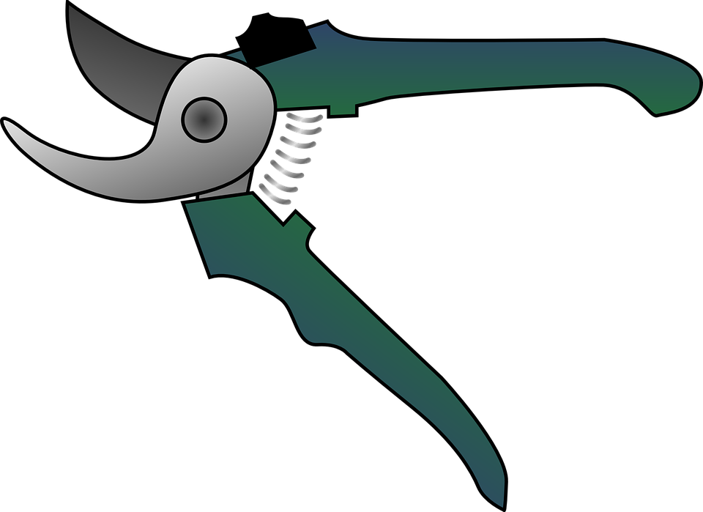

- How do you properly store grapes?

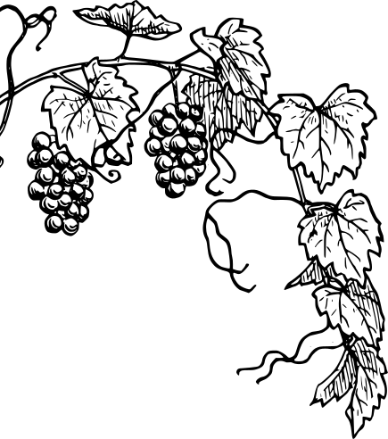

- Grape vines require care throughout the year. Complete the task chart below.

Month | Tasks
March
April, May
April – June
April – August
April – October
May, June
September, October
September, October
October, November

