Grapevine Wreaths
Created: 07/2020 by the National FFA Organization

Chloe Jones’ supervised agricultural experience (SAE) program is making grapevine wreaths using vines from the grapes her family grows. Learn how an interest in craft production led to growing, caring for and harvesting grapes and grapevines.

Student Learning Objectives:
After completing these activities, students will …
- Discover the work and process required to make grapevine wreaths.
- Examine how to select grape varieties and how to care for grape plants.
- Examine the tasks that must be completed throughout the year to care for grapes.

Time Required: 90 minutes
Resources/References:
- Video: “Grapevine Wreaths SAE | Chloe Jones,” available at https://vimeo.com/377181367
- Website: Growing Grapes in the Home Garden, https://extension.umn.edu/fruit/growing-grapes-home-garden

Equipment and Supplies Needed:
- A copy of the “All About the Vine” worksheet for each student
- A copy of the “Have You Got Any Grapes?” worksheet for each student
- Internet access to play the video in real time or embed it in a PowerPoint ahead of time

Student activity sheets:
Direct access to student activity sheets without lesson plan or answer key for easy upload to learning management system or printing for classwork.
https://ffa.box.com/s/531trmn9arhqst6dco5867kn5ii0jh1a (Word)
https://ffa.box.com/s/8u3pxmrzuiwbzx9w9cv5mnczzdfspjz6 (PDF)

Student activity sheets:
Direct access to student activity sheets without lesson plan or answer key for easy upload to learning management system or printing for classwork.
https://ffa.box.com/s/531trmn9arhqst6dco5867kn5ii0jh1a (Word)
https://ffa.box.com/s/8u3pxmrzuiwbzx9w9cv5mnczzdfspjz6 (PDF)

Cross-Curricular Connections:
Science
Examine the water, fertilizer and pruning requirements of grapes.

These activities are aligned to the following standards:

AFNR Performance Element
- PS.03. Propagate, culture, and harvest plants and plant products based on current industry standards.
FFA Precept
- FFA.PL-A.Action: Assume responsibility and take the necessary steps to achieve the desired results, no matter what the goal or task at hand.
- FFA.PG-J.Mental Growth: Embrace cognitive and intellectual development relative to reasoning, thinking and coping.
- FFA-CS-M.Communication: Effectively interact with others in personal and professional settings.
Common Career Technical Core
- AG-PL3 Propagate, culture, and harvest plants and plant products based on current industry standards.
NASDCTEc
- AGPB01.03 Examine and apply fundamentals of production and harvesting when producing plants to demonstrate plant management and production techniques.
Common Core – Reading: Informational Text
- CCSS.ELA-Literacy.RI.9-10.1 Cite strong and thorough textual evidence to support analysis of what the text says explicitly as well as inferences drawn from the text.
Common Core – Speaking and Listening
- CCSS.ELA-Literacy.SL.9-10.4 Present information, findings, and supporting evidence clearly, concisely, and logically such that listeners can follow the line of reasoning and the organization, development, substance, and style are appropriate to purpose, audience, and task.
Common Core – Science & Technical Subjects
- CCSS.ELA-Literacy.RST.9-10.4 Determine the meaning of symbols, key terms, and other domain-specific words and phrases as they are used in a specific scientific or technical context relevant to grades 9-10 texts and topics.
Common Core – Literacy in Science & Technical Subjects: Writing
- CCSS.ELA-Literacy.WHST.9-10.4 Produce clear and coherent writing in which the development, organization, and style are appropriate to task, purpose, and audience.
- CCSS.ELA-Literacy.WHST.9-10.7 Conduct short as well as more sustained research projects to answer a question (including a self-generated question) or solve a problem; narrow or broaden the inquiry when appropriate; synthesize multiple sources on the subject, demonstrating understanding of the subject under investigation.
- CCSS.ELA-Literacy.WHST.9-10.9 Draw evidence from informational texts to support analysis, reflection, and research.
AFNR Career Ready Practices
- CRP.02. Apply appropriate academic and technical skills. Career-ready individuals readily access and use the knowledge and skills acquired through experience and education to be more productive.
- CRP.04. Communicate clearly, effectively, and with reason. Career-ready individuals communicate thoughts, ideas and action plans with clarity, whether using written, verbal and/or visual methods.
- CRP.07. Employ valid and reliable research strategies. Career-ready individuals are discerning in accepting and using new information to make decisions, change practices or inform strategies.
- CRP.08. Utilize critical thinking to make sense of problems and persevere in solving them. Career-ready individuals readily recognize problems in the workplace, understand the nature of the problem, and devise effective plans to solve the problem.
Partnership for 21st Century Skills
- Communication
- Information Literacy
- Initiative and Self-Direction
- Productivity and Accountability

Lesson Plan:
- Bell Ringer: Have you ever grown your own grapes? What about someone you know? Would you like to have fresh grapes available in your yard? Why or why not?

- Introduction: Supervised agricultural experience (SAE) programs are as diverse as the opportunities in agriculture. Students will learn about an FFA member who used her creative talents to combine artistry and fruit production. She grows her own grapes, harvests the grapes and the vines, and designs and makes grapevine wreaths, which she sells.

- Activity: Each student needs a copy of the worksheet “All About the Vine.” Students will complete the worksheet as they watch the video “Grapevine Wreaths SAE | Chloe Jones,” available at https://vimeo.com/377181367. After students have finished the video and worksheet, give each student a copy of the “Have You Got Any Grapes?” worksheet. Students will use an informative, easy-to-understand resource from University of Minnesota Extension to learn how to grow grapes at home. The worksheet will guide them through the website as they gather information about choosing varieties, caring for young plants and harvesting them.

- Follow-up: As a class, discuss Chloe’s SAE. Determine if any students were surprised that she created wreaths. Has any student ever thought about using their creativity as part of their SAE? How is it related to agriculture?

- Optional — Extended Learning Opportunities (Not factored into time requirement):
  - If you have the resources, have your classes work together to start growing grapes. This could expand into school-based enterprise SAEs for your students, and it is something that students could benefit from year after year.
  - If you teach a floral design class or if you had several students intrigued by Chloe’s SAE, bring in materials for students, either individually or in groups, to create their own grapevine wreaths. These could be displayed at the front of the school and even sold.

- Exit Ticket: How can you put your creative talents to use in your SAE? (If you don’t have an SAE, how could your creative talents help you start one?)

All About the Vine
Aligned to the following standards:
PS.03; PL-A.; PG-J.; CS-M.; AG-PL3; AGPB01.03; CCSS.RI.9-10.1; CCSS.SL.9-10.4; CCSS.RST.9.10.4; CCSS.WHST.9.10.4; CCSS.WHST.9.10.7; WHST.9.10.9; CRP.02; CRP.04; CRP.07; CRP.08
Directions:
Answer the questions below as you watch the video “Grapevine Wreaths SAE | Chloe Jones,” available at https://vimeo.com/377181367.

What does Chloe do in the summer and in the winter to create her grapevine wreaths?
How does Chloe’s SAE impact her community?



What daily tasks is she responsible for?


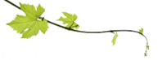
What things must be considered when decorating the wreath?

How do you make a grapevine wreath?

How has Chloe’s SAE grown?

What did she have to learn so she could grow her SAE?

Do You Have Any Grapes?
Aligned to the following standards:
PS.03; PL-A.; PG-J.; CS-M.; AG-PL3; AGPB01.03; CCSS.RI.9-10.1; CCSS.SL.9-10.4; CCSS.RST.9.10.4; CCSS.WHST.9.10.4; CCSS.WHST.9.10.7; WHST.9.10.9; CRP.02; CRP.04; CRP.07; CRP.08
Directions:
To grow her SAE, Chloe had to learn how to grow, care for, and harvest grapes and grapevines. Complete the worksheet by examining the suggest resource and answering the questions below.
Suggested Resource:
- Growing Grapes in the Home Garden, https://extension.umn.edu/fruit/growing-grapes-home-garden

- List five facts about grapes.

- What should you consider when choosing what grape variety to grow?

- How much water do young grapes require? How do water needs change as the plants mature?

- Why should you reduce watering young grapes in the fall?
  - They are not growing so they do not need water.
  - It encourages the plant to harden-off.
  - It prevents the roots from freezing during the winter.
  - You should not reduce watering in the fall.

- What are the fertilizer needs of grape vines?

- True or False. Mulching around the base of the vine is beneficial. (If false, explain why.)

- Why is weeding around grape vines so important?

- What steps should you follow to harvest grapes?
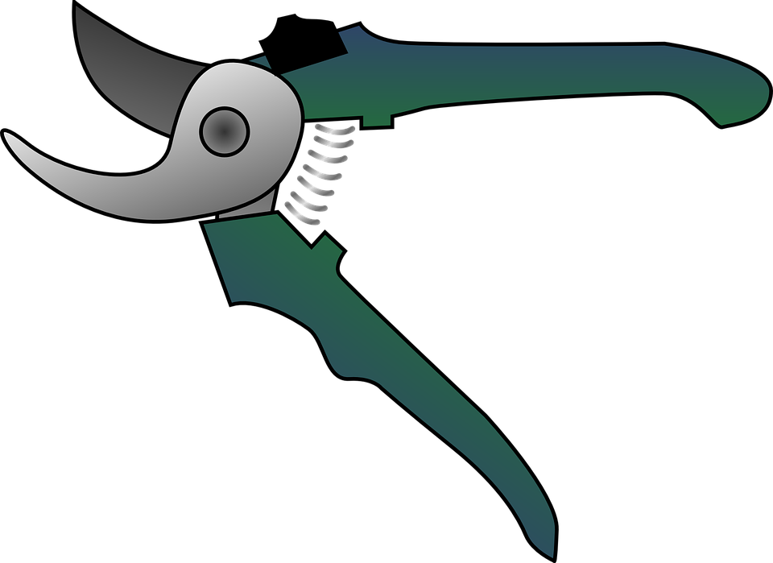

- How do you properly store grapes?

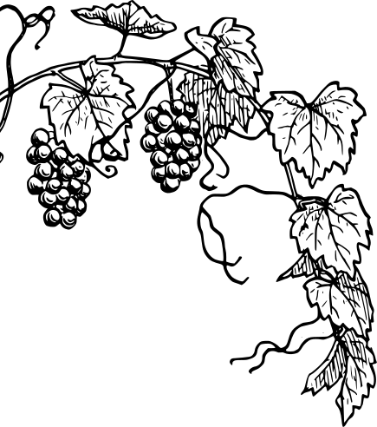

- Grape vines require care throughout the year. Complete the task chart below.

Month | Tasks
March
April, May
April – June
April – August
April – October
May, June
September, October
September, October
October, November

KEY: All About the Vine
Aligned to the following standards:
PS.03; PL-A.; PG-J.; CS-M.; AG-PL3; AGPB01.03; CCSS.RI.9-10.1; CCSS.SL.9-10.4; CCSS.RST.9.10.4; CCSS.WHST.9.10.4; CCSS.WHST.9.10.7; WHST.9.10.9; CRP.02; CRP.04; CRP.07; CRP.08
Directions:
Answer the questions below as you watch the video “Grapevine Wreaths SAE | Chloe Jones,” available at https://vimeo.com/377181367.

What does Chloe do in the summer and in the winter to create her grapevine wreaths?
How does Chloe’s SAE impact her community?

When she harvests extra fruit, she gives it to the community. She also sells the wreaths in her community. She sells on social media, to neighbors and sometimes at the farmers market.
Removes (harvests) the grapes
When the grapes have stopped growing, she cuts the grapevine, makes wreathes and decorates them.
What tasks is she responsible for?
Waters if it is too dry

Mows if needed, making sure not to knock off fruit

Rakes under the vines to keep area clean and prevent disease

Picks the fruit when it is ripe

Cuts the vines and removes all the leaves
What things must be considered when decorating the wreath?

Some customers specify what they want on their wreaths, but mostly you need to bring your own ideas. You should play around with different decorative items and place them (without gluing) on the wreath to see how it looks.
How do you make a grapevine wreath?

Twist the vines and wrap them together to make a circle

Keep wrapping the vines until you have the desired thickness
How has Chloe’s SAE grown?

When she started, she only decorated wreaths — she didn’t grow the vines and grapes herself.
What did she have to learn so she could grow her SAE?

She had to learn everything about grapes and grape vines. She has to know when to harvest the grapes and when the vines have stopped growing so she can cut them.

KEY: Do You Have Any Grapes?
Aligned to the following standards:
PS.03; PL-A.; PG-J.; CS-M.; AG-PL3; AGPB01.03; CCSS.RI.9-10.1; CCSS.SL.9-10.4; CCSS.RST.9.10.4; CCSS.WHST.9.10.4; CCSS.WHST.9.10.7; WHST.9.10.9; CRP.02; CRP.04; CRP.07; CRP.08
Directions:
To grow her SAE, Chloe had to learn how to grow, care for, and harvest grapes and grapevines. Complete the worksheet by examining the suggest resource and answering the questions below.
Suggested Resource:
- Growing Grapes in the Home Garden, https://extension.umn.edu/fruit/growing-grapes-home-garden

- List five facts about grapes.
Answers will vary, but could include the following:
Grapes are woody perennial vines.
Plant in full sun to provide the heat required to ripen the fruit.
Each vine needs about six feet of space.
Flowers and fruit develop on new shoots called canes.
It is possible to get fruit one year after planting.
Flowers are pollinated by wind and insects.
Vines can be trained to many decorative forms.
Annual pruning is very important to keep growth healthy each year.
Prune in spring before leaves emerge.

- What should you consider when choosing what grape variety to grow?

You need to consider what you want to do with the grapes: cover an arbor, make grape juice and jelly, eat fresh grapes or make wine. Once you know what you want to do with the grapes, then you examine the varieties and determine what will grow in your area.

- How much water do young grapes require? How do water needs change as the plants mature?

Young grapes require about 1/2 to 1 inch of water per week, depending on rainfall, for the first two years during the growing season. By the end of the second growing season, a trunk should be established, and your vine is likely to not need additional watering unless specific soil conditions (sandy, well drained) or prolonged drought dictate the need.

- Why should you reduce watering young grapes in the fall?
  - They are not growing so they do not need water.
  - It encourages the plant to harden-off.
  - It prevents the roots from freezing during the winter.
  - You should not reduce watering in the fall.

- What are the fertilizer needs of grape vines?
The first two or three years, each early spring, apply compost around the base of the vines. Grape vines grow vigorously and might need a nutrient boost each year. You may not have to do this as the vines mature; it all depends on what you observe. If the vines look vigorous and healthy, you might not need any fertilizer.

- True or False. Mulching around the base of the vine is beneficial. (If false, explain why.)
False. Mulching around the base keeps the soil too cool. Grapevine roots like to be warm.

- Why is weeding around grape vines so important?
This allows the soil to heat up early in the spring and maintain higher soil temperatures to encourage growth. When plants grow under vines, the soil temperature stays cooler. With grapes, this will delay growth in the spring.

- What steps should you follow to harvest grapes?
Clip full clusters off the vine with pruning shears or heavy scissors.

Handle clusters carefully.

Remove any discolored, injured or undesirable berries.

Cool them as soon as they are picked.

- How do you properly store grapes?
Store grapes in a refrigerator in a steady, consistent temperature. Cover grape clusters loosely with plastic to reduce moisture loss. Most grapes can be stored in the refrigerator for up to a week or two.

- Grape vines require care throughout the year. Complete the task chart below.

Month | Tasks
March | For existing vines, prune before growth starts.
April, May | Plant bare root grapevines as soon as soil can be worked.
April – June | Rub off any shoots that start growing lower down on the trunk.
April – August | Tie new growth to trellis as needed.
April – October | Inspect vines throughout the season to catch disease and insect problems.
May, June | Plant potted grapevines after threat of frost has passed.
September, October | As fruit ripens, watch for bird damage; cover with netting if needed
September, October | Harvest fruit based on color and flavor.
October, November | Clean up all fallen leaves, fruit and debris.

