Climate Smart Agriculture
Created: 12/2015 by the National FFA Organization

Student Learning Objectives
After completing these activities students will…
- Understand how changes in climate can effect agriculture globally.
- Identify best practices that help farmers improve conditions and become more sustainable.
- Use what they learn to develop a plan to integrate climate smart agriculture.

Time Required: 60 minutes
Resources: FFA.org
Video: Climate-Smart Agriculture: Helping the World Produce More Food https://youtu.be/i0V2xzEw44Y
Equipment and Supplies Needed:
- A copy of the “Climate Smart Agriculture” worksheet for each student.
- Internet access to play the video in real time or embed it in a PowerPoint ahead of time.

This quick lesson plan would work well as:
- Supplemental lesson for a plant science or agronomy course
- Introduction to agriculture course
- Primer for FFA CDEs

These activities are aligned to the following standards:

AFNR Performance Element
- CS.01. Analyze how issues, trends, technologies and public policies impact systems in the Agriculture, Food & Natural Resources Career Cluster
- CS.02. Evaluate the nature and scope of the Agriculture, Food & Natural Resources Career Cluster and the role of agriculture, food and natural resources (AFNR) in society and the economy.
- CS.04. Demonstrate stewardship of natural resources in AFNR activities.
- CS.06. Analyze the interaction among AFNR systems in the production, processing and management of food, fiber and fuel and the sustainable use of natural resources.
FFA Precept
- FFA.PG-J.Mental Growth: Embrace cognitive and intellectual development relative to reasoning, thinking and coping.
Common Career Technical Core
- AG1 Analyze how issues, trends, technologies and public policies impact systems in the Agriculture, Food & Natural Resources Career Cluster.
NASDCTEc
- AGC10.04 Envision emerging technology and globalization and project its influence on widespread markets to demonstrate an understanding of technologies and trends that will impact the AFNR industry.
Common Core- Math Practices
- CCSS.MP1: Make sense of problems and persevere in solving them.
- CCSS.MP6: Attend to precision.
AFNR Career Ready Practices
- CRP.02. Apply appropriate academic and technical skills. Career-ready individuals readily access and use the knowledge and skills acquired through experience and education to be more productive.
- CRP.05. Consider the environmental, social and economic impact of decisions. Career-ready individuals understand the interrelated nature of their actions and regularly make decisions that positively impact and/or mitigate negative impact on other people, organizations and the environment.
- CRP.08. Utilize critical thinking to make sense of problems and persevere in solving them. Career-ready individuals readily recognize problems in the workplace, understand the nature of the problem, and devise effective plans to solve the problem.

Partnership for 21st Century Skills
- Global Awareness
- Communication
- Critical Thinking and Problem Solving
- Information, Communications, and Technology Literacy

Lesson Plan:
- Introduction:

The relationship between agriculture and climate change can often be complex. This activity will help students understand some of the potential impacts and solutions for climate change in regards to global agriculture.

- Activity: Each student needs a copy of the handout “Climate Smart Agriculture.”
  - Show the video “Climate-Smart Agriculture: Helping the World Produce More Food.” The direct url is https://youtu.be/i0V2xzEw44Y.

- Follow-up:

  - Have students research climate change impacts and solutions in a specific country.
  - Have students research how the World Bank is aiding countries and cultures around the world to combat climate change and other issues.

Climate Smart Agriculture
Directions:
Watch the video “Climate-Smart Agriculture: Helping the World Produce More Food” at https://youtu.be/i0V2xzEw44Y.

The Problem 
- __________, ___________, ___________, and ___________ are impacting agriculture as a result of climate change.

- These impacts lead to ________ crops, ________ food, and ________ incomes.

- Global agriculture production must increase by ____% to feed a projected population of ____ billion people in the year ______.

- __________, ______________, and __________ produce ______(fraction) of greenhouse gases.

- _____ (fraction) of the world’s poor depend on land for their livelihood.


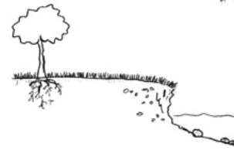


Answer Bank:

Flood

Soil Erosion

Drought

Deforestation

Crop Pests

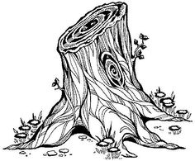


Solutions 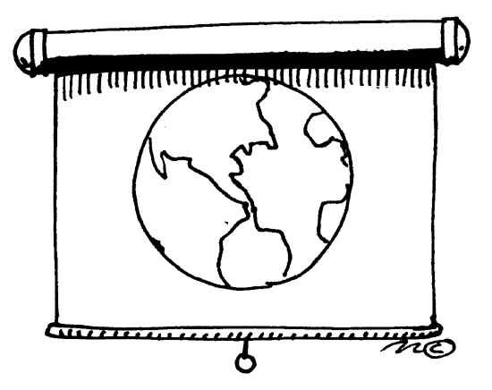
- ____________, _____________, _____________, _____________, ____________, and __________ are a few countries that have made great advancements in climate smart agriculture.

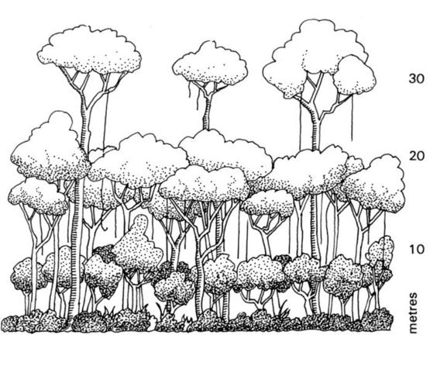
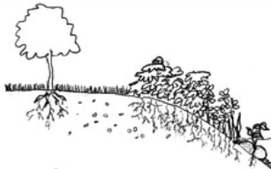

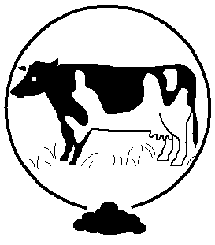
Answer Bank:

Planting Trees

Soil Stabilization

Manure Management

Intercropping

Water Harvesting

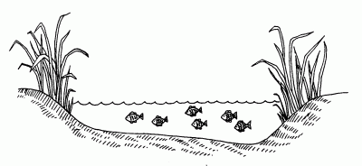
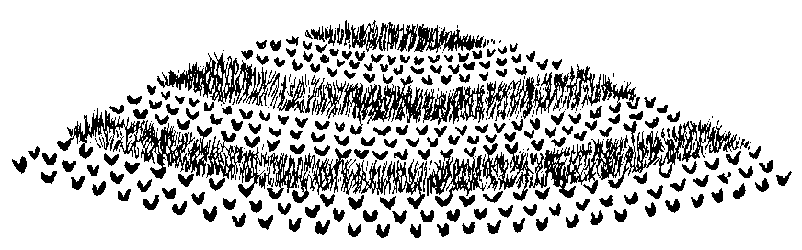

This activity is aligned the following standards:
CS.01, CS.02, CS.04, CS.06, FFA.PG-J., AG1, AGC10.04, CCSS.MP1, CCSS.MP6, CRP.02, CRP.05, CRP.08

Reflection 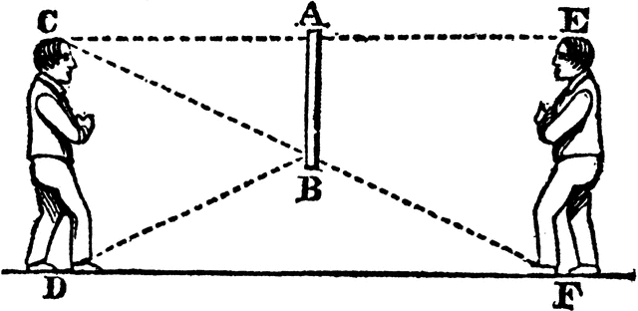
What practices are used in your community (agriculture and otherwise) to combat climate change?

Aligned to the following standards:
NRS.01; AGPE01.01; CCSS.ELA-Literacy.RI.9-10.3; CCSS.ELA-Literacy.SL.9-10.1; RST.9.10.1; RST.9.10.2; RST.9.10.4; RST.9.10.5; RST.9.10.6; RST.9.10.8; RST.9.10.9; WHST.9.10.7; WHST.9.10.9; MP3; MP6; AG-NR2; HS-LS2-6; HS-LS2-7

