You. Belong. Here.
Created: 04/2023 by the National FFA Organization
Description of Lesson: FFA is a place for all, no matter your style or milestones. Zipping up that blue corduroy jackets means you are in a place that provides both unity and individuality. Through his retiring address, 2021-22 National FFA President Cole Baerlocher shares how he has learned to embrace his story and how you can also.
Student Learning Objectives:
After completing these activities, students will …
- List the unique traits that make them who they are.
- Define what it means to belong.
- Identify their milestones in life and learn how to grow from them.

Suggested Grade Level:
Grades 9 and 10 (This lesson is written so instructors can scale up or down based on class needs.)

Suggested Time: 60 minutes (*Time requirements may vary based upon student understanding and class schedule.)

Resources/References:
- Video: “You. Belong. Here.” | Cole Baerlocher 2022 Retiring Address, https://vimeo.com/779370136

Related Resources:
- Retiring Addresses and Keynote Speeches, FFA.org/ffa-video-center/convention-keynotes-and-retiring-addresses/
- Spanish version: https://ffa.box.com/s/bvib09fd2q5b4d43jjwmnuhxq286478g

Equipment and Supplies Needed:
- A copy of the “Embrace Your Story” worksheet for each student
- Internet access to play the video in real time or embed it in a PowerPoint ahead of time

Vocabulary:
- Belonging
- Milestones
Cross-Curricular Connections:
English/Language Arts
- Students will write about milestones in their lives.
- Students will critically think about how to create a belonging space for others.

Virtual Instruction Ideas:
Have students download and watch the video on a device of their choice and complete the worksheet.

Student Activity Sheets:
PDF: https://ffa.app.box.com/file/1218328479464
Word: https://ffa.app.box.com/file/1218329993586
Non-Design Word: https://ffa.app.box.com/file/1218321960551
Google Doc: https://docs.google.com/document/d/18XrVUwFS9s0maF-EvNCDjHeWbeC8OsA1NlNf3Y_Xmxo/copy

These Activities Are Aligned to the Following Standards:
FFA Precept
- FFA.PL-B.Relationship: Build relationships, work as a team player and appreciate the talents of others.
- FFA.PL-D.Character: Conduct oneself appropriately in relation to others regardless of the situation.
- FFA.PL-F.Continuous Improvement: Accept responsibility for learning and personal growth.
- FFA.PG-H.Social Growth: Successfully interact with others and adapt to various social situations.
- FFA.PG-K.Emotional Growth: Share and express healthy feelings and emotions.
Common Core – Speaking and Listening
- CCSS.ELA-LITERACY.SL.9-10.1 Initiate and participate effectively in a range of collaborative discussions (one-on-one, in groups, and teacher-led) with diverse partners on grades 9-10 topics, texts, and issues, building on others’ ideas and expressing their own clearly and persuasively.
AFNR Career Ready Practices
- CRP.01. Act as a responsible and contributing citizen and employee. Career-ready individuals understand the obligations and responsibilities of being a member of a community, and they demonstrate this understanding every day through their interactions with others.
- CRP.04. Communicate clearly, effectively, and with reason. Career-ready individuals communicate thoughts, ideas and action plans with clarity, whether using written, verbal and/or visual methods.
- CRP.06. Demonstrate creativity and innovation. Career-ready individuals regularly think of ideas that solve problems in new and different ways, and they contribute those ideas in a useful and productive manner to improve their organization.
- CRP.09. Model integrity, ethical leadership and effective management. Career-ready individuals readily recognize problems in the workplace, understand the nature of the problem, and devise effective plans to solve the problem.
- CRP.12. Work productively in teams while using cultural/global competence. Career-ready individuals positively contribute to every team, whether formal or informal.
Partnership for 21st Century Skills
- Collaboration
- Communication
- Global Awareness
- Social and Cross-Cultural Skills
- Work Creatively with Others

Lesson Plan:
- Bell Ringer: Describe an article of clothing that you own that has a meaning or memory attached to it (a hand-me-down sweater from a sibling, letterman jacket from your grandparent, etc.).

- Introduction: Hand out the “Embrace Your Story” worksheet to each student. Today, we are going to watch a retiring address from the 95th National FFA Convention & Expo. This retiring address was given by 2021-22 National FFA President Cole Baerlocher. In his speech, we will learn how to embrace our story and find a place to belong. As we are watching the video, look over the questions on the worksheet “Embrace Your Story” and be ready for the answers as you view the video.

- Activity: Each student needs a copy of the worksheet “Embrace Your Story.”
  - Part 1: Have students watch the retiring address of 2021-22 National FFA President Cole Baerlocher. The video is available at https://vimeo.com/779370136. While students view the video, have them complete the questions.
  - Part 2: Students will answer the three questions that Cole proposes at the end of the video. These are thought-provoking questions. Then students will add drawings or quotes that represent who they are to the locker graphic.

- Follow-up: Students can share with a neighbor their answers to the questions or present their lockers.

- Exit Ticket: What space, in school or out of school, do you believe you belong to the most? Why?

Embrace Your Story
Aligned to the following standards:
FFA.PL-B; FFA.PL-D; FFA.PL-F; FFA.PG-H; FFA.PG-K; CCSS.ELA-LITERACY.SL.9-10.1; CRP.01; CRP.04; CRP.06; CRP.09; CRP.12
Part 1
Directions:
Complete the following activities while watching the retiring address of 2021-22 National FFA President Cole Baerlocher, “You. Belong. Here.” The video is available at https://vimeo.com/779370136.


1) What “tea” did Cole spill as he came out on stage? Who is his excuse?

2) What does Cole say he spends all his money on?

3) Cole says that when you are comfortable, you are __________________________________.

4) Cole states that, to him, clothing is how you express who you are and what your values are. Do you agree? Why or why not?

“While there is power in a name, there is more power in being authentically YOU!”

5) What is Cole’s favorite outfit of all time?

6) Cole tells the audience that his FFA jacket makes him feel more like himself. How does wearing an FFA jacket (yours or borrowed) make you feel? (If you are not in FFA, think about something similar — school uniform, letterman jacket, etc.) Why do you think you feel that way?

7) Who did Cole’s first FFA jacket originally belong to?

8) What two things does Cole say the blue jacket symbolizes?
a)

b)

“We need to realize that it isn’t a name or a title that makes you great — it’s you!”

9) Cole tells a story about a time when he felt a little “in over his head.” Think
about a time you have felt this way and describe it below. What did you do to overcome this feeling?

“Belonging is not about finding a place; belonging is about creating a space.”

10) Cole says that creating space means that we meet others where they are at and we understand that all of us are different. Has anyone ever done this for you? How?

11) What state did Cole visit for summer camp?

12) What types of milestones in our lives does Cole say we should focus on?


13) Fill in four milestones from your life in the stones below. These can be serious, major milestones or fun, small milestones.

1.
4.
3.
2.

Part 2
Directions:
Decorate the locker below to represent who you are. Draw five things that represent who you are and your likes and interests, or write your favorite quotes that impact you and your values (or include both drawings and quotes!).
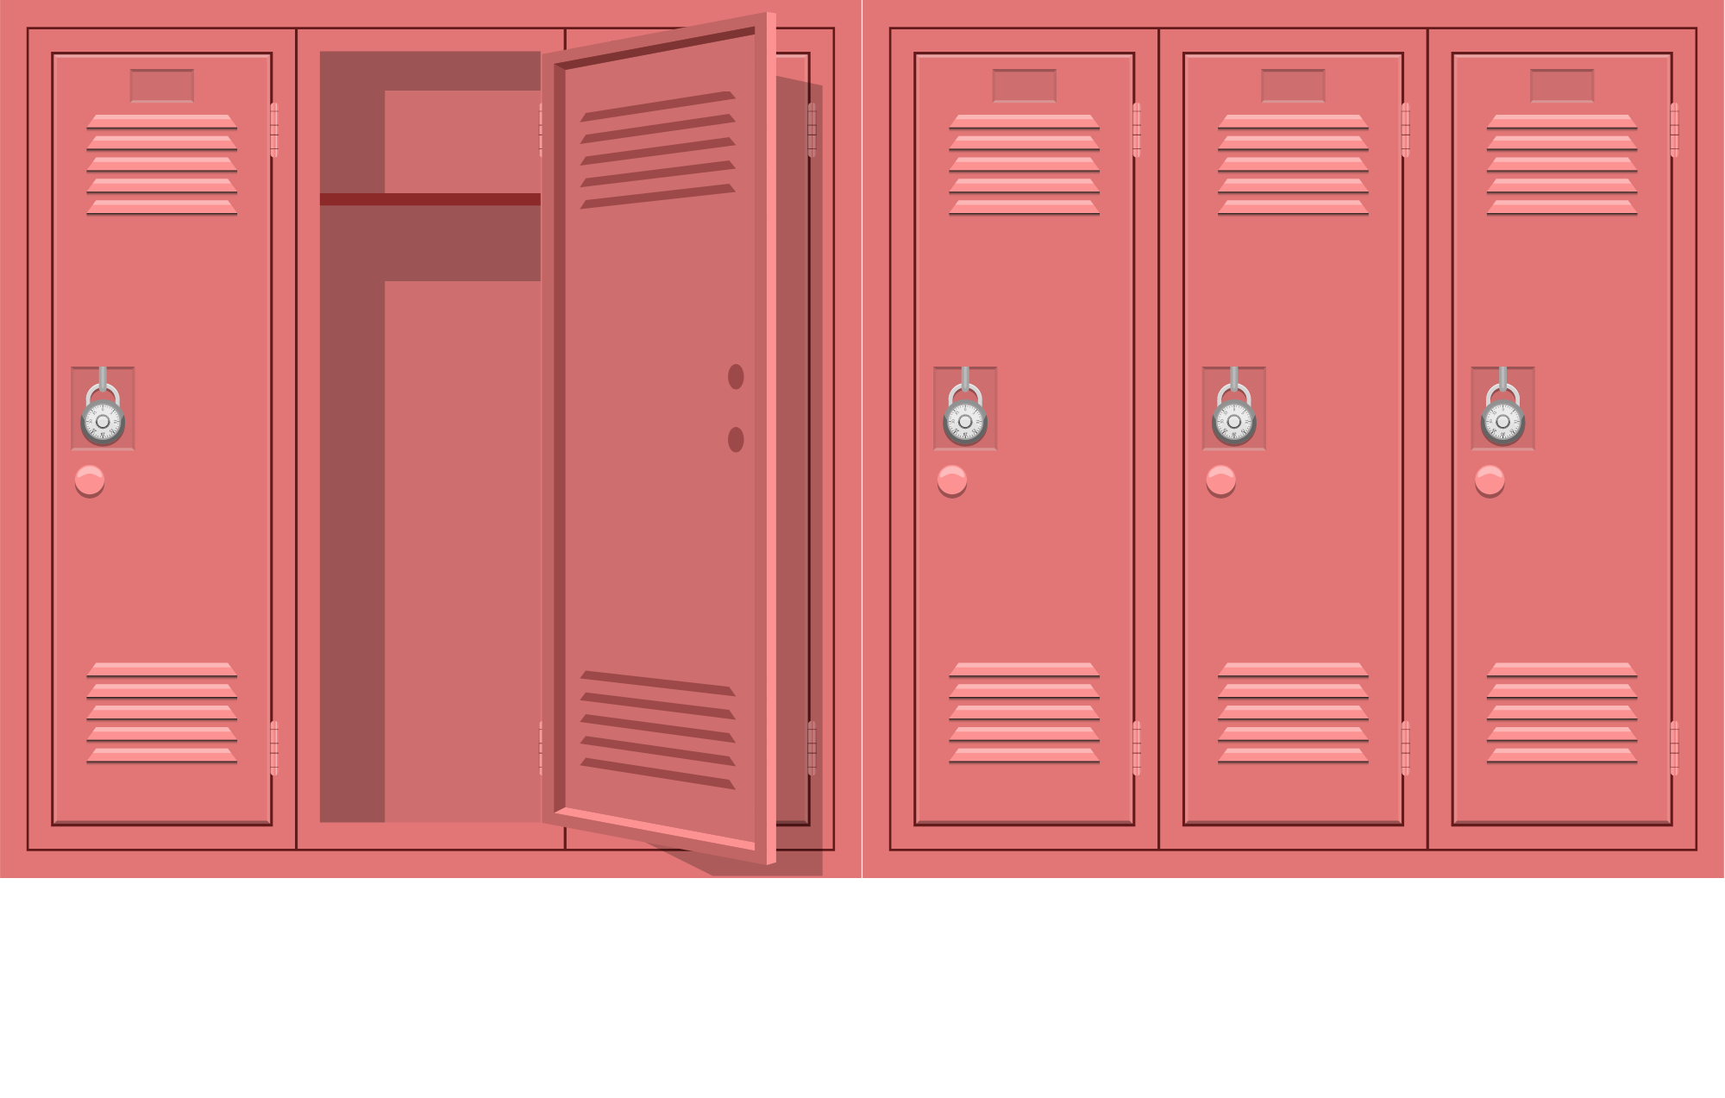
Why did you choose these items?
Item/Quote 1: | Why this item/quote?
Item/Quote 2: | Why this item/quote?
Item/Quote 3: | Why this item/quote?
Item/Quote 4: | Why this item/quote?
Item/Quote 5: | Why this item/quote?


Answer the three questions below. These questions were asked by Cole at the end of the video.
How will you embrace your story?
What will you do to create space for others to belong?
How will you maximize your potential HERE (at school, in FFA, on a team, etc.)?

KEY: Embrace Your Story
Part 1
Directions:
Complete the following activities while watching the retiring address of 2021-22 National FFA President Cole Baerlocher, “You. Belong. Hear.” The video is available at https://vimeo.com/779370136.

1) What “tea” did Cole spill as he came out on stage? Who is his excuse?
He’s horrible with money. He says his grandma is his excuse.

2) What does Cole say he spends all his money on?
He spends his money on clothes.

3) Cole says that when you are comfortable, you are confident.

4) Cole states that, to him, clothing is how you express who you are and what your values are. Do you agree? Why or why not?
Answers will vary.
“While there is power in a name, there is more power in being authentically YOU!”

5) What is Cole’s favorite outfit of all time?
Official dress is Cole’s favorite outfit of all time.

6) Cole tells the audience that his FFA jacket makes him feel more like himself. How does wearing an FFA jacket (yours or borrowed) make you feel? (If you are not in FFA, think about something similar — school uniform, letterman jacket, etc.) Why do you think you feel that way?
Answers will vary.

7) Who did Cole’s first FFA jacket originally belong to?
His first jacket belonged to his older brother.

8) What two things does Cole say the blue jacket symbolizes?
a) Unity

b) Individuality

“We need to realize that it isn’t a name or a title that makes you great — it’s you!”
9) Cole tells a story about a time when he felt a little “in over his head.” Think
about a time you have felt this way and describe it below. What did you do to
overcome this feeling?
Answers will vary.

“Belonging is not about finding a place; belonging is about creating a space.”

10) Cole says that creating space means we meet others where they are at and we understand that all of us are different. Has anyone ever done this for you? How?
Answers will vary.

11) What state did Cole visit for summer camp?
Oklahoma

12) What types of milestones in our life does Cole say we should focus on?
We should focus on the milestones that went well.
13) Fill in four milestones from your life in the stones below. These can be serious, major milestones or fun, small milestones.

1.
Answers will vary.
4.
3.
2.

Part 2
Directions:
Decorate the locker below to represent who you are. Draw five things that represent who you are and your likes and interests, or write your favorite quotes that impact you and your values (or include both drawings and quotes!).

Why did you choose these items?
Item/Quote 1: Answers will vary. | Why this item/quote? Answers will vary.
Item/Quote 2: Answers will vary. | Why this item/quote? Answers will vary.
Item/Quote 3: Answers will vary. | Why this item/quote? Answers will vary.
Item/Quote 4: Answers will vary. | Why this item/quote? Answers will vary.
Item/Quote 5: Answers will vary. | Why this item/quote? Answers will vary.

Answer the three questions below. These questions were asked by Cole at the end of the video.
How will you maximize your potential HERE (at school, in FFA, on a team, etc.)?
Answers will vary.
What will you do to create space for others to belong?
Answers will vary.
How will you embrace your story?
Answers will vary.

