On the Lawn
Aligned to the following standards:
PS.02; PL-A.; PG-J.; CS-M.; AG-PL2; AGPB01.02; CCSS.RI.9-10.3; CCSS.SL.9-10.1A; CCSS.RST.9-10.4; CCSS.RST.9-10.9; CRP.02; CRP.04; CRP.07; CRP.08
Directions:
Answer the questions below as you watch the video “Lawn Care SAE | Cole Hanson,” available at https://vimeo.com/368997622.
When did he start working in the family business?

What is Cole’s SAE?

What beginning steps did he take to become involved in the business?


What are his daily tasks?

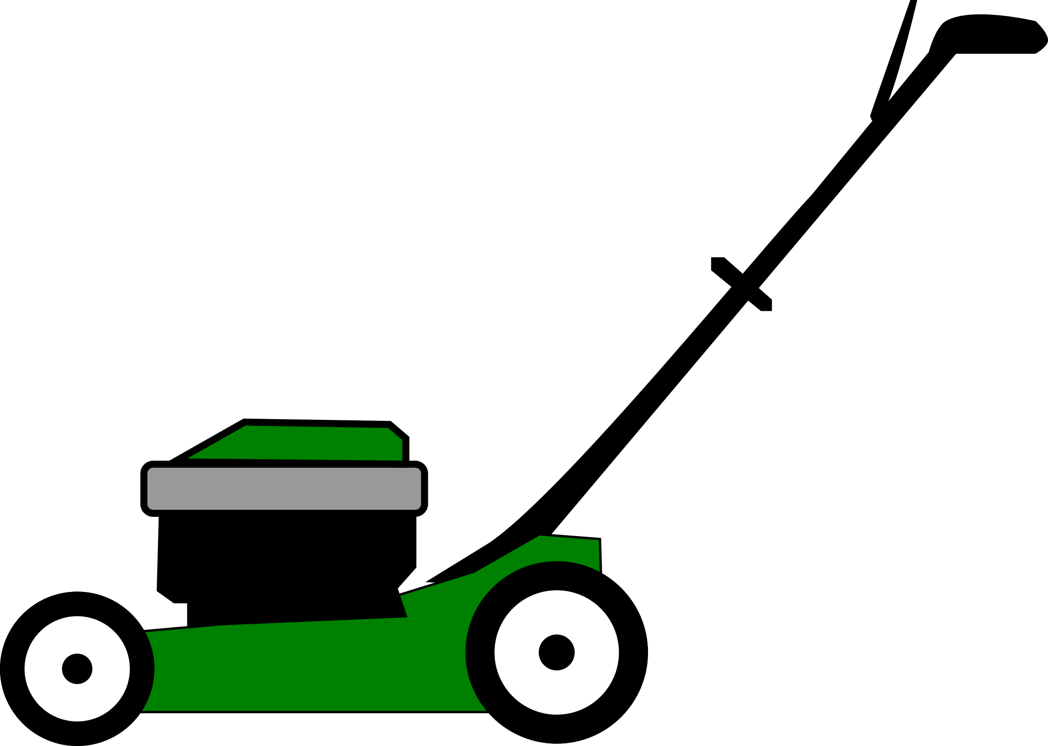



What is Cole obsessed with?

What advice does he have for students trying to start an SAE?

Grass and Lawn Basics
Aligned to the following standards:
PS.02; PL-A.; PG-J.; CS-M.; AG-PL2; AGPB01.02; CCSS.RI.9-10.3; CCSS.SL.9-10.1A; CCSS.RST.9-10.4; CCSS.RST.9-10.9; CRP.02; CRP.04; CRP.07; CRP.08
Directions:
Lawn care and landscape management is a booming business, but it helps to have some basic understanding about grass physiology and what grasses grow best in certain climate and conditions. Complete the following activities to learn more!

- On the diagram below, label the vegetative structures of grass. Then, define each vegetative part. Suggested Resource: Grass Structures, https://forages.oregonstate.edu/regrowth/how-does-grass-grow/grass-structures
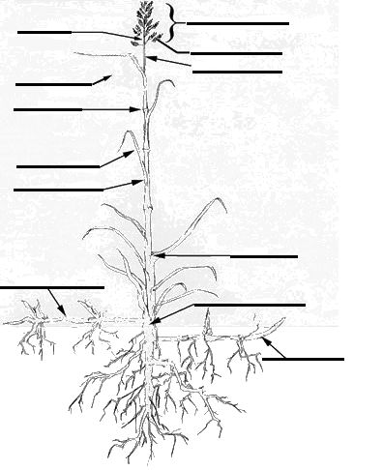

Vegetative Structure | Definition
Auricles
Collar region
Crown
Culm
Culm node
Flag leaf
Leaf blade
Leaf sheath
Ligule
Meristem
Peduncle
Rhizome
Stolon
Tiller

- When considering what grasses grow in a specific area, the U.S. is divided into five zones. Using http://www.lawnplugs.com/info/what-to-plant.html, answer the following questions.
  - What zone do you live in? (Circle your zone.)

Cool/Humid Warm/Humid Warm/Arid Cool/Arid Transition

  - Scroll down to the Plant Hardiness Zone Map. What is the temperature range where you live?

_____°F to _____°F

  - List three varieties of grass that work for your climate.

_______________________ _______________________ ____________________

- Research the three varieties you identified in Question 2c and complete the chart.
Suggested Resources:
- Grass Varieties, https://www.thelawninstitute.org/lawn-care-basics/grass-selection-and-management/
- Buffalo Grass, https://www.lawn-care-academy.com/planting-and-growing-warm-season-grass/

Grass Variety | Description | Shade Adaptation | Wear Resistance | Water Needs | Mowing Requirements | Disease, Insect and Weed Control

