Lawn Care
Created: 07/2020 by the National FFA Organization

Cole Hanson’s supervised agricultural experience (SAE) program is working in his family’s lawn care and landscape management business. Learn how he developed his knowledge and experience in this area.

Student Learning Objectives:
After completing these activities, students will …
- Understand the daily activities of someone who works in lawn care.
- Label and define the vegetative structures of grass.
- Recommend grass varieties suitable for their climate.

Time Required: 120 minutes
Resources/References:
- Video: “Lawn Care SAE | Cole Hanson,” available at https://vimeo.com/368997622
- Website: Grass Structures, https://forages.oregonstate.edu/regrowth/how-does-grass-grow/grass-structures
- Website: What Type of Grass to Plant in Your Area, http://www.lawnplugs.com/info/what-to-plant.html
- Website: Grass Varieties, https://www.thelawninstitute.org/lawn-care-basics/grass-selection-and-management/
- Website: Buffalo Grass, https://www.lawn-care-academy.com/planting-and-growing-warm-season-grass/

Equipment and Supplies Needed:
- A copy of the “On the Lawn” worksheet for each student
- A copy of the “Grass and Lawn Basics” worksheet for each student
- Internet access to play the video in real time or embed it in a PowerPoint ahead of time

Student activity sheets:
Direct access to student activity sheets without lesson plan or answer key for easy upload to learning management system or printing for classwork.
https://ffa.box.com/s/onq6jqogyifmaug70vkosq0dszp7zcsh (Word)
https://ffa.box.com/s/ojw31hb1qyao14i8ypp7uk8882fihs9a (PDF)

Cross-Curricular Connections:
Science
Label and define the vegetative structures of grass.

These activities are aligned to the following standards:
AFNR Performance Element
- PS.02. Apply principles of classification, plant anatomy and plant physiology to plant production and management.
FFA Precept
- FFA.PL-A.Action: Assume responsibility and take the necessary steps to achieve the desired results, no matter what the goal or task at hand.
- FFA.PG-J.Mental Growth: Embrace cognitive and intellectual development relative to reasoning, thinking and coping.
- FFA-CS-M.Communication: Effectively interact with others in personal and professional settings.
Common Career Technical Core
- AG-PL2 Apply the principles of classification, plant anatomy and plant physiology to plant production and management.
NASDCTEc
- AGPB01.02 Examine and explain basic plant anatomy and physiology using taxonomic and other classifications to build a working understanding of functional differences among plant structures.
Common Core – Reading: Informational Text
- CCSS.ELA-Literacy.RI.9-10.3 Analyze how the author unfolds an analysis or series of ideas or events, including the order in which the points are made, how they are introduced and developed, and the connections that are drawn between them.
Common Core – Speaking and Listening
- CCSS.ELA-Literacy.SL.9-10.1.A Come to discussions prepared, having read and researched material under study; explicitly draw on that preparation by referring to evidence from texts and other research on the topic or issue to stimulate a thoughtful, well-reasoned exchange of ideas.
Common Core – Science & Technical Subjects
- CCSS.ELA-Literacy.RST.9-10.4 Determine the meaning of symbols, key terms, and other domain-specific words and phrases as they are used in a specific scientific or technical context relevant to grades 9-10 texts and topics.
- CCSS.ELA-Literacy.RST.9-10.9 Compare and contrast findings presented in a text to those from other sources (including their own experiments), noting when the findings support or contradict previous explanations or accounts.
AFNR Career Ready Practices
- CRP.02. Apply appropriate academic and technical skills. Career-ready individuals readily access and use the knowledge and skills acquired through experience and education to be more productive.
- CRP.04. Communicate clearly, effectively, and with reason. Career-ready individuals communicate thoughts, ideas and action plans with clarity, whether using written, verbal and/or visual methods.
- CRP.07. Employ valid and reliable research strategies. Career-ready individuals are discerning in accepting and using new information to make decisions, change practices or inform strategies.
- CRP.08. Utilize critical thinking to make sense of problems and persevere in solving them. Career-ready individuals readily recognize problems in the workplace, understand the nature of the problem, and devise effective plans to solve the problem.
Partnership for 21st Century Skills
- Information Literacy

Lesson Plan:
- Bell Ringer: When you think of “landscape management,” what comes to mind? Why do you have that impression?

- Introduction: Most of us either know someone who works in lawn care and landscape management or know someone who hires a lawn care company. And even if we don’t know anyone in the industry, we’ve either mowed the lawn ourselves or seen someone, somewhere on a lawn mower. Lawn care is just a part of our existence. We don’t often think about how people in lawn care need to understand how grass grows, be able to identify different grasses, and know the proper care and mowing requirements for a variety of grasses.

- Activity: Each student needs a copy of the worksheet “On the Lawn.” Students will complete the worksheet as they watch the video “Lawn Care SAE | Cole Hanson,” available at https://vimeo.com/368997622. Once students are done, give students the “Grass and Lawn Basics” worksheet. Students will label and define the vegetative structures of grass, discover the climate zone and temperature of their area, identify three grass varieties appropriate for their area and research each of the three grass varieties.

- Follow-up: As a class, discuss the climate zone you live in. Then, have students share lawns they have seen in their neighborhoods and what they looked like (green, brown, dry, wet, lush, etc.) Ask students if they have seen any indicators that people might have a grass variety unsuitable for the climate. Discuss what guesses about variety can be made based on lawn appearance.

- Optional — Extended Learning Opportunities (Not factored into time requirement):
  - Either outside or in a controlled environment, attempt to cultivate small patches (maybe a foot square) of different varieties of grass — some suitable for your region and others that are not. Over time, have students observe and record how the grasses react to weather changes.

- Exit Ticket: What is one thing about grass varieties and regional climates that you would like to know more about?

On the Lawn
Aligned to the following standards:
PS.02; PL-A.; PG-J.; CS-M.; AG-PL2; AGPB01.02; CCSS.RI.9-10.3; CCSS.SL.9-10.1A; CCSS.RST.9-10.4; CCSS.RST.9-10.9; CRP.02; CRP.04; CRP.07; CRP.08
Directions:
Answer the questions below as you watch the video “Lawn Care SAE | Cole Hanson,” available at https://vimeo.com/368997622.
When did he start working in the family business?

What is Cole’s SAE?

What beginning steps did he take to become involved in the business?


What are his daily tasks?

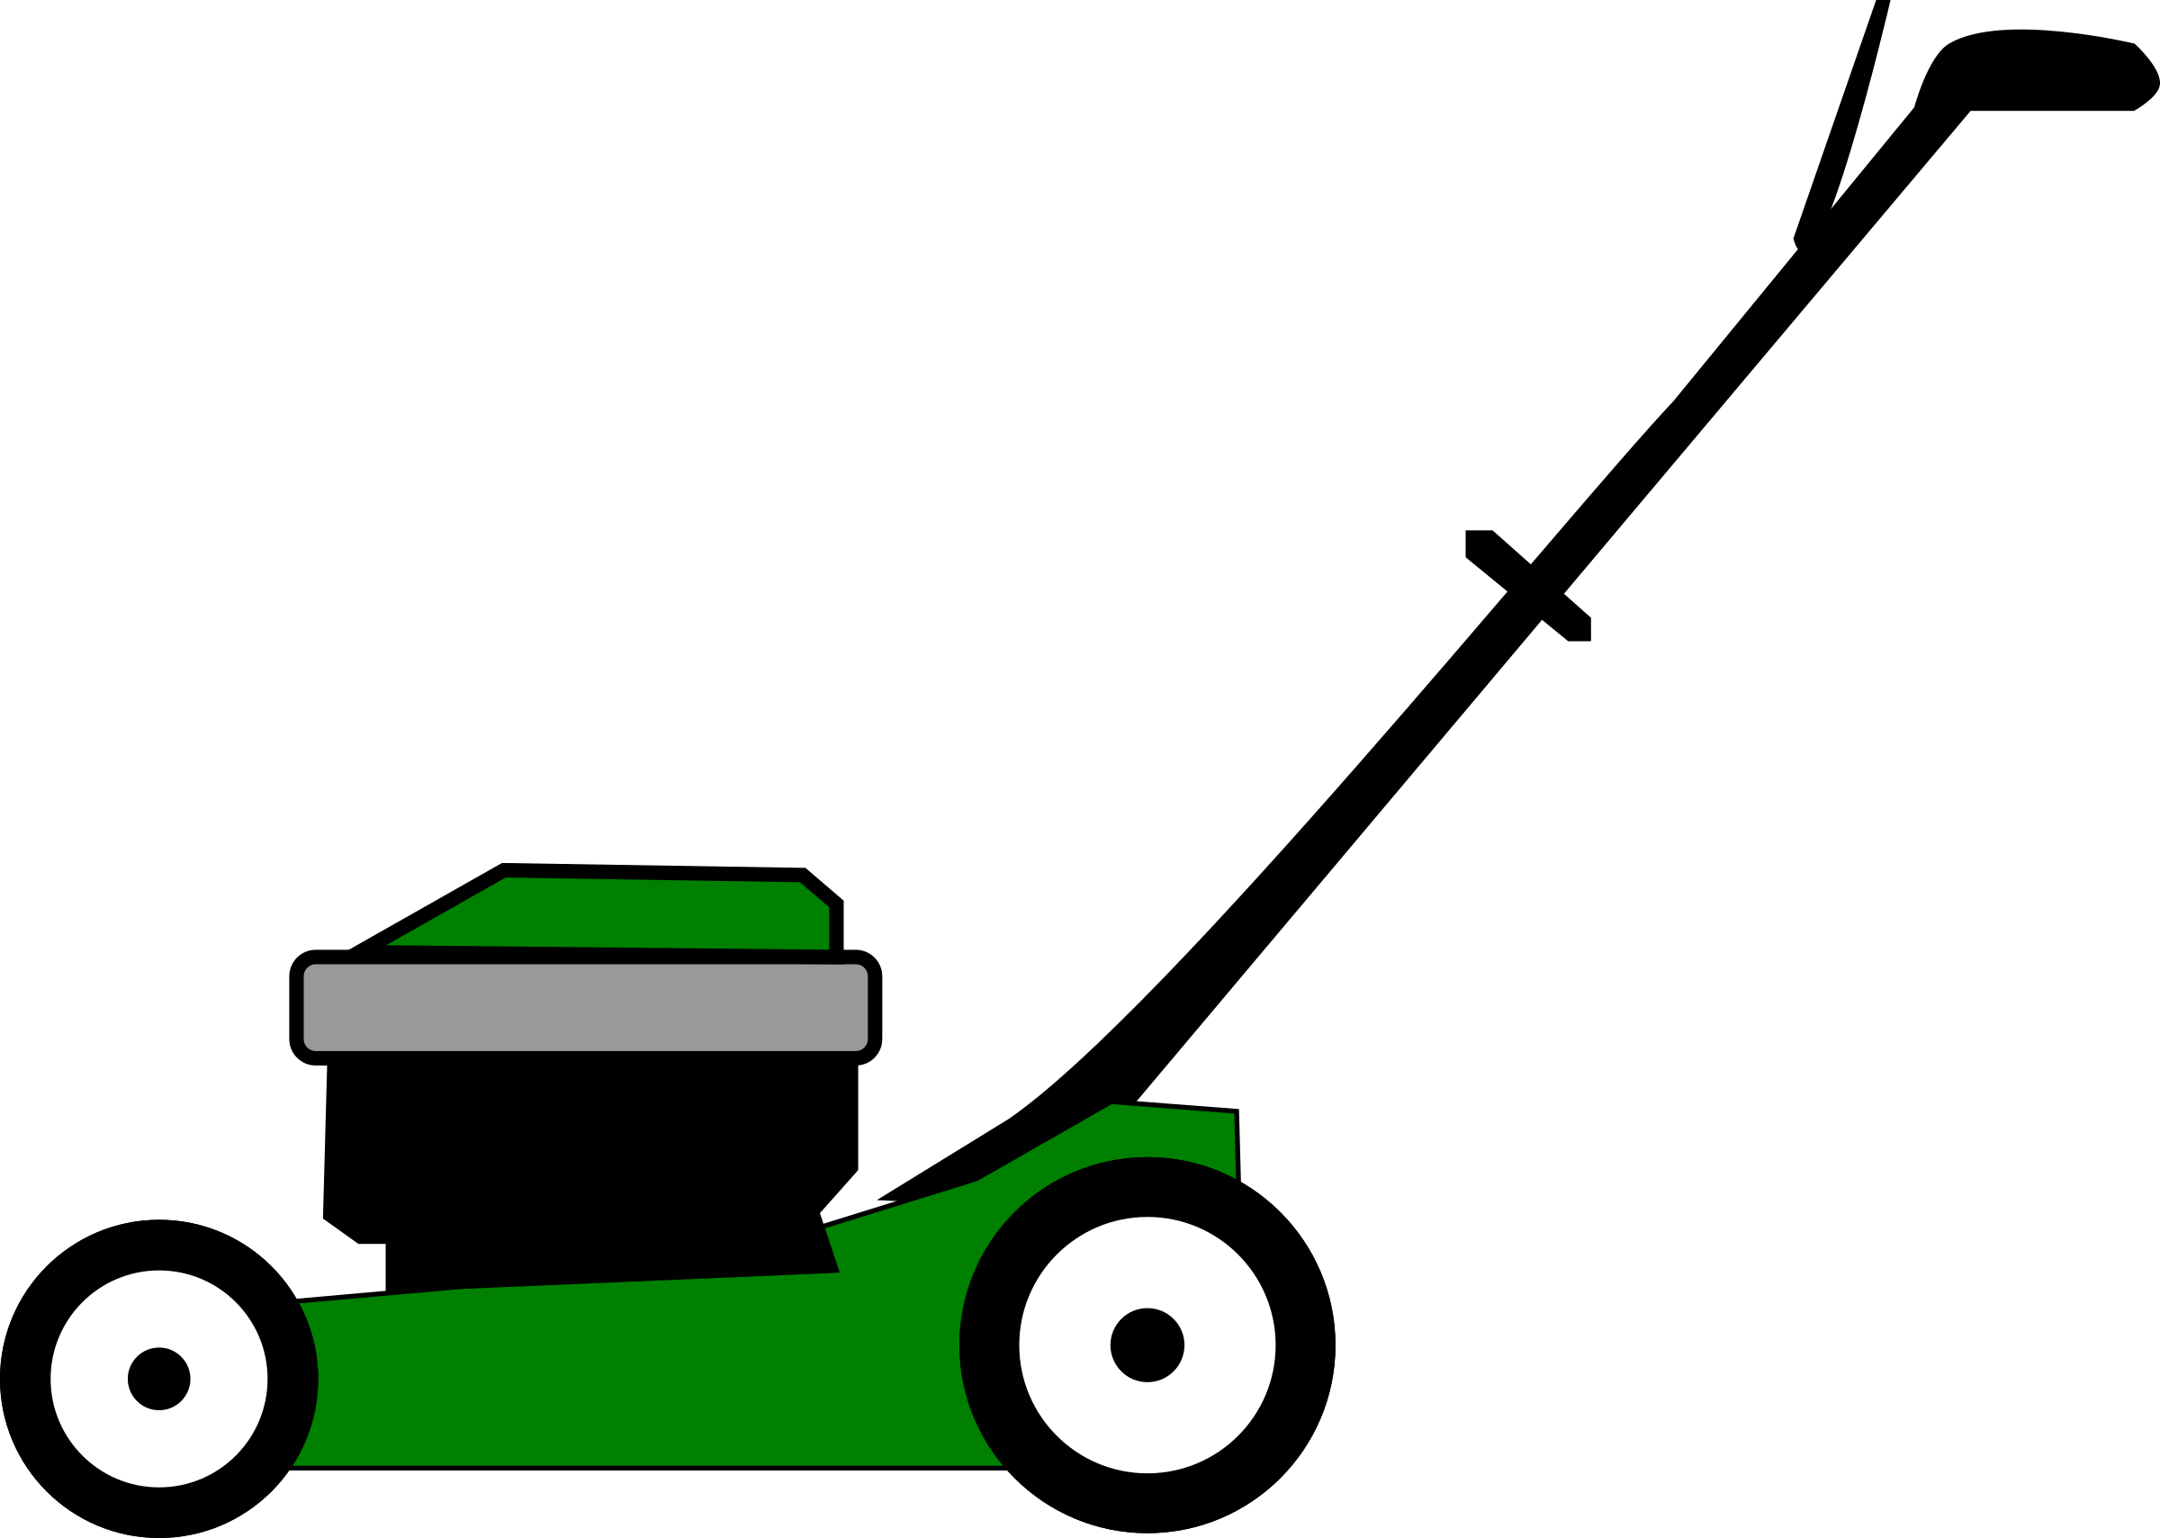



What is Cole obsessed with?

What advice does he have for students trying to start an SAE?

Grass and Lawn Basics
Aligned to the following standards:
PS.02; PL-A.; PG-J.; CS-M.; AG-PL2; AGPB01.02; CCSS.RI.9-10.3; CCSS.SL.9-10.1A; CCSS.RST.9-10.4; CCSS.RST.9-10.9; CRP.02; CRP.04; CRP.07; CRP.08
Directions:
Lawn care and landscape management is a booming business, but it helps to have some basic understanding about grass physiology and what grasses grow best in certain climate and conditions. Complete the following activities to learn more!

- On the diagram below, label the vegetative structures of grass. Then, define each vegetative part. Suggested Resource: Grass Structures, https://forages.oregonstate.edu/regrowth/how-does-grass-grow/grass-structures
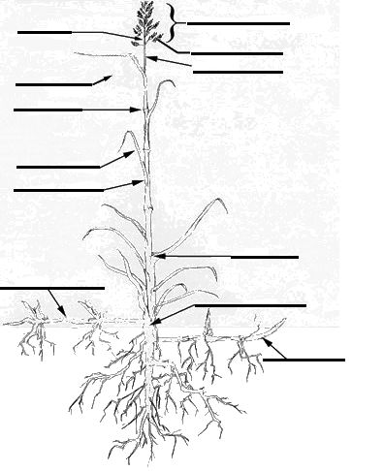

Vegetative Structure | Definition
Auricles
Collar region
Crown
Culm
Culm node
Flag leaf
Leaf blade
Leaf sheath
Ligule
Meristem
Peduncle
Rhizome
Stolon
Tiller

- When considering what grasses grow in a specific area, the U.S. is divided into five zones. Using http://www.lawnplugs.com/info/what-to-plant.html, answer the following questions.
  - What zone do you live in? (Circle your zone.)

Cool/Humid Warm/Humid Warm/Arid Cool/Arid Transition

  - Scroll down to the Plant Hardiness Zone Map. What is the temperature range where you live?

_____°F to _____°F

  - List three varieties of grass that work for your climate.

_______________________ _______________________ ____________________

- Research the three varieties you identified in Question 2c and complete the chart.
Suggested Resources:
- Grass Varieties, https://www.thelawninstitute.org/lawn-care-basics/grass-selection-and-management/
- Buffalo Grass, https://www.lawn-care-academy.com/planting-and-growing-warm-season-grass/

Grass Variety | Description | Shade Adaptation | Wear Resistance | Water Needs | Mowing Requirements | Disease, Insect and Weed Control

KEY: On the Lawn
Aligned to the following standards:
PS.02; PL-A.; PG-J.; CS-M.; AG-PL2; AGPB01.02; CCSS.RI.9-10.3; CCSS.SL.9-10.1A; CCSS.RST.9-10.4; CCSS.RST.9-10.9; CRP.02; CRP.04; CRP.07; CRP.08
Directions:
Answer the questions below as you watch the video “Lawn Care SAE | Cole Hanson,” available at https://vimeo.com/368997622.
When did he start working in the family business?

He started when he was 12.

What is Cole’s SAE?

Lawn care and landscape management

What beginning steps did he take to become involved in the business?
Learned from his father how to do the different tasks that make up the business, such as:

Running the lawn mower.

Learning which direction to mow the lawn.

How to operate a weed eater.

What are his daily tasks?

Get to work within 30 minutes of school ending

Make sure machine maintenance has been done before work for the day begins

Mow, weed eat or do other tasks as assigned to him
What is Cole obsessed with?

Plants! He loves learning how things grow and why they grow.
What advice does he have for students trying to start an SAE?

Know the process and career path you want to take and know what interests you

KEY: Grass and Lawn Basics
Aligned to the following standards:
PS.02; PL-A.; PG-J.; CS-M.; AG-PL2; AGPB01.02; CCSS.RI.9-10.3; CCSS.SL.9-10.1A; CCSS.RST.9-10.4; CCSS.RST.9-10.9; CRP.02; CRP.04; CRP.07; CRP.08
Directions:
Lawn care and landscape management is a booming business, but it helps to have some basic understanding about grass physiology and what grasses grow best in certain climate and conditions. Complete the following activities to learn more!

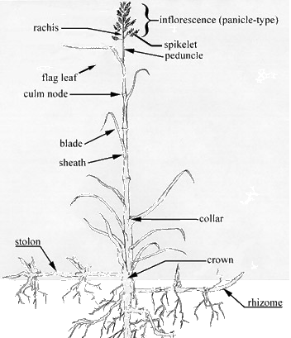
- On the diagram below, label the vegetative structures of grass. Then, define each vegetative part. Suggested Resource: Grass Structures, https://forages.oregonstate.edu/regrowth/how-does-grass-grow/grass-structures

Vegetative Structure | Definition
Auricles | short, often claw-like appendages at the base of the leaf blade which tend to clasp the sheath at the culm internode. The various shapes can be useful for identifying certain grasses.
Collar region | consists of the leaf blade, the leaf sheath, auricles (if present), a ligule and connective tissue called the collar. The collar is a narrow band of intercalary meristem (tissue capable of growth) which accounts for blade growth.
Crown | basal zone of the shoot, the origin was tissue at the base of the coleoptile during the seedling stage. The crown is essential for the perennial growth of the plant as this zone is comprised of over-wintering tissues (basal internodes, rhizomes, stolons, corms), which produce new shoots the following spring. Annual grasses do not develop a crown.
Culm | central axis of the mature grass shoot, comprised of nodes and internodes; each node bears a leaf
Culm node | solid region on the culm that gives rise to a leaf sheath. On certain grass species, lower culm nodes may bear adventitious buds capable of producing new tillers.
Flag leaf | uppermost leaf of the culm, enclosing the seed head during the boot stage
Leaf blade | part of the leaf above the sheath, also known as the lamina
Leaf sheath | lower section of a grass, enclosing its associated culm internode
Ligule | a variously modified extension of the sheath lying at the base of the blade; often a vertical membrane, and in certain cases, mere bristles
Meristem | cells capable of growth
Peduncle | upper-most culm segment supporting the seed head
Rhizome | a prostrate subterranean stem, capable of rooting at the nodes and becoming erect at the apex; a means of vegetative reproduction
Stolon | a prostrate or creeping, above-ground stem, rooting at the nodes; a means of vegetative reproduction
Tiller | a daughter plant, a shoot capable of producing a new plant

Questions 2 and 3: Answers will vary.

