Agricultural Technology and Mechanical Career Development Event
IMPORTANT: Before you begin this activity, you must have two pages open:
- This sheet containing the questions to be answered.
- The online e-Scansheet Universal Form E, where you will bubble your answers.

Compact Equipment Systems

Five information pages are located at the end of this document which will provide information to complete this activity.

Situation: In this activity you are to determine the wear of a cylinder on a single-cylinder engine. The purpose is to determine if the cylinder needs to be bored out, if the rings need to be replaced, and if the crankshaft needs to be replaced.

Given: The engine is a Briggs and Stratton model 90302.
- All Figures and illustrations are on the “Compact Equipment Skill Information Pages.”
- The engine code is 95041803.
- Measurements A, C and E on Figure 3 are parallel with the crankshaft
- Measurements B, D and F on Figure 3 are perpendicular to the crankshaft.
- The micrometer being used to measure the cylinder bore in Figure 3 is a 2-inch to 3-inch micrometer.
- The feeler gauges in Figures 6, 7 and 8 are two gauges combined to measure each gap.
- A dial caliper is used to measure the crankshaft journals.
- All questions are worth 1 point each.
Bubble the answers to each question on the e-Scansheet Universal Form E in Exam C, questions 1 through 30. Each question is worth one point.
- Based on the model number given (90302) for this engine, what is the approximate cubic inch displacement?
  - 2 cubic inches
  - 3 cubic inches
  - 9 cubic inches
  - 20 cubic inches

Use information page “Cylinder Measurements” to answer questions 2 through 16.
- Cylinder bore at location A
  - 2.524”
  - 2.574”
  - 2.599”
  - 3.524”

- Cylinder bore at location B
  - 2.502”
  - 2.752”
  - 2.577”
  - 3.502”

- Cylinder bore at location C
  - 2.571”
  - 3.021”
  - 3.521”
  - 3.571

- Cylinder bore at location D
  - 2.524”
  - 2.574”
  - 2.599”
  - 3.524”

- Cylinder bore at location E
  - 3.517”
  - 2.557”
  - 2.517”
  - 2.567”

- Cylinder bore at location F
  - 2.571”
  - 3.021”
  - 3.521”
  - 3.571

- Out of round at top of cylinder
  - 0.022”
  - 0.003”
  - 0.026
  - 1.022”

- Out of round at middle of cylinder
  - 0.000”
  - 0.503”
  - 0.006”
  - 0.003”

- Out of round at bottom of cylinder
  - 0.003”
  - 0.004”
  - 0.054”
  - 0.008”

- It is recommended that out-of-round not exceed 0.003”. Does the cylinder meet these specifications?
  - Yes
  - No
  - Cannot determine from the information given

- It is recommended that cylinder taper not exceed 0.005”. Does the cylinder meet these specifications?
  - Yes
  - No
  - Cannot determine from the information given

- Taper perpendicular to crankshaft from top to middle of cylinder
  - 0.000”
  - 0.003”
  - 0.004”
  - 0.006”

- Taper perpendicular to crankshaft from middle to bottom of cylinder
  - 0.000”
  - 0.003”
  - 0.004”
  - 0.007”

- Taper perpendicular to crankshaft from top to bottom of cylinder
  - 0.000”
  - 0.007”
  - 0.010”
  - 0.017”

- Based on the cylinder measurements, what decision should be made?
  - The cylinder meets specifications and should be left as is and reassembled.
  - The cylinder should be rebored to 0.010” and piston replaced with a 0.010” oversized piston
  - The cylinder should be rebored to 0.020” and piston replaced with a 0.020” oversized piston
  - These is not enough information to make this decision

Use information page “Ring End Gap Measurements” to answer questions 17 through 23. Compare the measurements to the Briggs and Stratton specifications on the same page.
- Top compression ring end gap
  - 0.001”
  - 0.022”
  - 0.021”
  - 0.043”

- Does the top compression ring meet specifications?
  - Yes
  - No
  - Cannot determine from the information given

- Middle compression ring end gap
  - 0.001”
  - 0.018”
  - 0.019”
  - 0.037”

- Does the middle compression ring meet specifications?
  - Yes
  - No
  - Cannot determine from the information given

- Bottom oil ring end gap
  - 0.001”
  - 0.025”
  - 0.026”
  - 0.051”

- Does the bottom oil ring meet specifications?
  - Yes
  - No
  - Cannot determine from the information given

- What recommendation would you make regarding the rings of this engine?
  - Reassemble the engine using the same rings
  - Purchase a new set of rings and replace the rings before reassembly
  - Purchase and replace the two compression rings before reassembly
  - Purchase and replace the oil ring only before reassembly
Use information page “Crankshaft Measurements” to answer questions 24 through 30. Compare the crankshaft measurements to specifications on the “Briggs and Stratton Specifications” page.
- What is the dial caliper reading for the magneto journal of the crankshaft?
  - 0.976”
  - 0.876”
  - 0.877”
  - 0.884”

- Does the measurement for the magneto journal meet specifications?
  - Yes, it meets specifications
  - No, it does not meet specifications
  - It cannot be determined if it meets specifications from the information provided

- What is the dial caliper reading for the crankpin journal of the crankshaft?
  - 0.998”
  - 1.002”
  - 0.980
  - 1.998”

- Does the measurement for the crankpin journal meet specifications?
  - Yes, it meets specifications
  - No, it does not meet specifications
  - It cannot be determined if it meets specifications from the information provided

- What is the dial caliper reading for the PTO journal of the crankshaft?
  - 0.876”
  - 0.976”
  - 0.770”
  - 0.877”

- Does the measurement for the PTO journal meet specifications?
  - Yes, it meets specifications
  - No, it does not meet specifications
  - It cannot be determined if it meets specifications from the information provided

- Based on the crankshaft measurements, what decision should be made?
  - The crankshaft meets specifications and should be reassembled in the engine as is.
  - The crankshaft does not meet specifications and should be replaced.
  - It cannot be determined if the crankshaft does or does not meet specifications.
Before you leave this skill activity, be sure you have bubbled in the answers to these questions on the online e-Scansheet Universal Form E in Exam C, questions 1 through 30. Do not submit your scan sheet yet. You will be completing two more activities before you need to submit the scan sheet.

Cylinder Measurements
(Use with questions 2 through 16)
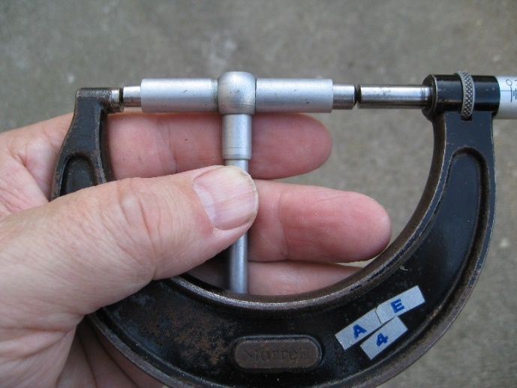
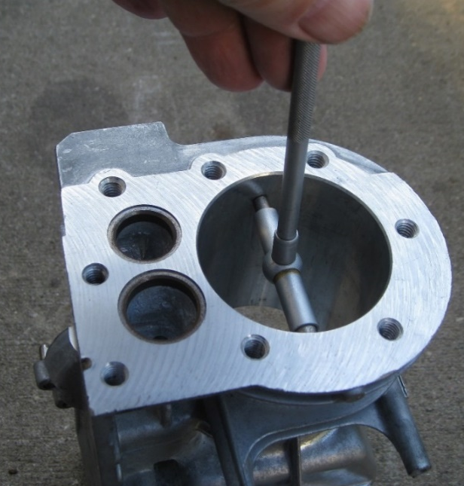

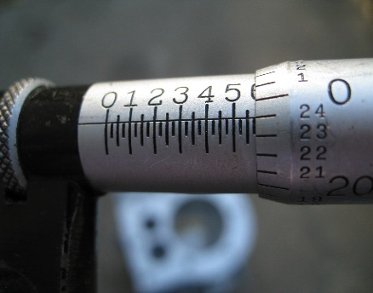
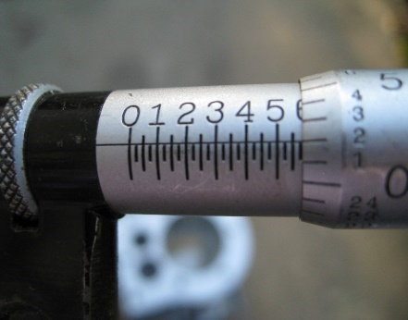
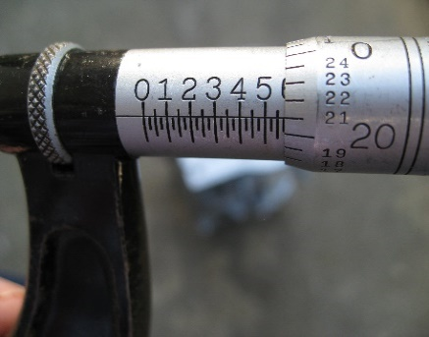
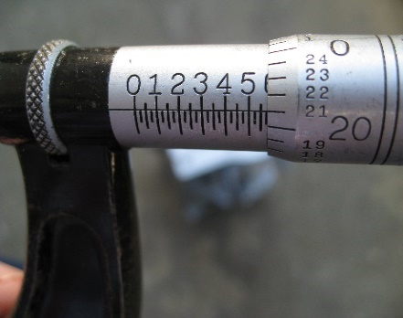
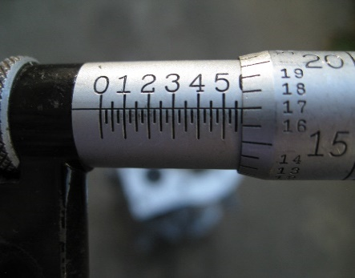
Micrometer is a two- to three-inch micrometer.
A
B
C
E
D
F
Top
Middle
Bottom
A
B
C
F
D
E
Figure 4. Micrometer readings from each location.
Figure 3. Locations of measurements in the cylinder. A, C and E are parallel with crankshaft. B, D and F are perpendicular to crankshaft.
Figure 1. Illustration of using a telescoping gauge to measure the bore (diameter) of the cylinder.
Figure 2. Illustration of using an English micrometer to take a reading from the telescoping gauge.
Ring End Gap Measurements
(Use with questions 17 through 23)

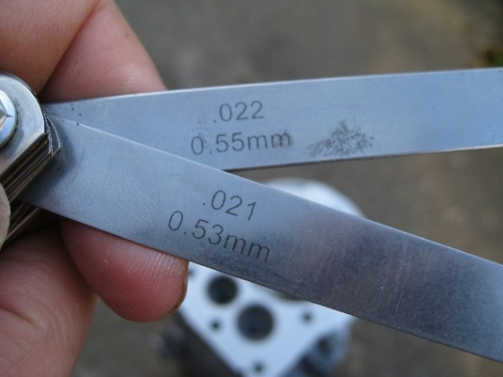
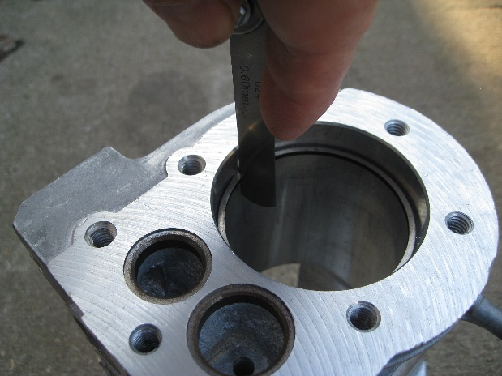

Figure 6. These two feeler gauges together are used to check top compression ring end gap. Use the combined feeler gauges to calculate the ring end gap.
Figure 5. Illustration of using a feeler gauge to check end gap of rings.
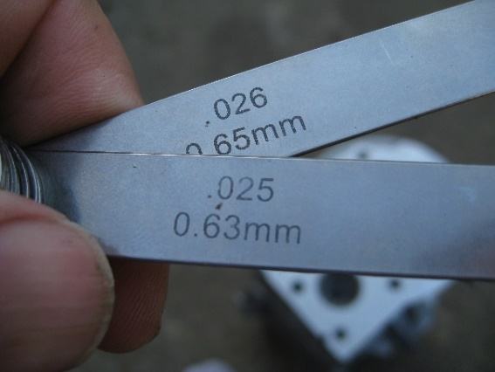
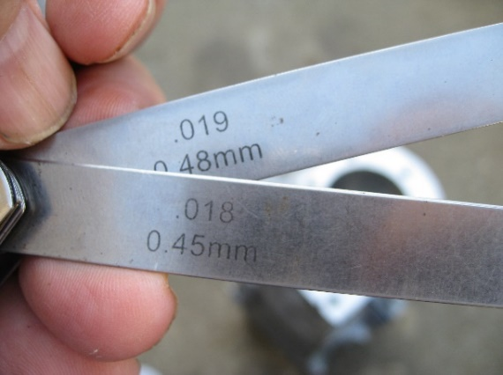

Figure 8. These two feeler gauges together are used to check oil ring end gap. Use the combined feeler gauges to calculate the ring end gap.
Figure 7. These two feeler gauges together are used to check middle compression ring end gap. Use the combined feeler gauges to calculate the ring end gap.

Ring Gap Rejection Sizes
Basic Model Series | Compression Ring |  | Oil Ring
Aluminum Block  60000, 80000, 90000, 100000, 110000, 120000, 130000, 170000, 190000, 250000 | Inches  0.035 | Millimeters  0.90 | Inches  0.045 | Millimeters  1.14
Cast Iron Block  23000, 240000, 300000, 320000 | Inches | Millimeters | Inches | Millimeters
Cast Iron Block  23000, 240000, 300000, 320000 | 0.030 | 0.75 | 0.035 | 0.90

Crankshaft Measurements
(Use with questions 24 through 30)

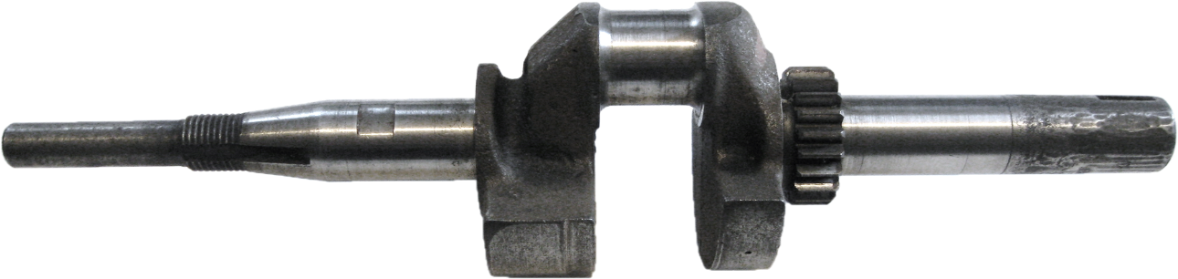
A
B
C

Figure 9. Crankshaft for Briggs and Stratton Model 90203
-
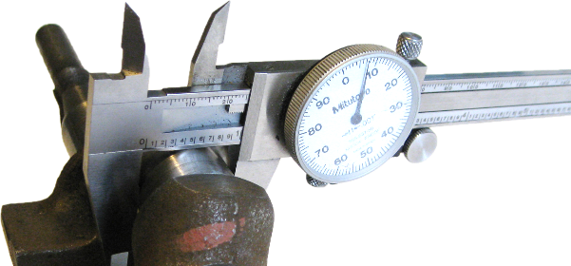

Figure 10. A dial caliper was used to measure the diameter of the crankshaft journals at A, B, and C.

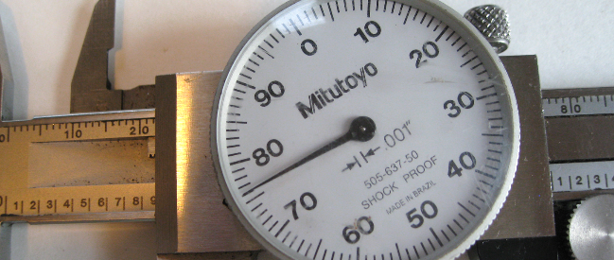
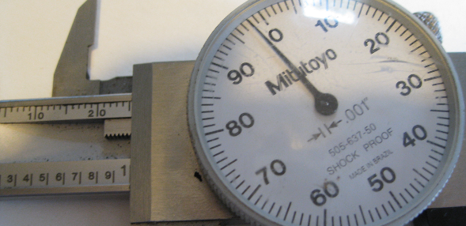

Figure 11. A dial caliper reading at point A.
Figure 12. A dial caliper reading at point B.

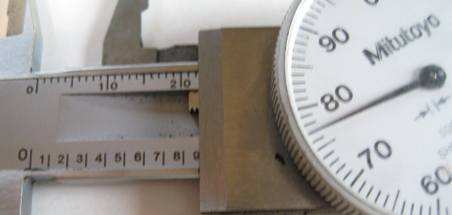

Figure 13. A dial caliper reading at point C.

(Use with questions 17 through 30)
BRIGGS AND STRATTON SPECIFICATIONS
COMMON SPECIFICATIONS FOR ALL SINGLE CYLINDER “L” HEAD ENGINE MODLES (page 1)
 | BASIC MODEL SERIES | OIL CAPACITY Fl. Ozs. | ARMATURE AIR GAP INCHES | TORQUE SPECIFICATIONS |  |  |  | VALVE CLEARANCE
 |  |  |  | FLYWHEEL NUT FT.LBS. | CYLINDER HEAD IN.LBS | CONN. ROD IN.LBS | CRANKCASE COVER OR SUMP IN.LBS | INTAKE INCHES | EXHAUST INCHES
A  L  U  M  I  N  U  M | 60000 | H 21 | .006  .010 | 55 | 140 | 100 | 85 | .005  .007 | .007  .009
A  L  U  M  I  N  U  M | 80000 | H 21 | .006  .010 | 55 | 140 | 100 | 85 | .005  .007 | .007  .009
A  L  U  M  I  N  U  M | 90000 | H 21  V 18 | .006  .010 | 55 | 140 | 100 | 85 | .005  .007 | .007  .009
A  L  U  M  I  N  U  M | 10A900, 10B900, 10C900 | V 18 | .006  .010 | 60 | 140 | 100 | 85 | .005  .007 | .007  .009
A  L  U  M  I  N  U  M | 100200, 100900 | H 21  V 18 | .006  .010 | 55 | 140 | 100 | 120 | .005  .007 | .007  .009
A  L  U  M  I  N  U  M | 100700 | V 18 | .006  .010 | 55 | 140 | 100 | 85 | .005  .007 | .007  .009
A  L  U  M  I  N  U  M | 110000 | H 21  V 18* | .006  .010 | 55 | 140 | 100 | 85 | .005  .007 | .007  .009
A  L  U  M  I  N  U  M | 120000 | V 28 | .006  .010 | 55 | 140 | 100 | 85 | .005  .007 | .007  .009
A  L  U  M  I  N  U  M | 130000 | H 21  V 28 | .010  .014 | 60 | 140 | 100 | 120 | .005  .007 | .007  .009
A  L  U  M  I  N  U  M | 170000 | H 44  V 36 | .010  .014 | 65 | 165 | 165 | 140 | .005  .007 | .007  .009
A  L  U  M  I  N  U  M | 190000 | H 48  V 48 | .010  .014 | 65 | 185 | 165 | 140 | .005  .007 | .007  .009
A  L  U  M  I  N  U  M | 220000 | H 48  V 48 | .010  .014 | 65 | 185 | 165 | 140 | .005  .007 | .007  .009
A  L  U  M  I  N  U  M | 250000 | H 48  V 48 | .010  .014 | 65 | 185 | 165 | 140 | .005  .007 | .007  .009
A  L  U  M  I  N  U  M | 280000 except 286700 | V 48 | .010  .014 | 65 | 185 | Sec. 9 Table 4 | 140Δ  200Δ | .005  .007 | .007  .009
A  L  U  M  I  N  U  M | 286700 | V 48 | .010  .014 | 65 | 185 | Sec. 9 Table 4 | 140Δ  200Δ | .004  .006 | .007  .009
C  A  S  T  I  R  O  N | 230000 | H 64 | .010  .014 | 145 | 190 | 190 | 90 mag.  190 PTO | .007  .009 | .017  .019
C  A  S  T  I  R  O  N | 240000 | H 64 | .010  .014 | 145 | 190 | 190 | 90 mag.  190 PTO | .007  .009 | .017  .019
C  A  S  T  I  R  O  N | 300000 | H 64 | .010  .014 | 145 | 190 | 190 | 90 mag.  190 PTO | .007  .009 | .017  .019
C  A  S  T  I  R  O  N | 320000 | H 64 | .010  .014 | 145 | 190 | 190 | 90 mag.  190 PTO | .007  .009 | .017  .019

■ H for Horizontal Crankshaft & V for Vertical Crankshaft, ♦ Governed Idle, See Sec. 5 for adjustment procedures, * Right Angle Drive 21 Fl. Ozs.
Δ See Section 11, TABLE NO. 5

(Use with questions 17 through 30)
BRIGGS AND STRATTON SPECIFICATIONS
COMMON SPECIFICATIONS FOR ALL SINGLE CYLINDER “L” HEAD ENGINE MODLES (page 2)
 | BASIC  MODEL  SERIES | STANDARD  CYLINDER BORE  INCHES | CRANKSHAFT
 | BASIC  MODEL  SERIES | STANDARD  CYLINDER BORE  INCHES | STROKE  INCHES | STANDARD  CRANKPIN  JOURNAL  INCHES | JOURNAL REJECT SIZES INCHES |  |  | END PLAY
 |  |  |  |  | MAGNETO | CRANKPIN | PTO | HORIZONTAL  INCHES | VERTICAL  INCHES
A  L  U  M  I  N  U  M | 60000 | 2.3740  2.3750 | 1.500 | Not required | .873 | .870 | .873 | .002  .008 | -
A  L  U  M  I  N  U  M | 80000 | 2.3740  2.3750 | 1.750 | .9983  .9988 | .873 | .996 | .873 | .002  .008 | -
A  L  U  M  I  N  U  M | 90000 | 2.5615  2.5625 | 1.750 | .9983  .9988 | .873 | .996 | .873 | .002  .010 | .002  .030
A  L  U  M  I  N  U  M | 10A900, 10B900, 10C900 | 2.5615  2.5625 | 1.876 | .8731  .8739 | .873 | .872 | .873 | .002  .030 | .002  .030
A  L  U  M  I  N  U  M | 100200, 100900 | 2.4990  2.5000 | 2.125 | .9983  .9988 | .873 | .996 | .998 | .002  .008 | .002  .008
A  L  U  M  I  N  U  M | 100700 | 2.5615  2.5625 | 1.940 | .9983  .9988 | .873 | .996 | 1.060 | .002  .030 | .002  .030
A  L  U  M  I  N  U  M | 110000 | 2.7802  2.7812 | 1.940 | .9983  .9988 | .873 | .996 | .873 | .002  .008 | .002  .008
A  L  U  M  I  N  U  M | 120000 | 2.6875  2.6885 | 2.020 | ▪ .9983  .9988 | .873 | .996 | 1.060 | .002  .030 | .002  .030
▫ 1.0983
1.0991
A  L  U  M  I  N  U  M | 130000 | 2.5615  2.5625 | 2.438 | .9983  .9988 | .873 | .996 | .998 | .002  .008 | .002  .008
A  L  U  M  I  N  U  M | 170000 | 2.9990  3.0000 | 2.375 | 1.0920  1.0924 | .997  1.179 • | 1.090 | 1.179 | .002  .008 | .002  .008
A  L  U  M  I  N  U  M | 190000 | 2.9990  3.0000 | 2.750 | 1.1239  1.1243 | .997  1.179 • | 1.122 | 1.179 | .002  .030 | .002  .030
A  L  U  M  I  N  U  M | 220000 | 3.4365  3.4375 | 2.375 | 1.2489  1.2493 | 1.376 | 1.247 | 1.376 | .002  .030 | .002  .030
A  L  U  M  I  N  U  M | 250000 | 3.4365  3.4375 | 2.265 | 1.2489  1.2493 | 1.376 | 1.247 | 1.376 | .002  .030 | .002  .030
A  L  U  M  I  N  U  M | 280000 except 286700 | 3.4365  3.4375 | 3.062 | 1.2489  1.2493 | 1.376 | 1.247 | 1.376 | .002  .023 | .002  .023
A  L  U  M  I  N  U  M | 286700 | 3.4365  3.4375 | 3.062 | 1.2489  1.2493 | 1.376 | 1.247 | 1.376 | .002  .023 | .002  .023
C  A  S  T  I  R  O  N | 230000 | 2.9990  3.0000 | 3.250 | 1.1840  1.1868 | 1.3769 | 1.1844 | 1.3769 | .002  .008 | .002  .008
C  A  S  T  I  R  O  N | 240000 | 3.0615  3.0625 | 3.250 | 1.3114  1.3118 | Ball | 1.3094 | Ball | .002  .008 | .002  .008
C  A  S  T  I  R  O  N | 300000 | 3.4365  3.4375 | 3.250 | 1.3114  1.3118 | Ball | 1.3094 | Ball | .002  .008 | .002  .008
C  A  S  T  I  R  O  N | 320000 | 3.5615  3.5625 | 3.250 | 1.3114  1.3118 | Ball | 1.3094 | Ball | .002  .008 | .002  .008
• Syncro-Balance® ▪ Before date code 97011300 ▫ After date code 97011200

