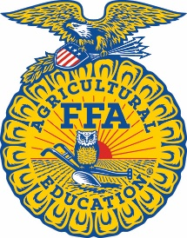
Sample Congressional Letter

[Insert Date]
The Honorable [Insert Representative/Senator’s Name]
Office Address
United States House of Representatives/United States Senate
City, State, Zip

Dear Rep./Sen. [Insert Last Name]:

My name is [Insert Your Name], and I am a constituent of the [Insert Chapter Name] FFA Chapter located at [Insert Your School Address] in [Insert Your City], [Insert Your State].

I am writing you during National FFA Week (Feb. 17-24, 2024) to let you know the importance of the National FFA Organization and the impact it makes on our local community. FFA is a national organization made up of 945,000 agricultural education students from all 50 states, Puerto Rico and the U.S. Virgin Islands. We focus on developing our potential for premier leadership, personal growth and career success through agricultural education. As FFA members, we have the opportunity to participate in career and leadership development events that range from livestock evaluation to floriculture.

I participate in FFA by [insert information about your CDE/LDE, SAE or brief FFA story.] At the local level, we make a difference in our communities through numerous community service projects.

We would love for Rep./Sen. [Insert Last Name] to continue his/her/their support of the National FFA Organization and the next generation of agriculturists. Agriculture needs a strong and skilled workforce, and we are the future farmers, biologists, chemists, veterinarians, engineers and entrepreneurs who will fill these roles. We invite Rep./Sen. [Insert Last Name] to visit our program when he/she/they is in the area so that we can show him/her/them what we offer students. We would also love to schedule a call next month on National Ag Day to continue the conversation about what we are doing.

Thank you for your time and for considering my request.

Sincerely,

[Insert Your Name]
[Insert Phone Number]
[Insert Email Address]

