The Courage to Live Life
Created: 12/2022 by the National FFA Organization
Description of Lesson: Life is tough today, but if we face our fears, push through the pain and face the obstacles life throws at us, we can reap the rewards in the end. In the retiring address of 2021-22 National FFA Central Region Vice President Cortney Zimmerman, we learn how to have the courage to live the life we are given and to face our battles without giving up.

Student Learning Objectives:
After completing these activities, students will …
- Understand what it means to have courage.
- Identify their values and develop their focus boards.

Suggested Grade Level:
Grades 9 and 10 (This lesson is written so instructors can scale up or down based on class needs.)

Suggested Time: 60 minutes (*Time requirements may vary based upon student understanding and class schedule.)

Resources/References:
- Video: “The Courage to Live Life” | Cortney Zimmerman 2022 Retiring Address, https://vimeo.com/777063547

Related Resources:
- Retiring Addresses and Keynote Speeches, FFA.org/ffa-video-center/convention-keynotes-and-retiring-addresses/
- Spanish version: https://ffa.box.com/s/k7kkoegdecphppy3sqrr0424al0mkahb

Equipment and Supplies Needed:
- A copy of the “The Courage to Live Life” worksheet for each student
- Internet access to play the video in real time or embed it in a PowerPoint ahead of time

Vocabulary:
- Courage
- Intentional

Cross-Curricular Connections:
English/Language Arts
Students write a plan to use in their daily lives and become more intentional in their daily actions.

Virtual Instruction Ideas:
Have students download and watch the video on a device of their choice and complete the worksheet.

Student Activity Sheets:
PDF: https://ffa.app.box.com/file/1218325932387
Word: https://ffa.app.box.com/file/1218330159390
Non-Design Word: https://ffa.app.box.com/file/1218326328888
Google Doc: https://docs.google.com/document/d/1I3von2IOeeZ4Ud_UyZ7sk7DgNgNsriHQVM4aFVpUi6I/copy

These Activities Are Aligned to the Following Standards:
FFA Precept
- FFA.PL-A.Action: Assume responsibility and take the necessary steps to achieve the desired results, no matter what the goal or task at hand.
- FFA.PL-C.Vision: Visualize the future and how to get there.
- FFA.PL-E.Awareness: Understand personal vision, mission and goals.
- FFA.PG-G.Physical Growth: Take care of one’s health by eating well, exercising, getting enough sleep, respecting one’s body, and setting personal goals for long-term health.
- FFA.PG-J.Mental Growth: Embrace cognitive and intellectual development relative to reasoning, thinking and coping.
- FFA.CS-M.Communication: Effectively interact with others in personal and professional settings.
- FFA.CS-N.Decision Making: Analyze a situation and execute an appropriate course of action.
Common Core – Writing
- CCSS.ELA-Literacy.W.9-10.4: Produce clear and coherent writing in which the development, organization, and style are appropriate to task, purpose, and audience.
AFNR Career Ready Practices
- CRP.02: Apply appropriate academic and technical skills. Career-ready individuals readily access and use the knowledge and skills acquired through experience and education to be more productive.
- CRP.04: Communicate clearly, effectively, and with reason. Career-ready individuals communicate thoughts, ideas and action plans with clarity, whether using written, verbal and/or visual methods.
- CRP.06: Demonstrate creativity and innovation. Career-ready individuals regularly think of ideas that solve problems in new and different ways, and they contribute those ideas in a useful and productive manner to improve their organization.
- CRP.08: Utilize critical thinking to make sense of problems and persevere in solving them. Career-ready individuals readily recognize problems in the workplace, understand the nature of the problem, and devise effective plans to solve the problem.
Partnership for 21st Century Skills
- Communication
- Critical Thinking and Problem Solving
- Flexibility and Adaptability
- Health Literacy
- Initiative and Self-direction
- Leadership and Responsibility
- Think Creatively

Lesson Plan:
- Bell Ringer: What is something in your life that causes you emotional discomfort? (Examples: a family member dying, not being selected for a position, etc.) Why does it cause you discomfort?

- Introduction: Hand out the worksheet “The Courage to Live Life” to each student. Today, we are going to watch a retiring address from the 95th National FFA Convention & Expo. This retiring address was given by 2021-22 National FFA Central Region Vice President Cortney Zimmerman. In her speech, we learn how to be courageous and not back down from what life gives us. Before watching the video, look over the questions on the worksheet “The Courage to Live Life,” and be ready for the answers as you view the video.

- Activity:
  - Part 1: Each student needs a copy of the worksheet “The Courage to Live Life.” Have students watch the retiring address of 2021-22 National FFA Central Region Vice President Cortney Zimmerman. The video is available at https://vimeo.com/777063547. While students view the video, have them complete the questions.
  - Part 2: Students will develop a plan to start living more intentionally throughout their day-to-day lives. They will answer a few questions that will help them create their vision boards. This vision board is a resource for them to use throughout their lives to help remember what they want to focus on and what matters most to them.

- Follow-up: Have students conduct a gallery walk to learn about their classmates and their visions.

- Exit Ticket: What is one area of your life where you would like to have more courage to reach a goal or complete something you have never done before?
The Courage to Live Life
Aligned to the following standards:
FFA.PL-A; FFA.PL-C; FFA.PL-E; FFA.PG-J; FFA.CS-N; CCSS.ELA.W.9-10.4; CRP.02; CRP.04; CRP.06; CRP.08
Part 1
Directions:
Complete the following activities while watching “The Courage to Live Life,” the retiring address of 2021-22 National FFA Central Region Vice President Cortney Zimmerman. The video is available at https://vimeo.com/777063547.
Where is one of Cortney’s favorite places? Why is it her favorite?


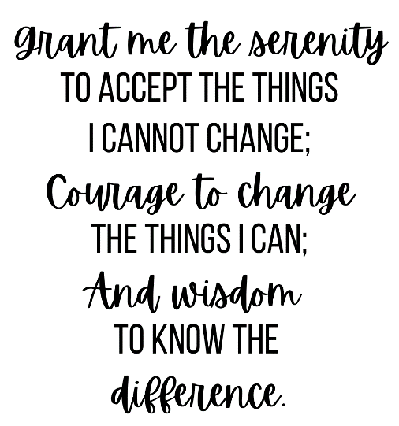

Cortney mentions this quote from a picture in her kitchen. Describe a time when this quote could have helped you to make changes or better respond to tough times.

Cortney looked forward to spending a week with her sister at her grandparents farm every summer. Do you have something you look forward to every year?
If not, what is something you would like to do every year?

Think about a time in your life that you had to accept what happened and could not change it.
Identify that time below.
How did you handle this time?
If you could go back to that time and have a redo, what would you do differently?

Who is someone you want to invest in?
Why this person?
How can you invest in this person?

In your own words, what does it mean to have courage?
Who is someone you believe to be courageous? Explain.

Courage

Part 2
Directions:
Intentional living may sound lofty, complicated or just plain confusing. But it’s a way of life that you can build with some reflection and small shifts. It seems like intentional living is everywhere these days. But what does it really mean to be intentional? What does it look like to do things with intention? And perhaps most importantly, is intentional living available to everyone?

Intentional – (adj) done on purpose; deliberate.

Define, in your own words, what you think “intentional” means.

Yes, it is available to everyone. Anyone can lead an intentional, purpose-filled life. The key is to identify what that personally means for you and make small but significant shifts and conscious choices to build it.

Complete the steps below to help you start living a more intentional life by identifying your values, setting a morning intention, identifying ways to refocus and creating a vision board.

Identify Your Values
From morning to night, what does an ideal day look like for you?

Why are these things so important?
What are the activities that bring you fulfillment?

Meaning?

Contentment?

What do these activities have in common?

What do you wish you had more of?
Less of?
What upsets you?
What inspires you?

Set a Morning Intention
To bring those big values down to the day to day, try setting an intention every morning. This daily intention can be a few words or an entire sentence. It may serve as a reminder of how you’d like to behave and the choices you’d like to make that day. In the box below, identify a morning intention for tomorrow.

Refocus
Here’s the thing about living an intentional life: You don’t need to overhaul your entire life or start from scratch. You can infuse intentionality into activities you’re already doing and actions you’re already taking. Identify three small things you could do to help you refocus in times of need.

1.
2.
3.

Create a Vision Board
Your vision board is the place where you’ll see your dreams in pictures and words, emotionally connect to your goals and begin to manifest them in your life. Follow the directions below to brainstorm and develop your Vision Board.


Areas to include on your vision board:
- Family
- Knowledge
- Relationships
- Health
- Possessions/Money
- Hobbies
- Words or phrases that empower you to build the life you’d like to have (Ex. “family first,” “abundance,” “the Golden Rule rules”)

Include images that represent the areas listed above. When selecting your images, consider these questions:
- What brings you joy in each category?
- What makes your heart feel full or even makes you to want to dance around?

*Take your time and think about your answers to the questions earlier in this activity. Use the layout below to help you develop your vision board, or use your own layout to make it more personal to you.
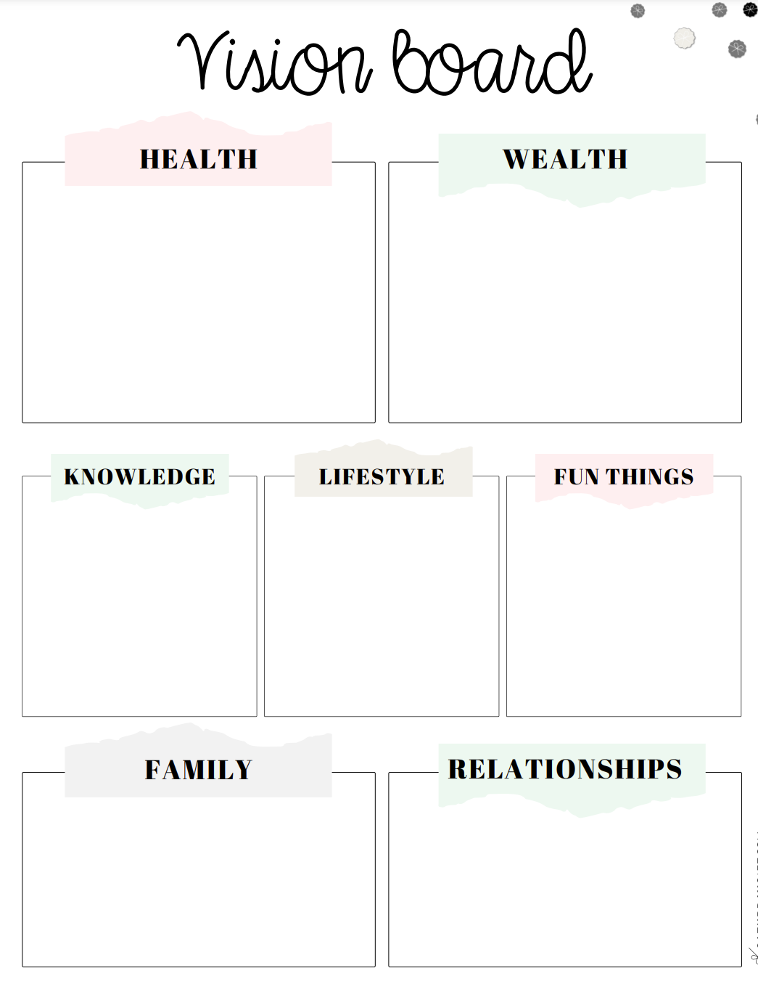
KEY: The Courage to Live Life
Aligned to the following standards:
FFA.PL-A; FFA.PL-C; FFA.PL-E; FFA.PG-J; FFA.CS-N; CCSS.ELA.W.9-10.4; CRP.02; CRP.04; CRP.06; CRP.08
Part 1
Directions:
Complete the following activities while watching “The Courage to Live Life,” the retiring address of 2021-22 National FFA Central Region Vice President Cortney Zimmerman. The video is available at https://vimeo.com/777063547.

Where is one of Cortney’s favorite places? Why is it her favorite?

The kitchen table at home

This is where her family spent time together enjoying Dad’s cooking and sharing stories, challenges and memories.

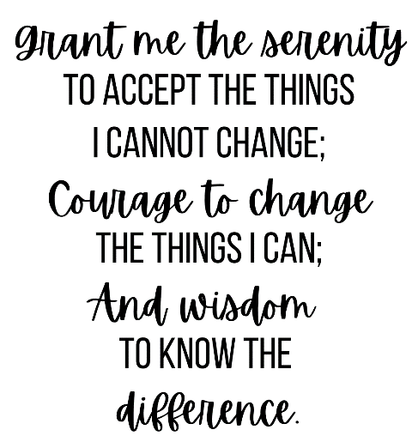

Cortney mentions this quote from a picture in her kitchen. Describe a time when this quote could have helped you to make changes or better respond to tough times.

Answers will vary.

Answers will vary.

Cortney looked forward to spending a week with her sister at her grandparents farm every summer. Do you have something you look forward to every year? If not, what is something you would like to do every year?

Think about a time in your life that you had to accept what happened and could not change it.
Identify that time below.
Answers will vary.

How did you handle this time?
Answers will vary.

If you could go back to that time and have a redo, what would you do differently?
Answers will vary.

Who is someone you want to invest in? | Answers will vary.
Why this person? | Answers will vary.
How can you invest in this person? | Answers will vary.

In your own words, what does it mean to have courage?
Answers will vary.

Who is someone you believe to be courageous? Explain.
Answers will vary.

Courage

Part 2
Directions:
Intentional living may sound lofty, complicated or just plain confusing. But it’s a way of life that you can build with some reflection and small shifts. It seems like intentional living is everywhere these days. But what does it really mean to be intentional? What does it look like to do things with intention? And perhaps most importantly, is intentional living available to everyone?

Intentional – (adj) done on purpose; deliberate.

Define, in your own words, what you think “intentional” means. | Answers will vary.

Yes, it is available to everyone. Anyone can lead an intentional, purpose-filled life. The key is to identify what that personally means for you and make small but significant shifts and conscious choices to build it.

Complete the steps below to help you start living a more intentional life by identifying your values, setting a morning intention, identifying ways to refocus and creating a vision board.

Identify Your Values
From morning to night, what does an ideal day look like for you? | Answers will vary.
Why are these things so important?
What are the activities that bring you fulfillment?

Meaning?

Contentment?

What do these activities have in common?
What do you wish you had more of?

Less of?
What upsets you?
What inspires you?

Set a Morning Intention
To bring those big values down to the day to day, try setting an intention every morning. This daily intention can be a few words or an entire sentence. It may serve as a reminder of how you’d like to behave and the choices you’d like to make that day. In the box below, identify a morning intention for tomorrow.

Answers will vary.

Refocus
Here’s the thing about living an intentional life: You don’t need to overhaul your entire life or start from scratch. You can infuse intentionality into activities you’re already doing and actions you’re already taking. Identify three small things you could do to help you refocus in times of need.

1. Answers will vary.
2.
3.

Create a Vision Board
Your vision board is the place you’ll see your dreams in pictures and words, emotionally connect to your goals and begin to manifest them in your life. Follow the directions below to brainstorm and develop your Vision Board.

Areas to include on your vision board:
- Family
- Knowledge
- Relationships
- Health
- Possessions/Money
- Hobbies
- Words or phrases that empower you to build the life you’d like to have (Ex. “family first,” “abundance,” “the Golden Rule rules”)

Include images that represent the areas listed above. When selecting your images, consider these questions:
- What brings you joy in each category?
- What makes your heart feel full or even makes you to want to dance around?

*Take your time and think about your answers to the questions earlier in this activity. Use the layout below to help you develop your vision board, or use your own layout to make it more personal to you.

