Create your own FFA New Horizons magazine cover
Utilize the magazine cover template to design and create your very own FFA New Horizons magazine cover to represent and summarize your convention experience. If you want to design your cover digitally, you can use the postermywall website.
Items to include in your design:
- Picture
- Three or four story titles (like in example covers below)
- Design should be colorful. Be creative!
Example of past covers:
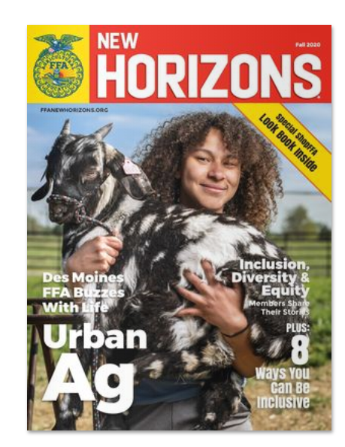
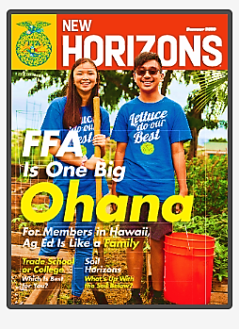
After you design your cover, answer these questions to reflect.
How does this convention experience influence some of your future behaviors and decisions?
Explain why you chose the stories and images you did.
Looking back at your completed magazine cover, which activity that you experienced during convention was your most enjoyable and why?

