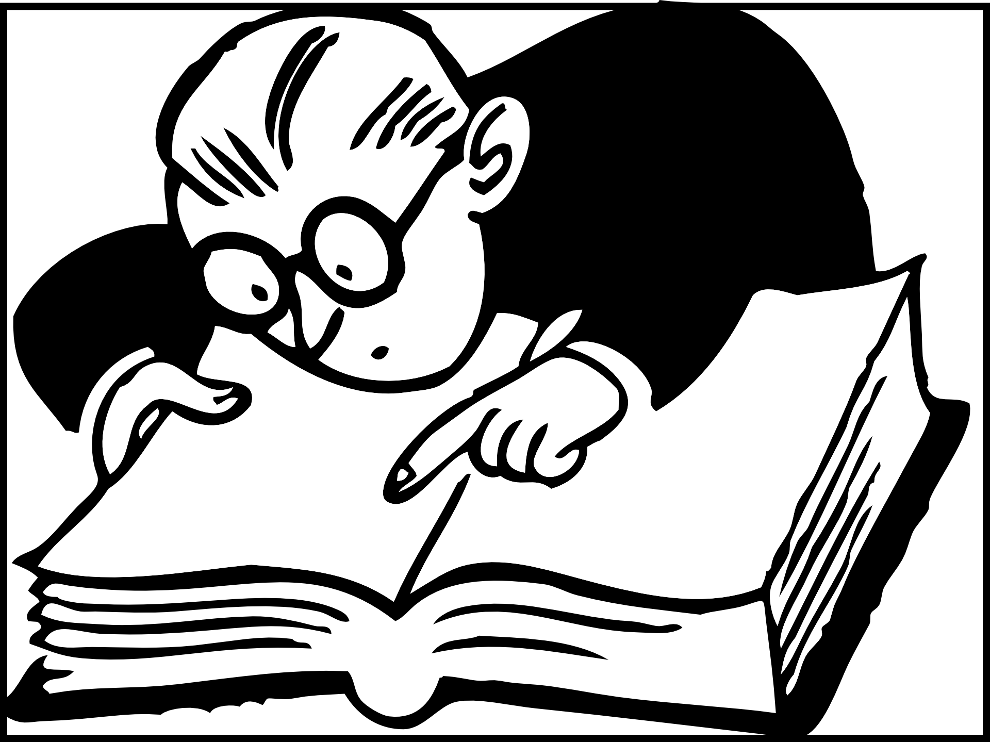
Current Event Worksheet: Reviewing the Article
Aligned to the following standards: CCSS.ELA.RI.9-10.1; CCSS.ELA.RI.9-10.2; CCSS.ELA.RI.9-10.4; CCSS.ELA.W.9-10.2
Directions:
Part 1: Read the title of the current event article, and predict the focus of the article.

1. Prediction:

Part 2: Continue reading the article, and answer the questions below.

2. Identify at least five key words from the article and their definitions: 3. What are five main points/facts from the article?

1.

2.

3.

4.

5.
1.

2.

3.

4.

5.

4. Write three review questions and answers based on the article:

