


Dairy Cattle Evaluation and Management
Examples

Team Activity Example Scenario
Directions: Please read the dairy farm management scenario and supplemental information provided for the scenario, identify problems and determine possible improvements. Your team should assume the role of a hired consultant advising the producer (judges). Your team has 40 minutes to prepare your recommendations to be presented to a panel of judges. It is not necessary to describe the scenario to the judges since they are the producer. Teams will be allowed 10 minutes to present their recommendations, followed by five minutes of clarifying questions from the judges.
You will be provided with a worksheet to assist you with your presentation. This worksheet will be turned in to the judges after the completion of your presentation and responses to the judges’ questions. All four team members are expected to participate in the oral presentation. You may make and take notes for the presentation.
This scenario, your responses and evidence of teamwork are worth 600 points (400 points on content and 200 points on communication).
Dairy Management Exercise Example
Dairy Nutrition Scenario
Scenario: You received a call from Fred F. Anderson, owner of FFA Dairy, LLC. Mr. Anderson feels that his nutrition program could be improved and would like you to evaluate his farm to see what suggestions you have for improvements.
FFA Dairy, LLC has 1,150 total Holstein dairy cows on a freestall dairy operation in the Midwestern US. The farm has a rolling herd average of24,000 pounds of milk. They typically average 3.8% milk fat, 3.0% protein and a SCC of 175,000. The cows are milked three times a day in a double-20 parallel milking parlor. The freestalls are bedded with sand, and the cows are utilizing their stalls well. They are feeding the same TMR ration to all lactating cows. The lactating cow ration was properly balanced by a nutritionist in September to meet the nutrient needs for cows producing 85 pounds of milk per day. The balanced ration fed daily to the cows contains the following amounts (as fed) on a per cow basis:
- 4 lbs. of dry hay
- 20 lbs. of haylage per cow
- 55 lbs. of corn silage per cow
- 27 lbs. of grain, concentrates, vitamins and minerals
The cows have recently dropped approximately 8 pounds of milk per day, and the milk fat percentage has dropped to 3.4 percent. Mr. Anderson would like to get the problem corrected immediately. A veterinarian has checked the cows and confirmed that there are no new, contagious or chronic disease issues and says to check with a nutritionist. The cows in the early lactation group are averaging a body condition score (BCS) of2.25. Cows in the dry cow group are a body condition score (BCS) of 4.0.

The day that you arrive, you watch the new employee that is feeding the cows mix a load of feed for the early lactation cows. They are feeding two times per day using a vertical TMR mixer. The mix is being made for 100 cows in the pen. They mix the following amount in the mixer in the following order:
- Dry hay: 200 lbs.
- Haylage: 1,000 lbs.
- Corn silage: 2,750 lbs.
- Grain mix: 1,350 lbs.
After adding all the ingredients, the TMR is mixed for 30 minutes. The TMR is then fed immediately to the cows. These early lactation cows are housed in a pen with a feed bunk that is 200 feet long. There are 100 freestalls in the pen as well. There are adequate fans in the barn and a properly functioning soaker system on the inside of the feeding lane to prevent heat stress.
The only change that has been recently made with the feed is that a new bunker of corn silage was just started. The feeder used the front bucket on a tractor to remove the silage from the face, starting in the middle of the pile face. The ration has not been adjusted since they started feeding the new corn silage. An analysis of both the old and the new corn silage has been provided for your information (Table 1).
After the ration was mixed, you particle sized the ration using a Penn State Particle Separator. The results from the using the separator were
- Top screen: 2%.
- Middle screen: 40%.
- Bottom pan: 58%.
In addition to an overall evaluation of his nutrition program, Mr. Anderson has a few specific questions for you:
- What changes should he make to help the cows return to their previous milk production level, and how would you work with him to implement these changes?
- Do you have suggestions to increase the percentage of milk fat of the lactating cows?
- Which of the nutrition-related or nutrition management changes would you make first?

Table 1. Chemical analysis of the original corn silage and the new corn silage.
 |  | Date of Analysis: 3/18/2013 |  |  | Date of Analysis: 10/11/2013
Corn Silage Analysis |  | Original Corn Silage |  |  | New Corn Silage
 |  | Dry matter basis | As fed basis |  | Dry matter basis | As fed basis
Dry Matter | % | 100 | 34.5 |  | 100 | 28.2
Crude Protein | % | 7.9 | 2.7 |  | 8.5 | 2.4
Soluble Protein | % | 54 | 18.6 |  | 52 | 14.7
Degradable Protein | % | 73 | 25.2 |  | 70 | 19.7
Acid Detergent Fiber | % | 23.5 | 8.1 |  | 30.5 | 8.6
Neutral Detergent Fiber | % | 41.5 | 14.3 |  | 48.9 | 13.8
NDFD, 30 hr | % of NDF | 56.4 | 19.5 |  | 41.5 | 11.7
Calcium | % | 0.25 | 0.09 |  | 0.21 | 0.06
Phosphorus | % | 0.24 | 0.08 |  | 0.26 | - 0.07
Magnesium | % | 0.17 | 0.06 |  | 0.18 | 0.05
Potassium | % | 1.2 | 0.41 |  | 1.4 | 0.39
Nitrate | % | negative |  |  | negative
Aflatoxin | ppb | negative |  |  | negative
DON | ppm | negative |  |  | negative
pH |  | 4.2 |  |  | 4.5
Lactic acid | % | 5.6 |  |  | 2.1
Acetic Acid | % | 2.25 |  |  | 2.4
Butyric Acid | % | 0.01
Lactic/ Acetic Ratio |  | 2.49 |  |  | 0.88

Example of SWOT Analysis
Strengths  1. Milk fat, protein and SCC are good prior to new corn silage.  2. Two feet of bunk space per cow  3.  4.  5. | Weaknesses  1. TMR mixing for 30 minutes  2. Using a bucket to face the silage pile  3. New feed samples: 7% higher in fiber, 15% lower in digestibility  4.  5.
Opportunities  1. On-farm moisture testing  2. Retrain feed mixer person  3. Check particle size with shaker box  4. Feed multiple groups of cattle | Threats  1. 8 lb milk drop; .4 % drop in milk fat  2. Particle size of diet  3. No moisture adjustments to new corn silage (6% change in moisture)  4. Too large of drop in body condition score
Team Activity Worksheet
Strengths | Weaknesses
Opportunities | threats
Example/Sample Response
Problems or opportunities identified | Relevant data and supporting facts | Proposed solutions
1. Length of time TMR is mixed | 1. Penn State shaker box information and lower fat test | 1. Run the mixer less time
2. Moisture testing | 2. Non-Adjustment to new moisture | 2. On-farm moisture tester
3. Bunker face | 3. Picture of bunker, use of bucket | 3. Silage facer
4. Body condition scores | 4. Body condition scoring | 4. Group cows to nutrition needs
5. Distribution of feed in feed bunk | 5. Picture | 5. Spread it evenly, push up more often

Problems or opportunities identified | Relevant data and supporting facts | Proposed solutions
1. | 1. | 1.
2. | 2. | 2.
3. | 3. | 3.
4. | 4. | 4.
5. | 5. | 5.

Dairy Scenario Presentation Outline
Introduction: Team Member #1
1) Introduce the team members
Strengths: Team Member #2
1) Bunk space
2) Cooling
Changes: Team Member #3
1) TEAM MEMBER R mixing time
2) Moisture Testing
Solutions: Team Member #4
Adjust mixing time/proper training for employees,
1) Work with nutritionist or equipment rep
2) Moisture testing on farm
Changes: Team Member #1
1) Bunker face
2) Distribution of feed
Solutions: Team Member #2
1) Use silage facer
2) Spread feed out in barn, push up feed
Changes: Team Member #3
1) Body condition scores
Solutions:
1) Multiple grouping strategies
Changes: Team Member #4
1) Inventory of feeds
Solutions:
1) Stockpile enough corn silage to let current crop ferment
Wrap up: Team Member #1
1) Boots on ground
2) Our team can monitor:
- Feed mixer
- Bunkers
- Body condition scores
Thank you for your time (shake hands).
Answer Key
FFA Dairy, LLC has several positive strengths. The cows are comfortable, and the barn is designed to help cool the cows. Up until recently, they have had good milk components. They are not overcrowding the early lactation cows, which should help those cows get off to a good start.
Feed not distributed full length of feedbunk
One of the easiest problems to fix in this scenario is to place feed along the entire length of the feed bunk. By not feeding the entire length of the feed bunk, there is not enough recommended space for the cows in the pen (24 inches of feed bunk space per cow). From the feed access standpoint, it is good that FFA Dairy, LLC is not overcrowding, but an overcrowding situation is being created by not feeding along the entire feed bunk. The overcrowding can reduce feed access for the cows.
TMR mixed too long
The feeds in the TMR are being mixed much too long. The time stated, 30 minutes, is definitely excessive. The long mixing time is further evidenced by the Penn State Particle Separator results. The amount of the TMR remaining on the top screen is much too low, and there is too much in the bottom pan. The amount on the top screen should be between 5 to 10 percent (note that recommendations will vary between 2 to 10 percent but are typically in the 5 to 10 percent range). There should be 30 to 50 percent remaining on the middle screen and less than 40 percent in bottom pan. The over-mixing of the TMR is one of the factors that could be contributing to the reduction in milk fat percentage from 3.8 to 3.4.
Change in nutrient analysis of corn silage
The rations need to be rebalanced for the new bunker of corn silage as the nutrient value of the corn silage has changed. The changes in nutrient value of the corn silage are likely one of the main reasons for the recent drop in milk production.
- The new corn silage (10/11/13) has greater levels of fiber (neutral detergent fiber [NDF] and acid detergent fiber [ADF]), indicating that the corn silage will contain less energy for the cows.
- Also, the NDF in the corn silage is much less digestible (41.5 percent as compared to 56.4 percent for 30 hour NDF). The decreased digestibility of the fiber will reduce the amount of energy the cows are able to utilize from the corn silage they are consuming.
- The moisture level of the new corn silage has increased dramatically (34.5 to 28.2 percentage dry matter), but the amount of the various feeds being included in the ration has not changed on an as fed basis. This has resulted in the cows receiving less forage in their ration, another possible cause of the reduced milk fat percentage.
- The VFA profile of the new corn silage shows a low level of lactic acid and a high level of acetic acid. This indicates that the silage did not ferment properly and could be leading to palatability issues as well.

Bunker Management
The new corn silage appears to have some mold along the edge, and the face of the silage is not being managed very well. The face of the bunker is very uneven, providing additional surface area and exposure of the silage to oxygen. The additional oxygen exposure can increase spoilage and increase the potential for molding.
Transition Cow Problem
The dry cows are too fat and are not transitioning well. Because of transition cow problems, the cows are losing too much weight early during their lactation. Ideally, the dry cows should have a BCS of 3.5 and the early lactation cows would be averaging 2.5 to 2.75.
New Feeder — Labor Management
There is a new feeder at FFA Dairy, LLC. The feeder needs to be properly trained to understand dry matter and inclusion of feeds in the TMR, mixing times and strategies for the TMR, and properly placing feed along the entire feed bunk and close enough that the cows can reach the feed.
Other Considerations — Multiple rations
Right now, FFA Dairy, LLC is feeding the same TMR to all the cows. They could consider grouping cows and feeding multiple rations to more closely meet the needs of the cows in the various groups. However, multiple rations do increase the chances of errors and labor management becomes an important factor.

Herd Record Evaluation Example
Select the one cow that best answers each of the following 10 questions.
For questions 1 through 10, use the “herd record evaluation.”
- Indicate which cow is potentially suffering from rumen acidosis.
- Which cow should be the next one to be dried off after the testing date, assuming that breeding dates are accurate?
- Indicate which cow has the highest index value that selects for the improvement of milk, fat and protein yield, somatic cell score and productive life.
- Which cow has the lowest mature equivalent for fat?
- Indicate the cow having the least impact on the somatic cell count in the bulk tank.
- Indicate which cow is having the most impact on the somatic cell count in the bulk tank.
- Select the cow that will transmit the lowest expected breeding value to her offspring for milk.
- Select which cow will be the next one to calve after the testing date, assuming normal gestation length.
- Determine the cow with the highest expectation among the cows for the value of a future lactation’s production, relative to the herd average.
- Select the cow which is the most significantly underweight.
Prepared by K.L. Heckaman, Purdue Extension – Kosciusko County, Warsaw, Ind.

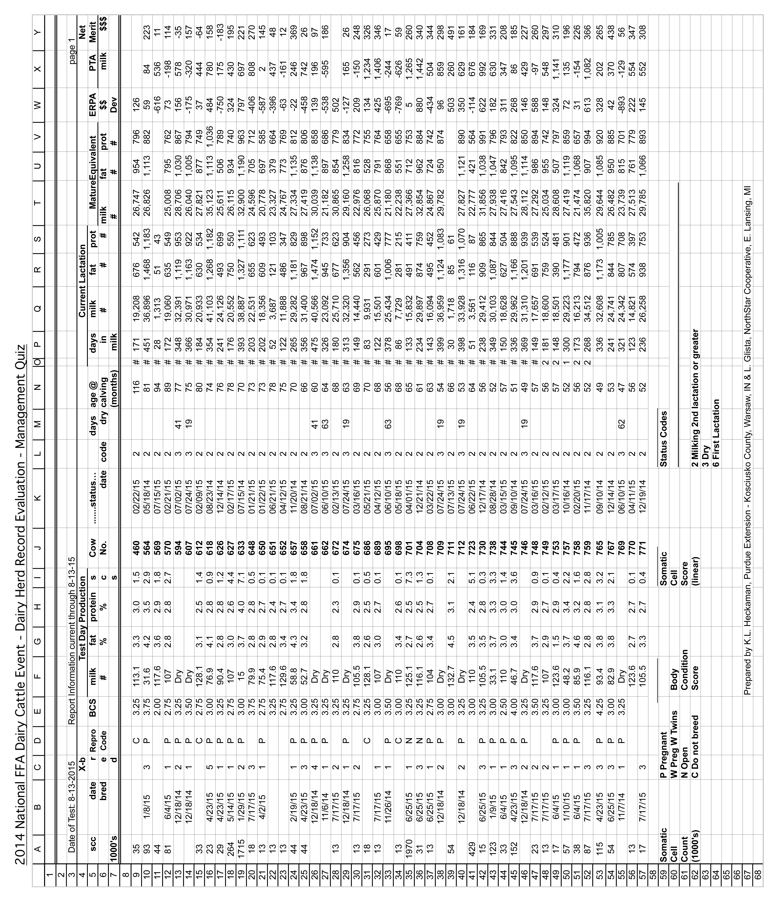
Key DHI Benchmarks from Dairy Metrics
 | Percentile
 | 50th | 75th | 95th
Holstein Herds (N=73) with at least 100 cows
Rolling Milk | 19388.6 | 21482.4 | 24494.6
Rolling Fat | 702.4 | 778.4 | 887.8
Rolling Protein | 595.4 | 657.4 | 746.6
Daily Milk-Milk cows | 59.0 | 65.6 | 75.1
Summit Milk 1st Lactation | 66.2 | 72.4 | 81.3
Summit Milk 2nd Lactation | 82.1 | 90.3 | 102.2
Summit Milk 3rd+ Lactation | 87.4 | 95.9 | 108.1
Peak Milk 1st Lactation | 71.8 | 78.5 | 88.2
Peak Milk 2nd Lactation | 88.8 | 98.2 | 111.7
Peak Milk 3rd+ Lactation | 95.2 | 103.7 | 115.9
Proj 305 Day ME Milk | 21502.8 | 23491.3 | 26352.0
Standardized 150 Day Milk | 67.6 | 75.2 | 86.0
Days in Milk | 210.9 | 191.4 | 163.4
Age of 1st Lactation Cows | 26.5 | 24.8 | 22.4
Cows Left Herd-All Lactations, % | 34.5 | 25.0 | 11.3
Cows Died-All Lactations, % | 7.4 | 4.0 | 0.0
Cows Left Herd for Repro-All Lactations, % | 5.5 | 1.3 | 0.0
SCC Actual | 397.0 | 273.0 | 94.5
SCC Score | 3.2 | 2.8 | 2.2
SCC Score for 1st Lact Cows | 2.8 | 2.4 | 1.8
SCC Score for 2nd Lact Cows | 3.1 | 2.6 | 1.9
SCC Score for 3rd+ Lact Cows | 3.6 | 3.1 | 2.4
Cows (SCCS of 0-3), % | 57.9 | 65.2 | 75.7
1st lact (SCCS of 0-3), % | 65.0 | 72.7 | 83.8
2nd lact (SCCS of 0-3), % | 60.9 | 70.1 | 83.4
3rd lact (SCCS of 0-3), % | 50.1 | 59.4 | 72.8
Pregnancy Rate-Current, % | 13.5 | 19.7 | 28.6
Days Open-Projected Minimum-Total Herd | 180.7 | 155.6 | 119.5
Projected Calving Interval | 15.2 | 14.3 | 12.9
Actual Calving Interval | 14.5 | 13.7 | 12.5
Days to 1st Service-(%herd < VWP) | 19.2 | 28.0 | 40.7
Days to 1st Service-(%VWP to 100D) | 44.8 | 56.9 | 74.2
Days to 1st Service-(%herd > 100D) | 37.5 | 49.9 | 67.8
Days to 1st Service-Total Herd | 108.1 | 84.0 | 49.2
Days to 1st Service (%herd <100D)-1st Lact | 62.5 | 76.3 | 96.1
Days to 1st Service (%herd <100D)-2nd Lact | 65.5 | 79.2 | 98.9
Days to 1st Service (%herd <100D)-3rd+ Lact | 63.0 | 74.1 | 90.1
Conception Rate for Past 12M-1st Service, % | 48.4 | 66.5 | 92.6
Conception Rate for Past 12M-2nd Service, % | 45.1 | 63.9 | 90.8
Conception Rate for Past 12M-3rd+ Service, % | 35.0 | 51.9 | 76.3
Service per Preg-All Lact | 2.5 | 1.8
Service per Preg-1st Lact | 2.5 | 1.8
Service per Preg-2nd Lact | 2.6 | 1.7
Service per Preg-3rd+ Lact | 2.6 | 1.8
Heats Observed, % | 29.7 | 42.1 | 60.0
Percentile Rank of Proven AI Bulls | 40.0 | 61.8 | 93.1
Herd Record Evaluation Answer Key
Cow No. | Q1 | Q2 | Q3 | Q4 | Q5 | Q6 | Q7 | Q8 | Q9 | Q10
460 | 0 | 0 | 0 | 0 | 0 | 0 | 0 | 0 | 0 | 0
564 | 0 | 3 | 0 | 0 | 0 | 0 | 0 | 0 | 0 | 0
569 | 0 | 0 | 0 | 0 | 0 | 0 | 0 | 0 | 0 | 3
570 | 0 | 0 | 0 | 0 | 0 | 0 | 0 | 0 | 0 | 0
594 | 0 | 0 | 0 | 0 | 0 | 0 | 0 | 0 | 0 | 0
607 | 0 | 0 | 0 | 0 | 0 | 0 | 0 | 0 | 0 | 0
612 | 0 | 0 | 0 | 0 | 0 | 0 | 0 | 0 | 0 | 0
618 | 0 | 0 | 0 | 0 | 0 | 0 | 0 | 0 | 0 | 0
626 | 0 | 0 | 0 | 0 | 0 | 0 | 0 | 0 | 0 | 0
627 | 0 | 0 | 0 | 0 | 0 | 0 | 0 | 0 | 0 | 0
633 | 2 | 0 | 0 | 0 | 0 | 0 | 0 | 0 | 1 | 0
648 | 0 | 0 | 0 | 0 | 0 | 0 | 0 | 0 | 0 | 0
650 | 0 | 0 | 0 | 0 | 3 | 0 | 0 | 0 | 0 | 0
651 | 0 | 0 | 0 | 3 | 0 | 0 | 0 | 0 | 0 | 0
652 | 0 | 0 | 0 | 0 | 0 | 0 | 0 | 0 | 0 | 0
657 | 0 | 0 | 0 | 0 | 0 | 0 | 0 | 0 | 0 | 0
658 | 0 | 0 | 0 | 0 | 0 | 0 | 0 | 0 | 3 | 0
661 | 0 | 0 | 0 | 0 | 0 | 0 | 0 | 0 | 0 | 0
662 | 0 | 0 | 0 | 0 | 0 | 0 | 1 | 3 | 0 | 0
672 | 0 | 0 | 0 | 0 | 0 | 0 | 0 | 0 | 0 | 0
674 | 0 | 0 | 0 | 0 | 0 | 0 | 0 | 0 | 0 | 0
675 | 0 | 0 | 0 | 0 | 0 | 0 | 0 | 0 | 0 | 0
686 | 0 | 0 | 0 | 0 | 0 | 0 | 0 | 0 | 0 | 0
689 | 0 | 0 | 0 | 0 | 0 | 0 | 0 | 0 | 0 | 0
695 | 0 | 0 | 0 | 0 | 0 | 0 | 0 | 0 | 0 | 0
698 | 0 | 0 | 0 | 0 | 0 | 0 | 3 | 0 | 0 | 0
701 | 0 | 0 | 0 | 0 | 0 | 3 | 0 | 0 | 0 | 0
704 | 0 | 0 | 0 | 0 | 0 | 0 | 0 | 0 | 3 | 0
708 | 0 | 0 | 0 | 0 | 0 | 0 | 0 | 0 | 0 | 0
709 | 0 | 0 | 0 | 0 | 0 | 0 | 0 | 0 | 0 | 0
711 | 0 | 0 | 3 | 0 | 0 | 0 | 0 | 0 | 0 | 0
712 | 0 | 0 | 0 | 0 | 0 | 0 | 0 | 0 | 0 | 0
723 | 0 | 0 | 0 | 1 | 0 | 0 | 0 | 0 | 0 | 0
730 | 0 | 0 | 0 | 0 | 0 | 0 | 0 | 0 | 0 | 0
738 | 0 | 2 | 0 | 0 | 0 | 0 | 0 | 0 | 0 | 0
744 | 0 | 0 | 0 | 0 | 0 | 0 | 0 | 0 | 0 | 0
745 | 0 | 0 | 0 | 0 | 0 | 0 | 0 | 0 | 0 | 0
746 | 0 | 0 | 0 | 0 | 0 | 0 | 0 | 0 | 0 | 0
748 | 0 | 0 | 0 | 0 | 0 | 0 | 0 | 0 | 0 | 0
749 | 0 | 0 | 0 | 0 | 0 | 0 | 0 | 0 | 0 | 0
753 | 3 | 0 | 0 | 0 | 0 | 0 | 0 | 0 | 0 | 0
757 | 0 | 1 | 0 | 0 | 0 | 0 | 0 | 0 | 0 | 0
758 | 0 | 0 | 0 | 0 | 0 | 0 | 0 | 0 | 0 | 0
759 | 0 | 0 | 0 | 0 | 0 | 0 | 0 | 0 | 0 | 0
765 | 0 | 0 | 0 | 0 | 0 | 0 | 0 | 0 | 0 | 0
767 | 0 | 0 | 1 | 0 | 0 | 0 | 0 | 0 | 0 | 0
769 | 0 | 0 | 0 | 0 | 0 | 0 | 0 | 2 | 0 | 0
770 | 0 | 0 | 0 | 0 | 0 | 0 | 0 | 0 | 0 | 0
771 | 0 | 0 | 0 | 0 | 0 | 0 | 0 | 0 | 0 | 0

3 is a full credit answer.
1 and 2 is partial-credit answer.
Prepared by K.L. Heckaman, Purdue Extension - Kosciusko County, Warsaw,

