Sustainability with Darling Ingredients
Created: 07/2022 by the National FFA Organization
Description of Lesson: Dive into the world of agricultural byproducts and sustainability by learning about Darling Ingredients, one of the world’s leaders in utilizing sustainable ingredients and maximizing the use of natural resources.
Student Learning Objectives:
After completing these activities, students will …
- Utilize resources and activities to discover opportunities within Darling Ingredients.
- Develop a foundational understanding of the necessity of sustainability to meet our growing needs.
- Develop a foundational understanding of the need to give back to nature.

Suggested Grade Level:
Grades 9 and 10 (This lesson is written so instructors can scale up or down based on class needs.)

Suggested Time: 240 minutes (*Time requirements may vary based upon student understanding and class schedule.)
Resources/References:
- Website: Darling Ingredients, https://www.darlingii.com/
- Video: Biofuels for a Growing Population, https://vimeo.com/304388616
- Video: Retrieving Nutrients From Manure, https://vimeo.com/352030137
- Video: Feeding Tomorrow’s World, https://vimeo.com/372647401
- Video: Ecozone: Giving Back to Nature, https://vimeo.com/309301311
- Article: Protectors of the Planet, https://d1ip4j1950xau.cloudfront.net/Corporate/Brochures/Protectors%20of%20the%20Planet_Biosecurity_Final.pdf
- Article: Gatekeepers of the Food Chain, https://d1ip4j1950xau.cloudfront.net/Corporate/Brochures/GP1b_Gatekeepers_of_the_food_chain_f.pdf
- Website: AgExplorer, AgExplorer.FFA.org/
- Website: Darling Ingredients Blog Posts, https://www.darlingii.com/media/blog
- Video: Diamond Green Diesel, https://vimeo.com/304388616

Related Resources:
- Link: Career and Leadership Development Events
  - Agricultural Communications,
  - Agricultural Issues, FFA.org/participate/cde-lde/agricultural-issues-forum/
  - Environmental and Natural Resources, FFA.org/participate/cdes/environmental-and-natural-resources/
  - Food Science and Technology, FFA.org/participate/cdes/food-science-and-technology/
  - Marketing Plan, FFA.org/participate/cdes/marketing-plan/
- Link: Agriscience Fair

Equipment and Supplies Needed:
- A copy of the “Darling Ingredients Key Vocabulary” list and the ”Darling Vocabulary Exercise”
- A copy of the “Choice Board” worksheet and appendices for each student
- Internet access to play the video in real time or embed it in a PowerPoint ahead of time

Virtual Instruction Ideas:
This entire lesson can be taught virtually. All student handouts can be sent or posted electronically.

Student Activity Sheets:
Direct access to student activity sheets without lesson plan or answer key for easy upload to a learning management system or printing for classwork.

Link (Word)https://ffa.app.box.com/file/1027540726529?s=yq2p0gwl8c9iyb8z1gyleotigpnov6sd
Link (PDF) https://ffa.app.box.com/file/1027540733729?s=n3i5iklenf8o4an6euc2eycvkjvafgwy
Link (Google) https://docs.google.com/document/d/1ybuQ3E_lDyALNLq9AG6APFcoidgh38Bd0a7la8WeIOE/edit?usp=share_link

These Activities are Aligned to the Following Standards:
AFNR Performance Element
- CS.01 Analyze how issues, trends, technologies and public policies impact systems in the Agriculture, Food and Natural Resources Career Cluster.
- CS.02. Evaluate the nature and scope of the Agriculture, Food and Natural Resources Career Cluster and the role of agriculture, food and natural resources (AFNR) in society and the economy.
- BS.03. NCAE Standard: Demonstrate the application of biotechnology to solve problems in Agriculture, Food and Natural Resources (AFNR) systems (e.g., bioengineering, food processing, waste management, horticulture, forestry, livestock, crops, etc.).
- ESS.04. Demonstrate the operation of environmental service systems (e.g., pollution control, water treatment, wastewater treatment, solid waste management and energy conservation).
- NRS.01. Plan and conduct natural resource management activities that apply logical, reasoned, and scientifically based solutions to natural resource issues and goals.
- NRS.04. Demonstrate responsible management procedures and techniques to protect, maintain, enhance, and improve natural resources.
- AS.08. Analyze environmental factors associated with animal production.
FFA Precept
- FFA.CS-O. Flexibility/Adaptability: Be flexible in various situations and adapt to change.
- FFA.CS-N. Decision Making: Analyze a situation and execute an appropriate course of action.
- FFA.CS-P. Technical/Function Skills in Agriculture: Obtain knowledge and skills needed for a career in agriculture and related industries.
Common Career Technical Core
- AG1 Analyze how issues, trends, technologies and public policies impact systems in the Agriculture, Food and Natural Resources Career Cluster.
- AG2 Evaluate the nature and scope of the Agriculture, Food and Natural Resources Career Cluster and the role of agriculture, food, and natural resources (AFNR) in society and the economy.
- AG3 Examine and summarize the importance of health, safety, and environmental management systems in AFNR businesses.
- AG6 Analyze the interaction among AFNR systems in the production, processing, and management of food, fiber, and fuel and the sustainable use of natural resources.
NASDCTEc
- AGC10.03 Compare and contrast issues affecting the AFNR industry including biotechnology, employment, safety, environmental and animal welfare to demonstrate an understanding of the trends and issues important to careers in this industry.
- AGC10.04 Envision emerging technology and globalization and project its influence on widespread markets to demonstrate an understanding of technologies and trends that will impact the AFNR industry.
Common Core – Reading: Informational Text
- CCSS.ELA-Literacy.RI.9-10.1 Cite strong and thorough textual evidence to support analysis of what the text says explicitly as well as inferences drawn from the text.
- CCSS.ELA-Literacy.RI.9-10.2 Determine a central idea of a text and analyze its development over the course of the text, including how it emerges and is shaped and refined by specific details; provide an objective summary of the text.
Common Core – Writing
- CCSS.ELA-Literacy.W.9-10.1 Write arguments to support claims in an analysis of substantive topics or texts, using valid reasoning and relevant and sufficient evidence.
- CCSS.ELA-Literacy.W.9-10.2 Write informative/explanatory texts to examine and convey complex ideas, concepts, and information clearly and accurately through the effective selection, organization, and analysis of content.
Common Core – Speaking and Listening
- CCSS.ELA-Literacy.SL.9-10.2 Integrate multiple sources of information presented in diverse media or formats (e.g., visually, quantitatively, orally) evaluating the credibility and accuracy of each source.
- CCSS.ELA-Literacy.SL.9-10.4 Present information, findings, and supporting evidence clearly, concisely, and logically such that listeners can follow the line of reasoning and the organization, development, substance, and style are appropriate to purpose, audience, and task.
Common Core – Science & Technical Subjects
- CCSS.ELA-Literacy.RST.9-10.7 Translate quantitative or technical information expressed in words in a text into visual form (e.g., a table or chart) and translate information expressed visually or mathematically (e.g., in an equation) into words.
Common Core – Literacy in Science & Technical Subjects: Writing
- CCSS.ELA-Literacy.WHST.9.10.1 Write arguments focused on discipline-specific content.
- CCSS.ELA-Literacy.WHST.9.10.4 Produce clear and coherent writing in which the development, organization, and style are appropriate to task, purpose, and audience.
Common Core – Math Practices
- MP2 Reason abstractly and quantitatively.
Green/Sustainability Knowledge and Skill Statements
- AFNR Career Cluster, Statement 6 Use green technologies and sustainability practices to maintain safe and healthful working environments that sustain the natural environment and promote well-being in the AFNR workplaces.
- AFNR Career Cluster, Statement 3 Communicate the impact of “green” and sustainability principles on agriculture, food and natural resource systems.
AFNR Career Ready Practices
- CRP.02. Apply appropriate academic and technical skills. Career-ready individuals readily access and use the knowledge and skills acquired through experience and education to be more productive.
- CRP.04. Communicate clearly, effectively, and with reason. Career-ready individuals communicate thoughts, ideas and action plans with clarity, whether using written, verbal and/or visual methods.
- CRP.05. Consider the environmental, social and economic impact of decisions. Career-ready individuals understand the interrelated nature of their actions and regularly make decisions that positively impact and/or mitigate negative impact on other people, organizations and the environment.
- CRP.06. Demonstrate creativity and innovation. Career-ready individuals regularly think of ideas that solve problems in new and different ways, and they contribute those ideas in a useful and productive manner to improve their organization.
- CRP.07. Employ valid and reliable research strategies. Career-ready individuals are discerning in accepting and using new information to make decisions, change practices or inform strategies.
- CRP.08. Utilize critical thinking to make sense of problems and persevere in solving them. Career-ready individuals readily recognize problems in the workplace, understand the nature of the problem, and devise effective plans to solve the problem.
- CRP.11. Use technology to enhance productivity. Career-ready individuals find and maximize the productive value of existing and new technology to accomplish workplace tasks and solve workplace problems.
Partnership for 21st Century Skills
- Communication
- Critical Thinking and Problem Solving
- Financial, Economic, Business, and Entrepreneurial Literacy
- Global Awareness
- Information, Communications, and Technology Literacy
- Think Creatively

Lesson Plan:

- Introduction: The Darling Ingredients "Choice Board” is designed to help students learn about sustainability and the future of agriculture while exploring Darling Ingredients, a leader in sustainability and repurposing our resources. There is a vocabulary list and activities to complete with this choice board.

- Suggested Use:
- If you have ample time to complete an entire unit, then these activities could be stretched over two or more weeks. Some activities require more work than others. If time is limited, this Choice Board could be used as substitute lesson plans, a grading period long-term project or however else you see fit in your classroom.
- Grading: How you determine if a student has completed the tasks depends on your preference and what resources are available to you. Suggestions include having them email or print something that proves they completed a task or for them to write a summary paragraph of a video they watched or article they read.
  - Work can be collected weekly or every few weeks for grading.
  - Tip: Count the entire choice board grade (each is worth 100 points) as a test or project grade or have it count twice.

- Follow-up: Have students present their findings to other students, teachers and community members to help educate and advocate for sustainability in agriculture.



*Key Vocabulary
Bioenergy is renewable energy derived from biological sources, to be used for heat, electricity or vehicle fuel.
Biofuel is a liquid fuel produced from renewable sources, such as new and used vegetable oils and animal fats and is a cleaner-burning replacement for petroleum-based fuel. It is nontoxic and biodegradable and is produced by combining alcohol with vegetable oil, animal fat or recycled cooking grease.
Byproduct: an incidental or secondary product made in the manufacture or synthesis of something else
Carbon footprint is the total greenhouse gas (GHG) emissions caused by an individual, event, organization, service, place or product, expressed as carbon dioxide equivalent (CO2e).
Climate change: long-term shifts in temperatures and weather patterns
Entrepreneurship: An entrepreneur is someone who organizes, manages and assumes the risks of a business or enterprise.
Greenhouse gas emissions (GHG): the emission into the earth's atmosphere of any of various gases, especially carbon dioxide, that contribute to the greenhouse effect
Humic acid: one of two classes of natural acidic organic polymer that can be extracted from humus found in soil, sediment or aquatic environments
Integrity: the quality of being honest and having strong moral principles
Low-carbon biofuel: made from sustainably produced nonfood biomass; can dramatically reduce CO2 emissions from the transportation sector while providing the high-energy density and easy storage of a liquid transportation fuel
Nutraceutical: a food containing health-giving additives and having medicinal benefit
Nutrient rich: food that is high in nutrients but relatively low in calories
Nutrient-dense foods contain vitamins, minerals, complex carbohydrates, lean protein and healthy fats. Examples of nutrient-dense foods include fruits and vegetables, whole grains, low-fat or fat-free milk products, seafood, lean meats, eggs, peas, beans and nuts.
Organic residuals: includes several different waste categories; among them are the organic fraction of municipal solid waste, animal wastes or manure and municipal biosolids that comprise the organic solids remaining after sewage treatment
Pharmaceutical: any kind of drug used for medicinal purposes
Rendering: the cooking and drying of meat and/or other animal byproducts not used for human consumption to recover fats and proteins
The process reuses materials that would otherwise be discarded and repurposes them for various applications, such as fuel and livestock feed.
Renewable diesel is made of nonpetroleum renewable resources such as natural fats, vegetable oils and greases. Because renewable diesel is chemically the same as petroleum diesel, it may be used in its pure form—called R100—as a drop-in fuel, or it can be blended with petroleum diesel and/or with biodiesel in various amounts. Renewable diesel-petroleum diesel blends are labeled with an R followed by the percentage (by volume) of the renewable diesel content. For example, a blend of 20% renewable diesel and 80% petroleum diesel is called R20. A blend of 20% biodiesel and 80% renewable diesel is called B20R80 to make a 100% biofuel. A blend of 20% biodiesel, 20% renewable diesel and 60% petroleum diesel is called B20R20.
Sustainable refers to the ability to maintain or support a process continuously over time.

Darling Vocabulary Exercise
Directions: *Match the vocabulary term to the correct definition and write your answer in the box next to the corresponding definition. See word bank below.
 | the quality of being honest and having strong moral principles
 | renewable energy derived from biological sources, to be used for heat, electricity or vehicle fuel
 | any kind of drug used for medicinal purposes
 | an incidental or secondary product made in the manufacture or synthesis of something else
 | a food containing health-giving additives and having medicinal benefit.
Food that is high in nutrients but relatively low in calories
Nutrient-dense foods contain vitamins, minerals, complex carbohydrates, lean protein and healthy fats. Examples of nutrient-dense foods include fruits and vegetables, whole grains, low-fat or fat-free milk products, seafood, lean meats, eggs, peas, beans and nuts.
 | the emission into the earth's atmosphere of any of various gases, especially carbon dioxide, that contribute to the greenhouse effect
 | refers to the ability to maintain or support a process continuously over time
the cooking and drying of meat and/or other animal byproducts not used for human consumption to recover fats and proteins
The process reuses materials that would otherwise be discarded and repurposes them for various applications, such as fuel and livestock feed.
 | the total greenhouse gas (GHG) emissions caused by an individual, event, organization, service, place or product, expressed as carbon dioxide equivalent (CO2e)
 | includes several different waste categories. Among them are the organic fraction of municipal solid waste, animal wastes or manure and municipal biosolids that comprise the organic solids remaining after sewage treatment
 | An entrepreneur is someone who organizes, manages and assumes the risks of a business or enterprise.
 | It is made of nonpetroleum renewable resources such as natural fats, vegetable oils and greases.
a liquid fuel produced from renewable sources, such as new and used vegetable oils and animal fats and is a cleaner-burning replacement for petroleum-based fuel
It is nontoxic and biodegradable and is produced by combining alcohol with vegetable oil, animal fat or recycled cooking grease.
 | one of two classes of natural acidic organic polymer that can be extracted from humus found in soil, sediment or aquatic environments
 | long-term shifts in temperatures and weather patterns
 | made from sustainably produced nonfood biomass; can dramatically reduce CO2 emissions from the transportation sector while providing the high-energy density and easy storage of a liquid transportation fuel
Word Bank
Bioenergy |  | Biofuel | Byproduct | Carbon footprint | Climate change
Entrepreneurship |  | Greenhouse gas emissions | Humic acid | Integrity | Low-carbon biofuel
Nutraceutical |  | Nutrient rich | Organic residuals | Pharmaceutical | Rendering
Renewable diesel |  | Sustainable

Key: Darling Vocabulary Exercise
Directions: *Match the vocabulary term to the correct definition and write your answer in the box next to the corresponding definition. See word bank below.
Integrity | the quality of being honest and having strong moral principles
Bioenergy | renewable energy derived from biological sources, to be used for heat, electricity or vehicle fuel
Pharmaceutical | any kind of drug used for medicinal purposes
Byproduct | an incidental or secondary product made in the manufacture or synthesis of something else
Nutraceutical | a food containing health-giving additives and having medicinal benefit.
Nutrient rich | Food that is high in nutrients but relatively low in calories  Nutrient-dense foods contain vitamins, minerals, complex carbohydrates, lean protein and healthy fats. Examples of nutrient-dense foods include fruits and vegetables, whole grains, low-fat or fat-free milk products, seafood, lean meats, eggs, peas, beans and nuts.
Greenhouse gas emissions | the emission into the earth's atmosphere of any of various gases, especially carbon dioxide, that contribute to the greenhouse effect
Sustainable | refers to the ability to maintain or support a process continuously over time
Rendering | the cooking and drying of meat and/or other animal byproducts not used for human consumption to recover fats and proteins  The process reuses materials that would otherwise be discarded and repurposes them for various applications, such as fuel and livestock feed.
Carbon footprint | the total greenhouse gas (GHG) emissions caused by an individual, event, organization, service, place or product, expressed as carbon dioxide equivalent (CO2e)
Organic residuals | includes several different waste categories. Among them are the organic fraction of municipal solid waste, animal wastes or manure and municipal biosolids that comprise the organic solids remaining after sewage treatment
Entrepreneurship | An entrepreneur is someone who organizes, manages and assumes the risks of a business or enterprise.
Renewable diesel | It is made of nonpetroleum renewable resources such as natural fats, vegetable oils and greases.
Biofuel | a liquid fuel produced from renewable sources, such as new and used vegetable oils and animal fats and is a cleaner-burning replacement for petroleum-based fuel  It is nontoxic and biodegradable and is produced by combining alcohol with vegetable oil, animal fat or recycled cooking grease.
Humic acid | one of two classes of natural acidic organic polymer that can be extracted from humus found in soil, sediment or aquatic environments
Climate change | long-term shifts in temperatures and weather patterns
Low-carbon biofuel | made from sustainably produced nonfood biomass; can dramatically reduce CO2 emissions from the transportation sector while providing the high-energy density and easy storage of a liquid transportation fuel
Word Bank
Bioenergy |  | Biofuel | Byproduct | Carbon footprint | Climate change
Entrepreneurship |  | Greenhouse gas emissions | Humic acid | Integrity | Low-carbon biofuel
Nutraceutical |  | Nutrient rich | Organic residuals | Pharmaceutical | Rendering
Renewable diesel |  | sustainable

Choice Board
Aligned to the following standards: CS.02. BS.03. ESS.04. NRS.01. NRS.04. AS.08. FFA. CS-O FFA.CS-N. FFA.CS-P. AG1 AG2 AG3 AG6 AGC10.03 AGC10.04 CCSS.ELA-Literacy.RI.9-10.1 CCSS.ELA-Literacy.RI.9-10.2 CCSS.ELA-Literacy.W.9-10.1 CCSS.ELA-Literacy.W.9-10.2 CCSS.ELA-Literacy.SL.9-10.2 CCSS.ELA-Literacy.SL.9-10.4 CCSS.ELA-Literacy.RST.9-10.7 CCSS.ELA-Literacy.WHST.9.10.1 CCSS.ELA-Literacy.WHST.9.10.4 MP2 CRP.02. CRP.04. CRP.05. CRP.06. CRP.07. CRP.08. CRP.11.

Directions:
You will explore different sustainability concepts from Darling Ingredients to complete the tasks below. Some tasks will take longer than others, but you can complete them in any order you choose. Your due date for completion of this board is _____________________________. Shade or color in each block below as you complete it.

Remember/Understand | Watch the “Biofuels for a Growing Population” video and complete “Appendix 1: Fuel Sources Venn Diagram.” | Watch the “Retrieving Nutrients from Manure” video and complete “Appendix 2: Sustainable Manure.” | Watch the “Feeding Tomorrow’s World” video and complete “Appendix 3: Hungry for Insects.” | Watch the video “Ecozone: Giving Back to Nature” and complete “Appendix 4: The Ecozone.”
Apply/Analyze/Evaluate | Read the publication Protectors of the Planet (Article Link) and complete “Appendix 5: Rendering for Earth’s Protection.” | Utilizing the Darling Ingredients website and AgExplorer, complete “Appendix 6: Career Discovery.” | Utilizing the Darling Ingredients website, choose one of their four main pillars and write a two-paragraph summary giving an overview of your chosen pillar and what it means to you. Use “Appendix 7: Diving Into Darling.” | Utilize the Darling blog posts to choose a blog to review. Write a paragraph summary of the blog and what it means to you. Use “Appendix 8: Blog Review.”
Create | Select one of the topic areas presented in one of the Darling Ingredients Showcase Videos and create a blog post about the topic. Use “Appendix 9: Darling Ingredients Blog Post” to plan. | Create counterclaims for topics that could be seen as misunderstood. Use “Appendix 10: Let’s Talk It Out.” | Utilize the information from the publication Gatekeepers of the Food Chain (Article Link) to create an infographic. Use “Appendix 11: Informing the Public” to complete this activity. | Create your own ecozone that would benefit the environment near your home or school. Use “Appendix 12: Create Your Own Ecozone.”

Appendix 1: Fuel Sources Venn Diagram
Directions: Watch the video “Diamond Green Diesel” (https://vimeo.com/304388616) to learn more about Darling Ingredients biodiesel production. Then, complete the Venn diagram below comparing biodiesel and petroleum-based fuels.
Biofuels


Which type of fuel do you think is more sustainable and realistic for our growing population? Cite at least three supporting factors to support your decision.

___________________________________________________________________________________________________________________________________________________________________________________________________________________________________________________________________________________________________________________________
_________________________________________________________________________________________________________
Appendix 2: Sustainable Manure
Directions: View the video “Retrieving Nutrients from Manure,” https://vimeo.com/352030137, to complete this activity.
Problems came about when the company tried completing the processing of the residue. Identify the following pieces to this problem and how Darling Ingredients came to a resolution:

Piece of equipment malfunctioning:

Cause of the clogging filter:

Who resolved the problem?

What changes did they make?

End results:

Darling Ingredients knew how to produce _____________________ from manure but were left with a _______________. This ____________________ contained crucial building blocks like ______________________ that can work as soil _____________________________.
How does Darling Ingredients help farmers with their excess manure?
- Complete the flow chart with the images shown in the video
that allow farmers to be more sustainable.

Appendix 3: Hungry for Insects
Directions:
Watch the video “Tomorrow’s Nutrition Today,” https://vimeo.com/372647401, to complete this activity.

Global population is expected to reach ten billion people by ________.
2025 | 2030 | 2042 | 2050



A LARGE problem can have ____________ solutions.



What is the common name of the insect mentioned in the video?
- Feeding tomorrow’s population means we must double the _____________________ food we are producing today.
- Give two examples of protein-rich food you like to eat.


ENTOMOPHAGY
Using your own words and pictures, describe what this term means.

In what state was the first commercial insect farm in the United States started?
Darling uses a farm-raised insect that can be fed as a protein source in animal diets. Draw three animals the insect can be fed to.
Do you feel this innovation is a realistic tool to help approach our food production problems in the future? Explain.
Appendix 4: The Ecozone
Directions:
Watch the video “Ecozone: Giving Back to Nature,” https://vimeo.com/309301311, and complete the questions below.
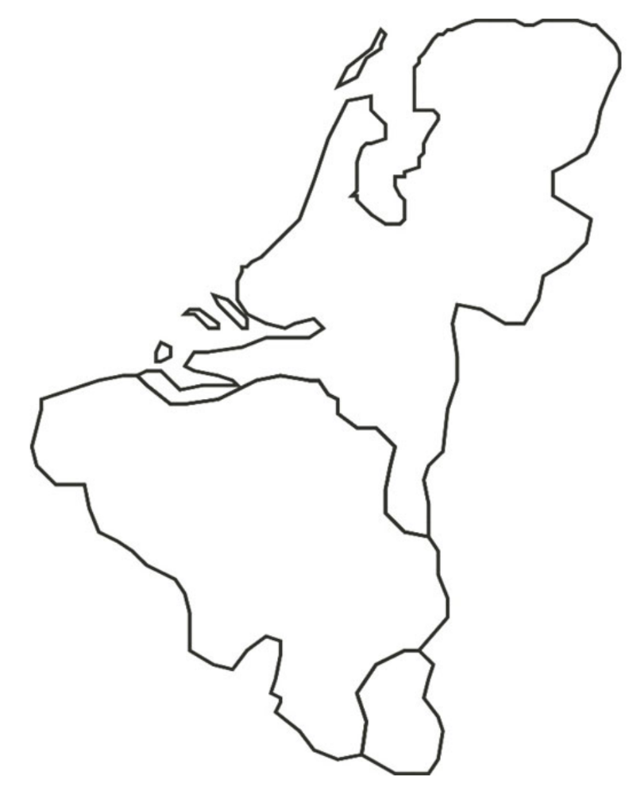
Where did Darling Ingredients study to develop the ecozone?

________________
What did Darling Ingredients study near its factories?
__________________
_________
*Answer each of the questions on the map to the right.
*Shade and outline the country to represent the colors of this country’s flag.
Describe the terms “flora” and “fauna” that are mentioned in the video by drawing visual representations of each.

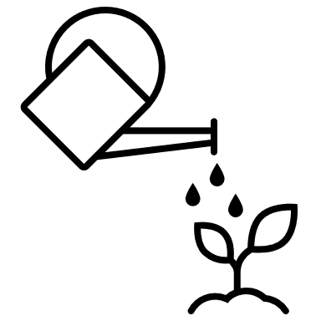

Water is a byproduct retrieved through plant operations. Darling captures this water, then recovers and treats the water from the raw materials. Lastly, the company gives this water back to the environment. Daily, it retrieves 3,600 cubic meters of water and 1.3 million cubic meters per year. Complete the math to convert that to the number of gallons Darling gives back to the environment. (1 cubic meter = 265 gallons)

Amount in Cubic Meters | Conversion to Gallons | Total Gallons Retrieved | Number of Olympic-Size Pools That Could Be Filled
3,600 cubic meters
1,300,000 cubic meters



Darling Ingredients receives an excess of raw materials such as _______________________________________________ that they repurpose into valuable ingredients for __________________________________________________________.

Identify the three major tasks that were completed so that Darling could start giving water back to the environment.

1.

2.

3.

How do the efforts of Darling Ingredients giving back water impact you? ____________________________________
The ecozone brought many new visitors to the area. What did Darling provide for its new visitors?

Who could be found resting at ecozone? Draw and label an example below.
Identify an area near your school that could be turned into an environmentally friendly space like the ecozone.
Location: __________________

Why is this an ideal location?

Appendix 5: Rendering for Earth’s Protection
Directions: Utilizing the “https://ffa.app.box.com/file/1027540724129” publication, complete this activity to gain a better understanding of how the rendering industry protects our health and well-being.

Meat-animal diets generate a lot of waste. In the space below, draw what you believe are three items that generally would go to waste from the animal butchering process.


Complete a line graph below to show the correlation of human population and meat-animal consumption. Label your x-axis and y-axis.

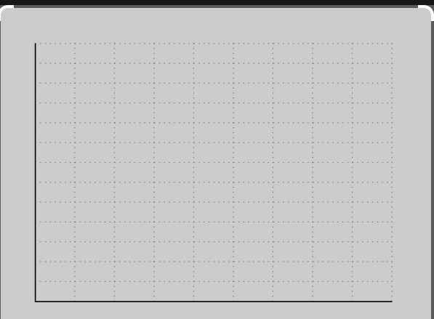


Which are potential problems that can result from the natural decomposition of animals? Shade the correct answer choices ORANGE.

E. coli | Protozoa | Salmonella | Pneumonia
Warts | Pathogenic bacteria | Diarrhea | Viruses

Complete the mind map below depicting what biosecurity represents in the food animal industry. (Example: using high heat to kill bacteria)

Complete the general steps of the rendering process below.

Rendering companies spend ____________ of dollars on equipment, analytical labs and monitoring instrumentation to meet ___________________, state and ___________ standards and obtain operating permits for each rendering facility.

As of 2019, Darling owns and operates ________% of the industry-certified rendering facilities in the United States.
Rendering processes use high temperatures between _____ and _____ degrees F that destroy harmful pathogens and microorganisms within the first ______ minutes of processing.

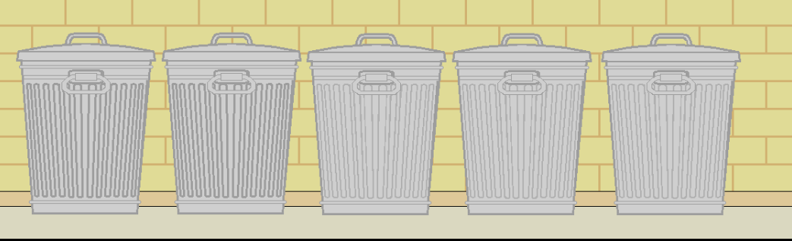
On the trash cans below, identify the common disposal methods for animal mortalities or meat byproducts.

Identify at least three examples of why rendering is a more effective disposal method than landfills and composting.

Example 1 | Example 2 | Example 3

Identify the four major government agencies that play an integral role in the regulation of the rendering industry and describe their roles.
Agency: ______________ | Agency: ______________ | Agency: ______________ | Agency: ______________
Role: | Role: | Role: | Role:

What are the three biggest takeaways from this publication from your viewpoint? In the space below, use words and pictures to describe them.

Appendix 6: Career Discovery
Directions:
Choose three agriculture careers that Darling Ingredients offers and that interest you. Once you have identified your careers, utilize the Career Profiles from AgExplorer to complete this handout.

Career 1: ________________________

- Responsibilities: 

- Education/Training: 

- Where They Work: 

- Job Outlook: 

Career 2: ________________________

- Responsibilities:

- Education/Training:

- Where They Work:

- Job Outlook:

Career 3: ________________________

- Responsibilities:

- Education/Training:

- Where They Work:

- Job Outlook:

Appendix 7: Diving Into Darling
Directions:
Utilizing the Darling Ingredients website, https://www.darlingii.com/, choose one of their four main pillars of the company and write a two-paragraph summary giving an overview of the chosen pillar and what it means to you or how it impacts your life.


Appendix 8: Blog Review
Directions:
Utilizing the Darling blog posts (https://www.darlingii.com/media/blog), choose a blog to review. Write a paragraph summary of the blog and what it means to you.

Appendix 9: Darling Ingredients Blog Post
Directions:
Select one of the topic areas presented in one of the Darling Ingredients showcase videos ( https://www.darlingii.com/csr/darling-cares/showcases) and create a blog post about the topic. A blog is a regularly updated website or webpage typically run by an individual or small group that is written in an informal or conversational style.


Title: Create an “attention-getting,” creative title.
Main Body of the Blog: In this section, include these key factors:
- Why you chose this topic
- A brief introduction/explanation about this topic
- 3 or 4 facts about the topic




Every blog post needs a picture. Describe the picture (in one sentence) and draw the picture you will have on your blog post page in the box below.
You want to leave your readers with a question that will prompt them to comment. What question will you ask your readers?

Blog Post Rubric
Area | 4 Points | 3 Points | 2 Points | 1 Point
Content | All content is accurate. There are no factual errors. | Most of the content is accurate, but there is one piece of information that seems inaccurate. | The content is generally accurate, but one piece of information is clearly inaccurate. | Content is confusing or contains more than one factual error.
Clarity and Neatness | The blog post is easy to read, and all elements are clearly written, labeled and drawn. Creativity was used. | The blog post is easy to read, and most elements are clearly written, labeled and drawn. Some creativity was used. | The blog post is hard to read with rough drawings, labels and color. Little creativity was used. | The blog post is hard to read, and one cannot tell what goes where or what the illustrations represent. No creativity was used.
Organization of Thoughts | Clearly organized in a logical sequence  Excellent introduction and conclusion | Adequate evidence of a logical sequence of information  Satisfactory introduction and conclusion | Order and sequence could be improved.  Weak introduction  and conclusion | No logical organization, unclear and confusing  No  introduction or conclusion
Picture | Student included a picture that matches the blog topic and is appealing to readers. | Student included a picture that matches the blog topic and is not appealing to readers. | Student included a picture that does not match the blog topic but is appealing to readers. | Student did not include a picture that matches the blog topic, and/or it is not appealing to readers.

Comments:

_____________________________________________________________________________________________________________________

_____________________________________________________________________________________________________________________

_____________________________________________________________________________________________________________________

_____________________________________________________________________________________________________________________

_____________________________________________________________________________________________________________________

_____________________________________________________________________________________________________________________

_____________________________________________________________________________________________________________________

Appendix 10: Let’s Talk It Out
Directions:
To complete these activities, utilize the animal rendering information from Darling Ingredients and any other research you feel necessary from reliable resources (Ex. educational institutions). Next, select a topic of your choice that could be misunderstood and complete the counterclaim sentence starters. Counterclaims are an argument offered in opposition to another argument. Example: After a bank sues a customer for an unpaid debt, the customer counterclaims (sues back) against the bank for fraud in procuring the debt.

Animal Rendering | Your Topic: ____________________________
Critics argue that … | Critics argue that …
While it might be true that …  Still, all in all, … | While it might be true that …  Still, all in all, …
Others might say that …  but I argue … | Others might say that …  but I argue …
A common argument against this position is …  but … | A common argument against this position is …  but …
It may be true that …  but … | It may be true that …  but …
It’s easy to think …  but when you look at the facts, … | It’s easy to think …  but when you look at the facts, …
It is often thought … | It is often thought …

How are these counterclaims effective in having a conversation about a topic that may be misunderstood?

Why is it important to be nonaggressive and nonconfrontational when discussing a misunderstood topic?

Appendix 11: Informing the Public
Directions:
You work for Darling Ingredients. You are expected to create an infographic that depicts the food waste problems we have here in the United States. Your boss wants to display this infographic on the company's website and social media platforms. Read the memo from your boss below for additional instructions.

To: All Agricultural Education Students
From: (Teacher’s name here), Darling Ingredients CEO
Date: (Use current date of project)
Subject: Food Waste Infographic Project

Dear Employee,

I have another project for you! We really want to educate American society about our food waste problems and how we here at Darling Ingredients can help resolve these problems. The board of trustees has decided to use infographics to display this information. We’re hoping you can help us create a detailed infographic on food waste and the rendering process. Utilize the Green Paper: Gatekeepers of the Food Chain https://ffa.app.box.com/folder/167842846537 to develop the content of your infographic. Here’s some information that must be included:

- Five statistics or facts about food waste in America
- Five statistics or facts about roles of the gatekeepers
- One graph or chart
- Concise statement on the impact Darling has through rendering
- Two pictures
- Darling Ingredients logo

If this information isn’t included, then you won’t be getting paid ^{(or a grade.)}. You MUST cite all your sources at the bottom of your infographic to get paid. Citations should use APA style. This infographic will be displayed on our website, on our social media platforms and in other literacy publications. So, it must be professional. Grammar, spelling and citations matter. Please see the attached document for more information about my expectations.

Suggested websites to help create your infographic:
- Canva, https://www.canva.com/
- Venngage, https://venngage.com/templates/infographics

If you have any questions, let me know.

Thanks,

Darling Ingredients CEO

Rubric for Infographic
 | A | B | C | D
Information | Detailed information from multiple sources including all required information from the checklist | Detailed information from one source including all required information from the checklist | Information from one or more sources lacking in detail  All items from the checklist are included; however, some information is vague. | Missing information from checklist  Information contradicts other information and/or is incorrect.
Visuals | All visuals are cited. Captions are present where needed. Visuals support the infographic and are appealing. A clear color scheme was chosen that attracts the viewer. There is great attention to arrangement and font. | Visuals are cited. Visuals support the infographic and are generally appealing. A color scheme was chosen | Visuals somewhat support the information. The color scheme, font and/or arrangement is messy and unorganized. | Color scheme is random, and applicable visuals are lacking.
Professionalism | All information is cited in APA style with correct formatting.  No grammar/spelling errors | All information is cited in APA style with mostly correct formatting.  Very few grammar errors | Information is cited with some errors.  Some grammar/spelling errors are present. | Multiple errors  Citation was attempted; however, key information is missing.

Appendix 12: Create Your Own Ecozone
Directions:
Develop your own ecozone to benefit an area near your school. Utilize the information below and reference the Darling Ingredients video “Ecozone: Giving Back to Nature” (https://vimeo.com/309301311) to help you plan out your project.

- Project Choice
  - 3-D Model and Poster Display
  - 3-D Model and Interactive Presentation (Google Slides, video, Prezi, etc.)

- Required Information
  - Name
  - Specific location (include a Google Earth image)
  - Size: breakdown and layout of the land
  - Purpose/Goals of the ecozone
  - Specific components (pond, woods, walking trails, etc.)
  - Resources needed to construct the ecozone (people, places, things)
  - Benefits of the space
  - Images/Drawings of plan
  - Why: Explain your decisions of location, purpose, size, etc.

- Use the rubric on the next page to guide you as you create your ecozone.

- Evaluation of Project
Topic | 25–20 Points | 19–15 Points | 14–8 Points | 7–1 Points
Content | Thoroughly and clearly states the main points and precise details that are accurately focused on the topic  Includes detailed information on each item:  - Name  - Specific location (include a Google Earth image)  - Size: breakdown and layout of the land  - Purpose/Goals of the ecozone  - Specific components (pond, woods, walking trails, etc.)  - Resources needed to construct the ecozone (people, places, things)  - Benefits of the space  - Images/Drawings of plan  - Why: Explain your decisions of location, purpose, size, etc. | Generally states the main points and details that discuss the topic  Includes information on each of the following:  - Name  - Specific location (include a Google Earth image)  - Size: breakdown and layout of the land  - Purpose/Goals of the ecozone  - Specific components (pond, woods, walking trails, etc.)  - Resources needed to construct the ecozone (people, places, things)  - Benefits of the space  - Images/Drawings of plan  - Why: Explain your decisions of location, purpose, size, etc. | States most of the main points and details that focus on the topic Leaves out necessary information on one or two of the following:  - Name  - Specific location (include a Google Earth image)  - Size: breakdown and layout of the land  - Purpose/Goals of the ecozone  - Specific components (pond, woods, walking trails, etc.)  - Resources needed to construct the ecozone (people, places, things)  - Benefits of the space  - Images/Drawings of plan  - Why: Explain your decisions of location, purpose, size, etc. | States few main points and details that focus on the topic, or information does not relate to topic Missing information on three or four of the following:  - Name  - Specific location (include a Google Earth image)  - Size: breakdown and layout of the land  - Purpose/Goals of the ecozone  - Specific components (pond, woods, walking trails, etc.)  - Resources needed to construct the ecozone (people, places, things)  - Benefits of the space  - Images/Drawings of plan  - Why: Explain your decisions of location, purpose, size, etc.
Educational Display | Clearly organized in a logical sequence  Neat, accurate and illustrative representations  All pictures, charts and graphs are clear and distinct. Text is of adequate size and font to read. | Adequate evidence of a logical sequence  Representations are accurate and illustrative.  Pictures, charts and graphs are clear and distinct. Text is of adequate size and font to read. | Order and sequence could be improved  Representations are illustrative but lack accuracy and neatness.  Pictures, charts and graphs are legible. Text is difficult to read. | No logical organization; unclear and confusing  Representations are unclear and difficult to read.  Pictures, charts and graphs are indistinct.
Three-Dimensional Model | Effectively and creatively models all components of the ecozone | Models the components of the ecozone | Models most components of the ecozone | Model is missing a majority of components of the ecozone.
Works Cited | Includes three or more sources from a mix of books and Internet sites  Each citation is correctly formatted in APA style. | Includes three sources, all of which are internet sites  Each citation is correctly formatted in APA style. | Includes two sources  Each citation attempts formatting in APA style. | Includes two sources  No attempt at proper APA style formatting
Teacher Comments

Total Score | /100

Key: Appendix 2: Sustainable Manure
Directions: View the video “Retrieving Nutrients from Manure,” https://vimeo.com/352030137, to complete this activity.
Reactor

Humic acid

Engineers

Treated the residue in a dedicated bioreactor and reduced the filtration speed

The company now fully process all residue. The company retrieves humic acid and generates a large volume of reclaimed water.
improvers
Problems came about when the company tried completing the processing of the residue. Identify the following pieces to this problem and how Darling Ingredients came to a resolution?

Piece of equipment malfunctioning:

Cause of the clogging filter:

Who resolved the problem?

What changes did they make?

End results:

humic acid
residue
large volume of unprocessed material
biphosphate
Darling Ingredients knew how to produce _____________________ from manure but were left with a ______________________________. This _____________ contained crucial building blocks like ______________________ that can work as soil _____________________________.
Collect the excess manure in a sustainable way and process it into a useable product
How does Darling ingredients help farmers with their excess manure?

- Complete the flow chart with the images shown in the video
that allow farmers to be more sustainable.
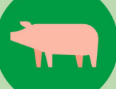





Key: Appendix 3: Hungry for Insects
Directions:
Watch the video “Tomorrow’s Nutrition Today,” https://vimeo.com/372647401, to complete this activity.

Global population is expected to reach ten billion people by ________.
2025 | 2030 | 2042 | 2050

A LARGE problem can have ____________ solutions.
tiny

Examples:

Meat, eggs, nuts
Black soldier fly
What is the common name of the insect mentioned in the video?
- Feeding tomorrow’s population means we must double the ___protein-rich__ food we are producing today.
- Give two examples of protein rich food you like to eat.

ENTOMOPHAGY
Using your own words and pictures, describe what this term means.

Answers will vary.

In what state was the first commercial insect farm in the United States started?

Kentucky
Darling uses a farm-raised insect that can be fed as a protein source in animal diets. Draw three animal the insect can be fed to.
Examples: chickens, poultry, fish
Do you feel this innovation is a realistic tool to help approach our food production problems in the future? Explain.
Answers will vary.
Key: Appendix 4: The Ecozone
Directions:
Watch the video “Ecozone: Giving Back to Nature,” https://vimeo.com/309301311, and complete the questions below.
Where did Darling Ingredients study to develop the ecozone?
Netherlands
___________________
What did Darling Ingredients study near its factories?
_plants_____animals
_________
*Answer each of the questions on the map to the right.
*Shade and outline the country to represent the colors of this country’s flag.
Describe the terms “flora” and “fauna” that are mentioned in the video by drawing visual representations of each.

Flora Fauna


Map should be shaded red, white and blue to represent the Netherlands flag

Water is a byproduct retrieved through plant operations. Darling captures this water, then recovers and treats the water from the raw materials. Lastly, the company gives this water back to the environment. Daily, it retrieves 3,600 cubic meters of water and 1.3 million cubic meters per year. Complete the math to convert that to the number of gallons Darling gives back to the environment. (1 cubic meter = 265 gallons)

Amount in Cubic Meters | Conversion to Gallons | Total Gallons Retrieved | Number of Olympic-Size Pools That Could Be Filled
3,600 cubic meters | 3,600 X 265 = 954,000 | 954,000 gallons per day | 954,000/660,000 = 1.45 Olympic-size pools per day
1,300,000 cubic meters | 1,300,000 X 265 = 344,500,000 | 344,500,000 gallons per year | 344,500,000/660,000 = 521.97 Olympic-size pools per year

Darling Ingredients receives an excess of raw materials such as _manure, feed scraps and animal byproducts__ that they repurpose into valuable ingredients for ___fertilizer, feed and fuel.
Identify the three major tasks that were completed so that Darling could start giving water back to the environment.

- Digging

- Reshaping surroundings

- Planting trees and reeds

How do the efforts of Darling Ingredients giving back water impact you? ___Answers will vary.
The ecozone brought many new visitors to the area. What did Darling provide for its new visitors?

Information about the flora and fauna found in the Ecozone

Who could be found resting at ecozone? Draw and label an example below.

Migratory and local bird species
Identify an area near your school that could be turned into an environmentally friendly space like the ecozone.
Location: __________________

Why is this an ideal location?

Answers will vary.

Key: Appendix 5: Rendering for Earth’s Protection
Directions: Utilizing the “ https://ffa.app.box.com/file/985937535284” publication, complete this activity to gain a better understanding of how the rendering industry protects our health and well-being.

Meat-animal diets generate a lot of waste. In the space below, draw what you believe are three items that generally would go to waste from the animal butchering process.

Examples: hooves, horns, blood, urine, connective tissue, hides, organs

Complete a line graph below to show the correlation of human population and meat-animal consumption. Label your x-axis and y-axis.

Graphs should show a trend that with increased population comes an increase in meat-animal consumption.

Which are potential problems that can result from the natural decomposition of animals? Shade the correct answer choices ORANGE.

E. coli | Protozoa | Salmonella | Pneumonia
Warts | Pathogenic bacteria | Diarrhea | Viruses

Complete the mind map below depicting what biosecurity represents in the food animal industry. (Example: using high heat to kill bacteria)
Limited traffic at all farms and processing facilities
These are just a few ideas for students to think about. Many others are possible.

Daily disinfecting and cleaning of facilities
Disposable footwear

Shower In/Out

Complete the general steps of the rendering process below.

Kill the pathogens.

Separate the fats from proteins.

Rendering companies spend millions of dollars on equipment, analytical labs and monitoring instrumentation to meet federal, state and local standards and obtain operating permits for each rendering facility.

Rendering processes use high temperatures between 240 and 295 degrees F that destroy harmful pathogens and microorganisms within the first five minutes of processing.
As of 2019, Darling owns and operates 52% of the industry-certified rendering facilities in the United States.

On the trash cans below, identify the common disposal methods for animal mortalities or meat byproducts.
rendering
composting
Anerobic digestion
Incineration
Landfills and burial

Identify at least three examples of why rendering is a more effective disposal method than landfills and composting.

Example 1  Reduces the spread of pathogens | Example 2  Less time and energy needed  Cost of running incinerators | Example 3  Less animal and human exposure to bacteria and disease  Less emission of greenhouse gases

Identify the four major government agencies that play an integral role in the regulation of the rendering industry and describe their roles.
Agency: EPA | Agency: FDA | Agency: USDA | Agency: OSHA
Role: The EPA ensures that all processes affecting the air and water follow environmentally considerate practices. | Role: The FDA oversees regulation of animal feed and food for human consumption. This agency places an emphasis on identifying and developing limits for hazardous contaminants within feed and developing process controls with audited oversight to ensure compliance with regulations. | Role: The USDA plays a role in regulating dedicated edible rendering facilities (producing ingredients used in human food, such as gelatin, collagens, meat binders and texturizers) and has a tangential regulatory role over material intended for animal feed. | Role: OSHA takes on a role that focuses on the safety of both employees and consumers.
What are the three biggest takeaways from this publication from your viewpoint? In the space below, use words and pictures to describe them.

Answers will vary.

