The Book of Life
Created: 02/2018 by the National FFA Organization

Student Learning Objectives:
After completing these activities, students will …
- Recognize important life events and their effects on others.
- Evaluate their lives to determine who they are and who they want to be.

Time REQUIRED: 50 minutes
Resources:
- FFA.org
- Video: “2016–17 National FFA Southern Region Vice President DeShawn Blanding’s Retiring Address,” https://vimeo.com/252531526/252080dc6c
- Appendix 1

Equipment and Supplies Needed:
- A copy of the “Book of Life” worksheet for each student
- A copy of the “My Book of Life” worksheet for each student
- Internet access to play the video in real time or embed it in a PowerPoint ahead of time
- Internet access for students

This quick lesson plan would work well as:
- An activity to have students reflect on their personal goals and ideals.
- A personal growth development activity.

Student Activity Sheets:
Direct access to student activity sheets without lesson plan or answer key for easy upload to learning management systems or printing for classwork.
https://ffa.box.com/s/e5e9ed4apsb73m6d2fl8pokcsyd0lkj0 (Word)
https://ffa.box.com/s/uhvl8trdf6z9k9ozmqskcrty5vdz01w8 (Non-Designed)
https://ffa.box.com/s/xveufrpzmcf7a1yoa0bcpljvl4hronpq (PDF)

These activities are aligned to the following standards:

FFA Precept
- FFA.PL-A.Action: Assume responsibility and take the necessary steps to achieve the desired results, no matter what the goal or task at hand.
- FFA.PL-C.Vision: Visualize the future and how to get there.
- FFA.PL-D.Character: Conduct oneself appropriately in relation to others regardless of the situation.
- FFA.PL-E.Awareness: Understand personal vision, mission and goals.
- FFA.PL-F.Continuous Improvement: Accept responsibility for learning and personal growth.
- FFA.PG-I.Professional Growth: Assume responsibility for attaining and improving upon the skills needed for career success.
- FFA.PG-J.Mental Growth: Embrace cognitive and intellectual development relative to reasoning, thinking and coping.
- FFA.PG-K.Emotional Growth: Share and express healthy feelings and emotions.
- FFA.PG-L.Spiritual Growth: Define personal beliefs, values, principles and sense of balance.
AFNR Performance Element
- CS.02. Evaluate the nature and scope of the Agriculture, Food & Natural Resources Career Cluster and the role of agriculture, food and natural resources (AFNR) in society and the economy.
Common Core - Writing
- CCSS.ELA-Literacy.W.9-10.2 Write informative/explanatory texts to examine and convey complex ideas, concepts, and information clearly and accurately through the effective selection, organization, and analysis of content.
- CCSS.ELA-Literacy.W.9-10.3 Write narratives to develop real or imagined experiences or events using effective technique, well-chosen details, and well-structured event sequences.
- CCSS.ELA-Literacy.W.9-10.4 Produce clear and coherent writing in which the development, organization, and style are appropriate to task, purpose, and audience.
Partnership for 21st Century Skills
- Communication
- Critical Thinking and Problem Solving
- Initiative and Self-direction
- Leadership and Responsibility
- Productivity and Accountability
- Social and Cross-Cultural Skills
- Think Creatively

Lesson Plan:
- Interest Approach:

Close your eyes and think about your life and experiences, both good and bad. Based on all those experiences, if someone were writing a biography of your life, consider the different chapters that would be included and also think of a title that would best summarize your “book of life.”

Have students share their titles and discuss as a class.

Activity:

Today we are going to watch a retiring address from the 90th National FFA Convention and Expo. This retiring address was given by 2016-17 National FFA Southern Region Vice President DeShawn Blanding. In his speech, he shares the different chapters that are a part of his book of life.

Before watching the video, look over the questions on the worksheet “The Book of Life,” and be ready to listen for their answers as you view the video.

Activity: Show the video “2016–17 National FFA Southern Region Vice President DeShawn Blanding’s Retiring Address.” The direct URL is https://vimeo.com/252531526/252080dc6c.

After the video is over, discuss the main concepts that DeShawn shared and how students can apply them to their own lives.

Now that we have learned about DeShawn’s book of life, we will all create our own by dividing our lives into different chapters and describing and illustrating those chapters.

Distribute the worksheet “My Book of Life.” Students will complete this activity individually and then share based on personal discretion.

4. Leveling Up:

“Ag Book of Life”: Using the same concept as the “My Book of Life” activity, have students choose one topic in agriculture and determine how they would categorize the major events in that topic into four chapters. They should also create a title and illustration for the topic. (See Appendix 1.)

The Book of Life
Aligned to the following standards:
FFA.PL-A.; FFA.PL-C.; FFA.PL-D.; FFA.PL-E.; FFA.PL-F.; FFA.PG-I.; FFA.PG-J.; FFA.PG-K.; FFA.PG-L.; CS.02; CCSS.W.9-10.2; CCSS.W.9-10.3; CCSS.W.9-10.4

directions:
Answer the questions below based on the video “2016–17 National FFA Southern Region Vice President DeShawn Blanding’s Retiring Address.” The direct URL is https://vimeo.com/252531526/252080dc6c.

1. As you watch the video, select five key terms and capture them in the chart below, and then explain how each word is important to the retiring address.

Key Term | Importance to the Retiring Address
 | 

2. Describe the first disappointment DeShawn mentions and how he overcame the issue.

___________________________________________________________________________________________________

___________________________________________________________________________________________________

___________________________________________________________________________________________________

3. List and describe a time you faced disappointment. Additionally, explain how you overcame the issue.

___________________________________________________________________________________________________

___________________________________________________________________________________________________

___________________________________________________________________________________________________

4. Throughout his speech, DeShawn mentions people he has met and places he has been. Shade in five states he mentioned in the map below:
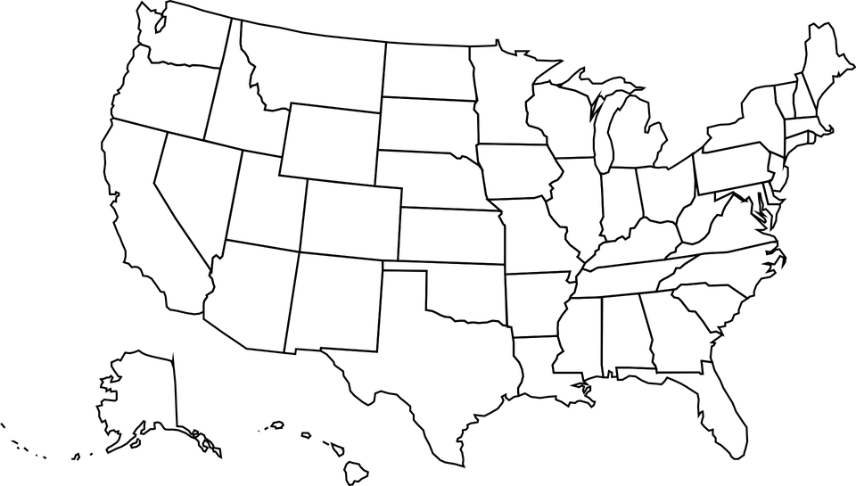
5. DeShawn discusses four chapters in his “Book of Life.” List each chapter title and a key takeaway you can apply to your own life.
Chapter | Title of Chapter | Key Takeaway
Chapter 1
Chapter 2
Chapter 3
Chapter 4

NAME:
Aligned to the following standards:
FFA.PL-A.; FFA.PL-C.; FFA.PL-D.; FFA.PL-E.; FFA.PL-F.; FFA.PG-I.; FFA.PG-J.; FFA.PG-K.; FFA.PG-L.; CCSS.W.9-10.2; CCSS.W.9-10.3; CCSS.W.9-10.4

My Book of Life
directions:
Think about your life and the experiences you have had. Divide your life into four parts, create a title for each chapter and write it on the blank page in the book image. Additionally, develop and capture a description and illustration for each chapter in your life.


Chapter 1-Title
Illustration: 
Description of chapter: 

Chapter 2-Title
Illustration:
Description of chapter:

Chapter 3-Title
Illustration:
Description of chapter:
Chapter 4-Title
Illustration:
Description of chapter:

Create a title for your “Book of Life” and include a mini illustration for the front cover:

NAME:
Aligned to the following standards:
FFA.PL-A.; FFA.PL-C.; FFA.PL-D.; FFA.PL-E.; FFA.PL-F.; FFA.PG-I.; FFA.PG-J.; FFA.PG-K.; FFA.PG-L.; CCSS.W.9-10.2; CCSS.W.9-10.3; CCSS.W.9-10.4

Appendix 1 — Ag Book of Life
directions:
Choose one topic in agriculture and categorize it into four chapters based on major events related to your topic. Create a title for each chapter and write it on the blank page in the book image. Additionally, develop and capture a description and illustration for each chapter. Write your selected agricultural topic in the space below.

Agricultural topic: __________________________________________________________________________

Chapter 1-Title
Illustration:
Description of chapter:
Chapter 2-Title
Illustration:
Description of chapter:
Chapter 3-Title
Illustration:
Description of chapter:
Chapter 4-Title
Illustration:
Description of chapter:
Create a title for this book of agriculture and include a mini illustration for the front cover:

