The Book of Life
Aligned to the following standards:
FFA.PL-A.; FFA.PL-C.; FFA.PL-D.; FFA.PL-E.; FFA.PL-F.; FFA.PG-I.; FFA.PG-J.; FFA.PG-K.; FFA.PG-L.; CS.02; CCSS.W.9-10.2; CCSS.W.9-10.3; CCSS.W.9-10.4

directions:
Answer the questions below based on the video “2016–17 National FFA Southern Region Vice President DeShawn Blanding’s Retiring Address.” The direct URL is https://vimeo.com/252531526/252080dc6c.

1. As you watch the video, select five key terms and capture them in the chart below, and then explain how each word is important to the retiring address.

Key Term | Importance to the Retiring Address

2. Describe the first disappointment DeShawn mentions and how he overcame the issue.

___________________________________________________________________________________________________

___________________________________________________________________________________________________

___________________________________________________________________________________________________

3. List and describe a time you faced disappointment. Additionally, explain how you overcame the issue.

___________________________________________________________________________________________________

___________________________________________________________________________________________________

___________________________________________________________________________________________________

4. Throughout his speech, DeShawn mentions people he has met and places he has been. Shade in five states he mentioned in the map below:
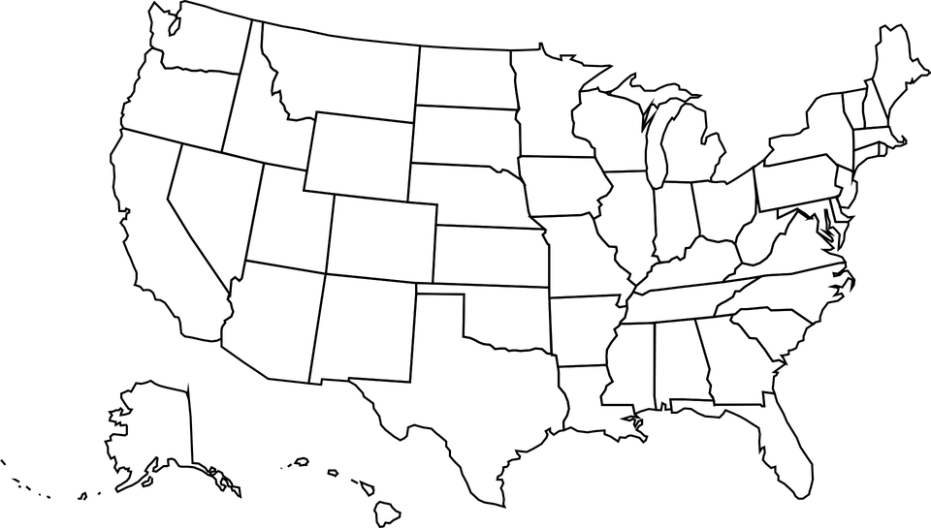
5. DeShawn discusses four chapters in his “Book of Life.” List each chapter title and a key takeaway you can apply to your own life.
Chapter | Title of Chapter | Key Takeaway
Chapter 1
Chapter 2
Chapter 3
Chapter 4

NAME:
Aligned to the following standards:
FFA.PL-A.; FFA.PL-C.; FFA.PL-D.; FFA.PL-E.; FFA.PL-F.; FFA.PG-I.; FFA.PG-J.; FFA.PG-K.; FFA.PG-L.; CCSS.W.9-10.2; CCSS.W.9-10.3; CCSS.W.9-10.4

My Book of Life
directions:
Think about your life and the experiences you have had. Divide your life into four parts, create a title for each chapter and write it on the blank page in the book image. Additionally, develop and capture a description and illustration for each chapter in your life.
Chapter Title | Description of Chapter | Illustration
Chapter 1 Title:

Chapter 2 Title:

Chapter 3 Title:

Chapter 4 Title:

- Create a title for your “Book of Life” and include a mini illustration for the front cover:

NAME:
Aligned to the following standards:
FFA.PL-A.; FFA.PL-C.; FFA.PL-D.; FFA.PL-E.; FFA.PL-F.; FFA.PG-I.; FFA.PG-J.; FFA.PG-K.; FFA.PG-L.; CCSS.W.9-10.2; CCSS.W.9-10.3; CCSS.W.9-10.4

Appendix 1 — Ag Book of Life
directions:
Choose one topic in agriculture and categorize it into four chapters based on major events related to your topic. Create a title for each chapter and write it on the blank page in the book image. Additionally, develop and capture a description and illustration for each chapter. Write your selected agricultural topic in the space below.

Agricultural topic: __________________________________________________________________________

Chapter Title | Description of Chapter | Illustration
Chapter 1 Title:

Chapter 2 Title:

Chapter 3 Title:

Chapter 4 Title:

- Create a title for this book of agriculture and include a mini illustration for the front cover:

