Reptiles, Fish and Small Animals, Oh My!
Created: 06/2019 by the National FFA Organization

SAE Video Summary: Follow Denisha as she walks us through her supervised agricultural experience (SAE) program working at Pet’s Palace. She shows us her daily tasks and responsibilities as a pet store employee.
Student Learning Objectives:
After completing these activities, students will …
- Describe the tasks in an animal-based small-business SAE.
- Identify career opportunities related to small animals.
- Create tasks list for their SAE programs.

Time Required: 45 minutes
Resources:
- Video: “Denisha Washington – SAE – Pet Store,” https://vimeo.com/315688197
- AgExplorer, AgExplorer.ffa.org
- SAE Idea Cards, https://FFA.box.com/v/saeideacards

Equipment and Supplies Needed:
- A copy of the “Get to Know the Pet Store” worksheet for each student
- A copy of the “What Do I Need to Do?” worksheet for each student
- Internet access to play the video in real time or embed it in a PowerPoint ahead of time

This quick lesson plan would work well as Part Of:
- An SAE lesson/unit.
- An introductory animal science lesson.

Student Activity Sheets:
Direct access to student activity sheets without lesson plan or answer key for easy upload to learning management systems or printing for classwork.
https://ffa.box.com/s/zkh4r3hluy7l174t5tl6vqv864vtk5hg (Word)
https://ffa.box.com/s/v60yuh7dnxhhgb7t9lbi8o5nxtz8puk2 (PDF)
These activities are aligned to the following standards:

FFA Precept
- FFA.PL-A.Action: Assume responsibility and take the necessary steps to achieve the desired results, no matter what the goal or task at hand.
- FFA.PL-C.Vision: Visualize the future and how to get there.
- FFA.PL-E.Awareness: Understand personal vision, mission and goals.
- FFA.PL-F.Continuous Improvement: Accept responsibility for learning and personal growth.
- FFA.PG-I.Professional Growth: Assume responsibility for attaining and improving upon the skills needed for career success.
- FFA.CS-M.Communication: Effectively interact with others in personal and professional settings.
Common Core – Speaking and Listening
- CCSS.ELA-Literacy.SL.9-10.1 Initiate and participate effectively in a range of collaborative discussions (one-on-one, in groups, and teacher-led) with diverse partners on grades 9-10 topics, texts, and issues, building on others' ideas and expressing their own clearly and persuasively.
- CCSS.ELA-Literacy.SL.9-10.2 Integrate multiple sources of information presented in diverse media or formats (e.g., visually, quantitatively, orally) evaluating the credibility and accuracy of each source.
AFNR Career Ready Practices
- CRP.04. Communicate clearly, effectively, and with reason. Career-ready individuals communicate thoughts, ideas and action plans with clarity, whether using written, verbal and/or visual methods.
- CRP.10. Plan education and career path aligned to personal goals. Career-ready individuals take personal ownership of their own educational and career goals, and they regularly act on a plan to attain these goals.
Partnership for 21st Century Skills
- Communication
- Initiative and Self-Direction
- Leadership and Responsibility

Lesson Plan:
- Bell Ringer: Create your daily task list. What tasks do you complete in the morning before coming to school?

- Introduction: Review students’ answers from the bell ringer. Now that you have looked at your daily morning tasks, we are going to watch a short video about a student’s SAE at a local pet store.
*Note: In the video, Denisha talks about her daily tasks at the pet store.

- Activity:
  - Each student needs a copy of the worksheet “Get to Know the Pet Store.” Have students watch the video “Denisha Washington – SAE – Pet Store” (https://vimeo.com/315688197) and answer the accompanying questions.

  - Each student needs a copy of the worksheet “What Do I Need to Do?”
Denisha has a task list she completed on a daily basis at her place of work. Students will develop a task list for their own SAE program.
- If a student doesn’t have an SAE yet, have them choose one from the SAE Idea Cards (https://FFA.box.com/v/saeideacards) that aligns with their interests.

- Follow Up: Upon completion of the activity, have students discuss the task list they developed and how they will increase the productivity of their SAE programs.

- Leveling Up: To take this lesson one step further, have students plan an event (Ex. prom, FFA community service activity) and create task lists for all of the different people working the event.

- Exit Ticket: Why is it important to have a list of your daily tasks?

Get to Know the Pet Store
Aligned to the following standards:
FFA.PL-A; FFA.PL-C; FFA.PL-E; FFA.PL-F; FFA.PG-I; FFA.CS-M; CCSS.SL.9-10.1; CCSS.SL.9-10.2; CRP.04; CRP.10

Directions:
Answer the questions below as you watch the video “Denisha Washington – SAE – Pet Store.” The video is available at https://vimeo.com/315688197.
Pet Store
What is Denisha’s SAE?

What are Denisha’s daily duties?


What was Denisha’s biggest challenge at the pet store?

How did she overcome this challenge?
What types of animals does Denisha work with?
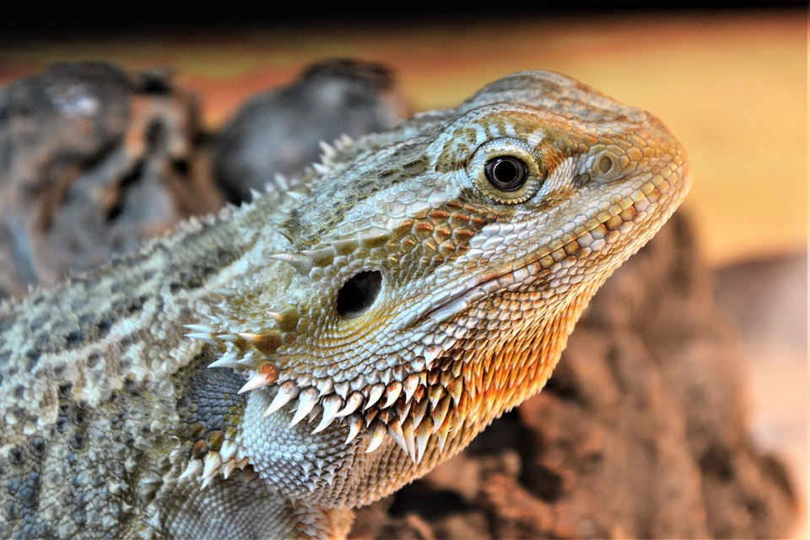

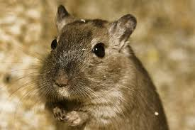
What career opportunities would match Denisha’s SAE? (Utilize AgExplorer.ffa.org.)

What Do I Need to Do?
Aligned to the following standards:
FFA.PL-A; FFA.PL-C; FFA.PL-E; FFA.PL-F; FFA.PG-I; FFA.CS-M; CCSS.SL.9-10.1; CCSS.SL.9-10.2; CRP.04; CRP.10

Directions:
Denisha has a task list she completes at her SAE workplace on a daily basis. Develop a task list for your own SAE program using the space below. (If you don’t have an SAE, choose one from the SAE Idea Cards [https://FFA.box.com/v/saeideacards] that aligns with your interests.)

Task List for ________________________ SAE

KEY: Get to Know the Pet Store
Aligned to the following standards:
FFA.PL-A; FFA.PL-C; FFA.PL-E; FFA.PL-F; FFA.PG-I; FFA.CS-M; CCSS.SL.9-10.1; CCSS.SL.9-10.2; CRP.04; CRP.10

Directions:
Answer the questions below as you watch the video “Denisha Washington – SAE – Pet Store.” The video is available at https://vimeo.com/315688197.
Pet Store
What is Denisha’s SAE?

She works at Pet’s Palace (a pet store in Louisville).

What are Denisha’s daily duties?

- Clean the cages
- Feed and water the animals

What was Denisha’s biggest challenge at the pet store?

Working with animals she was scared of (spiders)

How did she overcome this challenge?

Pushing past her fear and just getting comfortable with them
What types of animals does Denisha work with?

Reptiles
Rodents
Fish
Small animals

What career opportunities would match Denisha’s SAE? (Utilize AgExplorer.ffa.org.)

Answers will vary.

