Appendix 1: Well-Polished Machine
Aligned to the following standards:
FFA.PL-A; FFA.PL-F; FFA.PG-I; FFA.CS-N; FFA.CS-P; CS.05; AG5; CCSS.ELA.RI.9-10.2; CCSS.ELA.RI.9-10.3; CCSS.ELA.W.9-10.4; MP1; MP6; CRP.02; CRP.04; CRP.06; CRP.11

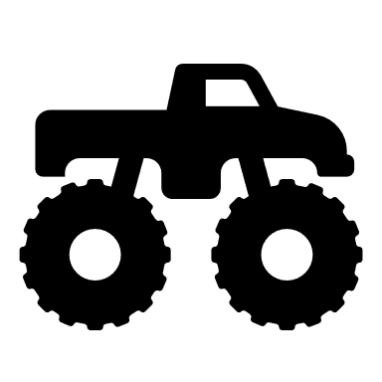
Part 1
What motivated Boys to begin his detailing business?
In the first year, how much did his detailing business earn?

- $5,000
- $10,000
- $15,000
- $20,000
Using AgExplorer.FFA.org, identify the career pathway Boys’ detailing SAE would fit into.

- Agribusiness Systems
- Agricultural Education
- Animal Systems
- Biotechnology Systems
- Environmental Service Systems
- Food Products and Processing Systems
- Natural Resources Systems
- Plant Systems
- Power, Structural and Technical Systems
What was so important both in starting Boys’ detailing business and for its success?

N___________________________________________g
Identify three careers in the identified pathway that Boys could easily pursue with what he learned through his car-detailing SAE.

- _______________________________
- _______________________________
- _______________________________
Directions:
Read the article “Well-Polished Machine” in the spring 2022 issue of FFA New Horizons and complete the
following activities.
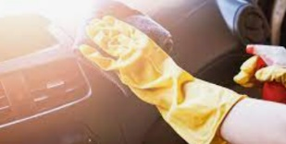
You have a GMC Acadia to detail, and it will take you four hours at $20/hour. You have $18 in materials. How much will it cost your customer? Use this space to calculate your answer.

$ _________________

Part 2
Directions:
Using the following resource, https://rallyways.com/2445/complete-professional-car-detailing-step-by-step-process/, develop a list of materials in the space below that you would need for a complete car detail. Tip: This list should be as if you are starting with nothing for the process.
Using the Tractor Supply Co. website, add a price to each item on your supply list.
Total: $ ________________

Part 3
Directions:
Based on what you have learned, you have decided to start your own detailing business. Use the space below to develop a poster that could be shared on social media, in the local newspaper and in the local community. If you would like to use an online poster maker, consider a program like Canva.com. Be sure to include the following:
- The name of your business.
- The location of your business.
- What types of vehicles you service.
- Pictures and color.
If you are interested in creating a digital poster, here are some options to consider:

- Canva.com (free but requires an account)
- Microsoft Publisher
- Microsoft PowerPoint
- Keynote
- Microsoft Word (https://www.goskills.com/Microsoft-Office/Articles/How-to-make-a-brochure-in-Microsoft-Word)

