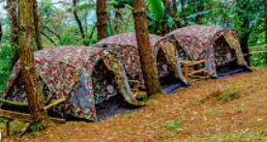
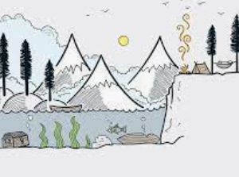
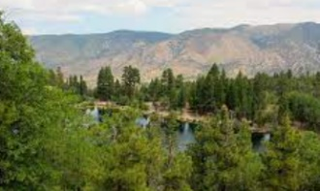
Appendix 2: A Summertime Staple
When you think of summer camp, what do you see in your mind? Draw a picture of your thoughts here.
According to the article, what are four outcomes of attending an FFA camp?

- ___________________________________
- ___________________________________
- ___________________________________
- ___________________________________
Which of the following is the oldest FFA camp?

- Camp Shadow Pines
- Camp Clements
- Oswegatchie FFA Camp
- Camp Couchdale
Which of the following caused the oldest FFA campgrounds to close until 1946?

- The Vietnam War
- World War I
- World War II
- The Civil War
How does the image you created above align with what you learned about FFA camps?
Describe the benefits, you as a student, could gain by attending a camp through an organization such as FFA.
Using different state FFA association websites, identify the FFA camp closest to you, FFA.org/state-ffa-associations/.

___________________________________________________________
Aligned to the following standards:
FFA.PL-A; FFA.PL-C; FFA.PG-I; FFA.CS-P; CS.05; AG5; CCSS.ELA.RI.9-10.2; CCSS.ELA.W.9-10.4; CCSS.ELA.W.9-10.5; CRP.02; CRP.04; CRP.06; CRP.07; CRP.08
Part 1
Directions:
Read the article “A Summertime Staple” in the spring 2022 issue of FFA New Horizons and
complete the activities.

Part 2
Directions:
Attending a camp can be a great way to grow as a person. Follow the steps below to develop your own camp itinerary for premier leadership, personal growth and career success.
- Select a camp you would like to attend and assign it a name that would make others want to attend.
Tip: This can be anything of interest to you that might host a camp for students in grades 7-12. Examples include FFA, field hockey, art, theater, etc.

Camp Title: ____________________________________________________________________

- Using the space provided, create a postcard that would serve as an advertisement for the camp.

Front

Back
- You are now going to design the itinerary for one day at the camp you selected/named in Step 1. The camp will run 8 a.m. to 9 p.m. You will block off the amount of time each activity will take and describe how that activity is meeting the needs of attendees. You will need to have activities (color coded) that get the mind moving in blue (Ex. Trivia game, career exploration activity), the body moving in purple (Ex. Sand volleyball, hiking, yoga) and the excitement moving in green (Ex. Team building activity, camp dance).
Time | Activity | How is this meeting the needs of attendees?
Example: 7 a.m. | Rise and Shine Yoga | Allowing attendees to wake up and focus for their day. Mental and physical health.
8 a.m.

9 a.m.

10 a.m.

11 a.m.

12 p.m. | Lunch | Lunch
1 p.m.

2 p.m.

3 p.m.

4 p.m.

5 p.m.

6 p.m. | Dinner | Dinner
7 p.m.

8 p.m.

9 p.m.

Part 3
Directions:
Thinking about the activities in Part 1 and Part 2, respond to the following questions.




Was planning the schedule easy or challenging? Why or why not?
What did you learn about yourself when completing these activities?
Using AgExplorer.FFA.org, identify three careers that would use the same types of skills that you used to design your postcard and the single-day plan.

- ____________________________________________________________________________________
- ____________________________________________________________________________________
- ____________________________________________________________________________________
Is there anything that surprised you about the careers that utilize similar skills?
In one sentence, describe the potential impact of extracurricular/intracurricular camps on those that attend.

