Appendix 5: Recapturing a Lost Culture
Aligned to the following standards:
FFA.PL-A., FFA.PL-C, FFA.PL-D, FFA.PL-E, FFA.PL-F, FFA.PG-H, FFA.PG-I., FFA.CS-N,
FFA.CS-O, CCSS.RI.9-10.4, CCSS.WHST.9.10.6, CCSS.WHST.9.10.2, CCSS.WHST.9.10.4, CCSS.WHST.9.10.6, CCSS.W.9-10.2, CCSS.W.9-10.4, CCSS.W.9-10.6, CCSS.W.9-10.8, CCSS.SL.9-10.2, CCSS.SL.9-10.4, AG1, CRP.02, CRP.04, CS.05

Part 1
Directions:
Read the article “Recapturing a Lost Culture” in the spring 2022 issue of FFA New Horizons and complete the activities below.
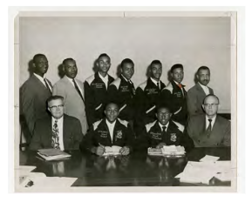
1. What did the letters “NFA” represent?
2. What year did the NFA and FFA merge?
A. 1969 B. 1970 C. 1965 D. 1964

3. At the time of the merger, both
organizations were independently
successful in honing _____________
skills and providing professional
___________ opportunities for young
_______ in agriculture.
4. After the NFA and FFA merger, the number of Black Americans in FFA and agricultural education has ______________ drastically.

5. More is known about the experiences of former NFA members because of recent research conducted by two professors. Who are the professors?

6. The roots of NFA can be traced back more than ________ years to whom? ___________________

7. Describe the background of the person NFA was traced back to, and explain what he established.

8. What four pieces of legislation, mentioned in the article, had an effect/impact on NFA? Identify them below and briefly describe them in the space provided.
a. Legislation: ___________________ Description: ___________________________________________________________________
_________________________________________________________________________________________________________________
b. Legislation: ___________________ Description: ___________________________________________________________________
_________________________________________________________________________________________________________________
c. Legislation: ___________________ Description: ___________________________________________________________________
_________________________________________________________________________________________________________________
d. Legislation: ___________________ Description: ___________________________________________________________________
_________________________________________________________________________________________________________________

Part 2
Directions:
Use the following link, https://special.ulib.iupui.edu/special/nfa, to complete a scavenger hunt through the New Farmers of America archives to learn more about the organization. Answer the following questions to complete the scavenger hunt.

1. At the time of the merger, the NFA consisted of how many chapters, how many states and how many members?
Chapters: ___________________
States: ______________________
Members: ___________________

2. Color in the state where the NFA started as a localized movement. In what year? _________________
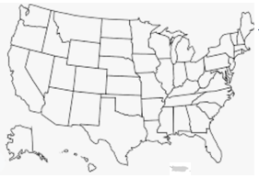

3a. Who were the two earliest proponents of an organization for African American farm youth?

3b. What contributions did they make to help start the organization?

4. As vocational agriculture became part of the curriculum, NFA chapters formed in local high schools. What areas did students receive training in?

5. What responsibilities did the vocational agriculture teacher have?

6. What were the four degrees of membership that were awarded?
_______________________________
_______________________________
_______________________________
_______________________________

7. What were other awards/contests that were available?

8. National officers for NFA originally consisted of:

9. How did former NFA members feel about the merger of the two organizations?

10. The NFA is commemorated by what award? ____________________

11. When was this award established, and what is its purpose?

Part 3
Directions:
Complete the Venn diagram below to learn about the similarities and differences of the National FFA Organization and the New Farmers of America. Identify 5 similarities and differences. Use these sites to help with your research: https://www.ffa.org/ffa-history/, https://ffa.box.com/s/nuvxzie0xx8cbadsihh9uonhzxitcwnq, https://ffa.box.com/s/653l5n7a0d816dmkh7kixc9yxgtly4xv, https://special.ulib.iupui.edu/special/nfa and https://exhibits.ulib.iupui.edu/sc001/exhibits/show/ffafashion/2.

New Farmers of America
National FFA Organization

Part 4
Directions:
Answer the following questions to reflect on the article and what you have learned.

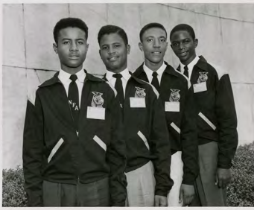
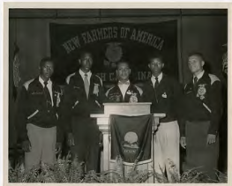
1. Did you know about the NFA prior to this article? Yes or No

If yes ...

What is something new that you learned that you didn’t know before?

Summarize in two sentences what you learned from reading the article and completing Parts 1 and 2?

If no ...

2. How can you take what you have learned and apply it in your life, your school, and your agriculture classroom and/or FFA chapter?

3. Create a hashtag that summarizes the article:

article.

