Appendix 6: Learning to Lead
Aligned to the following standards:
FFA.PL-A., FFA.PL-C, FFA.PL-D, FFA.PL-E, FFA.PL-F, FFA.PG-H, FFA.PG-I., FFA.CS-N,
FFA.CS-O, CCSS.RI.9-10.4, CCSS.WHST.9.10.6, CCSS.WHST.9.10.2, CCSS.WHST.9.10.4, CCSS.WHST.9.10.6, CCSS.W.9-10.2, CCSS.W.9-10.4, CCSS.W.9-10.6, CCSS.W.9-10.8, CCSS.SL.9-10.2, CCSS.SL.9-10.4, AG1, CRP.02, CRP.04, CS.05

Part 1
Directions:
Read the article “Learning to Lead” in the spring 2022 issue of FFA New Horizons and answer the questions below.
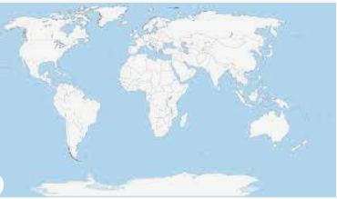
1. Bennett Perez found her footing in
______________ _________________ in an unexpected way.
2. From what school did she graduate? What state?
3. In which CDE did she place eighth as an individual?

What did she say about the CDE?
4. What was another CDE she competed in?
What did she say about the CDE?
5. What did Bennett do after high school?
6. What was her plan after college? Color in the country where she planned to live.
7. What does she credit to FFA?


Part 2
Directions:
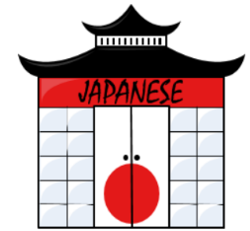
Thanks to the confidence she built in FFA, Bennett was able to chase her dream. Use this website, https://www.kids-world-travel-guide.com/japan-facts.html, to learn about Japan and answer the questions below.
1. Use the box below to draw the flag of Japan:

2. As of 2020, what is the population?
3. What is the capital?
4. What is the name of Japan in Japanese?
5. What is the currency in Japan?

6. What are the national symbols of Japan? Identify and draw each in the space below.
National Symbol: ________________________

National Bird: __________________________

National Flower: __________________________

National Fish: ____________________________
7. What does the Japanese diet mainly consist of?
8. What are two facts about Japan’s economy?
a.

b.

Part 3
Directions:

The 2020 Summer Olympics, postponed until 2021, took place in Japan. Read this article, https://news.uga.edu/grass-in-the-olympic-stadium-uga-developed/, to learn how the University of Georgia’s Tifton Campus and agriculture are connected to the Olympics. Answer the questions below.
- What grass variety was used?
2. Describe the variety.
3. What stadium at the Olympics will use this variety?
4. Describe the development of this variety of grass:
5. Describe how this variety is considered a sport-friendly grass:
Why do you think it is important to know about varieties of turfgrass?

How can you apply this knowledge in your future?

