Educational Institutions
Directions: Visit a minimum of three educational institutions, and complete the questions below (there is one sheet for each educational institution).
School Name:

Location:
What agricultural majors do they offer?

Develop two questions to ask the school representative that will help you learn about the school.
1.

2.
Draw a picture of the school’s mascot.
After visiting this school, are you interested in attending? Why or why not?

What is one interesting fact you learned about the school?
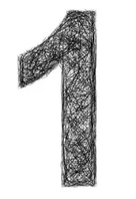

Shade in the state where this school is located.

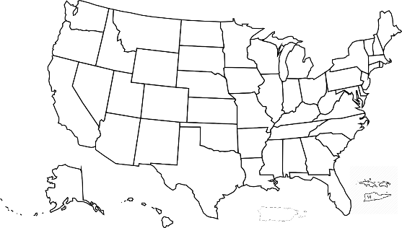

School Name:

Location:
What agricultural majors do they offer?

Develop two questions to ask the school representative that will help you learn about the school.
1.

2.
Draw a picture of the school’s mascot.
After visiting this school, are you interested in attending? Why or why not?

What is one interesting fact you learned about the school?

Shade in the state where this school is located.

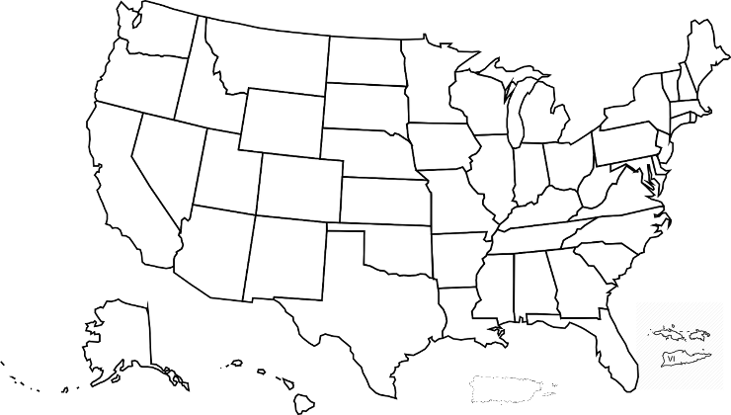

School Name:

Location:
What agricultural majors do they offer?

Develop two questions to ask the school representative that will help you learn about the school.
1.

2.
Draw a picture of the school’s mascot.
After visiting this school, are you interested in attending? Why or why not?

What is one interesting fact you learned about the school?

Shade in the state where this school is located.

