Welcome Home
Created: 01/2025 by the National FFA Organization
Description of Lesson: A place is only as good as the people in it. In her retiring address, 2023-24 National FFA Western Region Vice President Emily Gossett shares her experience with the power of an invitation.
Student Learning Objectives:
After completing these activities, students will …
- Reflect on the importance of community and how it shapes a sense of belonging.
- Identify ways they can contribute to making others feel welcome and included.

Suggested Grade Level:
Grades 9 and 10 (This lesson is written so instructors can scale up and down based on class needs.)

Suggested Time: 60 minutes (*Time requirements may vary based upon student understanding and class schedule.)

Resources/References:
- Video: “Welcome Home” | Emily Gossett 2024 Retiring Address, https://vimeo.com/1023621234

Related Resources:
- Retiring Addresses and Keynote Speeches, FFA.org/ffa-video-center/convention-keynotes-and-retiring-addresses/
- Keynote-Retiring Address Lessons, https://FFA.box.com/v/retiringaddresslessons
- FFA Values Lesson Series, https://FFA.box.com/s/u9qnfyvape9sy3d3xc85hlgxdxghq3dg

Equipment and Supplies Needed:
- A copy of the “Welcome Home” worksheet for each student
- Internet access to play the video in real-time or embed it in a PowerPoint ahead of time

Vocabulary:
- Belonging
- Community

Cross-Curricular Connections:
English/Language Arts
Read scenarios and make recommendations for each.

SAE and FFA Connections:
- Agricultural Communications and Education SAE Idea Cards, https://FFA.box.com/s/x7e4v2qzxcwkleuqkun3mt0421m5nejx
- Extemporaneous Public Speaking LDE, FFA.org/participate/ldes/extemporaneous-public-speaking/
- Prepared Public Speaking LDE, FFA.org/participate/prepared-public-speaking/
Student Activity Sheets:
Direct access to student activity sheets without lesson plan or answer key for easy upload to a learning management system or printing for classwork.

https://ffa.box.com/s/zofai0mpuzirm8idr88vn6r25b8430k5 (Word)
https://ffa.box.com/s/0xbxy7m2rfg6ebgjcyan8ug3kyv5r5m4 (PDF)
https://docs.google.com/document/d/176qNMYAVFfjYf9HBylp8byWELuWBBt4VpPZumFg2X1I/copy (Google)

These Activities Are Aligned to the Following Standards:
FFA Precept
- FFA.PL-A.Action: Assume responsibility and take the necessary steps to achieve the desired results, no matter what the goal or task at hand.
- FFA.PL-D.Character: Conduct oneself appropriately in relation to others regardless of the situation.
- FFA.PL-F.Continuous Improvement: Accept responsibility for learning and personal growth.
- FFA.PG-K.Emotional Growth: Share and express healthy feelings and emotions.
AFNR Career Ready Practices
- CRP.01. Act as a responsible and contributing citizen and employee. Career-ready individuals understand the obligations and responsibilities of being a member of a community, and they demonstrate this understanding every day through their interactions with others.
- CRP.04. Communicate clearly, effectively, and with reason. Career-ready individuals communicate thoughts, ideas and action plans with clarity, whether using written, verbal and/or visual methods.
- CRP.06. Demonstrate creativity and innovation. Career-ready individuals regularly think of ideas that solve problems in new and different ways, and they contribute those ideas in a useful and productive manner to improve their organization.
- CRP.09. Model integrity, ethical leadership and effective management. Career-ready individuals readily recognize problems in the workplace, understand the nature of the problem, and devise effective plans to solve the problem.
Partnership for 21st Century Skills
- Communication
- Initiative and Self-direction
- Productivity and Accountability
- Social and Cross-Cultural Skills
- Think Creativity

Lesson Plan:
- Bell Ringer: What does the word “home” mean to you? Draw a picture that represents what it means to you.

- Introduction: Give a copy of the “Welcome Home” worksheet to each student. Today, we are going to watch a retiring address from the 97th National FFA Convention & Expo. This retiring address was given by 2023-24 National FFA Western Region Vice President Emily Gossett. In her speech, we will learn the importance of community. As we are watching the video, look over the questions on the worksheet “Welcome Home” and be ready for the answers.

- Activity: Each student needs a copy of the worksheet “Welcome Home.”
  - Part 1: Have students watch the retiring address of the 2023-24 National FFA Western Region Vice President Emily Gossett. The video is available at https://vimeo.com/1023621234. While students watch the video, have them complete the questions.
  - Part 2: Have students read through five scenarios and share two techniques they could use to make that person feel “at home.”

- Follow-up: Pair students together and have them share their techniques on how they can make others feel welcome.

- Optional – Extended Learning Opportunities (Not factored into time requirement):
  - This should take 15 minutes. Create a class collage where students can contribute drawings, photos or words that represent what makes their “home” or community special.

- Exit Ticket: What is one small action you can take this week to make someone feel at home in your school or community?

Welcome Home
Aligned to the following standards:
FFA.PL-A; FFA.PL-D; FFA.PL-F; FFA.PG-K; CRP.01; CRP.04; CRP.06; CRP.09.
Part 1
Directions:
Answer the following questions while watching the retiring address of 2023-24 Western Region Vice President Emily Gossett, “Welcome Home.” The video is available at https://vimeo.com/1023621234.

- How did the words “we are moving” impact Emily?

- What does the number 1,773 represent?

- Emily was invited to sit next to someone in class. How did that change her mindset?

- Why is acceptance important?

- Fill in the blank:
Acceptance partnered with community builds a _____________.

- Why was it okay to pack up all the memories from Emily’s childhood?

- Why is it important to show up?

- Fill in the blank:
A __________ is only as good as the _____________ in it.
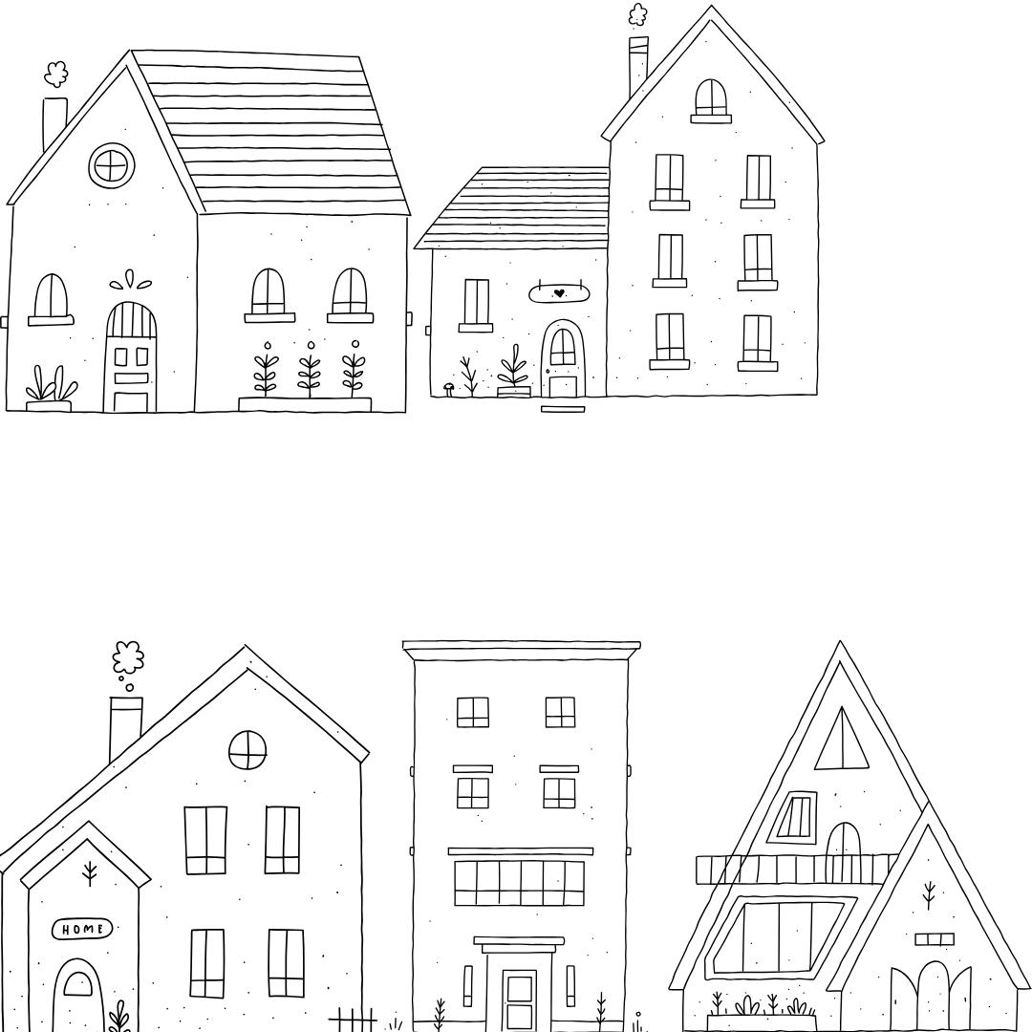


- What is the difference between a house and a home?

- Fill in the blank:
_______ will take you far, but ______ will lead you home.

Part 2
Directions:
In Emily Gossett’s retiring address, she shares the importance of making people feel “at home" when they are around you. In this activity, you will go through five scenarios and share two techniques you could use to make that person feel comfortable.

Scenarios | Techniques
Example:  Hugo is a new student who has joined your plant science class. | Example:  - Introduce myself and ask him to sit with me during lunch or group work.  - Share tips about the school and offer to walk him to his next class.
Your classmate Olivia sits alone at lunch every day.
Your teammate Demari is struggling during soccer practice and seems frustrated or withdrawn.
Jacob is a new student who has recently moved to your town and isn’t familiar with the community.
Your friend Jody is going through a tough time and seems distant.
Charlie is attending their first FFA meeting and looks unsure of what to do.

- What are some common themes you noticed in your techniques?

- How does inviting someone create a sense of belonging?

- Reflect on a time that you did not feel “at home.” What would have made you feel more comfortable?

KEY: Welcome Home
Part 1
Directions:
Answer the following questions while watching the retiring address of 2023-24 Western Region Vice President Emily Gossett, “Welcome Home.” The video is available at https://vimeo.com/1023621234.

- How did the words “we are moving” impact Emily?
She was upset.

- What does the number 1,773 represent?
The number of miles between Emily and her family.

- Emily was invited to sit next to someone in class. How did that change her mindset?
From anxious and negative to happy and appreciative

- Why is acceptance important?
We start to let it change our view and how we live.

- Fill in the blank:
Acceptance partnered with community builds a home.

- Why was it okay to pack up all the memories from Emily's childhood?
Because they still have so many more to make

- Why is it important to show up?
Answers will vary.

- Fill in the blank:
A place is only as good as the people in it.

- What is the difference between a house and a home?
A house is four walls and a door; a home is the people.

- Fill in the blank:
Life will take you far, but love will lead you home.

Part 2
Directions:
In Emily Gossett’s retiring address, she shares the importance of making people feel at “home” when they are around you. In this activity, you will go through five scenarios and share two techniques you could use to make that person feel comfortable.

Scenarios | Techniques
Example:  Hugo is a new student who has joined your plant science class. | Example:  - Introduce myself and ask him to sit with me during lunch or group work.  - Share tips about the school and offer to walk him to his next class.
Your classmate Olivia sits alone at lunch every day. | Answers will vary.
Your teammate Demari is struggling during soccer practice and seems frustrated or withdrawn. | Answers will vary.
Jacob is a new student who has recently moved to your town and isn’t familiar with the community. | Answers will vary.
Your friend Jody is going through a tough time and seems distant. | Answers will vary.
Charlie is attending their first FFA meeting and looks unsure of what to do. | Answers will vary.

- What are some common themes you noticed in your techniques?
Answers will vary.

- How does inviting someone create a sense of belonging?
Answers will vary.

- Reflect on a time that you did not feel “at home.” What would have made you feel more comfortable?
Answers will vary.

