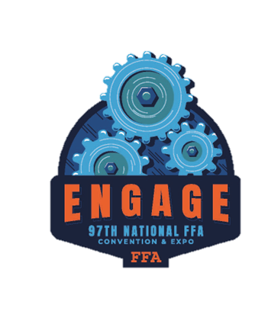
EngagE
Directions: Engage Your Journey at the 97th National FFA Convention & Expo. Complete the following activity after watching a National FFA Officer’s retiring address or a keynote speaker’s comments from the National FFA Convention & Expo.
- What is the speaker’s name?

- Explain how this retiring address/keynote is connected to the FFA values statements, mission, vision, or code of ethics.

- How do retiring addresses/keynote speakers inspire and motivate FFA members?

- What was the overall message or lesson and how can you apply this to your own life and FFA involvement?

- Reflect on your own experience while listening to or watching this speech. What resonated with you the most, and why?

- What visual elements accompany this speech, such as stage setup, lighting, or images?

  - How do these elements enhance the message?

- What did you learn about the speaker?

  - Why did this stand out?

- Create a list of three vocabulary words from this speech and define them.

- Create an image that summarizes the speech and then explain your drawing in three sentences

After watching a national FFA officer’s retiring address or a keynote speaker’s comments from the National FFA Convention & Expo, you will plan your own. Imagine yourself delivering a retiring address or keynote speech at a future National FFA Convention. What message would you convey, and why? Use the mind map below to brainstorm your ideas, and then create a rough draft.
Title:
- Topic or theme of your speech
Introduction:
- Get the audience’s Attention (hook)
- Brief introduction of the topic
- Share a brief story or example that directly relates to the theme/topic
- Your “why”
Body points (3):
- Main points of your message
- Use transitional phrases or words such as again, and then, finally, next, lastly, what's more, in addition, first (second, etc.)
- Use stories, personal experiences, or humor to add interest and reinforce each point
- Use descriptive words (adjectives) help the audience visualize what you say and keep them interested
Conclusion:
- Summarize what you said
- Why should the audience care?
- Call to action
For the mind map, you will begin with the main concept or topic, this will serve as the main bubble. From there, create subtopics that will branch off the main idea. These tend to be your three body points. Once your subtopics are complete, start including support points. This will be the details of your body points. See the example below:
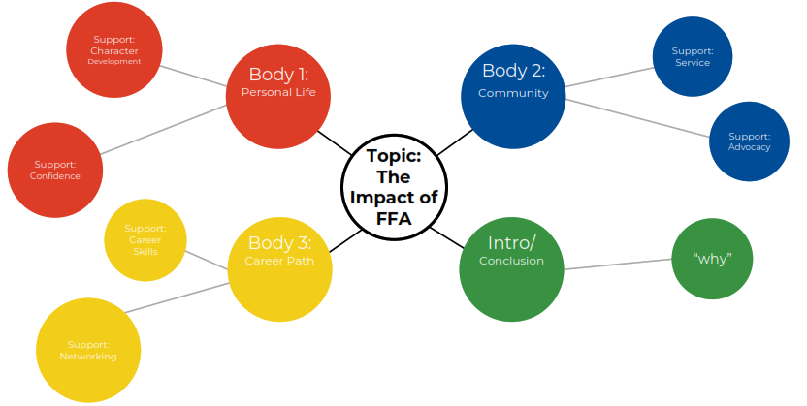
Use the space on the next page to create your own mind map! You can use the temple provided or create your own.

Support:

Support:

Support:

Body 1:
Title:
Body 2:

Support:

Support:

Support:

Conclusion

Support:

Support:

Support:

Support:

Support:

Support:

Introduction

Support:

Support:

Support:

Body 3:

Keynote/ Retiring Address Outline Draft
Directions: After completing your mind map brainstorming, use the space below to expand on your retiring address or keynote speech to create a rough draft of your outline.

Speech topic: ______________________________________________________________

Introduction:

Body Point 1 (briefly explain):

Body Point 2 (briefly explain):

Body Point 3 (briefly explain):

Conclusion:

Rubric: Draft and Speech
Qualification | Very strong evidence of skill is present.  (5–4 points) | Moderate evidence of skill is present.  (3–2 points) | Weak evidence of skill is present.  (1–0 poi5nts) | Total Points  (30 possible)
Engaging Title and Description (Description Refers to Title) | Title and description are engaging and attention grabbing; description refers to title. | Title and description are mediocre; description somewhat refers to title. | Title and description are very weak; description does not refer to title.
Sections completed | The introduction, body points 1-3, and conclusion are detailed. | The introduction, body points 1-3, and conclusion are somewhat detailed. | The introduction, body points 1-3, and conclusion are lacking information.
Presentation Skills | Thorough and maintains eye contact | Somewhat professional; depends on the presentation | No evidence of preparation
Grammar/Punctuation/  Spelling | Spelling, grammar and punctuation are extremely high quality with two or less errors in the document. | Spelling, grammar and punctuation are adequate with three to five errors in the document. | Spelling, grammar and punctuation are less than adequate with six or more errors in the document.
Time | Ten minutes | Between five and ten minutes | Under five minutes
Overall Impression | Presentation was consistent and appropriately highlighted a topic of the presenters’ choosing that they feel passionate about. | Presentation was consistent and generally highlighted a topic of the presenters’ choosing that they feel passionate about. | The presentation was not consistent and did not highlight a topic of the presenters’ choosing that they feel passionate about.
 |  |  | Total | /30 points

