Agricultural Technology and Mechanical Career Development Event
IMPORTANT: Before you begin this activity, you must have two pages open:
- This sheet containing the questions to be answered.
- The online e-Scansheet Universal Form E, where you will bubble your answers.

Environment Systems

An information sheet to complete this activity is located at the end of this document.
If you prefer to toggle between the questions sheet and the information sheet, rather than page up and down, you can open “Environment Skill Information Sheet” in a separate tab or on a separate device and toggle between the questions and information.

Situation: In this activity you are to determine the slope from Point A to Point B. The instrument is set up and levelled. You are given the views of the rod as seen through the instrument.
Given:
- The instrument has been correctly leveled.
- Figure 1 and Figure 2 represent the views through the instrument as you look at Point A and Point B.
- The line from the instrument to Point A is perpendicular to the line from the instrument to Point B.
Directions: Answer the following questions. The questions will lead you to the final question which will give you the slope of the land from Point A to Point B. Refer to the information sheet titled “Environmental and Natural Resources Skill: Information Sheet” found at the bottom of this document for illustrations of the instrument readings.
Bubble the answers to each question on the e-Scansheet Universal Form E in Exam A, questions 1 through 12. The points per question are indicated at the end of each question.
- What is the top stadia hair reading at Point A? (2 points)
  - 4.30 feet
  - 4.95 feet
  - 4 feet – 9½ inches
  - 4 feet, 9 and 3/8 inches

- What is the bottom stadia hair reading at Point A? (2 points)
  - 4 feet – 2½ inches
  - 4 feet – 2 and 3/8 inches
  - 4.24 feet
  - 4.22 feet
- What is the crosshair reading at Point A? (2 points)
  - 4 feet – 5 and 7/8 inches
  - 4 feet – 6 inches
  - 4.60 feet
  - 4.59 feet

- What is the top stadia hair reading a Point B? (2 points)
  - 2.00 feet
  - 2 feet - 2 inches
  - 2.20 feet
  - 2.21 feet

- What is the bottom stadia hair reading at Point B? (2 points)
  - 1.78 feet
  - 1 foot – ¾ inches
  - 1.80 feet
  - 1 foot – 7½ inches

- What is the crosshair reading at Point B? (2 points)
  - 2.00 feet
  - 2 feet – no inches
  - 1 foot – 7/8 inches
  - 1.99 feet

- What is the distance from the instrument to Point A? (3 points)
  - 49.5 feet
  - 42.2 feet
  - 71.0 feet
  - 91.7 feet

- What is the distance from the instrument to Point B? (3 points)
  - 22.0 feet
  - 42.0 feet
  - 199 feet
  - 398 feet

- Calculate the distance from Point A to Point B. (4 points)
  - 54.2 feet
  - 82.5 feet
  - 91.5 feet
  - 306.3 feet

- What is the vertical change in elevation between Point A and Point B? (3 points)
  - 1.13 feet
  - 2.46 feet
  - 2.60 feet
  - 2.75 feet

- Calculate the slope between Point A and Point B. (4 points)
  - 1.37 %
  - 3.15 %
  - 3.59 %
  - 13.7 %

- Contours are generally recommended on slopes between 2 percent and 10 percent. Would you recommend contours on this land? (1 point)
  - Yes, contours are to be recommended
  - No, contours are not necessary
  - More information is needed before recommending contours

Before you leave this skill activity, be sure you have bubbled in the answers to these questions on the online e-Scansheet Universal Form E in Exam A, questions 1 through 12. Do not submit your scan sheet yet. You will be completing four more activities before you need to submit the scan sheet.

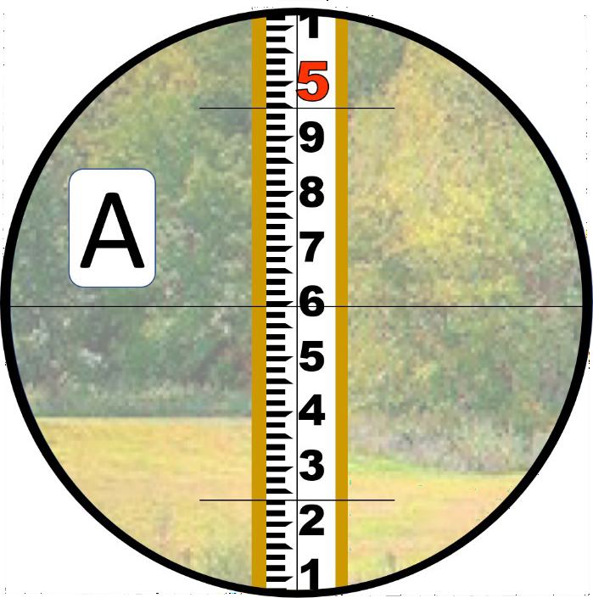
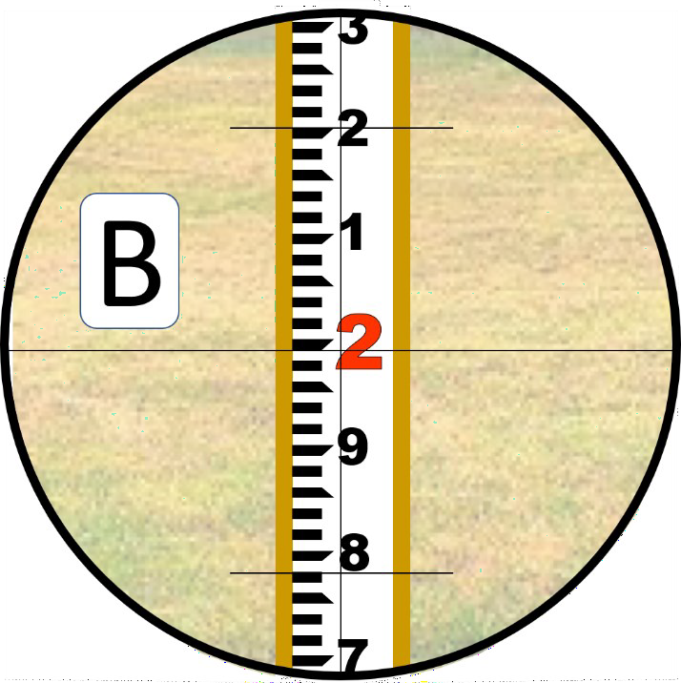
Environmental and Natural Resources: Skill Information Sheet

Figure 1. Instrument view to Point Figure 2. Instrument view to Point
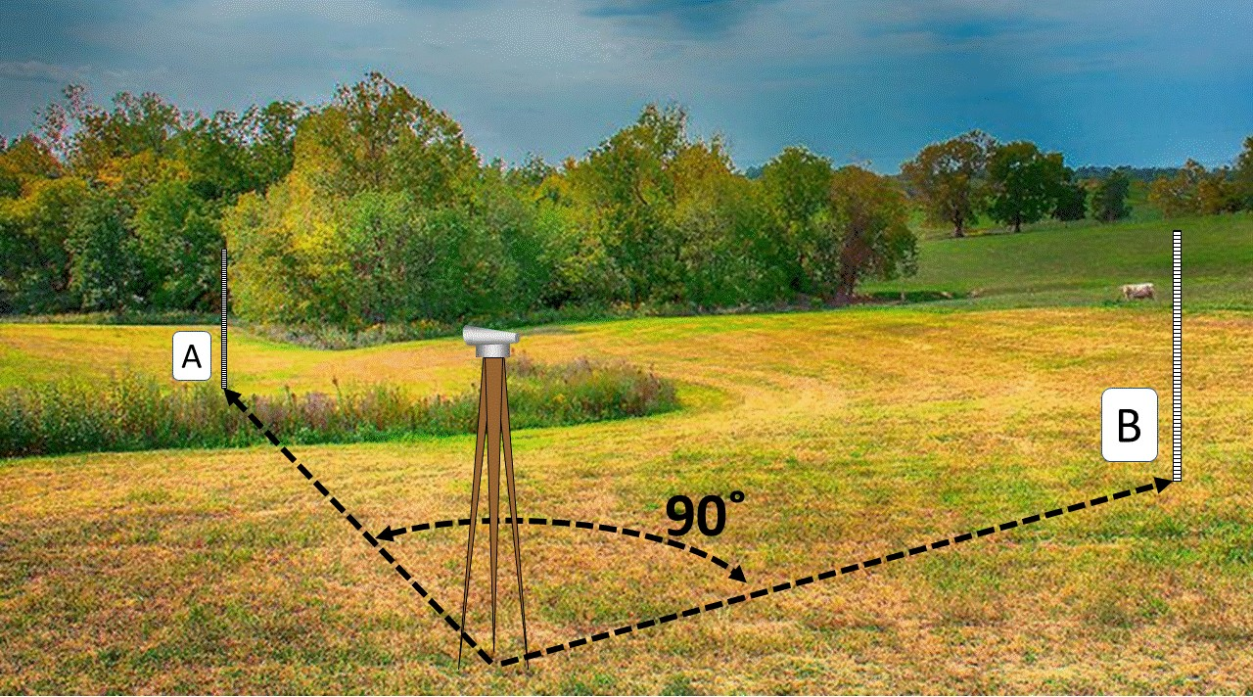

Figure 3. Overall field

