Equine Dentistry: Looking a Horse in the Mouth
Created: 06/2015 by the National FFA Organization

Student Learning Objectives
After completing these activities students will…
- Identify tools used in equine dentistry.
- Summarize the process of oral surgery in equine.
- Examine the skills needed to be a veterinarian.
Time Required: 15 minutes
Resources: FFA.org
Equipment and Supplies Needed:
- A copy of the “Looking a Horse in the Mouth” worksheet for each student.
- Internet access to play the video in real time or embed it in a PowerPoint ahead of time.

This quick lesson plan would work well as:
- Directly before or after a unit on equine health care or equine teeth anatomy.
- As a portion of a career unit.
- As a standalone agriculture careers spotlight.
These activities are aligned to the following standards:

AFNR Performance Element
- AS.03. Provide for the proper health care of animals.
- CS.03. Performance Element: Career Success: Demonstrate those qualities, attributes and skills necessary to succeed in, or further prepare for, a chosen career while effectively contributing to society.
Common Career Technical Core
- AG5 Describe career opportunities and means to achieve those opportunities in each of the Agriculture, Food & Natural Resources Career Pathways.
NASDCTEc
- AGC09.02 Select, research and examine critical aspects of career opportunities in one or more AFNR career pathways in order to gain an understanding of the breadth of occupations within this cluster.
Common Core- Speaking and Listening
- CCSS.ELA-Literacy.SL.9-10.1 Initiate and participate effectively in a range of collaborative discussions (one-on-one, in groups, and teacher-led) with diverse partners on grades 9-10 topics, texts, and issues, building on others' ideas and expressing their own clearly and persuasively.
- CCSS.ELA-Literacy.SL.9-10.1.D Respond thoughtfully to diverse perspectives, summarize points of agreement and disagreement, and, when warranted, qualify or justify their own views and understanding and make new connections in light of the evidence and reasoning presented.
Partnership for 21st Century Skills
- Communication
- Critical Thinking and Problem Solving
- Health Literacy
Lesson Plan:
- Interest Approach: Ask students to share the various ways humans care for their teeth, and then ask students if caring for an animal’s teeth is important. Push students to expand on this idea by thinking of ways to take care of an animal’s teeth. After they have developed a short list, explain the typical ways of caring for a horse’s teeth.
  - Tip: Use the Think-Pair-Share strategy for these questions.
- Activity: Show the video Vets on Call: Horse Dentist Removes Fractured Tooth. The direct url is: http://youtu.be/r5YT0lsChhU
  - Each student needs a copy of the handout “Looking a Horse in the Mouth.” They should complete this while watching the video.
- Follow-up: Have students share the skills they identified as important for a veterinarian to possess. Discuss how many important skills go beyond technical knowledge like the ability to communicate with clients effectively by explaining complex issues and calming the fears of clients. Discuss ways someone interested in vet medicine could practice and develop these skills.

Looking a Horse in the Mouth
Directions:
Complete this worksheet using information provided in the video Vets on Call: Horse Dentist Removes Fractured Tooth. The direct url is: http://youtu.be/r5YT0lsChhU

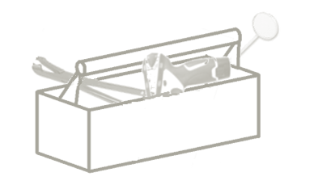
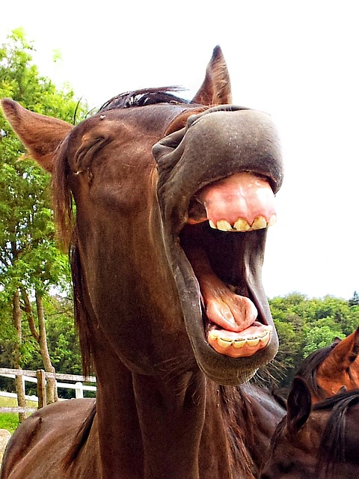
1. ____________________
2. ____________________
3. ____________________
4. ____________________

Name four tools used in equine dental care.

- What two steps are taken to prepare a horse for oral surgery?
Step 2:
Tooth Extraction
Step 1:

What is wrong with the horse’s tooth? | What does the vet have to do to get the tooth out? Why is this method necessary? | Why does the veterinarian use a diamond disc float with water irrigation?

Based on this video, what skills do you think a veterinarian should possess to be successful?
Skills can include technical skills, interpersonal skills, etc.
Aligned to the following standards:
AS.03; CS.03; AGC09.02; CCSS.ELA-Literacy.SL.9-10.1; CCSS.ELA-Literacy.SL.9-10.1.D; AG5

Looking a Horse in the Mouth
Directions:
Complete this worksheet using information provided in the video Vets on Call: Horse Dentist Removes Fractured Tooth. The direct url is: http://youtu.be/r5YT0lsChhU
Possible answers: mirror, molar extractor, x-ray machine, drill, diamond disc, mouth speculum (might say separator), and head lamp/light

Name four tools used in equine dental care.

- What two steps are taken to prepare a horse for oral surgery?
Step 2: Clean mouth
Tooth Extraction
Step 1: Nerve block

What is wrong with the horse’s tooth? | What does the vet have to do to get the tooth out? Why is this method necessary? | Why does the veterinarian use a diamond disc float with water irrigation?
Cracked tooth with abscess. | He has to cut the tooth into pieces to get it out. The other teeth have tightened around the loose tooth making it difficult to extract it in one piece. | It is strong enough to grind the body’s hardest tissue (enamel) without cutting the soft tissue in the mouth.

Based on this video, what skills do you think a veterinarian should possess to be successful?
Skills can include technical skills, interpersonal skills, etc.
Answers will vary. Will probably include: knowledge of horse anatomy/teeth; ability to understand x-rays; explain issue to animal owners in terms they understand; calm fears of animal owners; diagnose animals; know what technique to use to solve the problem

Aligned to the following standards:
AS.03; CS.03; AGC09.02; CCSS.ELA-Literacy.SL.9-10.1; CCSS.ELA-Literacy.SL.9-10.1.D; AG5

