A Bin of Worms
Aligned to the following standards:
ESS.03; FFA.PL-A; FFA.PG-J; FFA.CS-M; FFA.CS-N; AG-ENV3; AGPF01.03;CS.01; CCSS.RI.9-10.8; CCSS.SL.9-10.1.C; CCSS.RST.9-10.1; CCSS.RST.9-10.2; CCSS.RST.9-10.5; CCSS.RST.9-10.10; CCSS.WHST.9.10.2; ; CCSS.WHST.9.10.4; CCSS.WHST.9.10.7; ; CCSS.WHST.9.10.8; ; CCSS.WHST.9.10.9; CCSS.MP7; HS-ETS1-2; CRP.02; CRP.04; CRP.05; CRP.07; CRP.08; CRP.11
Directions:
Answer the following questions as you watch the video “Vermicomposting SAE | Ethan Shelden,” available at https://vimeo.com/328434623.

What is vermicomposting?

What is Ethan’s SAE?

What test does he have to do to maintain the ideal worm environment?


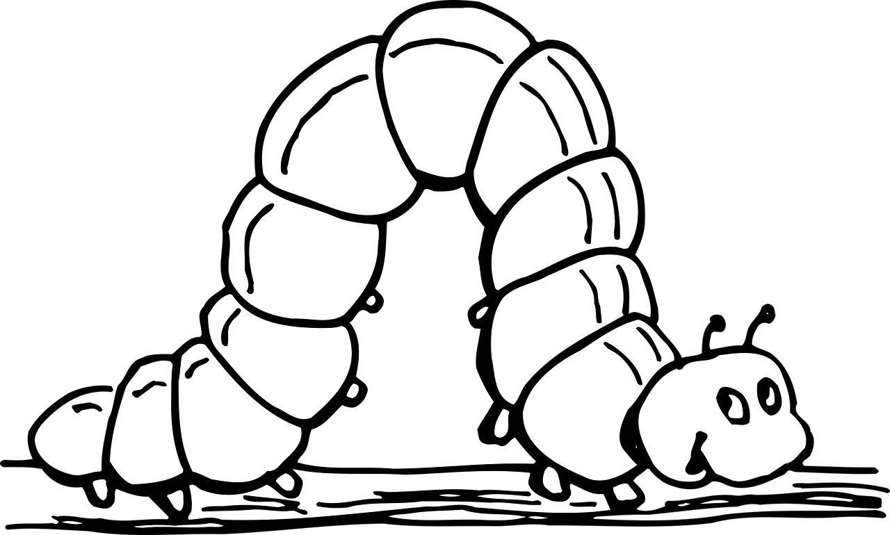
What has his SAE taught him about work ethic? How did his work ethic improve?

What types of worms does Ethan use?

How do worms help the environment?

What steps did Ethan take to start his SAE?


Why did he choose to save money for certain items while spending more on other items?



From Scraps to Black Gold
Aligned to the following standards:
ESS.03; FFA.PL-A; FFA.PG-J; FFA.CS-M; FFA.CS-N; AG-ENV3; AGPF01.03;CS.01; CCSS.RI.9-10.8; CCSS.SL.9-10.1.C; CCSS.RST.9-10.1; CCSS.RST.9-10.2; CCSS.RST.9-10.5; CCSS.RST.9-10.10; CCSS.WHST.9.10.2; ; CCSS.WHST.9.10.4; CCSS.WHST.9.10.7; ; CCSS.WHST.9.10.8; ; CCSS.WHST.9.10.9; CCSS.MP7; HS-ETS1-2; CRP.02; CRP.04; CRP.05; CRP.07; CRP.08; CRP.11
Part 1
Directions:
Complete the activities below to learn how worms eat and make compost.
Suggested resource: https://unclejimswormfarm.com/red-worms-eat-compost/

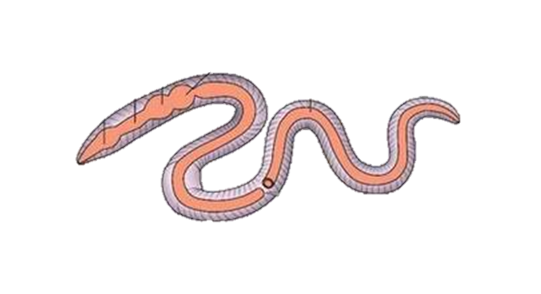
- Label the diagram of a worm digestive tract and explain what each part does.
Label: _______________________
Explanation:
Label: _______________________
Explanation:
Label: _________________
Explanation:
Label: _______________________
Explanation:
Label: _______________________
Explanation:
Label: _______________________
Explanation:
Label: _______________________
Explanation:
What are worm castings?

- List four things worms love to eat and three things that should not be fed to them.





- What is “black gold”? Why is it called that?

- What are pre-digesters?
  - Microbes in the worm’s mouth that take the place of teeth
  - Bacteria, mold and fungi that break down the organic matter
  - Bad bacteria that compete with worms for food
  - None of the above

Part 2
Directions:
Did you know you can do vermicomposting virtually anywhere, even in a small urban apartment? Fill in the buckets below with each step for creating your own worm composting farm. If you work at it, you could even sell your “black gold”!
Suggested resource: https://www.thespruce.com/inexpensive-worm-bin-from-plastic-buckets-2540077

- What materials do you need to start a vermicomposting bin?

- Explain why the bin is constructed with three buckets. (Be sure to explain the function of each bucket.)

- On each bucket, describe what you need to do in each step to create your vermicomposting bin.

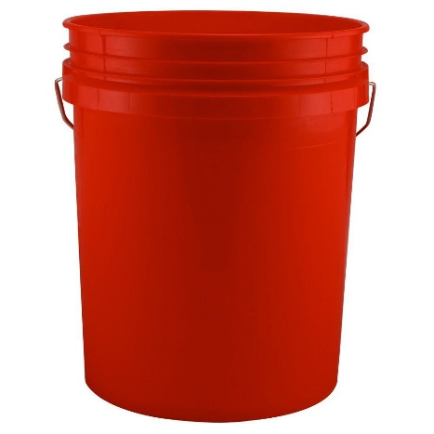
Step 1

Step 2

Step 3

Step 4

Step 5

Step 6

Step 7

Step 8

Aligned to the following standards:
ESS.03; FFA.PL-A; FFA.PG-J; FFA.CS-M; FFA.CS-N; AG-ENV3; AGPF01.03;CS.01; CCSS.RI.9-10.8; CCSS.SL.9-10.1.C; CCSS.RST.9-10.1; CCSS.RST.9-10.2; CCSS.RST.9-10.5; CCSS.RST.9-10.10; CCSS.WHST.9.10.2; ; CCSS.WHST.9.10.4; CCSS.WHST.9.10.7; ; CCSS.WHST.9.10.8; ; CCSS.WHST.9.10.9; CCSS.MP7; HS-ETS1-2; CRP.02; CRP.04; CRP.05; CRP.07; CRP.08; CRP.11

