Vermicomposting
Created: 03/2019 by the National FFA Organization

Ethan’s supervised agricultural experience (SAE) program is vermicomposting, which is composting with worms. Discover the steps he took to start his SAE and what he has learned about using worms effectively to improve the soil.

Student Learning Objectives:
After completing these activities, students will …
- Label the worm digestive tract.
- Explain the function of each part of the worm digestive tract.
- Discover how to create their own vermicomposting system.

Time Required: 90 minutes
Resources/References:
- Video: “Vermicomposting SAE | Ethan Shelden,” https://vimeo.com/328434623
- Website: “How Do Red Worms Eat and Make Compost?” https://unclejimswormfarm.com/red-worms-eat-compost/
- Website: “Make a Worm-Composting Bin From Plastic Buckets,” https://www.thespruce.com/inexpensive-worm-bin-from-plastic-buckets-2540077

Equipment and Supplies Needed:
- A copy of the “A Bin of Worms” worksheet for each student
- A copy of the “From Scraps to Black Gold” worksheet for each student
- Internet access to play the video in real time or embed it in a PowerPoint ahead of time
- Technology access for students to do additional research into worms and vermicomposting

Student activity sheets:
Direct access to student activity sheets without lesson plan or answer key for easy upload to learning management systems or printing for classwork.
https://ffa.box.com/s/8r76tok9o0kzmutkdekt4od3uduekh21 (Word)
https://ffa.box.com/s/3zw19fx9al495ns9uktuqx7y3hu424ou (PDF)

Cross-Curricular Connections:
Science
Identify and explain the parts and functions of the worm digestive tract

These activities are aligned to the following standards:

AFNR Performance Element
- ESS.03. Develop proposed solutions to environmental issues, problems and applications using scientific principles of meteorology, soil science, hydrology, microbiology, chemistry and ecology.
FFA Precept
- FFA.PL-A.Action: Assume responsibility and take the necessary steps to achieve the desired results, no matter what the goal or task at hand.
- FFA.PG-J.Mental Growth: Embrace cognitive and intellectual development relative to reasoning, thinking and coping.
- FFA.CS-M.Communication: Effectively interact with others in personal and professional settings.
- FFA.CS-N.Decision Making: Analyze a situation and execute an appropriate course of action.
Common Career Technical Core
- AG-ENV3 Develop proposed solutions to environmental issues, problems and applications using scientific principles of meteorology, soil science, hydrology, microbiology, chemistry and ecology.
NASDCTEc
- AGPF01.03 Apply scientific principles to the study of environmental service systems in order to facilitate development of solutions to environmental issues, problems and applications.
AFNR Cluster Skills
- CS.01. Analyze how issues, trends, technologies and public policies impact systems in the Agriculture, Food & Natural Resources Career Cluster.

Common Core – Reading: Informational Text
- CCSS.ELA-Literacy.RI.9-10.8 Delineate and evaluate the argument and specific claims in a text, assessing whether the reasoning is valid and the evidence is relevant and sufficient; identify false statements and fallacious reasoning.
Common Core – Speaking and Listening
- CCSS.ELA-Literacy.SL.9-10.1.C Propel conversations by posing and responding to questions that relate the current discussion to broader themes or larger ideas; actively incorporate others into the discussion; and clarify, verify, or challenge ideas and conclusions.
Common Core – Science & Technical Subjects
- CCSS.ELA-Literacy.RST.9-10.1 Cite specific textual evidence to support analysis of science and technical texts, attending to the precise details of explanations or descriptions.
- CCSS.ELA-Literacy.RST.9-10.2 Determine the central ideas or conclusions of a text; trace the text's explanation or depiction of a complex process, phenomenon, or concept; provide an accurate summary of the text.
- CCSS.ELA-Literacy.RST.9-10.5 Analyze the structure of the relationships among concepts in a text, including relationships among key terms (e.g., force, friction, reaction force, energy).
- CCSS.ELA-Literacy.RST.9.10.10 By the end of grade 10, read and comprehend science/technical texts in the grades 9-10 text complexity band independently and proficiently.
Common Core – Literacy in Science & Technical Subjects: Writing
- CCSS.ELA-Literacy.WHST.9.10.2 Write informative/explanatory texts, including the narration of historical events, scientific procedures/ experiments, or technical processes.
- CCSS.ELA-Literacy.WHST.9.10.4 Produce clear and coherent writing in which the development, organization, and style are appropriate to task, purpose, and audience.
- CCSS.ELA-Literacy.WHST.9.10.7 Conduct short as well as more sustained research projects to answer a question (including a self-generated question) or solve a problem; narrow or broaden the inquiry when appropriate; synthesize multiple sources on the subject, demonstrating understanding of the subject under investigation.
- CCSS.ELA-Literacy.WHST.9.10.8 Gather relevant information from multiple authoritative print and digital sources, using advanced searches effectively; assess the usefulness of each source in answering the research question; integrate information into the text selectively to maintain the flow of ideas, avoiding plagiarism and following a standard format for citation.
- WHST.9.10.9 Draw evidence from informational texts to support analysis, reflection, and research.
Next Generation Science
- HS-ETS1-2. Design a solution to a complex real-world problem by breaking it down into smaller, more manageable problems that can be solved through engineering.
AFNR Career Ready Practices
- CRP.02. Apply appropriate academic and technical skills. Career-ready individuals readily access and use the knowledge and skills acquired through experience and education to be more productive.
- CRP.04. Communicate clearly, effectively, and with reason. Career-ready individuals communicate thoughts, ideas and action plans with clarity, whether using written, verbal and/or visual methods.
- CRP.05. Consider the environmental, social and economic impact of decisions. Career-ready individuals understand the interrelated nature of their actions and regularly make decisions that positively impact and/or mitigate negative impact on other people, organizations and the environment.
- CRP.07. Employ valid and reliable research strategies. Career-ready individuals are discerning in accepting and using new information to make decisions, change practices or inform strategies.
- CRP.08. Utilize critical thinking to make sense of problems and persevere in solving them. Career-ready individuals readily recognize problems in the workplace, understand the nature of the problem, and devise effective plans to solve the problem.
- CRP.11 Use technology to enhance productivity. Career-ready individuals find and maximize the productive value of existing and new technology to accomplish workplace tasks and solve workplace problems.
Partnership for 21st Century Skills
- Critical Thinking and Problem Solving
- Environmental Literacy
- Global Awareness
- Information Literacy
- Initiative and Self-Direction
- Productivity and Accountability

Lesson Plan:
- Bell Ringer: Have students respond to this prompt: When you were young, did you play with worms or did you try to avoid them at all costs? Why?

- Introduction: Because we don’t see the role they play, it can be easy for us to forget the role of creatures that live in the ground. Their role in improving our soil and breaking down waste is significant. Today, we will learn how one student decided to learn more about one of those creatures and make some of them work for him.

- Activity:
  - Each student needs a copy of the worksheet “A Bin of Worms.” Have students complete the worksheet as they watch “Vermicomposting SAE | Ethan Shelden,” available at https://vimeo.com/328434623. When students are done, have a class discussion about the role of worms in our environment.
  - In this activity, students will use internet resources to learn more about the worm digestive system and how it works to break down food waste. They will also learn how to create their own vermicomposting system using buckets, which is a simple and cheap way to vermicompost on a small scale. Give each student a copy of the worksheet “From Scraps to Black Gold” and have them work through each question.

- Follow-up: When students are finished, have a class discussion about vermicomposting versus standard composting. Use these questions as a starting point: What are the advantages of vermicomposting versus composting? What are the disadvantages?

- Optional — Extended Learning Opportunities (Not factored into time requirement):
  - Depending on your time and resources, you could have students construct the vermicomposting bucket system they learned about. It is one of the cheaper options, and students can often get three old buckets from family or friends. Kitty litter buckets work well for this. If each student (or small group of students) created a system, then worms could be purchased in bulk and thus save money.
    - Tip: This could potentially be a school-based enterprise for students, and the worm castings could be sold.

- Exit Ticket: Would you consider starting a vermicomposting system at your home? Why or why not?

A Bin of Worms
Aligned to the following standards:
ESS.03; FFA.PL-A; FFA.PG-J; FFA.CS-M; FFA.CS-N; AG-ENV3; AGPF01.03;CS.01; CCSS.RI.9-10.8; CCSS.SL.9-10.1.C; CCSS.RST.9-10.1; CCSS.RST.9-10.2; CCSS.RST.9-10.5; CCSS.RST.9-10.10; CCSS.WHST.9.10.2; ; CCSS.WHST.9.10.4; CCSS.WHST.9.10.7; ; CCSS.WHST.9.10.8; ; CCSS.WHST.9.10.9; CCSS.MP7; HS-ETS1-2; CRP.02; CRP.04; CRP.05; CRP.07; CRP.08; CRP.11
Directions:
Answer the following questions as you watch the video “Vermicomposting SAE | Ethan Shelden,” available at https://vimeo.com/328434623.

What is vermicomposting?

What is Ethan’s SAE?

What test does he have to do to maintain the ideal worm environment?


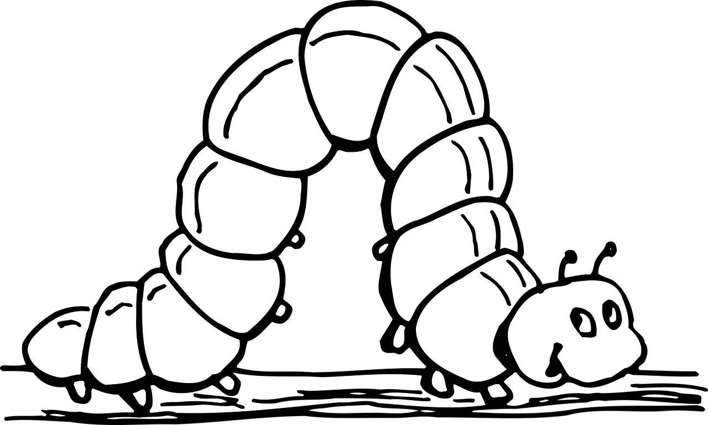
What has his SAE taught him about work ethic? How did his work ethic improve?

What types of worms does Ethan use?

How do worms help the environment?

What steps did Ethan take to start his SAE?


Why did he choose to save money for certain items while spending more on other items?



From Scraps to Black Gold
Aligned to the following standards:
ESS.03; FFA.PL-A; FFA.PG-J; FFA.CS-M; FFA.CS-N; AG-ENV3; AGPF01.03;CS.01; CCSS.RI.9-10.8; CCSS.SL.9-10.1.C; CCSS.RST.9-10.1; CCSS.RST.9-10.2; CCSS.RST.9-10.5; CCSS.RST.9-10.10; CCSS.WHST.9.10.2; ; CCSS.WHST.9.10.4; CCSS.WHST.9.10.7; ; CCSS.WHST.9.10.8; ; CCSS.WHST.9.10.9; CCSS.MP7; HS-ETS1-2; CRP.02; CRP.04; CRP.05; CRP.07; CRP.08; CRP.11
Part 1
Directions:
Complete the activities below to learn how worms eat and make compost.
Suggested resource: https://unclejimswormfarm.com/red-worms-eat-compost/

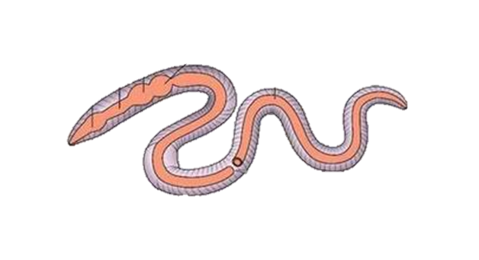
- Label the diagram of a worm digestive tract and explain what each part does.
Label: _______________________
Explanation:
Label: _______________________
Explanation:
Label: _________________
Explanation:
Label: _______________________
Explanation:
Label: _______________________
Explanation:
Label: _______________________
Explanation:
Label: _______________________
Explanation:
What are worm castings?

- List four things worms love to eat and three things that should not be fed to them.





- What is “black gold”? Why is it called that?

- What are pre-digesters?
  - Microbes in the worm’s mouth that take the place of teeth
  - Bacteria, mold and fungi that break down the organic matter
  - Bad bacteria that compete with worms for food
  - None of the above

Part 2
Directions:
Did you know you can do vermicomposting virtually anywhere, even in a small urban apartment? Fill in the buckets below with each step for creating your own worm composting farm. If you work at it, you could even sell your “black gold”!
Suggested resource: https://www.thespruce.com/inexpensive-worm-bin-from-plastic-buckets-2540077

- What materials do you need to start a vermicomposting bin?

- Explain why the bin is constructed with three buckets. (Be sure to explain the function of each bucket.)

- On each bucket, describe what you need to do in each step to create your vermicomposting bin.

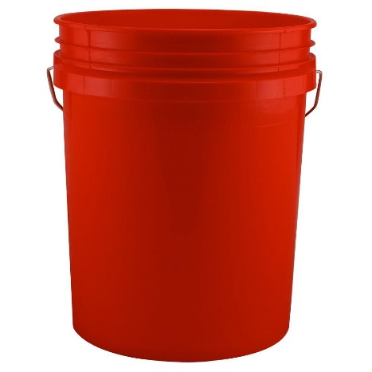
Step 1

Step 2

Step 3

Step 4

Step 5

Step 6

Step 7

Step 8

Aligned to the following standards:
ESS.03; FFA.PL-A; FFA.PG-J; FFA.CS-M; FFA.CS-N; AG-ENV3; AGPF01.03;CS.01; CCSS.RI.9-10.8; CCSS.SL.9-10.1.C; CCSS.RST.9-10.1; CCSS.RST.9-10.2; CCSS.RST.9-10.5; CCSS.RST.9-10.10; CCSS.WHST.9.10.2; ; CCSS.WHST.9.10.4; CCSS.WHST.9.10.7; ; CCSS.WHST.9.10.8; ; CCSS.WHST.9.10.9; CCSS.MP7; HS-ETS1-2; CRP.02; CRP.04; CRP.05; CRP.07; CRP.08; CRP.11

KEY: A Bin of Worms
Aligned to the following standards:
ESS.03; FFA.PL-A; FFA.PG-J; FFA.CS-M; FFA.CS-N; AG-ENV3; AGPF01.03;CS.01; CCSS.RI.9-10.8; CCSS.SL.9-10.1.C; CCSS.RST.9-10.1; CCSS.RST.9-10.2; CCSS.RST.9-10.5; CCSS.RST.9-10.10; CCSS.WHST.9.10.2; ; CCSS.WHST.9.10.4; CCSS.WHST.9.10.7; ; CCSS.WHST.9.10.8; ; CCSS.WHST.9.10.9; CCSS.MP7; HS-ETS1-2; CRP.02; CRP.04; CRP.05; CRP.07; CRP.08; CRP.11
Directions:
Answer the following questions as you watch the video “Vermicomposting SAE | Ethan Shelden,” available at https://vimeo.com/328434623.
What is vermicomposting?
Worm composting

What is Ethan’s SAE?
Vermicomposting

What tests does he have to do to maintain the ideal worm environment?
pH
temperature
soil moisture

What has his SAE taught him about work ethic? How did his work ethic improve?

He started out only watering the worms once or twice a week and feeding them only once every two weeks. After doing a lot of research, he realized he needed to maintain a consistent rate by watering them every day and feeding them at least twice a week.

What types of worms does Ethan use?

Red worms/red wigglers
Earthworms
How do worms help the environment?

They help soil composition. Without worms, we would have terrible soil, which would have an effect on agriculture in general.

What steps did Ethan take to start his SAE?
estimated amount he wanted to spend
found cheapest worms that were still the best kind for composting
invested the rest of his budget into good equipment

Why did he choose to save money for certain items while spending more on other items?

By having good equipment, he can make sure he has really good
soil and a healthy environment for the worms, so they will
hopefully compost more.

KEY: From Scraps to Black Gold
Aligned to the following standards:
ESS.03; FFA.PL-A; FFA.PG-J; FFA.CS-M; FFA.CS-N; AG-ENV3; AGPF01.03;CS.01; CCSS.RI.9-10.8; CCSS.SL.9-10.1.C; CCSS.RST.9-10.1; CCSS.RST.9-10.2; CCSS.RST.9-10.5; CCSS.RST.9-10.10; CCSS.WHST.9.10.2; ; CCSS.WHST.9.10.4; CCSS.WHST.9.10.7; ; CCSS.WHST.9.10.8; ; CCSS.WHST.9.10.9; CCSS.MP7; HS-ETS1-2; CRP.02; CRP.04; CRP.05; CRP.07; CRP.08; CRP.11
Part 1
Directions:
Complete the activities below to learn how worms eat and make compost.
Suggested resource: https://unclejimswormfarm.com/red-worms-eat-compost/

- Label the diagram of a worm digestive tract and explain what each part does.
What are worm castings?
Worm castings are alive with soil-friendly bacteria and valuable nutrients. Adding worm castings to soil increases its porosity and nutrient content.
Label: _Mouth_
Explanation:
Food enters the body through the mouth.
Label: __Esophagus__
Explanation: It connects the pharynx and crop (food travels through it to get to the crop).
Label:
___ Pharynx____
Explanation:
The pharynx acts as a suction pump to pull the food into the digestive tract.
Label: ___Anus______
Explanation:
Excretes the worm castings.
Label: ___Crop______
Explanation:
Stores food
Label: ___Gizzard____
Explanation:
The gizzard grinds up food using sandy particles.
Label: ___Intestine____
Explanation:
Nutrients are absorbed here.

- List four things worms love to eat and three things that should not be fed to them.

Answers will vary, but will probably include the following:
leftover organic matter
peels
cores
tea bags
bread, pasta, grains
shredded black print newspaper
coffee grounds
hair

meat

dairy

oils

acidic foods

- What is “black gold”? Why is it called that?
Worm castings are called “black gold” because gardeners love adding worm castings to their soil. They quickly see results.

- What are pre-digesters?
  - Microbes in the worm’s mouth that take the place of teeth
  - Bacteria, mold and fungi that break down the organic matter
  - Bad bacteria that compete with worms for food
  - None of the above

Part 2
Directions:
Did you know you can do vermicomposting virtually anywhere, even in a small urban apartment? Fill in the buckets below with each step for creating your own worm composting farm. If you work at it, you could even sell your “black gold”!
Suggested resource: https://www.thespruce.com/inexpensive-worm-bin-from-plastic-buckets-2540077

- What materials do you need to start a vermicomposting bin?
Three plastic buckets (five-gallon size is best and they should stack well)
One bucket lid
Drill
Shredded newspaper or cardboard
Red wiggler worms (the best composting worms)

- Explain why the bin is constructed with three buckets. (Be sure to explain the function of each bucket.)
Vermicomposting bins are structured so that the worms will start out with bedding and food on one level. As that level gets digested and turned into vermicompost, you start adding food and bedding to the next level. The worms instinctively migrate up into that level, leaving behind finished vermicompost for you to use in your garden. You simply keep switching back and forth between the two buckets, emptying finished compost then adding fresh food and bedding as the worms break it down for you. The third bucket is to catch any moisture created as a byproduct from the other two bins.

- On each bucket, describe what you need to do in each step to create your vermicomposting bin.

Step 1

In two of the buckets, drill 3/16-inch holes in the bottom, about 1 inch apart. Do not drill holes in the third bucket.
Step 2

Drill a line of 1/8-inch holes through the lip of both buckets, near the top. These holes will provide airflow for your bins, so they don't get too wet.
Step 3

Drill a bunch of 1/8 inch holes through the lid, for added aeration.
Step 4

Stack one of the bins that has holes in the bottom inside the bucket without holes. Add 3 to 4 inches of moistened shredded newspaper or cardboard to this bucket, then add your worms. You can also add some food scraps at this time.
Step 5

Put the lid on the bin and let the worms do their thing. Add food as often as you need to.
Step 6
After this layer has been partially digested by the worms, stack the next bucket (with holes in the bottom) onto the bin, adding fresh bedding and food to the new bucket and placing the lid on top. The worms will migrate to the top bucket for fresh food and bedding.
Step 7

Allow a couple of weeks to ensure that most of the worms have migrated to the top bin, then harvest the vermicompost from the underlying bucket.
Step 8

Keep repeating the process as the buckets get full.
Aligned to the following standards:
ESS.03; FFA.PL-A; FFA.PG-J; FFA.CS-M; FFA.CS-N; AG-ENV3; AGPF01.03;CS.01; CCSS.RI.9-10.8; CCSS.SL.9-10.1.C; CCSS.RST.9-10.1; CCSS.RST.9-10.2; CCSS.RST.9-10.5; CCSS.RST.9-10.10; CCSS.WHST.9.10.2; ; CCSS.WHST.9.10.4; CCSS.WHST.9.10.7; ; CCSS.WHST.9.10.8; ; CCSS.WHST.9.10.9; CCSS.MP7; HS-ETS1-2; CRP.02; CRP.04; CRP.05; CRP.07; CRP.08; CRP.11

