Name_____________________________________________________ | 
Ethanol Activity 1 – History

Purpose
With the world population growing, the need for new energy sources is increasing. Society uses renewable and non-renewable sources of energy to meet daily needs to operate electrical appliances, drive cars, heat homes, and endless other tasks.

Forward thinkers and entrepreneurs have been considering alternative energies for decades. Biofuels are an alternative energy source developed and utilized to benefit the environment and economy. Biofuels made from plants, such as ethanol, are blended in gasoline used in vehicles. Ethanol was always intended to be the leading fuel of choice for automobiles. When Henry Ford created the Model T in 1908, he designed its engine to run on ethanol and gasoline. Ethanol can be produced from a variety of agricultural crops. Agricultural producers in the Midwest United States produce starch-based ethanol. During the 1970’s and 1980’s, the corn used for starch-based ethanol came from the surplus grain supply to create a critical market for American agriculture. A coproduct produced during starch-based ethanol production valuable to agriculture is distillers grain. Distillers grain are the solid materials remaining after ethanol has been distilled. Distillers grain contains protein, fiber, and oil making it a quality animal feed.

What is the history of ethanol used as an energy source? How is corn-based ethanol produced? What are its environmental benefits?

Materials
Per pair of students:  - Computer with internet access and printer  - Classroom textbooks  - Poster board  - Assorted markers  - Glue  - Scissors | Per student:  - Pencil

Procedure
Work with your partner to design and construct a display to educate the public about ethanol. When you have completed your educational display, share your findings with the class.

Part One – Research and Display
- Draw a corn kernel in the center of the poster to represent the energy source. Make sure the image is large enough to see detail, leaving enough room to add images around the edges of the illustration.
- Use the internet and classroom textbooks to research the following about ethanol.
- History of ethanol and ethanol as an energy source
- How ethanol was discovered as an energy source
- Who introduced ethanol as an energy source
- When starch ethanol processing from corn was developed
- Current amount of ethanol available
- Future availability and production potential of ethanol
- Physical characteristics
- Ethanol production and processing
- A map identifying areas of the United States currently producing ethanol and areas with potential to produce this source in the future
- How ethanol is produced and/or processed
- Production costs
- Materials and infrastructure needed to process/or produce ethanol
- Annual ethanol production
- Coproducts produced during the ethanol production process.
- Ethanol Usage
- Annual consumption
- Materials and infrastructure needed to use ethanol
- Where and how it is used
- Environmental information  - Environmental impact of ethanol production  - Environmental impact of ethanol use  - Byproducts produced during production and use  - Agricultural Impact  - How agriculture consumes and or/produces ethanol  - Type, print, and organize your information on the display board. See Figure 1 for an example.  - Display your research as instructed by your teacher. | 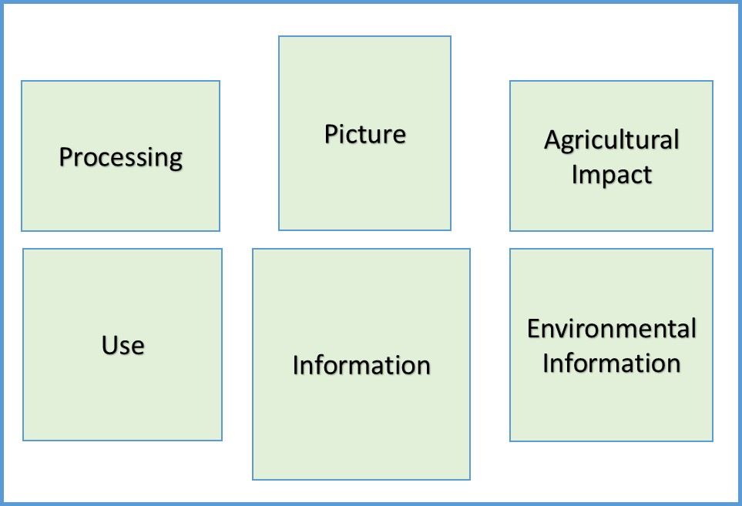
 | Figure 1. Sample Display Layout
- Discuss with your peers the impact ethanol has and will have on your community. Your teacher will lead the discussion.

Conclusion
- How can agriculture provide an alternative energy source?

- What are the advantages and disadvantages of using ethanol as an energy source?

- Where is ethanol produced and used near you?

- What are ways to get ethanol to areas where it is not as available?

