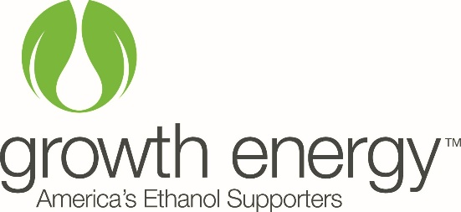
Activity 3 Community Role Cards

Make 2 copies for a total of 20 roles for students.
Community Member
You are a local homeowner with a flex fuel vehicle (FFV). You are concerned about greenhouse gas emissions and the affect they will have on the environment.
Downtown Business Owner
As a downtown business owner, you understand ethanol’s potential to reduce consumer costs at the gas pump and have seen an increase in business since the opening of the ethanol plant in town.
Community Member
You are a local homeowner and resident with a vehicle that uses gasoline. You are concerned about the fluctuation in oil prices and how they affect your costs to commute to the neighboring town for work.
Wildlife Biologist
You are local biologist who has seen a change in wildlife populations over the past 10 years and are concerned that it may be due to climate change caused by greenhouse gas emissions.
Ethanol Plant Executive
You are strongly in favor of ethanol production and helped plan the construction of an ethanol plant in town. As an executive you oversee 75 workers and managers at the ethanol plant.
Gas Station Owner
You are the owner of a gas station. You sell gasoline blended with 10% ethanol and E85 ethanol,
Ethanol Plant Employee
You moved to town because of the construction of the ethanol plant.
City Council Person
You have seen the ethanol plant bring new industry to your community and the benefits to the local economy. You also understand the rural farm economy and how it supports local businesses in town.
Crop Farmer
You are a fourth generation farmer who owns 2000 acres and grows corn and soybeans. You market your crops and sell corn to the local ethanol plant.
Beef Farmer
You are a new beef farmer who owns 200 acres and raises beef cows. You purchase distillers grains from the ethanol plant in town.

