Example Icebreaker Activities 
This or That:
- Prepare a list of choices (e.g., Coke or Pepsi, summer or winter, pizza or burgers).
- Students stand on opposite sides of the room based on their preference for each choice.
Choice Ideas:
- Coffee or Tea
- Beach or Mountains
- Cats or Dog
- Books or Movies
- Morning Person or Night Owl
- Sweet or Savory
- Netflix or YouTube
- Fiction or Nonfiction
- Sneakers or Sandals
- CDEs or LDEs
- FFA Convention or FFA Camp
- Texting or Calling
- Pizza or Tacos
- Sunrise or Sunset
- Comedy or Horror
- City Life or Country Life
- Summer Olympics or Winter Olympics
- Cake or Pie
- Hiking or Biking
- Instagram or Snapchat
- Camping or Hotel

Photo Scavenger Hunt
- Create a list of items or situations students need to capture with their phones (e.g., a group selfie with a stranger, a funny sign).
- Students work in teams to take photos and return within a time limit.
Ideas:

- A group photo with a local landmark
- A funny street sign
- A selfie with a stranger (ask for permission!)
- A picture of a street performer
- An item that starts with the letter Z

- A photo of someone wearing a hat
- A picture of a pet (with owner’s permission)
- A photo of a rainbow (if possible)
- A creative shadow photo
- A selfie with a police officer or firefighter (with permission)
- A photo of a historical plaque or marker
- A picture of a food truck
- A photo of something that represents teamwork
- A picture of local street art or mural
- A creative reflection photo (e.g., in a puddle or mirror)
- A photo of a unique mailbox
- A picture of something abandoned or forgotten
- A selfie with a statue or sculpture
- A photo of someone doing a random act of kindness
Emoji Charades
- Write a list of emojis on cards.
- One student picks a card and acts out the emoji without speaking while others guess.
Guess Who?
- Before the session, gather interesting facts or unique traits from each student (e.g., favorite movie, dream vacation, hobby).

- Students take turns reading out a fact about themselves while others guess who it is.
Song Lyrics Challenge
- Provide students with lines from popular songs (or songs they might know) with a word or phrase missing.
- Teams compete to fill in the blanks correctly or guess the song title and artist.

Minute to Win It Games
- Choose simple, fun challenges that can be completed in a minute (e.g., stacking cups, cookie face challenge).
- Students compete individually or in teams to complete as many challenges as possible within the time limit.
Ideas:
Stack Attack
  - Objective: Stack a set of 36 plastic cups into a pyramid shape and then back into a single stack in under a minute.
  - Materials: 36 plastic cups
  - Rules: Participants can only use one hand at a time to stack and unstack the cups.
Cookie Face Challenge
- Objective: Move a cookie from the forehead to the mouth using only facial muscles, without dropping it, in under a minute.
- Materials: Cookies (like Oreo cookies)
- Rules: Participants cannot use their hands to assist the cookie.
Junk in the Trunk
- Objective: Shake ping pong balls out of a tissue box tied to the participant’s waist using only hip movements in under a minute.
- Materials: Empty tissue box, ping pong balls
- Rules: No touching the box with hands; only hip movements allowed.
Movin’ On Up
- Objective: Stack a set of 25 plastic cups into a pyramid shape and then unstack them back into a single stack in under a minute, one cup at a time.
- Materials: 25 plastic cups
- Rules: Only one hand can be used at a time; cups must be stacked and unstacked one by one.
Penny Tower
- Objective: Stack pennies on top of each other to create the tallest freestanding tower in under a minute.
- Materials: Pennies
- Rules: Only one hand can be used at a time to stack the pennies.
Defying Gravity
- Objective: Keep three balloons in the air for one minute using only your breath (no hands or other body parts).
- Materials: Balloons
- Rules: Balloons must stay airborne the entire time without touching the ground.
Straw and Pasta Challenge
- Objective: Use a straw to pick up pieces of dry spaghetti and transport them to a bowl across the room in under a minute.
- Materials: Dry spaghetti, straw, bowls
- Rules: Spaghetti must be picked up one piece at a time using the straw; no hands allowed.
Suck It Up
- Objective: Use a straw to transfer a pile of M&Ms from one plate to another across the room in under a minute.
- Materials: M&Ms, straws, plates
- Rules: Only one M&M can be transferred at a time using the straw; no hands allowed.
Cotton Ball Scoop
- Objective: Use a spoon to scoop cotton balls from one bowl to another across the room in under a minute.
- Materials: Cotton balls, spoons, bowls
- Rules: Only one cotton ball can be scooped at a time; no hands allowed.
Pencil Flip
- Objective: Flip pencils and land them eraser-side down into a cup in under a minute.
- Materials: Pencils, cups
- Rules: Participants must flip the pencils from a designated distance; each successful flip into the cup counts as a point.
Nutstacker
- Objective: Stack metal nuts from a table onto a chopstick held in the participant’s mouth in under a minute.
- Materials: Metal nuts, chopsticks
- Rules: Only one nut can be stacked at a time using the chopstick held in the mouth.
Paper Airplane Race
- Give each student a sheet of paper and challenge them to create the best paper airplane.
- Have a competition to see whose airplane flies the farthest or stays in the air the longest.
Name That Tune
- Play short clips of popular songs or instrumental music.
- Participants guess the name of the song or the artist as quickly as possible.
Mystery Bag Challenge
- Prepare a bag with random items (e.g., household objects, toys, office supplies).
- Participants take turns reaching into the bag, feeling an item without looking, and describing it to the group.
- Others guess what the item is based on the description.
Bucket Brigade
- Divide participants into teams and set up a line.
- Provide each team with a bucket filled with water (or another safe liquid).
- Teams pass the bucket overhead, working together to transfer the liquid from one end of the line to the other.

Back-to-Back Drawing
- Pair participants back-to-back.
- One person is given a simple picture or shape to describe while the other person must draw it without seeing the original image.
Ideas:
- Circle
- Square
- Triangle
- Star

- Heart
- Diamond
- House
- Tree
- Car
- Sun
- Cloud
- Flower
- Cat
- Dog
- Fish
- Bird
- Butterfly
- Elephant
- Peace Sign
- Smiley Face
- Cross
- Arrow
- Dollar Sign
- Wi-Fi Symbol
- Beach Scene (sun, waves, umbrella)
- Park Scene (trees, bench, birds)
- Mountain Landscape (mountains, sun, clouds)
- City Skyline (skyscrapers, sun, clouds)
- Underwater Scene (fish, coral, seaweed)
Famous Pairs
- Write names of famous pairs (e.g., Batman and Robin, peanut butter and jelly) on separate cards.
- Tape one card to each participant’s back without showing them the name.
- Participants mingle and ask yes/no questions to figure out who they are.
Ideas for Famous Pairs:
- Batman and Robin
- Sherlock Holmes and Dr. Watson
- Mario and Luigi
- Harry Potter and Hermione Granger
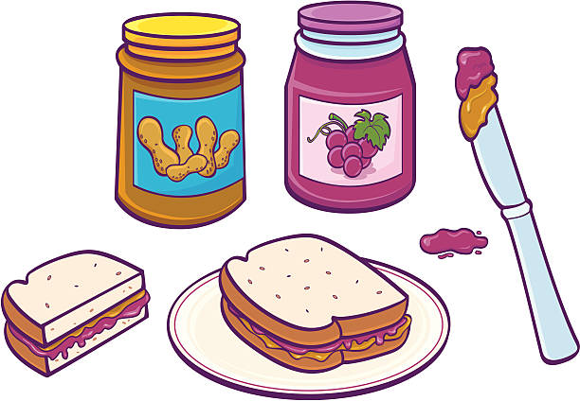
- Shrek and Donkey
- Mickey Mouse and Minnie Mouse
- Woody and Buzz Lightyear
- SpongeBob SquarePants and Patrick Star
- Luke Skywalker and Princess Leia
- Peanut Butter and Jelly
- Salt and Pepper
- Bacon and Eggs
- Chips and Salsa
- Batman and the Joker
- Tom and Jerry
- Hansel and Gretel
- Thelma and Louise
- Simon and Garfunkel
- Bert and Ernie

