Proposed Team Event Example
Region: West (processing…central California)
Crop: Tomato
Scenario: You have been called to visit a tomato processing grower, J&P Produce, with a field concern. As a producer Jamie is focused on continual improvement in their management of not only processing tomatoes, but all of the specialty crops they raise. They look at crop production as a system and how the various aspects of crop management work together to maximize both crop yield and quality.

Field Observations:
- Symptoms: Water soaked lesions on bottom of tomato fruit. Pictures below.
- Pattern: Appears random, but concentrated in certain areas of the field
- Damage: Damage to the fruit estimated at 20% by a field scout
- Concern: Jamie will not be able to fulfill his contract due to poor fruit quality.
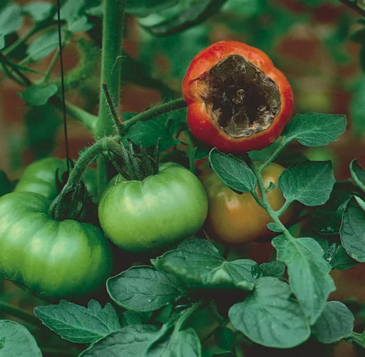
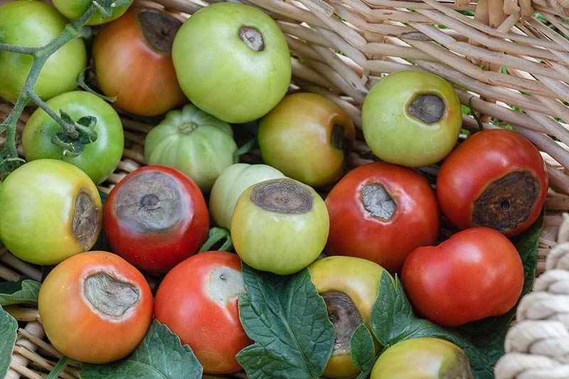

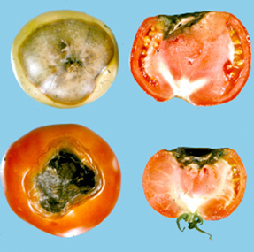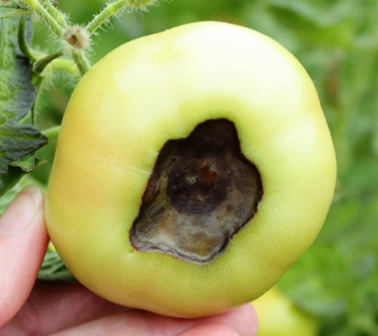
Previous Crop:
- 2022 Crop was Bell Peppers
- 2022 Herbicide was 5 QT/acre of Prefar 4E Selective herbicide as a pre-emerge application

Field Management:
- Fall 2022 Moldboard Plow
- Spring 2023 Disking and Land Planing to create beds
- No Black Plastic Mulch for transplanting

Nutrient Management:
- Dry Fertilizer prior to planting
  - 150 lbs/acre Urea (46-0-0)
  - 100 lbs/acre MAP (11-52-0)
  - 250 lbs/acre Potash (0-0-60)
- Liquid Fertilizer at transplanting
  - 25 gal/acre 21-17-0 (11.36 lb/gal)
  - 375 gal/acre water
- Liquid Fertilizer in-crop during Vegetative Growth prior to flowering
  - 30 gal/acre UAN (32-0-0) (11.06 lb/gal)

Crop Management:
- 2 varieties: HM-58841 and N-6428
- Transplanted as double-seeded plugs into prepared beds

Water Management:
- Drip Irrigation approximately every 2 weeks
- 10 inches of water over past 90 days

Weed Management:
- Prowl H2O at 32 fl oz/acre as pre-plant herbicide prior to transplanting

Insect Management:
- History of root knot nematodes
- Stink Bugs found feeding during early fruit set
- Danitol 2.4 ES Spray at 10.67 fl oz/acre to control stink bugs

Disease Management:
- Late Blight is primary concern in California Central Valley
- A Crop Consultant recommended complete protectant fungicide spray program was made prior to the field visit

