FFA 101 Handbook

This handbook is designed to provide educators, advisors and chapter leaders with a comprehensive resource to enhance their understanding of FFA.

Table of Contents
In this document, you will find links to resources that accompany the major components of FFA 101. (Each link will take you to specific sections. In each section of this document, there will be additional links to website resources.)
What Is FFA?
Items included in this section are meant to provide a brief overview of FFA. It will highlight history, structure and core values.
Deeper Dive Into FFA Basics
Items included in this section are meant to provide a deeper overview of FFA. It will highlight membership, degrees and awards, delegates and more.
Chartering a Chapter
Items included in this section are meant to guide you in starting an FFA chapter. To start an FFA chapter, you first begin by establishing an agricultural education program at your school.
Managing FFA
Items included in this section explain how to manage an FFA chapter. These chapters are student-led with the assistance of the FFA advisor(s). Advisors oversee chapter activities, facilitate supervised agricultural experience (SAE) programs, and prepare students for career and leadership development events (CDEs/LDEs).
FFA Alumni and Supporters
Items included in this section explain the importance of alumni and supporters and provides resources to help guide you.
Supervised Agricultural Experience (SAE)
Items included in this section are meant to introduce supervised agricultural experiences and the different types. SAEs allow students to experience hands-on learning and skill development, to explore careers, to impact the community and more!
Career and Leadership Development Events (CDEs/LDEs)
In this section, you will explore career development events (CDEs) and leadership development events (LDEs). You'll learn how these events help students develop hands-on skills in agriculture, sharpen their leadership and communication abilities and prepare for future careers.

Grants and Scholarships
FFA members have access to a variety of grants and scholarships that support their agricultural education, leadership development and career goals.
Quick Links
Items included in this section are meant to provide additional resources you may need to understand FFA.
Glossary of FFA Acronyms
Items included in this section are meant to define common FFA acronyms and terminology.

What is FFA?
Items included in this section are meant to provide a brief overview of FFA. It will highlight history, structure and core values.

Brief History
Future Farmers of America was founded in 1928 by 33 members in Kansas City, Mo., on Nov. 20. FFA is an intracurricular (activities that are connected to classroom instruction) student organization within agricultural education that prepares students for premier leadership, personal growth and career success. The official name of the organization is the National FFA Organization, and the letters “FFA” stand for Future Farmers of America. These letters are a part of our history that will never change. FFA is for those who want to be difference makers, whether as production agriculturists, teachers, doctors, scientists, business owners or experts in other fields. FFA is one of the three components of agricultural education, along with classroom/laboratory and supervised agricultural experience (SAE).

The Three-Component Model
The agricultural education mission states “Agricultural education prepares students for successful careers and a lifetime of informed choices in the global agriculture, food, fiber and natural resources systems.” Through agricultural education, students are provided opportunities for leadership development, personal growth and career success. (Learn how to start an agricultural education program in your community.) Agricultural education instruction is delivered through the three-component model, ensuring that students receive a well-rounded experience that combines classroom learning, real-world application and leadership development. Each component is equally important:
Classroom/Laboratory provides contextual, inquiry-based instruction and learning through an interactive classroom and laboratory
FFA prepares members for premier leadership, personal growth, and career success through agricultural education. It is a dynamic youth organization that helps students discover their talent through hands-on experiences.
SAE provides experiential, service and/or work-based learning through the implementation of a supervised agricultural experience (SAE) program
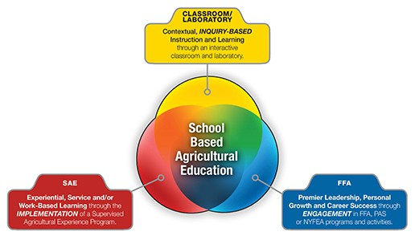
The FFA Mission
FFA makes a positive difference in the lives of students by developing their potential for premier leadership, personal growth and career success through agricultural education.
The FFA Vision
Growing the next generation of leaders who will change the world.
The FFA Motto
Learning to Do, Doing to Learn, Earning to Live, Living to Serve.
FFA Value Statements
The FFA Value Statements promote a more inclusive, equitable organization for all FFA members. These four statements create a foundation to ensure we open doors and remove barriers for every individual in agricultural education to experience premier leadership, personal growth and career success through FFA.
- We respect and embrace every individual’s culture and experiences.
- We welcome every individual’s contribution to advance our communities and the industry of agriculture.
- We cultivate an environment that allows every individual to recognize and explore their differences.
- We create leadership opportunities for every individual to enhance their personal and professional endeavors.
Lesson plans to share in your classroom: Values Series Lessons and FFA Value Statements Reinforce Agricultural Education for All

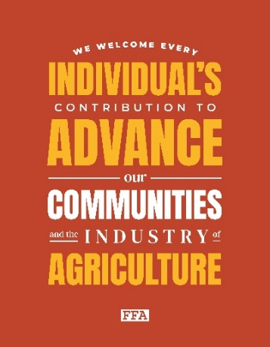
FFA Statement of Belonging
The National FFA Organization is committed to fostering a welcoming, supportive, engaging and growth-focused environment for all students. We prioritize the well-being of our members and actively challenge prejudice while promoting a culture of inclusivity where every individual is respected, treated with dignity and valued for their unique identities.
As FFA members, agriculture teachers, supporters and employees, let’s hold each other accountable, take care of one another and be kind.
FFA Salute
The Pledge of Allegiance is the official salute of the FFA organization. To properly conduct the salute, face the United States flag, place the right hand over the left part of the chest and, holding it there, repeat the following:
“I pledge allegiance to the flag of the United States of America and to the Republic for which it stands, one Nation under God, indivisible, with liberty and justice for all.”
Brief History Timeline
- Important Dates:
  - 1917: The Smith-Hughes National Vocational Education Act established vocational
  - agriculture courses.
  - 1925: The Future Farmers of Virginia is founded by Henry Groseclose, Harry Sanders, Walter S. Newman and Edmund C. Magill and would later serve as the model for the Future Farmers of America
  - 1928: The Future Farmers of America was established.
  - 1929: National blue and corn gold were adopted as official FFA colors.
  - 1930: The Official FFA Creed, written by E.M. Tiffany, was adopted.
  - 1933: The blue corduroy jacket was adopted as official dress.
  - 1935: New Farmers of America was founded. (The NFA was an agricultural organization for African-American students.)
  - 1944: The Future Farmers of America Foundation formed.
  - 1965: The New Farmers of America merged with the Future Farmers of America.
  - 1969: FFA opened membership to girls.
  - 1988: Future Farmers of America changed its name to the National FFA Organization to reflect the growing diversity in the industry of agriculture.
- Learn more about FFA History.
- Lesson plans to share in your classroom: Generic Timeline Lesson Plan
The FFA Creed
E.M. Tiffany wrote the FFA Creed. It was adopted at the third national convention and revised at the 38th and 63rd conventions.
  - The FFA Creed:
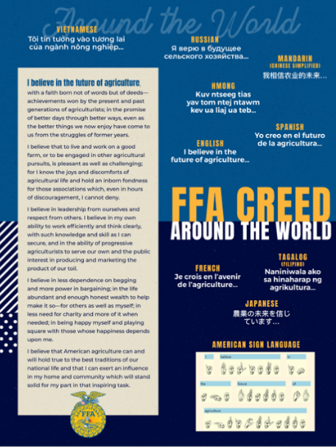
    - I believe in the future of agriculture, with a faith born not of words but of deeds — achievements won by the present and past generations of agriculturists; in the promise of better days through better ways, even as the better things we now enjoy have come to us from the struggles of former years.

I believe that to live and work on a good farm, or to be engaged in other agricultural pursuits, is pleasant as well as challenging; for I know the joys and discomforts of agricultural life and hold an inborn fondness for those associations which, even in hours of discouragement, I cannot deny.

I believe in leadership from ourselves and respect from others. I believe in my own ability to work efficiently and think clearly, with such knowledge and skill as I can secure, and in the ability of progressive agriculturists to serve our own and the public interest in producing and marketing the product of our toil.

I believe in less dependence on begging and more power in bargaining; in the life abundant and enough honest wealth to help make it so — for others as well as myself; in less need for charity and more of it when needed; in being happy myself and playing square with those whose happiness depends upon me.

I believe that American agriculture can and will hold true to the best traditions of our national life and that I can exert an influence in my home and community which will stand solid for my part in that inspiring task.

  - History of the FFA Creed
  - FFA Creed Vimeo
  - FFA Creed in Spanish Vimeo
  - Lesson plans to share in your classroom: “I Believe” student worksheet, Lesson 3: The FFA Creed as a Speech
History of Official Dress
This uniform is worn by FFA members at the local, state and national levels.
  - 1930: First Official Dress Adopted (dark blue shirt, blue or white pants, blue cap and yellow tie)
    - Today, Official Dress for an FFA member includes the following:
      - An official FFA jacket zipped to the top.
      - Black slacks and black socks/nylons or black skirt and black nylons.
      - White collared blouse or white collared shirt.
      - Official FFA tie or official FFA scarf.
      - Black dress shoes with closed heel and toe.
  - 1933: Blue corduroy jacket is adopted as Official Dress. The jacket is a symbol of pride and unity.
  - Additional Resources: Jacket Measuring Tools, Caring for Corduroy, Give the Gift of Blue, ShopFFA Official Dress
  - Lesson plans to share in your classroom: Appendix 7: More Than a Jacket, Appendix 6: More Than a Jacket
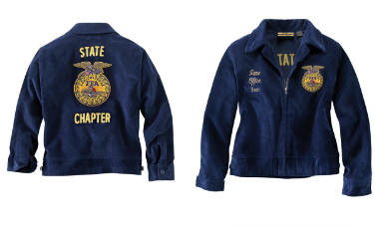
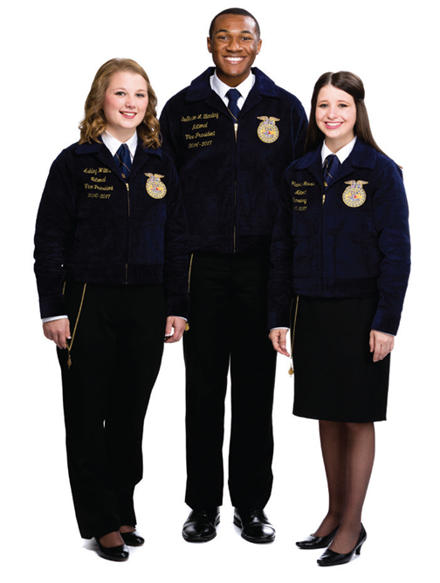





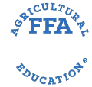

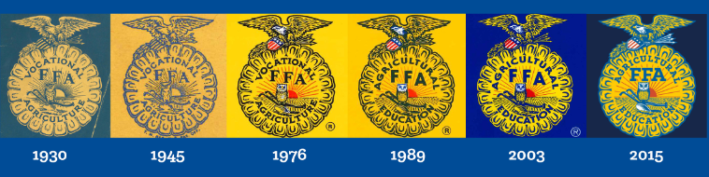
History of the Emblem
    - The cross section of the ear of corn represents unity.
      - Whether you live in Maine, Hawaii, Alaska, Puerto Rico or one of the states in between, corn is grown somewhere in your state. Corn signifies unity, and it has historically served as the foundation crop of American agriculture. It is appropriate then that the cross section of an ear of corn be used as the foundation of the FFA emblem.
    - The rising sun represents progress.
      - Just as the industry of agriculture has developed new technologies and evolved to meet the next generation of consumer demands, the National FFA Organization has continued to evolve as it looks to the future to meet FFA members’ needs. The rising sun signifies progress and holds the promise that tomorrow will bring a new day, shining with opportunity.
    - The plow represents labor and tillage of the soil.
      - The National FFA Organization is founded in agriculture, the backbone of our country. The plow signifies labor and tillage of the soil and the historic foundation of our country’s strength.
    - The eagle represents freedom.
      - The eagle is a national symbol that reminds all FFA members of our freedom and our ability to explore new horizons for the future of agriculture.
    - The owl represents knowledge.
      - Long recognized as a symbol of wisdom and knowledge, the owl symbolizes the knowledge required to be successful in the industry of agriculture.
    - The words “Agricultural Education” and the letters “FFA” are emblazoned in the center of the emblem to signify the combination of learning and leadership necessary for progressive agriculture.

deeper dive into ffa basics
Items included in this section are meant to provide a deeper overview of FFA. It will highlight membership, degrees and awards, delegates and more.
Levels
FFA is structured on three levels — local, state and national.
Local FFA chapters may be chartered in any public school with an agricultural education program. These chapters are led by student officers who are elected each year by chapter members and by the agriculture teacher who serves as the advisor for the chapter.
State FFA associations function within the constitution of the National FFA Organization but may also create individual leadership structures, awards, programs and competitions. State FFA officers lead the membership of the state associations and are elected by state FFA convention delegates.
The National FFA Organization is led by a board of directors and six student national officers. The national officers are elected at the National FFA Convention & Expo.
All three levels work together to provide FFA members with opportunities to experience premier leadership, personal growth and career success.
Types of FFA Membership
- Active/Student Membership: Must be enrolled in a secondary agricultural education program
- Alumni/Adult Membership: Open to former active, collegiate and honorary members and other FFA supporters
FFA Code of Ethics
FFA members conduct themselves at all times to be a credit to their organization, chapter, school, community and family. FFA members pledge to:
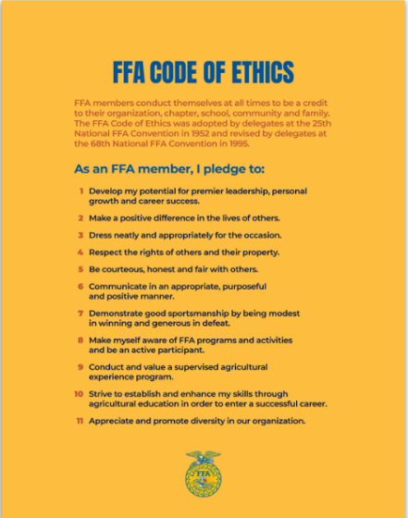
- Develop their potential for premier leadership, personal growth and career success.
- Make a positive difference in the lives of others.
- Dress neatly and appropriately for the occasion.
- Respect the rights of others and their property.
- Be courteous, honest and fair with others.
- Communicate in an appropriate, purposeful and positive manner.
- Demonstrate good sportsmanship by being modest in winning and generous in defeat.
- Make themselves aware of FFA programs and activities and be an active participant.
- Conduct and value a supervised agricultural experience program.
- Strive to establish and enhance their skills through agricultural education in order to enter a successful career.
- Appreciate and promote diversity in our organization.
The FFA Code of Ethics was adopted by the delegates at the 1952 National FFA Convention. It was revised by the delegates at the 1995 National FFA Convention.
FFA Pins/Medals
All chapter degree, officer and award medals should be worn beneath the name on the right side of the jacket, with the exception of a single State FFA Degree charm or American FFA Degree key. These should be worn above the name or attached to a standard degree chain. No more than three medals should be worn on the jacket. These should represent 1.) the highest degree earned, 2.) the highest office held and 3.) the highest award earned by the member.
Example Pins
Degrees and Awards in FFA
FFA offers a wide variety of awards to recognize members for their achievements in leadership, community involvement and career development. These awards provide recognition at local, state and national levels.
- Discovery Degree
This degree recognizes students enrolled in seventh and eighth grade agricultural science classes making strides toward successful involvement in the FFA.
  - Levels: Local
  - Eligibility: It is intended for seventh and eighth grade members who participate in FFA activities.
  - Learn more about Discovery Degrees
- Greenhand Degree
This degree is awarded to ninth grade or older members who learn about the FFA history, mission, creed and emblem and make plans for an SAE
  - Levels: Local
  - Eligibility: It is intended for students that meet the above criteria. They must submit a written application.
  - Learn more about Greenhand degrees.
- Chapter Degree
This degree is awarded to members in tenth grade or higher who are involved in chapter activities and community service and complete the minimum hours of instruction and SAE program growth.
  - Levels: Local
  - Eligibility: Students must have their Greenhand degrees and have completed at least two semesters of agricultural science.
  - Learn more about Chapter degrees.
- State Degree
This degree is awarded by state associations and is open to members in 11th grade or higher who are involved in chapter leadership, state-level activities and community service, and who complete a set number of hours of instruction and SAE growth and productivity.
  - Levels: Local and state recognition
  - Eligibility: Students must have their Chapter degree.
  - Learn more about State degrees.
- American FFA Degree
The American FFA Degree is the highest honor a member can achieve in the National FFA Organization. It recognizes members for their commitment to their chapters and state FFA, their SAE programs and their leadership achievements.
  - Eligibility: Members must have earned their State FFA Degree and meet other rigorous qualifications, including hours invested in an SAE program and community service.
  - Recognition: Recipients are honored at the National FFA Convention & Expo.
  - Learn more about the American FFA Degree.
- Proficiency Awards
These awards honor FFA members who excel in their supervised agricultural experience (SAE) programs.
  - Levels: Local, state and national recognition.
  - Eligibility: Open to members who complete an SAE program and meet specific requirements in their area of interest
  - Learn more about proficiency awards.
- Star Awards
The Star awards recognize top FFA members in various categories: Star Farmer, Star in Agribusiness, Star in Agricultural Placement and Star in Agriscience. These awards honor outstanding SAE programs and leadership.
  - Levels: Local, state and national awards are given in each category.
  - Eligibility: Open to members who excel in their SAE programs and demonstrate exceptional leadership.
  - Learn more about Star awards.
- National Chapter Award
This award program recognizes chapters that actively implement the mission and strategies of the organization. Chapters are evaluated based on their annual activities and programs that promote student involvement and community engagement.
  - Levels: State and national recognition
  - Eligibility: A chapter must complete at least 15 activities: one for each of the five quality standards in each of the three divisions. Additionally, the chapter must meet the minimum requirements as outlined in the National Quality Chapter Standards.
  - Learn more about the National Chapter Award.
- Honorary Awards
Honorary awards recognize individuals, businesses and organizations that have made outstanding contributions to FFA and agricultural education.
  - Eligibility: Nominations can be made by FFA chapters and state associations.
  - Categories: Honorary American FFA Degree, Honorary State FFA Degree, and Honorary Chapter Degrees.
  - Learn more about Honorary Awards
Delegate Work
Delegates to the National FFA Convention & Expo are responsible for representing FFA members’ interests within their state FFA associations while working to advance the mission of the National FFA Organization.
There are two types of delegates, leadership delegates and committee delegates. Leadership delegates are individuals selected by their state FFA associations to participate in the National FFA Delegate Experience’s official kick-off during the State Officer Summit. Each state is allowed a maximum of two leadership delegates. The job of a leadership delegate is to facilitate the work of the delegate committees. Committee delegates represent the remainder of a state association’s delegation. These delegates are responsible for driving the direction of their delegate committees. They serve as the architects of the committee recommendation. Leadership and committee delegates are counted once in any matter requiring a counted vote. The exception is for those delegates serving as the presiding officer during committee work.
- Current Year Delegate Experience Files
- Archived Delegate Experience Files

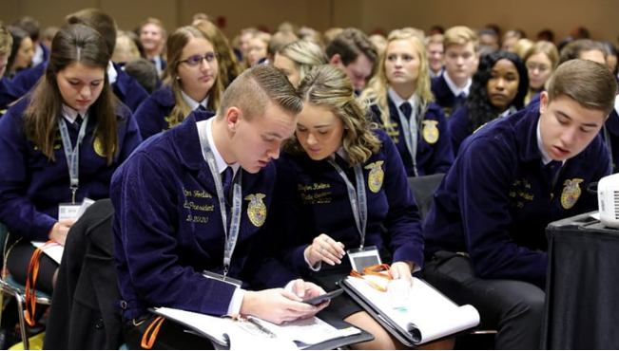
Chartering a Chapter
Items included in this section are meant to guide you in starting an FFA chapter. To start an FFA chapter, you first begin by establishing an agricultural education program at your school.
- The following eight steps (with helpful PDF downloads) will help you navigate the process for establishing a quality agricultural education program. Reach out to available resources to help you along the journey: the National FFA State Relations Team and agricultural education staff within your state (part of your state’s Department of Education). New chapters should choose to establish with a chapter constitution or chapter bylaws, not both. If you need more information on governing documents check out this guide.
1. Learn about agricultural education.
Agricultural education programs and FFA chapters are structured differently than most school courses. As the local champion for this new program, you’ll need a deep understanding of the integrated agricultural education model. Start with these resources:
- What is Agriculture Education? — National Association of Agricultural Educators (NAAE)
- National Quality Program Standards — The National Council for Agricultural Education
2. Determine your community’s philosophy for agricultural education.
Every community can benefit from an agricultural education program and FFA chapter, but you should also know that every community is different so the program’s areas of focus will be as well. Begin by asking yourself these questions. Reach out to nearby agricultural education teachers for their perspectives on what would work best in your school. Also gather facts and statistics about the specific need and opportunities in your area, especially post-secondary education programs nearby. Use this information to develop your program philosophy.
3. Gauge student and community interest.
Now that you understand agricultural education and have a general idea for how it would be structured in your school, it’s time to see if there’s enough interest to move forward. Surveys are a great way to gather feedback and support for the initiative. Utilize these resources:
- Tips for Administering Surveys
- Sample Student Survey
- Sample Parent Survey
Additional Resources:
- Partner Priority List
- Core Partner Action Plan
4. Consider specific requirements for your state.
Each state is different, so it’s time to discuss your specific plan with state staff. Agricultural education leaders are typically part of the Department of Education or Department of Agriculture; reach out to yours to ask these questions about next steps.
Additional Resource:
- Sample State Application
5. Outline your timeline and plan for action.
As mentioned before, this process can be lengthy. At this point, now that you’ve secured student and parent interest, recruited community support and consulted with state staff, staying on track is more important than ever. Create a timeline and task list to keep the project on track. Here’s an example.

6. Create a steering committee and a community campaign.
Once key community leaders are on board, ask them to join a local steering committee. Also consider forming an FFA Alumni and Supporters chapter as a method for engaging key community leaders. Have an informal discussion with school officials.
Share agricultural education key messages with these groups, along with the results of surveys and interviews conducted with students, parents and businesses. Include facts about agricultural education and FFA.
7. Organize your agricultural education curriculum.
A quality agricultural education curriculum is formed around the needs and career opportunities in your community. If your state does not provide curriculum for agricultural education, these resources can help build your program. They can also enhance what your state provides.
- The CASE Model — Curriculum for Agricultural Science Education
- Agriculture Teachers Resources
- Agriculture, Food and Natural Resources Career Pathways:
  - Agribusiness Systems
  - Animal Systems
  - Environmental Service Systems
  - Food Products and Processing Systems
  - Natural Resources Systems
  - Plant Systems
  - Power, Structural and Technical Systems
8. Present your proposal to the school board.
Your background research and plan are complete, and it’s finally time to go to the decision makers. Having your community support in place and a solid curriculum are essential to have ready for a school board presentation. Here are valuable tips and resources to use:
- Tips for Presenting to Your School Board
- Sample School Board PowerPoint Presentation (Missouri)

After these eight steps are complete, the National FFA State Relations Team and agricultural education staff within your state will send your FFA.org login as well as a link to the application which includes the following:
- A list of chapter officers/ members.
- A copy of your annual Program of Activities (skip to the POA section of this guide).
  - Consider These Activities for Your FFA POA
- A copy of the chapter’s constitution or bylaws.
- They may also send a form to collect new chapter information.

Managing FFA
Items included in this section explain how to manage an FFA chapter. These chapters are student-led with the assistance of the FFA advisor(s). Advisors oversee chapter activities, facilitate supervised agricultural experience (SAE) programs and prepare students for competitions like career and leadership development events (CDEs and LDEs).
Program of Activities
The Program of Activities (POA) serves to define chapter goals, outline steps needed to meet those goals and act as a written guide to provide a calendar of events the chapter will follow in the year ahead for administrators, advisory committees, alumni and other stakeholders. Every year, each FFA chapter takes time to plan ways to provide engaging opportunities focused on growing leaders, building communities and strengthening agriculture. A well-planned POA will ensure chapter activities meet the needs of its members, provide direction from year to year, lead to a workable budget, provide experience in planning and serve as a reference point throughout the year. Success is the result of creative planning and detailed preparation. To invest in chapter success, students set goals and plan the necessary steps to accomplish these goals. The POA provides a structure for student committees. By engaging in the development and delivery of a quality POA, students develop leadership and planning skills which are essential in all careers. The key to a quality POA is getting every member involved. In this guide, the steps to develop and implement a successful Program of Activities are outlined in four steps:
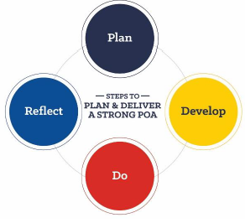

- Blank POA Forms
- Consider These Activities for Your FFA POA
- POA Divisions and Quality Standards

Officers:
The officer team and the advisor are often identified as the executive committee in formal documents like the constitution, policies and procedures, etc. The titles, duties and responsibilities are listed below.
- Advisor: Guides members in planning and executing local activities while supporting students in competitions, awards and public relations
- President: Leads meetings, oversees chapter activities, and represents the chapter at public and official functions
- Vice President: Assists the president, coordinates committee work and helps develop and assess chapter goals
- Secretary: Prepares meeting agendas and minutes, handles chapter correspondence and keeps membership records
- Treasurer: Manages chapter finances, collects dues and provides financial reports at meetings
- Reporter: Promotes chapter activities through media, maintains a chapter newsletter and serves as chapter photographer
- Sentinel: Maintains order during meetings, welcomes guests and ensures the meeting room is prepared
- Parliamentarian: Is proficient with parliamentary procedure and rules on all questions of parliamentary conduct at chapter meetings
- Chaplain: Presents the reflections at banquets and other functions
- Historian: Researches and prepares items of significance in the chapter’s history
- Student Advisor: Assists the advisor with any needs and oversees chapter activities, including meetings, projects and fundraising
FFA Officer Training Manual


Chapter Meetings
- Planning
  - The officer team should plan the agenda and post it in the chapter meeting room several days prior to each meeting.
  - Official opening and closing ceremonies are to be used at all meetings.
    - Official Manual p. 54-58
  - As meetings are planned, preparations must be made in advance by the officer team.
These may include, but are not limited to:
    - Placing the meeting schedule on the school’s activity calendar before the start of the school year.
    - Making sure officer and committee reports are written and ready to present.
- Order of Business
  - Opening Ceremonies (Official Manual p. 54-56)
    - Spanish
    - English
  - Reading and Approval of the Minutes
  - Reports of Officers, Boards and Standing Committees
  - Reports of Special Committees
  - Special Orders
  - Unfinished and General Orders
  - New Business
  - Special Features
  - Ceremonies
  - Announcements
  - Closing Ceremony (Official Manual p. 54-56)
  - Entertainment, Recreation and/or Refreshment
- Parliamentary procedure: The purpose is to promote efficient meeting so business can be transacted in an orderly manner.
  - Table of Motions: Official Manual p. 56
  - Observing Parliamentary Procedure will ensure:
    - One item is addressed at a time.
    - Courtesy is extended to everyone.
    - The majority rules.
    - The rights of the minority are protected.
- Taps of the Gavel
  - One tap of the gavel follows the announcement of adjournment, the completion of a business item or is a message to members to be seated.
  - Two taps of the gavel call the meeting to order.
  - Three taps of the gavel is the signal for all members to stand in unison on the third tap.
  - A series of sharp taps is used to restore order at a meeting.
- Educational Standards Alignment
- Conduct of Chapter Meetings Handbook
- Ceremonies
Fundraising
To start planning a fundraiser, you will need to check the guidelines of your school district for policies on fundraisers.
- Ask for Support: The first step in fundraising is simply to ask for donations. Begin by asking those closest to you, such as former members, FFA families or even a local FFA alumni and supporters’ chapter.

- Say Thanks: After every fundraising effort, remember to show your gratitude. Writing a quick thank- you note is the perfect way to show your appreciation for the time and money donated to your chapter. In addition to sharing your thanks, let your donors know how the money is being used so they can feel further connected to your work.
- Seek More Opportunities: Learn more about national fundraising opportunities through FFA.org/Financial-Assistance. Many companies establish programs that offer funding opportunities to local chapters and members. If you are just beginning to explore fundraising opportunities, this is a great place to start.
- National FFA Grants: Grants help build strong communities and lasting relationships between FFA chapters and local businesses. Grants for Growing and Living to Serve Grants can provide support for FFA chapters that meet the criteria.
- Lesson plans to share in the classroom: In-Depth Thank You
- Chapter Fundraising Toolkit

Banquets
Most chapters host a banquet or awards night near the end of the year. This event gives the FFA advisor and chapter officers a chance to recognize chapter members’ individual accomplishments and to celebrate the chapter’s success at the same time. Attendees can include parents, alumni members, chapter supporters, community members, school officials and local media.
- Additional Resources: Banquet Planning Guide, ShopFFA Banquet Supplies, ShopFFA Award Pins, Free Paper Certificates, Certificates for Purchase
National FFA Week
What is it? Why is it important?
Each year, FFA chapters around the country celebrate National FFA Week. The week-long tradition began in 1947 when the National FFA Board of Directors designated the week of George Washington's birthday as National FFA Week in recognition of his legacy as an agriculturist and farmer. The first National FFA Week was held in 1948. Today, FFA Week always runs from Saturday to Saturday and encompasses Feb. 22, Washington’s birthday.
The National FFA provides a National FFA Week implementation guide as a resource for agriculture educators, advisors, chapter FFA officers, state FFA officers, state FFA staff, alumni and supporters to assist in planning and executing an engaging National FFA Week experience for the FFA chapter, school and community.

Events and Conferences
FFA offers leadership conferences that can last from a few days to a week. These conferences provide an opportunity to focus on leadership skills and often include recreation and fun.
- FFA Member Leadership Series
- The International Leadership Seminar for State Officers (ILSSO)
- New Century Farmer
- Next Gen Conferences
- State Officer Leadership Continuum
- Washington Leadership Conference (WLC)
- National FFA Convention & Expo
Additional Chapter Management Resources
To help with chapter management, FFA offers a variety of resources:
- Roster System Help Center: The roster keeps track of your chapters’ FFA membership and then reports those numbers to your state and to National FFA so there is an accurate count of FFA members. NOTE: In some states, this is done through a person at the state level. Check with your state supervisor for more information.
- Recruitment and Retention Documents: This is designed to help FFA students promote FFA and recruit new members.
- FFA Merchandise: You can order chapter apparel, official dress, awards and more.
- Conferences: FFA leadership conferences may last for a few days or up to a week. They give students the opportunity to focus on their leadership skills.
- FFA Help Center
FFA Alumni and Supporters
Items included in this section explain the importance of alumni and supporters and provides resources to help guide you.
Start an Alumni Chapter
Former FFA members and interested adults are a natural, supportive resource for FFA advisors and their students. A National FFA Alumni and Supporters Chapter helps to rally the local community around agricultural education and FFA activities.
FFA alumni and supporters chapters also provide a helping hand to FFA advisors in coordinating activities for the local FFA chapter.
Your state FFA alumni and supporters association will forward all forms and documents to the National FFA Alumni and Supporters Association.
- Resources
- Nontraditional Alumni Chapters
Forever Blue Network
Encourage your students to join the Forever Blue Network (currently only seniors or graduates are approved to join). The Forever Blue Network gives FFA members, alumni and supporters the opportunity to come together no matter where they are. Click here to watch a video about why students should join. Click here to join the Forever Blue Network.
Forever Blue Network WebQuest: The Forever Blue Network is an opportunity for networking and professional and personal development. Using this WebQuest, enroll and engage juniors and seniors in the Forever Blue Network. Click here for the WebQuest worksheet. The PDF version can be found here.
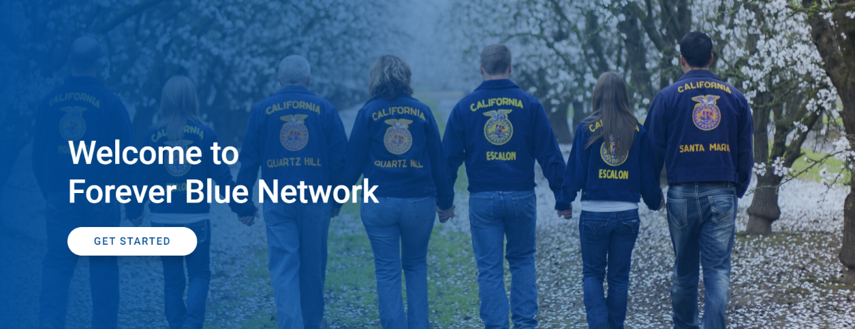
For More Information
Want to know more about FFA Alumni and Supporters?
Learn more about the various roles of FFA Alumni and Supporter by watching this short video.
- Additionally, learn about life membership by watching this video.
- Forever Blue Network for Teachers

Supervised agricultural experience (SAE)
Items included in this section are meant to introduce supervised agriculture experiences and the different types. SAEs allow students to experience hands-on learning, develop skills, explore careers, impact the community and more!
What is an SAE?
A supervised agriculture experience (SAE) is made up of projects or enterprises where you apply agricultural skills and knowledge learned in the classroom to the real world. There are two types of SAE, Foundational and Immersion. Your SAE may include projects from one or any combination of these types. Check out the National Council for Agricultural Education’s “SAE for All Guide” and SAE for All to learn more.
For SAE ideas, use these SAE idea cards. For access to the SAE video library, click here. For SAE testimonial videos, click here.
SAE Types
Foundational SAEs incorporate five essential components, each of which plays a critical role in shaping future agricultural leaders:
- Career exploration and planning
- Personal financial management and planning
- Workplace safety
- Employability skills for college and career readiness
- Agricultural literacy and exploration
The Foundational SAE is a continuous journey that spans a student’s entire enrollment in agricultural education. It blends hands-on experiences to enhance technical knowledge in Agriculture, Food and Natural Resources while also sharpening vital career-readiness skills.
Immersion SAEs are designed to build upon foundational SAE experiences through real-world applications:
- Placement/Internship SAE
- Ownership/Entrepreneurship SAE
- Research: Experimental, Analysis or Invention SAE
- School-Based Enterprise SAE
- Service-Learning SAE
By participating in Immersion SAEs, students can significantly enhance their preparation for a successful career.
Agriscience Fair
The Agriscience Fair is an opportunity that recognizes middle and high school students for their research SAEs. Research SAEs provide students with an in-depth exploration into the scientific aspects of agriculture. These programs involve the investigation of materials, processes and information either to generate new knowledge or validate existing research. Agriscience Research SAEs can be experimental, analytical or inventive research, offering a broad spectrum of inquiry. Through these projects, students are encouraged to collaborate with peers, educators, university researchers and industry specialists.
This journey culminates in an inspiring showcase at the National FFA Convention & Expo, where students proudly present their agriscience research SAEs, demonstrating their growth, expertise and passion for the agricultural sciences.
Agricultural Proficiency Awards
Agricultural Proficiency Awards honor FFA members who, through supervised agricultural experiences, have developed specialized skills they can apply toward their future careers.
Nationally, students can compete for awards in nearly 50 areas ranging from agricultural communications to wildlife management (see areas here). Proficiency awards are also recognized at local and state levels and provide recognition to members who are exploring and becoming established in agricultural career pathways.
- Proficiency Handbooks
- Proficiency Resources
- Application Center

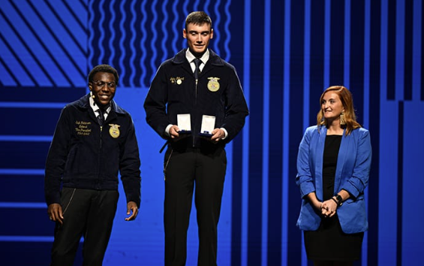
Career and leadership Events (cde/lde)
In this section, you will explore career development events (CDEs) and leadership development events (LDEs). You'll learn how these events help students develop hands-on skills in agriculture, sharpen their leadership and communication abilities and prepare for future careers.
What Is a CDE/LDE?
What are CDEs?
Career development events (CDEs) are competitions designed to measure students’ skills in various agriculture-related fields. These events provide hands-on experience and focus on preparing FFA members for careers in agriculture. Participating FFA members in grades 7 to 12 are challenged to develop critical-thinking skills and effective decision-making skills, foster teamwork and promote communication while recognizing the value of ethical competition and individual achievement. CDE and LDE events occur at the local, state and national levels.
Types of CDEs:
- Agricultural Communications
- Agricultural Issues Forum
- Agricultural Sales
- Agricultural Technology and Mechanical Systems
- Agronomy
- Dairy Cattle Evaluation and Management
- Dairy Cattle Handlers Activity
- Environmental and Natural Resources
- Farm and Agribusiness Business Management
- Floriculture
- Food Science and Technology
- Forestry
- Horse Evaluation
- Livestock Evaluation
- Marketing Plan
- Meats Evaluation and Technology
- Milk Quality and Products
- Nursery/Landscape
- Poultry Evaluation
- Veterinary Science
Benefits of CDEs:
  - Gain practical, industry-specific skills.
  - Develop critical-thinking and decision-making abilities.
  - Explore potential agricultural careers.
  - Network with industry professionals.

What are LDEs?
Leadership development events (LDEs) focus on communication, teamwork and public speaking, helping members strengthen their leadership abilities. These events emphasize presentation skills, interview techniques and collaborative problem-solving, all of which are essential for success in both FFA and future careers. CDE and LDE events occur at the local, state and national levels.
Types of LDEs:
- Conduct of Chapter Meetings
- Creed Speaking
- Employment Skills
- Extemporaneous Public Speaking
- Parliamentary Procedure
- Prepared Public Speaking
Benefits of LDEs:
  - Improve public speaking and communication.
  - Build self-confidence and poise.
  - Learn to work collaboratively and manage teams.
  - Develop essential leadership skills.
Resources for Preparing for CDEs and LDEs
To help students prepare, FFA offers a variety of resources:
- Official FFA Website: The FFA website provides detailed descriptions of each event, the skills required and judging criteria. You can also access study materials and practice exams for many of the events.
- Planning Guide: Use this guide to understand updates for this year’s events. All 2025 event information may be accessed through the CDE/LDE web page.
- CDE/LDE General Resources: This folder contains FAQs, cash award guidelines, AFNR content standards and more.
- CDE/LDE Classroom Resources: Many events have accompanying lesson plans available through the National FFA educator resources.
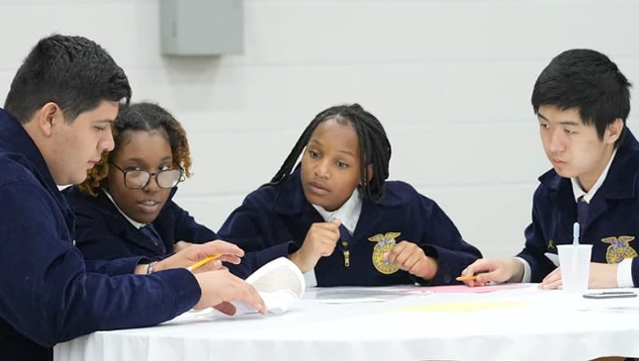
Grants and Scholarships
FFA members have access to a variety of grants and scholarships that support their agricultural education, leadership development and career goals.
Grants in FFA
- Grants for Growing
Grants for Growing (G4G) is a competitive grant program for middle and high school FFA chapters that are developing and improving project-based or experiential-learning opportunities for students.
  - Eligibility: FFA chapters must develop projects in one of three areas: Grow Your Classroom, Grow Your FFA Chapter and Grow Your Ag Awareness.
  - Amount: Up to $5,000 sponsored by Tractor Supply Company (TSC)
  - Learn more about G4G.
- Living to Serve Grants
These Living to Serve Grants provide an opportunity for FFA chapters (middle school, high school or alumni/collegiate) and state FFA associations/foundations to seek funding to support various types of service projects through a competitive application process.
  - Eligibility: Available to chapters and individual members with a clear service project proposal that falls within one of the focus areas — Community Safety; Hunger, Health and Nutrition; Environmental Responsibilities; and Community Engagement
  - Amount: Ranges from $400 to $8,000, depending on the specific grant (yearlong, semester, day of service and state day)
  - Learn more about Living to Serve Grants.
- Supervised Agricultural Experience (SAE) Grants
SAE grants help FFA members fund their projects. These grants can help with the purchase of equipment, supplies or livestock to start or expand an SAE.
  - Eligibility: Grant applications are evaluated by the SAE Grant Committee and are awarded primarily on demonstrated financial need.
  - Amount: $1,000, awarded annually
  - Learn more about SAE Grants.
Scholarships in FFA
National FFA scholarships are available to students pursuing a trade school, vocational certificate, or a two-year or four-year degree to help with their next steps in education.
  - Eligibility: Senior FFA member in high school or FFA alumni in college
  - Amount: Multiple scholarship opportunities totalling nearly $2.5 million
  - Learn more about Scholarships.
How to Apply for Grants and Scholarships
- Application Process: Applications for grants and scholarships are available through the official FFA grants and scholarships website. Each grant and award has its own set of criteria, and FFA members should work with their advisors to ensure they meet the eligibility requirements and submit strong applications.
- Deadlines: Be mindful of application deadlines, which vary for different grants and scholarships. Planning ahead is key to submitting a complete application.
- Helpful Hints for Writing Award Applications; Five Keys to a Great Grant Application
Quick Links: Links to General Supportive Resources
Items included in this section are meant to provide additional resources you may need to understand FFA.
- About Agricultural Education: Understand the agricultural education mission and the three-component model.

- AgEd Academy: An online learning environment designed to enhance understanding of agricultural education through interactive modules

- Ag Education Discussion Lab: This page is dedicated to a discussion of all things agricultural education, especially providing resources and mentors to beginning teachers. It is also a place of discussion for experienced and beginning teachers alike.

- Agriculture Teachers Resource: This guide is intended to serve as a resource for preservice, new, alternatively licensed and experienced agriculture educators. It is a project of The National Council for Agricultural Education and managed by the National Association of Agricultural Educators. It contains resources that have been gathered and developed by agriculture teachers, teacher educators, state staff and staff of the National FFA organization.

- Educator Resources: National FFA free educator resources features lesson plans, educator guides, program management and more!

- FFA Brand Center: This page explains what FFA stands for and its message and gives the proper FFA branding tools.

- FFA Print Center: Need classroom posters and promotional materials? This page has professionally designed printed materials.

- Integral Nature of Instruction: Integral nature of instruction, FFA and SAE in agricultural education

- NAAE #TeachAg Resources: National Association of Agricultural Educators provides resources for school-based agricultural education at any level.

- National FFA website: All things FFA can be found on this page.

- National Teacher Ambassadors for FFA: The National Teacher Ambassadors for FFA are equipped to help answer questions and provide training related to the various educational resources and experiences offered by the National FFA Organization.

Glossary of FFA Acronyms
Common FFA acronyms and terminology are defined in this section.

Acronym | Title | Explanation
AAAE | American Association for Agricultural Education | Association for university agricultural education educators
AAEA | American Agricultural Editors Association | Association for agriculture communicators and marketers
ACTE | Association for Career and Technical Education
AERO | Agricultural Education Related Organization | Common, catchall term used to categorize ag ed partner organizations, especially at the national level and on The Council
APLU | Association of Public Land Grant Universities | AERO group on The Council
Basecamp | Not an acronym | First leadership training for state officers  The second is Checkpoint.
CASE | Curriculum for Agricultural Science Education | National agriscience program run by NAAE
Checkpoint | Not an acronym | One or two in-state or virtual focused meetings with state officers conducted by national trainers on key development topics
CDE | Career Development Event | Events for members to develop skills in a career related area
HBCU | Historically Black Colleges and Universities | AERO group on The Council
ILSSO | International Leadership Seminar for State Officers | Program for 60 to 80 state officers to visit international locations and experience agriculture and leadership abroad
Impact | Not an acronym but rather a conference title as part of the National FFA member leadership series | Student and chapter development conference held at the state level for 11th and 12th graders
LDE | Leadership Development Event | Events for members to develop skills in leadership
LTS | Living to Serve | Programs focusing student efforts toward serving their local communities; various grants available
MANRRS | Minorities in Agriculture, Natural Resources and Related Sciences | AERO group on The Council
Mission | Not an acronym but rather a conference title as part of the National FFA member leadership series | Student development conference held at the state level for 8th and 10th graders
NAAE | National Association of Agricultural Educators
NAAJ | National Association of Agricultural Journalists
NAFB | National Association of Farm Broadcasters
NAMA | National Agri-Marketing Association
NASAE | National Association of Supervisors of Agricultural Education | Organization for state agricultural education leaders
NASDCTEc | National Association of State Directors of Career and Technical Education Consortium
NCF | New Century Farmer | Program focused on helping collegiate students embarking on a career in production agriculture develop their leadership skills for the industry
NFA | New Farmers of America | Agriculture student leadership organization for African-American males from 1935 to 1965
NFRBMEA | National Farm & Ranch Business Management Education Association | AERO group on The Council
NO | National Officer
NQPS | National Quality Program Standards | Council program designed to identify and deliver high-quality programs focused on rigorous goals and continuous improvement
NYFEA | National Young Farmer Educational Association Inc. | Organization for active young agricultural producers
PALS | Partners in Active Learning Support | Program to partner FFA members with elementary students as a mentor/mentee program
PAS | Professional Agricultural Student Organization | Postsecondary student organization and AERO group on The Council
PNO | Past National Officer
PSO | Past State Officer
POA | Program of Activities | This document serves to define chapter goals, outline steps needed to meet those goals and act as a written guide to provide a calendar of events the chapter will follow in the year ahead.
SAE | Supervised Agricultural Experience | Work or research project completed by FFA members as part of the agricultural education program
SO | State Officer
SOS | State Officer Summit | Weeklong conference in July in Washington D.C. specifically for each state’s two leadership delegates as well as their full state officer team to start the national delegate process
SRT/SRS | State Relations Team/State Relations Specialist | Staff employed by National FFA specifically focused on state related support, issues and development
TAE | Team Ag Ed | Collaborative stakeholder group organized to support agricultural education at the local, state and/or national level
The Council | National Council for Agricultural Education | Umbrella organization that helps focus efforts of member AERO groups (AAAE, NAAE, FFA, FFA Alumni, FFA Foundation, NASAE, NYFEA, NFRBMEA, PAS, etc.)
VSO | Visiting State Officer | Most frequently used when describing a visiting state officer to a major conference or convention outside their home state
WLC | Washington Leadership Conference | Weeklong leadership/citizenship conferences for FFA members held in Washington D.C.

