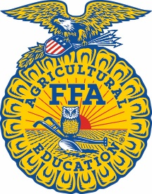
FFA Basics
FFA Mission
FFA makes a positive difference in the lives of students by developing their potential for premier leadership, personal growth and career success.

FFA Code of Ethics
FFA members always conduct themselves to be a credit to their organization, chapter, school, community and family. As an FFA member, I pledge to:
- Develop my potential for premier leadership, personal growth and career success.
- Make a positive difference in the lives of others.
- Dress neatly and appropriately for the occasion.
- Respect the rights of others and their property.
- Be courteous, honest and fair with others.
- Communicate in an appropriate, purposeful and positive manner.
- Demonstrate good sportsmanship by being modest in winning and generous in defeat.
- Make myself aware of FFA programs and activities and be an active participant.
- Conduct and value a supervised agricultural experience program.
- Strive to establish and enhance my skills through agricultural education in order to enter a successful career.
- Appreciate and promote diversity in our organization.


FFA Motto

Learning to Do
Doing to Learn
Earning to Live
Living to Serve

