Chapter Officer Leadership Training Manual
Created: 08/2024 by the National FFA Organization

This guide is a resource for agriculture educators, advisors and chapter FFA officers to assist in planning and executing an engaging Chapter Officer Leadership Training.
Table of Contents

Educational Standards Alignment

Section 1: FFA Basics
Learn how your role as an officer connects to the National FFA Organization.
- FFA Mission, Code of Ethics and Motto
- This resource can assist in teaching the FFA basics to your officer team.
- Opening Ceremonies
  - Use this resource to prepare your officer team for opening ceremonies.
- Officer Roles
  - This resource introduces each of your officers to their roles.

Section 2: Selecting Your Officer Team
Selecting your officer team is a vital component to a successful FFA chapter. Use these resources to begin selecting the most impactful officer team for your chapter. In this section, you will find ideas and templates for implementation within your chapter.
- Example Letter Template
  - Utilize this example template for letters throughout the year.
- Example Letters to Candidates
  - This resource serves as a guide to explain the process and timeline of running for a chapter officer position.
- Example Officer Expectations
  - Consult this resource to explain the expectations of becoming an FFA chapter officer.
- Example Officer Handbook
  - Use this example to share with chapter officer applicants and edit to make it your own.
- Example Officer Applications
  - Use these examples as a starting point for students applying to be chapter officers.
- Example Principal or Teacher Recommendation
  - Engage with this resource to have a principal and/or teachers recommend students for your officer team.
- Example Officer Contracts
  - Use these examples to set high standards for your officer team from the beginning.
- Example Interview Questions
  - Better prepare your officer selection committee with the help of these examples.

Section 3: Planning
A lot happens to get ready for an officer retreat. Use these resources to begin planning the most impactful Chapter Officer Leadership Training for your chapter.
- Example Student and Parent Letter
  - Use this resource to share information about the upcoming chapter officer leadership training.
- Example Packing List
  - Use this resource to prepare students for training.
- Example of a Chapter Officer Leadership Training Plan
  - Use this resource to plan your officer retreat and edit it to fit your needs.

Section 4: Hosting an Officer Retreat
There is a lot that goes into hosting a quality officer retreat. Make sure you are prepared in advance for it to be successful.
References and resources for this section were drawn from the Minnesota FFA Association and the Texas FFA Association, contributing valuable insights and materials to support the content.

- Icebreaker Activities
- These icebreakers can help to get your officers comfortable with each other.
- One-Word Activity
  - For assistance with reflection, use this resource to reflect and create one word to plan the year around.
- Personal Mission Statement Activity
  - Have officers reflect and create their own mission statements.
- Chapter Mission Statement Activity
  - Develop a chapter mission statement for the year with the help of this activity.
- Personal Goals Activity
  - Better assist officers with developing goals for their year.
- Chapter Goals Activity
  - Use this resource to develop shared chapter goals for the year.
- True Colors Assessment
  - Get to know your officer team better through this assessment.
- Enneagram Personality Test
  - Get to know your officer team better through this personality test.
- Chapter SWOT Analysis
  - A SWOT analysis can help to start planning for the upcoming year.
- Start, Stop, Continue Activity
  - Use this resource to start planning for the upcoming year.
- POA Planning
  - Utilize this resource to enhance planning chapter activities for the upcoming year.
- Team-Building Activities
  - Enhance how your officer team works together with the help of these activities.

Section 5: Media, Promotion and Advocacy
The included resources will help you share your FFA chapter’s story throughout the community.
- Tell the FFA Story
  - This resource can better help officers tell your school and community about FFA.
- Social Media Tool Kit
  - Prepare students for properly posting on social media with the help of this kit.
- Social Media Post Examples
  - Utilize these examples to prepare students for properly posting on social media.
- News Release Template
  - This template can better prepare students to write articles for the newspaper.
- Public Service Announcement Scripts
  - Use these scripts to prepare students to speak publicly about FFA.
- Morning Announcement Script
  - Better prepare students for speaking on the announcements through this sample script.
- Planning for Advocacy
  - Prepare students to advocate for agriculture and FFA through this resource.

Section 6: Prepare Your Officer Team for the Year Ahead
The included resources will help you set up your officer team for success in the year ahead.
- Time Management Activity
  - Guide students to manage their time effectively with the help of this activity.
- Planning Expectations
  - Better prepare students for planning out meetings and FFA activities with these expectations.
- How to Properly Run a Meeting
  - Use this resource to prepare students to properly run an FFA meeting.
- Example Agendas
  - These example agendas will help prepare students to create meeting agendas throughout the year.
- Example Meeting Minutes
  - Utilize these example minutes to prepare students to properly take minutes during a meeting.
- Parliamentary Procedure
  - Prepare students to efficiently run a meeting with the assistance of this resource.
- Facilitation Tips and Tricks
  - Equip students for facilitating workshops throughout the year by implementing these tips and tricks.
- Thank-You Note Writing
  - Instruct students to write thank-you notes throughout the year with this activity.
- Writing a Proper Email
  - Instruct students to write professional emails with the assistance of this resource.
- Making a Professional Phone Call
  - Use this resource to prepare students to make professional phone calls.
- Post Officer Retreat Reflection
  - This resource allows officers to reflect on their officer retreat experiences.

Educational Standards Alignment
FFA Precept
- FFA.PL-A.Action: Assume responsibility and take the necessary steps to achieve the desired results, no matter what the goal or task at hand.
- FFA.PL-B.Relationship: Build relationships, work as a team player and appreciate the talents of others.
- FFA.PL-C.Vision: Visualize the future and how to get there.
- FFA.PL-D.Character: Conduct oneself appropriately in relation to others regardless of the situation.
- FFA.PL-E.Awareness: Understand personal vision, mission and goals.
- FFA.PL-F.Continuous Improvement: Accept responsibility for learning and personal growth.
- FFA.PG-H.Social Growth: Successfully interact with others and adapt to various social situations.
- FFA.PG-I.Professional Growth: Assume responsibility for attaining and improving upon the skills needed for career success.
- FFA.PG-J.Mental Growth: Embrace cognitive and intellectual development relative to reasoning, thinking and coping.
- FFA.CS-M.Communication: Effectively interact with others in personal and professional settings.
- FFA.CS-N.Decision Making: Analyze a situation and execute an appropriate course of action.
- FFA.CS-O.Flexibility/Adaptability: Be flexible in various situations and adapt to change.
Common Core — Reading: Informational Text
- CCSS.ELA-Literacy.RI.9-10.4 Determine the meaning of words and phrases as they are used in a text, including figurative, connotative, and technical meanings; analyze the cumulative impact of specific word choices on meaning and tone (e.g., how the language of a court opinion differs from that of a newspaper).
Common Core — Writing
- CCSS.ELA-Literacy.W.9-10.2 Write informative/explanatory texts to examine and convey complex ideas, concepts, and information clearly and accurately through the effective selection, organization, and analysis of content.
- CCSS.ELA-Literacy.W.9-10.6 Use technology, including the Internet, to produce, publish, and update individual or shared writing products, taking advantage of technology’s capacity to link to other information and to display information flexibly and dynamically.
Common Core — Speaking and Listening
- CCSS.ELA-Literacy.SL.9-10.1 Initiate and participate effectively in a range of collaborative discussions (one-on-one, in groups, and teacher-led) with diverse partners on grades 9-10 topics, texts, and issues, building on others' ideas and expressing their own clearly and persuasively.
- CCSS.ELA-Literacy.SL.9-10.2 Integrate multiple sources of information presented in diverse media or formats (e.g., visually, quantitatively, orally) evaluating the credibility and accuracy of each source.
- CCSS.ELA-Literacy.SL.9-10.5 Make strategic use of digital media (e.g., textual, graphical, audio, visual, and interactive elements) in presentations to enhance understanding of findings, reasoning, and evidence and to add interest.
Common Core — Literacy in Science & Technical Subjects: Writing
- CCSS.ELA-Literacy.WHST.9.10.4 Produce clear and coherent writing in which the development, organization, and style are appropriate to task, purpose, and audience.
- CCSS.ELA-Literacy.WHST.9.10.6: Use technology, including the Internet, to produce, publish, and update individual or shared writing products, taking advantage of technology’s capacity to link to other information and to display information flexibly and dynamically

AFNR Career Ready Practices
- CRP.02. Apply appropriate academic and technical skills. Career-ready individuals readily access and use the knowledge and skills acquired through experience and education to be more productive.
- CRP.04. Communicate clearly, effectively, and with reason. Career-ready individuals communicate thoughts, ideas and action plans with clarity, whether using written, verbal and/or visual methods.
- CRP.06. Demonstrate creativity and innovation. Career-ready individuals regularly think of ideas that solve problems in new and different ways, and they contribute those ideas in a useful and productive manner to improve their organization.
- CRP.07. Employ valid and reliable research strategies. Career-ready individuals are discerning in accepting and using new information to make decisions, change practices or inform strategies.
- CRP.08. Utilize critical thinking to make sense of problems and persevere in solving them. Career-ready individuals readily recognize problems in the workplace, understand the nature of the problem, and devise effective plans to solve the problem.
- CRP.11. Use technology to enhance productivity. Career-ready individuals find and maximize the productive value of existing and new technology to accomplish workplace tasks and solve workplace problems.
Partnership for 21st Century Skills
- Critical Thinking
- Creativity
- Collaboration
- Communication
- Flexibility and Adaptability
- Initiative and Self-direction
- Leadership and Responsibility
- Technology Literacy
- Think Creatively

How To Implement
Utilize the table below for ideas on how to integrate this manual into your chapter officer training.

Section 1 | Section 2 | Section 3 | Section 4 | Section 5 | Section 6
Utilize all three resources. | Select one from each of the resources. | Choose one from each of the resources. | Utilize the following:  -Three icebreakers.  -One-word activity.  -Personal and chapter mission statement activities or personal and chapter goals activities.  -One of the personality tests.  -Chapter SWOT analysis.  -Start, stop, continue activity.  -POA planning.  -Two team-building activities. | Choose one from each of the resources. | Utilize one from each of the resources.

Section 1: FFA Basics 
Learn how your role as an officer connect to the National FFA Organization.
- FFA Mission, Code of Ethics and Motto
- This resource can assist in teaching the FFA basics to your officer team.
- Opening Ceremonies
  - Use this resource to prepare your officer team for opening ceremonies.
- Officer Roles
  - This resource introduces each of your officers to their roles.


FFA Basics
FFA Mission
FFA makes a positive difference in the lives of students by developing their potential for premier leadership, personal growth and career success.

FFA Code of Ethics
FFA members always conduct themselves to be a credit to their organization, chapter, school, community and family. As an FFA member, I pledge to:
- Develop my potential for premier leadership, personal growth and career success.
- Make a positive difference in the lives of others.
- Dress neatly and appropriately for the occasion.
- Respect the rights of others and their property.
- Be courteous, honest and fair with others.
- Communicate in an appropriate, purposeful and positive manner.
- Demonstrate good sportsmanship by being modest in winning and generous in defeat.
- Make myself aware of FFA programs and activities and be an active participant.
- Conduct and value a supervised agricultural experience program.
- Strive to establish and enhance my skills through agricultural education in order to enter a successful career.
- Appreciate and promote diversity in our organization.


FFA Motto

Learning to Do
Doing to Learn
Earning to Live
Living to Serve

Opening and Closing Ceremonies
Opening the Meeting

President: “The __________ (meeting room, banquet hall, etc.) will come to order. We are now holding a meeting of the _________ FFA chapter. Mr./ Mdm. Vice President or Vice President (Last Name), are all officers at their stations?”

Vice President: (Rising and facing the president) “I shall call the roll of officers, determine if they are at their stations and report back to you, Mr./Mdm. President or President (Last Name).”

Vice President: (Calling roll of officers) “The chaplain*.”

Chaplain*: “Stationed by the dove.”

Vice President: “Your duties there?”

Chaplain*: ”The dove is an international symbol of peace and love. It is my duty to welcome FFA members of all faiths and beliefs. I assist in fostering positive, moral participation in chapter activities and the lives of our members.”

Vice President: “The historian*”

Historian*: “Stationed by the historical scroll.”

Vice President: ”Your duties there?”

Historian*: “I keep an accurate record of the history of our chapter and its members. I preserve and document our chapter membership, officers, events, and teams. I organize the chapter scrapbook and serve as a reference on chapter history. Our FFA chapter is stronger by honoring our history.”

Vice President: ”The parliamentarian*”

Parliamentarian*: “Stationed by the fasces.” [FA-seez]

Vice President: ”Your duties there?”

Parliamentarian*: “The fasces is a symbol of order and authority. I assist the President in conducting the business of our organization by following the principles of parliamentary procedure. I refer to Robert's Rules of Order Newly Revised, our constitution, and bylaws, to ensure that every member will be heard and that the majority will prevail.”

Vice President: “The sentinel.”

Sentinel: “Stationed by the door.”

Vice President: “Your duties there?”

Sentinel: “Through this door pass many friends of the FFA. It is my duty to see that the door is open to our friends at all times and that they are welcome. I care for the meeting room and paraphernalia. I strive to keep the room comfortable and assist the president in maintaining order.”

Vice President: “The reporter.”

Reporter: “The reporter is stationed by the flag.”

Vice President: “Why by the flag?”

Reporter: “As the flag covers the United States of America, so I strive to inform the people in order that every man, woman and child may know that the FFA is a national organization that reaches from the state of Alaska to the Virgin Islands and from the state of Maine to Hawaii.”

Vice President: “The treasurer.”

Treasurer: “Stationed at the emblem of Washington.”

Vice President: “Your duties there?”

Treasurer: “I keep a record of receipts and disbursements just as Washington kept his farm accounts—carefully and accurately. I encourage thrift among the members and strive to build up our financial standing through savings and investments. George Washington was better able to serve his country because he was financially independent.”

Vice President: “The secretary.”

Secretary: “Stationed by the ear of corn.”

Vice President: “Your duties there?”

Secretary: “I keep an accurate record of all meetings and correspond with other secretaries wherever corn is grown and FFA members meet.”

Vice President: “The advisor.”

Advisor: “Here by the owl.”

Vice President: “Why stationed by the owl?”

Advisor: “The owl is a time-honored emblem of knowledge and wisdom. Being older than the rest of you, I am asked to advise you from time to time, as the need arises. I hope that my advice will always be based on true knowledge and ripened with wisdom. “Mr./Mdm. Vice President or Vice President (Last Name), why do you keep a plow at your station?”

Vice President: “The plow is the symbol of labor and tillage of the soil. Without labor, neither knowledge nor wisdom can accomplish much. My duties require me to assist at all times in directing the work of our organization. I preside over meetings in the absence of our president, whose place is beneath the rising sun.”

Advisor: “Why is the president so stationed?”

Vice President: “The rising sun is the token of a new era in agriculture. If we will follow the leadership of our president, we shall be led out of the darkness of selfishness and into the glorious sunlight of brotherhood and cooperation. Mr./Mdm. President or President (Last Name), all officers are at their stations.”

President: (Rises and faces the vice president) “Thank you, Mr./Mdm. Vice President or Vice President (Last Name).” (All take seats at tap of gavel.) “The secretary will call the roll of members.”

Secretary: “There are __________ members and __________ guests present, Mr./Mdm. President or President (Last Name).”

President: “Thank you. FFA members, why are we here?” (All members stand at three taps of gavel.)

All members in unison: “To practice brotherhood, honor agricultural opportunities and responsibilities and develop those qualities of leadership which an FFA member should possess.” (All are seated at one tap of gavel.)

President: “May we accomplish our purposes. I now declare this meeting of the ________ FFA Chapter duly open for the transaction of business, or attention to any matters which may properly be presented.”

Closing the Meeting

President: “Mr./Mdm. Secretary or Secretary (Last Name), do you have a record of any further business which should now be transacted?”

Secretary: (Rises, replies and is seated.) “I have none, Mr./Mdm. President or President (Last Name).”

President: “Does any member know of any new or unfinished business which should properly come before this meeting? (If no answer, proceed as follows.) “We are about to adjourn this meeting of the _______ FFA chapter. As we mingle with others, let us be diligent in labor, just in our dealings, courteous to everyone and, above all, honest and fair in the game of life. Fellow members and guests, join me in a salute to our flag.” (Tap three times with gavel to call members to stand, face the flag at the reporter’s station and, with their right hands over their hearts, repeat the following salute.)

All in unison: “I pledge allegiance to the Flag of the United States of America and to the Republic for which it stands, one Nation under God, indivisible, with liberty and justice for all.”
President: “I now declare this meeting adjourned.” (Tap once with gavel and the meeting is adjourned.)

Officer Roles and Responsibilities


President

“Beneath the Rising Sun”

- Presides over meetings.
- Appoint committees.
- Coordinate activities of the chapter and evaluate the progress of each division of the Program of Activities.
- Represent the chapter in public relations and official functions.

FFA Advisor

“Here by the Owl”

- Supervise chapter activities.
- Inform students and parents about FFA.
- Instruct students in leadership and personal development.
- Build school and community support.
- Encourage involvement of FFA members in activities
- Prepare students for involvement in career and leadership development events.


Secretary

“Stationed by the Ear of Corn”

- Prepare and post the agenda for each chapter meeting.
- Prepare and present the minutes of each chapter meeting.
- Place all committee reports in the secretary’s file.
- Maintain chapter correspondence.
- Maintain member attendance and activity records.


Vice President

“Stationed by the Plow”

- Assume all duties of the president, if necessary.
- Develop the POA and serve on the committees.
- Coordinate all committee work.
- Work closely with the president and advisor to assess progress toward meeting chapter goals.


Reporter

“Stationed by the Flag”

- Serves as public relations committee chair.
- Plans public information programs with local radio, television and newspaper.
- Releases news and information to local and regional news media.
- Publishes a chapter newsletter or website.
- Prepares and maintains a chapter scrapbook.
- Sends local stories to news reporters and to any school publications.
- Sends articles and photographs to FFA New Horizons and other national and regional publications.
- Works with local media on radio and television appearances and FFA news.
- Serves as the chapter photographer.


Treasurer

“Stationed at the
Emblem of Washington”

- Receives, records and deposits FFA funds and issues reports.
- Presents monthly treasurer reports at chapter meetings.
- Collects dues.
- Maintains neat and accurate records.
- Prepares and submits the membership roster to the National FFA Organization through the state FFA association.
- Serves as the finance committee chair.

Sentinel

“Stationed by the Door”

- Assists the president in maintaining order.
- Keeps the meeting room, chapter equipment and supplies in order.
- Welcomes guests and visitors.
- Keeps the meeting room comfortable.
- Takes charge of candidates for degree ceremonies.
- Assists with special features and refreshments.


Parliamentarian

“Stationed by
the Fasces”

- Is proficient with parliamentary procedure.
- Rules on all questions of parliamentary conduct at chapter meetings.
- Serves as a participant of the parliamentary procedure team.
- Conducts parliamentary procedure workshops at the chapter level.
- Chairs the committee for the conduct of meetings.


Historian

“Stationed by
the Historical Scroll”

- Develops and maintains a chapter scrapbook to record the chapter’s history.
- Researches and prepares items of significance in the chapter’s history.
- Prepares displays of chapter activities and submits stories of former members to the media.
- Assists the reporter in providing photography for chapter needs.

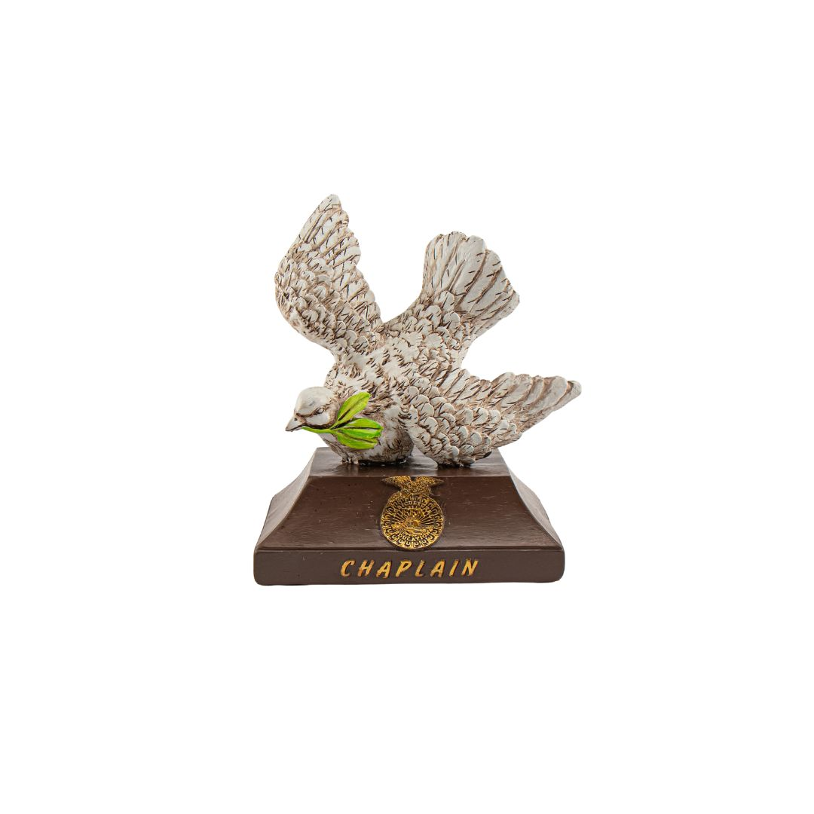
Chaplain

“Stationed by the Dove”

- Presents the reflections at banquets and other functions.
- Conducts reflection services at summer camps and conferences.


Section 2: Selecting Your Officer Team
Selecting your officer team is a vital component to a successful FFA chapter. Use these resources to begin selecting the most impactful officer team for your chapter. In this section, you will find ideas and templates for implementation within your chapter.
- Example Letterhead Template
  - Utilize this example template for letters throughout the year.
- Example Letters to Candidates
  - This resource serves as a guide to explain the process and timeline of running for a chapter officer position.
- Example Officer Expectations
  - Consult this resource to explain the expectations of becoming an FFA chapter officer.
- Example Officer Handbook
  - Use this example to share with chapter officer applicants and edit to make it your own.
- Example Officer Applications
  - Use these examples as a starting point for students applying to be chapter officers.
- Example Principal or Teacher Recommendation
  - Engage with this resource to have a principal and/or teachers recommend students for your officer team.
- Example Officer Contracts
  - Use these examples to set high standards for your officer team from the beginning.
- Example Interview Questions
  - Better prepare your officer selection committee with the help of these examples.

Example Letterhead Template

Example Letter 1 to Candidates 
Below is a sample letter to assist you in recruiting candidates for your chapter officer positions.

Sample Letter to Candidates

To: Chapter Officer Candidates

From: (Insert advisor name)

RE: Chapter Officer Selection Process

Congratulations on being one of the FFA members considered for a chapter FFA office. The next few weeks are sure to be some of the most exciting times of your life. It is our hope that you will strive to make this time enjoyable and an extremely valuable learning experience for yourself. The greatest rewards can be achieved regardless of whether you’re nominated or elected. Let’s make it a positive, meaningful event for everyone.

Selection Process
The procedure will focus on trends that our counterparts in business and industry are using to find the “right” people for the “right” job. For the selection process, the nominating committee will consider the following components:
- Completing the officer application.
- Writing and presenting a one- to two-minute speech.
- Interviewing with the committee.
- If slated for an office, presenting speech before FFA members.
The timeline for events is as follows:
- Applications available: (insert date, about two months prior to installation)
- Applications due: (insert date)
- Interviews for all candidates: (insert date)
- Officer election for slated candidates: (insert date)
- Officer installation at chapter banquet: (Insert date)
Chapter Officer Handbook
Please review the enclosed Chapter Officer Handbook. It clarifies the expectations of chapter office including required activities.

If you have any questions about any part of the process or the expectations of Chapter FFA Officers, please contact me or a graduating senior officer [Insert names].

Example Letter 2 to Candidates
Below is a sample letter to assist you in recruiting candidates for your chapter officer positions.

Sample Letter to Candidates

To: Chapter Officer Candidates

From: [Insert advisor name]

RE: Chapter Officer Selection Process

Thank you for expressing interest in becoming a ________ FFA Officer. Like all FFA chapters, _________ FFA is a student-led organization; our officers play a vital role in conducting meetings, organizing events and supporting other members. The purpose of this letter is to explain the opportunities available and the expectations of officers as well as give a brief outlook on the year ahead. It is our goal to provide the best possible team for our chapter and help those students develop into successful leaders.

Since our chapter is run by the members, being an officer provides ample opportunity for developing leadership skills and character. Officers often run into situations where they have difficult choices to make: solving conflicts with other members, scheduling around other activities or conducting business at a meeting that affects all members. Making choices such as these provides members with the scaffolding they need to develop into leaders. Chapter officers will also have the opportunity to travel across the country. They may attend National FFA Convention in Indianapolis, Ind., or Washington Leadership Conference in our nation’s capital. Students will also be able to attend local FFA banquets to get to know their peers in other towns.

The following pages of this packet include a guideline for student conduct and a list of responsibilities for the entire officer team as well as individual obligations for specific offices. Please read through these and return the signature page. Serving as a chapter officer is a significant time commitment. Elected students serve a one-year term with different events happening every month of the year. Some of these events require early mornings and late nights; however, it is important to be able to balance school, work, family and other activities. During our selection process, students will submit an application (attached) and schedule a time to be interviewed by a committee. This committee will consist of the chapter advisors, a representative of the ______ FFA Alumni, a representative of the _______ Ag Ed Advisory Committee, a senior officer and an additional volunteer. Listed in this packet are the available positions. Each position has different responsibilities, which are explained in the following pages, but all are important. Please keep in mind the order in which they are listed does not signify a “ranking.” They are listed according to the order presented in the official FFA handbook. After all interviews are conducted, the committee will provide a slate of officers for the members to vote on. If the committee decides not all offices will be filled, the positions will be left open.

_______ FFA has a ___ year history of successful students. Members have won state career development events, proficiencies and state star awards, but the focus is always on providing students with the abilities they need to make a positive impact on their community. The basis for this success is the chapter officer team. We look forward to another successful year in _______.

Sincerely,

______ and ______, _________ Chapter Advisors

Example Officer Expectations 1
Expectations of the Chapter Officers

- This is YOUR organization, NOT the ag teachers’!
- Your number one priority and focus as a chapter officer is to serve the needs of the members of your chapter.
- The success of chapter officers is evaluated by team performance, not necessarily individual performance. Learn how to help each other become better leaders.
- Learn how to effectively win friends and influence those with differing viewpoints.
- It is expected that each chapter officer be a positive role model for the members of the chapter. (Suspensions, probations and repetitious disciplinary action is unacceptable.)
- It is expected that each chapter officer strives aggressively to achieve and maintain academic success.
- NEVER tell members or friends how important YOU are!
- NEVER use the word “I” or allow your individual ego to interfere with the functioning of the team.
- Conduct yourself in a dignified and professional manner at all times.
- Always be courteous and respectful to all members and advisors 100% of the time.
- Be discreet! Keep our business within the group. Communication is key to air likes, dislikes and other issues.
- DO NOT BE AFRAID OF THE POSSIBILITY OF FAILURE OR SUCCESS!
- When you need help, ask for it!
- NEVER wait until the last minute to complete your assignments.
- Give 100% effort!
- Be enthusiastic at all times. (You never know who is watching!)
- Learn how to be an effective leader and still have fun.
- Remember: “The task ahead of you is never as great as the power behind you!”
I have read and understand the "Expectations of the Chapter Officers. “I understand they apply to me in my pursuit of a position on the Chapter Officer Team. I further understand that failure to comply to the expectations may result in my early dismissal from the team.

Student Signature Date

I have read, and understand, that the "Expectations of the Chapter Officers" listed above apply to my child who is pursuing a position on the Chapter Officer Team.

Parent/Guardian Signature Date
Example Officer Expectations #2

General Responsibilities and Expectations

Conduct
FFA Code of Ethics
“FFA members conduct themselves at all times to be a credit to their organization, chapter, school, community and family. FFA members pledge to:
- Develop my potential for premier leadership, personal growth, and career success.
- Make a positive different in the lives of others.
- Dress neatly and appropriately for the occasion.
- Respect the rights of others and their property.
- Be courteous, honest, and fair with others.
- Communicate in an appropriate, purposeful, and positive manner.
- Demonstrate good sportsmanship by being modest in winning and generous in defeat.
- Make myself aware of FFA programs and activities and be an active participant.
- Conduct and value a supervised agricultural experience program.
- Strive to establish and enhance my skills through agricultural education in order to enter a successful career.
- Appreciate and promote the diversity in our organization.”
FFA officers must also comply with the student policies of ________ High School.

Responsibilities
- Attending all FFA functions is not required but is encouraged. These activities may include:
  - Local meetings (Monthly)
  - Parliamentary Procedure Practices (August-October)
  - District Leadership (October)
  - Fundraiser (October-December)
  - Winter Leadership (January)
  - Winter Career Development Events (January-March)
  - Local FFA banquets (March-May)
  - State FFA Convention (June)
  - Fairs (July)
  - National FFA Convention (October)
  - Washington Leadership Conference (June-July)
  - Officer Retreat (June-August)
- All officers are responsible for the following:
  - Opening ceremonies
  - Attending meetings
  - Assisting with chapter activities

Example Officer Handbook

(insert chapter)
FFA

Chapter Officer
Handbook
Insert Year

Becoming a chapter FFA officer is a challenging yet very rewarding opportunity. Through this chapter officer candidate process, you will grow as a person and advance in leadership development and career preparation. Congratulations on deciding to run for office!

Although chapter FFA office takes a great deal of hard work and dedication, officers will gain experiences and contacts that will last a lifetime. The skills gained will help prepare them for future careers, opportunities in college and leadership roles in other organizations. Chapter officers serve the _________ FFA members and advisors. They make a positive difference in the lives of many people.

This handbook is to help you prepare your candidacy for chapter FFA office. In it, you will find everything you need to get you on your way. Please thoroughly review all the enclosed information as you prepare for the chapter officer selection process.

Remember, this handbook is only the beginning! As a candidate, you will need to study agricultural education and FFA information as well as practice interviewing and presenting yourself in front of people. It will take your personal commitment and dedication to truly prepare for this process. You know yourself best! You know what areas you need to work on. We wish you the very best.

If you have any further questions regarding the responsibilities of chapter officers, or the
selection process, please contact your chapter advisor.

Organization
The __________ FFA Officers are overseen by the FFA advisor and the other agriculture teachers with support by the school administrative office. There will be _____ elected chapter officers for the school year, and the officers will be announced at the spring chapter banquet.

Qualifications
To participate in the _________ FFA Chapter Officer program, officer candidates must meet all of the eligibility requirements:
- Have and maintain a 2.0 GPA or higher.
- Have and maintain a clean discipline and attendance record.
- Attend the summer Chapter Officer Retreat scheduled for ______________.
- Have a signed, completed application on file with the chapter advisor.
- Have a signed, completed chapter Code of Ethics on file with the chapter advisor.
- Be a member of the local FFA chapter for the current school year.
- Review the Chapter Officer Handbook.
- Go through the chapter selection process.
Discipline
All FFA chapter officers will be placed on behavior contracts for any of the offenses listed below. The chapter officer is allowed two chances to improve their behavior, with the third offense resulting in removal from the team.

Offenses:
- Not abiding by the FFA Code of Ethics
- Unexcused absences: Anything but an illness or family emergency.
Offenses resulting in immediate removal from the Chapter Officer Team:
- Use and/or possession of alcohol or drugs.
- Use and/or possession of tobacco.
- Stealing or possession of stolen goods.
- Use and/or possession of weapons.
- Defiance of advisor, administrator or other teacher.
- Two consecutive grading periods below 2.0 GPA.
- Fighting.

A parent/guardian and/or officer has the right to request a hearing regarding this action. The hearing will be held as soon as possible with a panel consisting of an administrator, advisor, officer’s counselor and one teacher. The officer and parent will be given the opportunity to present reasons for this action to be voided. The decision of the panel will be final.

Required Activities Calendar
The following activities are required of all chapter officers. A description of the activities and calendar are as follows:

Activity Date

Candidate and Parent Meetings
Chapter Meeting – Selection Process
Initial Officer Retreat
Executive Committee Meetings
Chapter Meetings Midyear Retreat Chapter Banquet

Example Officer Application 1
Name: ______________________ Grade Level: ________________________

Highest Degree Earned: ________________

Agriculture class you will be enrolled in next year*:
*You must be enrolled in an agricultural education class both the fall and spring semesters to be a chapter officer.

Please type the following information. You may submit two (2) additional pages stapled to the back of this front/back information page.

1. List all FFA leadership roles you have experienced (officer, committees, etc.).

2. List all FFA activities/CDEs you have participated in, excluding seminar and night meetings.

3. List any FFA awards or honors you have received.

4. List involvement in school/community activities outside the FFA.

5. Describe leadership qualities you possess that would qualify you to be a chapter officer.

6. List at least three ideas for new chapter activities for the upcoming year.

7. Explain your present SAE program.

8. Describe why you want to become a chapter officer.
Example Officer Application 2

FFA Officer Application
Name: ______________________ Grade Level: ________________________

Agriculture class for upcoming school year: ________________

Preferred Office (Please rank 1st, 2nd, 3rd and 4th choices.)
President |  | Vice President |  | Secretary |  | Treasurer
Reporter |  | Sentinel |  | Parliamentarian |  | Chaplain
Historian |  | Student Advisor

FFA Activities (previous offices held, CDEs, events)

Other School/Community Activities

Essays
Please list one chapter goal for the ______ school year and explain how you will help work toward that goal.

How do you plan to make FFA a priority throughout the school year?

Recruitment is a major need for any FFA chapter. What ideas do you have for how we can recruit new members to join our chapter?

Example Officer Application 3
Chapter Officer Application

Applicant’s Name:

Address:
City: State: ZIP:
Phone Number: Grade: Age:

Agriculture classes planned for the coming year:

Rank from one to six your preference of officer positions you want to be considered for, if you are elected. (One is your most desired spot, and six is your least desired spot.)
(First-year applicants are eligible for sentinel, parliamentarian, historian and chaplain only.)

President | Vice President | Secretary | Treasurer | Reporter
Sentinel | Parliamentarian | Historian | Chaplain

1. Briefly state the qualities you possess that qualify you for a chapter office.

2. If you were elected to a chapter office, what would be your main goal for the chapter?

3. Describe your experiences speaking in front of large groups of students/people.

4. Select one of your personal qualities and explain how it will be of value to the chapter officer team.

5. What other commitments do you have in the year that would compete for your time?
6. What do you believe are the most important responsibilities of a chapter officer?

I, , hereby approve of my child, , running/becoming a FFA Chapter Officer for the school year. I realize that they are responsible for their officer duties and will uphold them to the best of their ability. I further understand my child is required to be at all executive committee meetings, on time, or will fall subject to the fees associated with absence and tardiness. I am aware that repeated absences (no more than three) from official officer functions will result in my student’s early dismissal from the officer team. Their presence at the officer retreat is mandatory!
Parent/Guardian Signature:
Date:

I understand I am responsible for my duties as a chapter officer and will uphold them to the best of my ability. I further understand I am required to be at all executive committee meetings, on time, or will fall subject to the fees associated with absence and tardiness. I am aware that repeated absences from required functions will result in my being dismissed from the officer team early. My presence at the officer retreat is mandatory!

Applicant Signature:

Example Principal/Teacher Recommendation
(insert chapter name) FFA

PRINCIPAL OR TEACHER RECOMMENDATION

Please rate this student in each of the following areas. Please be completely honest in your evaluation. This will not be seen by the student or parent/guardian. Please complete and turn in to (insert advisors name) box by (insert date).

Student’s Name: ___________________ Teacher’s Name: ________________

Category | Outstanding | Good | Fair | Poor
Responsibility
Respect for Authority
On Time to Class
Cooperative
Attitude
Gets Along with Others

Comments: Please justify the above ratings (especially outstanding and poor ratings).

Place this recommendation in (insert advisors name)’s box.
DO NOT GIVE IT BACK TO THE STUDENT. These are confidential.
Thank you for your time!

Example Officer Contract 1
____________ FFA Chapter Officer Contract

As an officer of the __________ FFA Chapter, I will (initial each):

- Give precedence to FFA over other activities when there is no chance to work out a compromise.
- Attend State Conference for Chapter Leaders in July (July 10,11,12 OR July 13,14, 15) and Chapter Officer Retreat during the summer
- Attend all weekly officer meetings and monthly chapter meetings (seminar and night).
- Cooperate with other officers and maintain a friendly attitude with them, always working as a team.
- Abide by the National FFA Code of Ethics and School Policies.
- Set an example for other members by my positive actions both inside and outside of the classroom and take part in all fundraising activities.
- Obtain and wear proper official dress at all meetings and official functions.
- Accept all responsibilities of the office I receive.

I have read and understand the above information. As an officer, I understand that I am required to abide by the high school drug and alcohol policy. Any violation at any time will result in my removal from the officer team.

If elected to a chapter office, I will fulfill my responsibilities in accordance with these statements. I understand I will be removed from office by the Advisor or membership if I have not followed the established standards for chapter FFA office.

Student Signature: Date:

Parent Signature: Date:

Advisor’s Signature: Date:

Example Officer Contract #2
____________ FFA Chapter Officer Contract
As an officer of the __________ FFA chapter, I will (initial each)
Area 1: This Is It!
- Be on time for all meetings, activities and departure times.
- Write dates for activities down in a planner.
- Keep our team and my office as a priority.
- Attend all officer meetings, seminar and night meetings.
- Attend all activities as I am able. If I cannot attend, I will let other officers/advisors know ahead of time.
- Be responsible by staying on task and sticking to the agenda at meetings.
- Always support each other and look for ways to help lighten my fellow officers’ loads.
Area 2: Living Above the Line
- Be honest with each other and be open to others’ honesty.
- Engage in confrontations only if necessary and away from school/FFA activities.
- Not talk behind the back of my fellow officers.
- Communicate with advisors.
- Keep my family informed of what the team and I are doing.
- Approach my teammates appropriately.
- Encourage ALL members.
- Take time to get to know ALL members.
- Step away from cliques and meet and learn about new people.
- Be a resource to members.
- Force and maintain a positive attitude.
Area 3: Pay It Forward
- Help my fellow officers, the members and our chapter.
- Maintain a community focus with activities and/or community service.
- Develop creative ideas to get members involved.
- Be involved and act as an example.
- Always wear proper official dress.
- Communicate a positive attitude about wearing official dress.
- Wear appropriate clothing to all events.
- Conduct myself in an appropriate manner at FFA events and outside FFA.
- Treat all members equally.
- Step out of my comfort zone.
- Provide constructive criticism for my teammates and fellow members.
- Have a member-focused attitude and actions.
- Guarantee incentives for member participation.
- Get members to buy in.
I have read, studied and understand the intent and the spirit of the three areas to our chapter officer team’s success. I will commit to modeling the three areas of success. I understand that failure to do so may result in limitations being set on my roles as a/an FFA officer and/or possible removal from office.

Student Signature: ____________________________ Date: ________________
Example Officer Interview Questions 1

What do you think makes a good officer?

Do you think you would make a good officer? Why?

What are your goals for this coming year?

What do you think makes you an honest person?

Do you think you would treat everyone with respect including your advisor?

Do you feel you are a lazy person?

What is your weakest quality? How do you plan to work that to the chapter’s advantage?

Do you feel you would be able to keep your chapter organized?

Is there anyone you think could replace you or be a better officer?

If you could select one person to assist you, whom would you choose from the chapter?

What is something you would go out of your way to do for the chapter?

Do you think you are a positive person?

What do you think the chapter needs? Do you think you could achieve those needs? How?

What are your expectations for the chapter?

What do you think the chapter’s expectations are of you?

List at least five activities you have participated in at the chapter level. Indicate years/amounts.

List at least two activities you have participated in above the chapter level. Indicate years/amounts.

What other high school and/or community activities are you involved in? How will you combine them with your officer responsibilities?

Briefly describe your complete SAE program.

What officer position do you mostly prefer and why? (Choose only one.)

If you became an officer, what activities would you like the _______ FFA Chapter to participate in?

Are there any involvements you foresee that may interfere with your commitment as an FFA officer? If so, please list.

List efficiencies attained in your SAE program.

List the major skills, competencies and knowledge you have gained through your SAE. How have these contributed to your continued success?

Describe the progress you are making toward achieving your career goals.

List major outcomes realized, or contributions made while serving as an officer.

List major outcomes realized, or contributions made other than serving as an FFA officer.

- Why do you desire to serve as an ______ FFA officer?
Other Potential Questions:
- How would you describe a good officer?
- What makes you feel important or significant? Do you have an example?
- Do you think it is all right to tell a white lie sometimes? Explain.
- How important is it to you that the people who serve on your officer team think well of you?
- How do you feel about unfinished work? Do you have an example?
- How do you feel about you or another officer that owes money to the chapter?

Example Officer Interview Questions 2
- What are your biggest strengths?
- What are your biggest weaknesses?
- Why do you want to be an officer?
- If you could change one thing about our chapter, what would it be?
- Describe a time when you solved a problem on a team.
- Describe a time when you balanced a long to-do list.
- What other activities and events do you participate in, and how will you balance those with your officer duties?
- How do you handle conflict?
- What are your goals as an officer?
- What are your goals in FFA?
- Tell me about your leadership style.
- What three qualities do you believe an officer should possess?
- What do you like most about our chapter?
- What is servant leadership?
- Do you have to have a title to be a leader?
- What officer position would you most like and why?
- How do you deal with stress?
- Describe a time you had to problem solve.
- What is your leadership experience?
- What issues do you see facing agriculture in our community, state and country today?
- How can we increase membership?
- What should goals for our chapter look like?

Section 3: Planning
A lot happens to get ready for an officer retreat. Use these resources to begin planning the most impactful Chapter Officer Leadership Training for your chapter.
- Example Student and Parent Letter
  - Use this resource to share about the upcoming chapter officer leadership training.
- Example Packing List
  - Use this resource to prepare students for training.
- Example of a Chapter Officer Leadership Training Plan
  - Use this resource to plan your officer retreat and edit it to fit your needs.

Example Student and Parent Letter
Dear Students and Parents/Guardians,
Thank you for allowing your student to attend the chapter officer leadership training. We will be leaving the school at ______ on __________. All expenses for the officer are covered by the chapter. We will return to the school at _______ on ___________. Included is a schedule for the officer training and a packing list for students. We will be staying at _____________.
What is the chapter officer leadership training all about?
Chapter Officer Leadership Training
The purpose of the officer retreat is to spend some time preparing for the upcoming year by setting goals, team building and planning. Being an officer is a big responsibility and the retreat is a great place to get the year started off right.

On this trip, students will be expected to follow the FFA Code of Ethics and the ____________ Public School Policies. Violations of these will result in you having to pick your student up and potential removal from the officer team.

Sincerely,

___________ FFA Advisor

Example Packing List

- Official Dress (Worn for officer photos)
  - FFA Jacket
  - Tie/Scarf
  - White button-down dress shirt
  - Black pants/skirt
  - Black, closed-toe shoes
- Casual Clothes
  - School Appropriate
  - Swimming Suit (school-appropriate, one piece preferred)
- Officer Materials
  - Officer book
  - Writing utensils
  - Notebook
  - Laptop
- Toiletries
- Towel
- Other recommendations
  - Fan
  - Sleeping bag/blankets
  - Extra pillow
  - Cooler with drinks to share
  - Snacks to share
  - Sunscreen
  - Bug spray

Example Chapter Officer Leadership Training Plan
Chapter Officer Leadership Training Agenda
Date: __________________
8:00 a.m. Arrive at Ag Department and pack vans.
8:30 a.m. Drive to grocery store for shopping challenge.
8:30-9:00 a.m. Grocery Shopping Challenge
9:30-11:30 a.m. Drive to retreat location.
11:30- 12:30 p.m. Lunch
12:30 p.m. Check-in
1:00 p.m. Icebreaker and Goal Setting
2:00 p.m. Personality Test
3:00 p.m. Chapter Mission Statement and SWOT Analysis
5:00 p.m. Dinner Prep
6:00 p.m. Dinner
6:30 p.m. Get to Know Your Fellow Officers/Orientation to Handbook
7:00 p.m. Who are you as a leader? What are the requirements of my office?
Officer Contract
8:00 p.m. Free Time (ice cream sundaes, games and campfire)
10:30 p.m. Reflections
11:00 p.m. Lights Out
Date: __________________
7:00 a.m. Rise and Shine
7:15 a.m. Breakfast Prep
7:30 a.m. Breakfast
8:00 a.m. Breakfast Cleanup
8:30 a.m. POA Planning
10:30 a.m. Etiquette, Thank You Letters, etc.
11:30 a.m. Lunch Prep
12:00 p.m. Lunch
12:30 p.m. Team-Building Activity
1:30 p.m. POA Planning
2:30 p.m. Free Time to Use the Park, Swim, etc.
4:30 p.m. Dinner Prep

5:30 p.m. Dinner
6:00 p.m. Dinner Cleanup
6:30 p.m. Facilitation Tips and Tricks
7:30 p.m. Calendar Work: What events would you like to change? Add? Delete?
9:30 p.m. Opening and Closing Ceremonies
10:30 p.m. Reflections
11:00 p.m. Lights Out
Date: __________________
7:00 a.m. Rise and Shine
7:15 a.m. Breakfast Prep
7:30 a.m. Breakfast
8:00 a.m. POA Planning
9:00 a.m. Committee Inclusion
10:30 a.m. Pack Up, Clean House
11:00 a.m. Team-Building Activity
12:00 p.m. Lunch
1:00 p.m. Putting It All Together
3:00 p.m. Leave for Home
5:00 p.m. Arrive at the Ag Department.

Section 4: Hosting an Officer Retreat
There is a lot that goes into hosting a quality officer retreat. Make sure you are prepared in advance for it to be successful.
- Icebreaker Activities
- These icebreakers can help get your officers comfortable with each other.
- One-Word Activity
  - For assistance with reflection, use this resource to reflect and create one word to plan the year around.
- Personal Mission Statement Activity
  - Have officers reflect and create their own mission statement.
- Chapter Mission Statement Activity
  - Develop a chapter mission statement for the year with the help of this activity.
- Personal Goals Activity
  - Better assist officers with developing goals for their year.
- Chapter Goals Activity
  - Use this resource to develop shared chapter goals for the year.
- True Colors Assessment
  - Get to know your officer team better through this assessment.
- Enneagram Personality Test
  - Get to know your officer team better through this personality test.
- Chapter SWOT Analysis
  - A SWOT analysis can help you start planning for the upcoming year.
- Start, Stop, Continue Activity
  - Use this resource to start planning for the upcoming year.
- POA Planning
  - Utilize this resource to enhance planning chapter activities for the upcoming year.
- Team-Building Activities
  - Enhance how your officer team works together with the help of these activities.

Example Icebreaker Activities
This or That:
- Prepare a list of choices (e.g., Coke or Pepsi, summer or winter, pizza or burgers).
- Students stand on opposite sides of the room based on their preference for each choice.
Choice Ideas:
- Coffee or Tea
- Beach or Mountains
- Cats or Dog
- Books or Movies
- Morning Person or Night Owl
- Sweet or Savory
- Netflix or YouTube
- Fiction or Nonfiction
- Sneakers or Sandals
- CDEs or LDEs
- FFA Convention or FFA Camp
- Texting or Calling
- Pizza or Tacos
- Sunrise or Sunset
- Comedy or Horror
- City Life or Country Life
- Summer Olympics or Winter Olympics
- Cake or Pie
- Hiking or Biking
- Instagram or Snapchat
- Camping or Hotel

Photo Scavenger Hunt
- Create a list of items or situations students need to capture with their phones (e.g., a group selfie with a stranger, a funny sign).
- Students work in teams to take photos and return within a time limit.
Ideas:

- A group photo with a local landmark
- A funny street sign
- A selfie with a stranger (ask for permission!)
- A picture of a street performer
- An item that starts with the letter Z

- A photo of someone wearing a hat
- A picture of a pet (with owner’s permission)
- A photo of a rainbow (if possible)
- A creative shadow photo
- A selfie with a police officer or firefighter (with permission)
- A photo of a historical plaque or marker
- A picture of a food truck
- A photo of something that represents teamwork
- A picture of local street art or mural
- A creative reflection photo (e.g., in a puddle or mirror)
- A photo of a unique mailbox
- A picture of something abandoned or forgotten
- A selfie with a statue or sculpture
- A photo of someone doing a random act of kindness
Emoji Charades
- Write a list of emojis on cards.
- One student picks a card and acts out the emoji without speaking while others guess.
Guess Who?
- Before the session, gather interesting facts or unique traits from each student (e.g., favorite movie, dream vacation, hobby).

- Students take turns reading out a fact about themselves while others guess who it is.
Song Lyrics Challenge
- Provide students with lines from popular songs (or songs they might know) with a word or phrase missing.
- Teams compete to fill in the blanks correctly or guess the song title and artist.

Minute to Win It Games
- Choose simple, fun challenges that can be completed in a minute (e.g., stacking cups, cookie face challenge).
- Students compete individually or in teams to complete as many challenges as possible within the time limit.
Ideas:
Stack Attack
  - Objective: Stack a set of 36 plastic cups into a pyramid shape and then back into a single stack in under a minute.
  - Materials: 36 plastic cups
  - Rules: Participants can only use one hand at a time to stack and unstack the cups.
Cookie Face Challenge
- Objective: Move a cookie from the forehead to the mouth using only facial muscles, without dropping it, in under a minute.
- Materials: Cookies (like Oreo cookies)
- Rules: Participants cannot use their hands to assist the cookie.
Junk in the Trunk
- Objective: Shake ping pong balls out of a tissue box tied to the participant’s waist using only hip movements in under a minute.
- Materials: Empty tissue box, ping pong balls
- Rules: No touching the box with hands; only hip movements allowed.
Movin’ On Up
- Objective: Stack a set of 25 plastic cups into a pyramid shape and then unstack them back into a single stack in under a minute, one cup at a time.
- Materials: 25 plastic cups
- Rules: Only one hand can be used at a time; cups must be stacked and unstacked one by one.
Penny Tower
- Objective: Stack pennies on top of each other to create the tallest freestanding tower in under a minute.
- Materials: Pennies
- Rules: Only one hand can be used at a time to stack the pennies.
Defying Gravity
- Objective: Keep three balloons in the air for one minute using only your breath (no hands or other body parts).
- Materials: Balloons
- Rules: Balloons must stay airborne the entire time without touching the ground.
Straw and Pasta Challenge
- Objective: Use a straw to pick up pieces of dry spaghetti and transport them to a bowl across the room in under a minute.
- Materials: Dry spaghetti, straw, bowls
- Rules: Spaghetti must be picked up one piece at a time using the straw; no hands allowed.
Suck It Up
- Objective: Use a straw to transfer a pile of M&Ms from one plate to another across the room in under a minute.
- Materials: M&Ms, straws, plates
- Rules: Only one M&M can be transferred at a time using the straw; no hands allowed.
Cotton Ball Scoop
- Objective: Use a spoon to scoop cotton balls from one bowl to another across the room in under a minute.
- Materials: Cotton balls, spoons, bowls
- Rules: Only one cotton ball can be scooped at a time; no hands allowed.
Pencil Flip
- Objective: Flip pencils and land them eraser-side down into a cup in under a minute.
- Materials: Pencils, cups
- Rules: Participants must flip the pencils from a designated distance; each successful flip into the cup counts as a point.
Nutstacker
- Objective: Stack metal nuts from a table onto a chopstick held in the participant’s mouth in under a minute.
- Materials: Metal nuts, chopsticks
- Rules: Only one nut can be stacked at a time using the chopstick held in the mouth.
Paper Airplane Race
- Give each student a sheet of paper and challenge them to create the best paper airplane.
- Have a competition to see whose airplane flies the farthest or stays in the air the longest.
Name That Tune
- Play short clips of popular songs or instrumental music.
- Participants guess the name of the song or the artist as quickly as possible.
Mystery Bag Challenge
- Prepare a bag with random items (e.g., household objects, toys, office supplies).
- Participants take turns reaching into the bag, feeling an item without looking, and describing it to the group.
- Others guess what the item is based on the description.
Bucket Brigade
- Divide participants into teams and set up a line.
- Provide each team with a bucket filled with water (or another safe liquid).
- Teams pass the bucket overhead, working together to transfer the liquid from one end of the line to the other.

Back-to-Back Drawing
- Pair participants back-to-back.
- One person is given a simple picture or shape to describe while the other person must draw it without seeing the original image.
Ideas:
- Circle
- Square
- Triangle
- Star

- Heart
- Diamond
- House
- Tree
- Car
- Sun
- Cloud
- Flower
- Cat
- Dog
- Fish
- Bird
- Butterfly
- Elephant
- Peace Sign
- Smiley Face
- Cross
- Arrow
- Dollar Sign
- Wi-Fi Symbol
- Beach Scene (sun, waves, umbrella)
- Park Scene (trees, bench, birds)
- Mountain Landscape (mountains, sun, clouds)
- City Skyline (skyscrapers, sun, clouds)
- Underwater Scene (fish, coral, seaweed)
Famous Pairs
- Write names of famous pairs (e.g., Batman and Robin, peanut butter and jelly) on separate cards.
- Tape one card to each participant’s back without showing them the name.
- Participants mingle and ask yes/no questions to figure out who they are.
Ideas for Famous Pairs:
- Batman and Robin
- Sherlock Holmes and Dr. Watson
- Mario and Luigi
- Harry Potter and Hermione Granger

- Shrek and Donkey
- Mickey Mouse and Minnie Mouse
- Woody and Buzz Lightyear
- SpongeBob SquarePants and Patrick Star
- Luke Skywalker and Princess Leia
- Peanut Butter and Jelly
- Salt and Pepper
- Bacon and Eggs
- Chips and Salsa
- Batman and the Joker
- Tom and Jerry
- Hansel and Gretel
- Thelma and Louise
- Simon and Garfunkel
- Bert and Ernie

One-Word Activity
STEP 1: The kind of person to become
Take some time and decide what kind of person you want to be at the end of this year.
STEP 2: Identify the characteristics.
Get a picture of who you want to be and identify their major characteristics. What are the qualities of the person you want to become?

STEP 3: Pick a word.

Once you have the characteristics, pick a word. Resist the change to pick them all and commit to ONE WORD.

My One Word:
My One Word

Personal Mission Statement

A mission statement is “a personal credo or motto that states what our life is about” (Covey, The Seven Habits of Highly Effective Teens, p. 81). It is like a map that helps you navigate the crossroads of your life or a filter to help you sort through life choices. Why is that important? It opens your eyes to what is important to you and helps you make decisions accordingly.
A mission statement establishes what is important to each of us. It allows us to connect with our own unique purpose. It allows us to put into words what we are all about and what success looks like to us.
STEP 1: IDENTIFY CORE VALUES
Now, narrow your list to the FIVE most important values.

Let’s get clear about our values. What matters most to you in life? Brainstorm all the things that matter to you.

STEP 2: VALUES in action
Actions speak louder than words! Review your five values and list at least TWO actions you currently do or want to do to live your values. What does it look like to LIVE our values?

Example: If you value kindness, what does that look like in action? It may be smiling at everyone you see or writing one note of encouragement to someone each week.
_________________________________________________________________________________________________________
_________________________________________________________________________________________________________
_________________________________________________________________________________________________________
_________________________________________________________________________________________________________
STEP 3: Identify Contributions
List the ways you could make a difference in your family, work, community, school and world.

_________________________________________________________________________________________________________
_________________________________________________________________________________________________________
_________________________________________________________________________________________________________
_________________________________________________________________________________________________________
_________________________________________________________________________________________________________
STEP 4: Identify goals
Think about your priorities and goals. Brainstorm your short-term and long-term goals.

_________________________________________________________________________________________________________
_________________________________________________________________________________________________________
_________________________________________________________________________________________________________
_________________________________________________________________________________________________________
_________________________________________________________________________________________________________

STEP 5: write mission statement
Begin writing your personal mission statement based on what you’ve learned about yourself.

_________________________________________________________________________________________________________
_________________________________________________________________________________________________________
_________________________________________________________________________________________________________
_________________________________________________________________________________________________________
_________________________________________________________________________________________________________
_________________________________________________________________________________________________________
_________________________________________________________________________________________________________
_________________________________________________________________________________________________________
_________________________________________________________________________________________________________
_________________________________________________________________________________________________________


THINGS TO KEEP IN MIND
- Keep it simple, brief and clear. Most effective mission statements tend to be three to five sentences long.
- Keep it positive. Focus on what you want to accomplish, achieve and become instead of what you don’t want to do or become.
- Keep it action oriented. Your mission statement should be applicable every day in your actions and decisions.
- Keep it real. Be true to yourself. Make sure your mission statement accurately reflects your biggest passion and what you truly believe your long-term purpose to be.

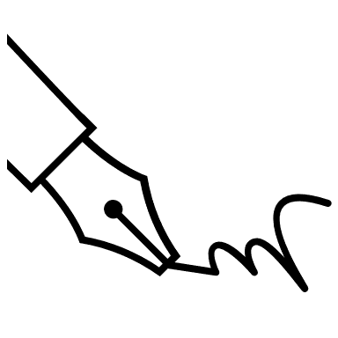

MISSION STATEMENT STARTERS
Stuck? Try some of these starters to get you writing.
- To (what you want to achieve/do) so that (why it’s important), I will (specific behaviors, attitudes and actions).
- To live each day (list value) so that (what living by these values will give you). I will (specific behaviors, attitudes and actions).
- To be known as a person who (qualities/values you have or want to have). I will (specific behaviors, attitudes and actions).
- To use my (skills or expertise) to inspire/lead (group of people) so that (ultimate goal).
- To develop and cultivate the qualities of (two or three values or character traits) that I admire in (an influential person in your life) so that (why you want to develop these qualities).
- To appreciate and enjoy (things you want to appreciate and enjoy more) by (what you can do to appreciate/enjoy these things).

Chapter Mission Statement
A mission statement is “a personal credo or motto that states what our life is about” (Covey, The Seven Habits of Highly Effective Teens, p. 81). It is like a map that helps us navigate the crossroads of our life or a filter to help us sort through life choices. Why is that important? It opens our eyes to what is important to us and helps us make decisions accordingly.
A mission statement establishes what is important to each of us. It allows us to connect with our own unique purpose. It allows us to put into words what we are all about and what success looks like to us.
**This activity could be completed as a large group using flip charts.
STEP 1: IDENTIFY CORE Chapter VALUES
Now narrow our list to the FIVE most important values.

Let’s get clear about our values. What matters most to us in life? Brainstorm all the things that matter to our chapter.

STEP 2: VALUES in action
Actions speak louder than words! Review our chapter’s five values and list at least TWO actions we currently do or want to do to live our chapter values. What does it look like to LIVE our values.

Example: If we value kindness, what does that look like in action. It may be smiling at everyone we see or writing one note of encouragement to someone each week.
_________________________________________________________________________________________________________
_________________________________________________________________________________________________________
_________________________________________________________________________________________________________
STEP 3: Identify Contributions
List the ways our chapter can make a difference in our community, school and world.

_________________________________________________________________________________________________________
_________________________________________________________________________________________________________
_________________________________________________________________________________________________________
_________________________________________________________________________________________________________
_________________________________________________________________________________________________________
STEP 4: Identify goals
Think about our chapter priorities and goals. Brainstorm what our short-term and long-term goals should be.

_________________________________________________________________________________________________________
_________________________________________________________________________________________________________
_________________________________________________________________________________________________________
_________________________________________________________________________________________________________
_________________________________________________________________________________________________________

STEP 5: write mission statement
Let’s write our chapter mission statement based on what we have learned.

_________________________________________________________________________________________________________
_________________________________________________________________________________________________________
_________________________________________________________________________________________________________
_________________________________________________________________________________________________________
_________________________________________________________________________________________________________
_________________________________________________________________________________________________________
_________________________________________________________________________________________________________
_________________________________________________________________________________________________________
_________________________________________________________________________________________________________
_________________________________________________________________________________________________________

THINGS TO KEEP IN MIND
- Keep it simple, brief and clear. Most effective mission statements tend to be three to five sentences long.
- Keep it positive. Focus on what we want to accomplish, achieve and become instead of what we don’t want to do or become.
- Keep it action oriented. Our mission statement should be applicable every day in our actions and decisions.
- Keep it real. Be true to our chapter. Make sure our mission statement accurately reflects our biggest passion and what we truly believe our long-term purpose to be.

MISSION STATEMENT STARTERS
Stuck? Try some of these starters to get you writing.
- To (what we want to achieve/do) so that (why it’s important), we will (specific behaviors, attitudes and actions).
- To live each day (list value) so that (what living by these values will give us). We will (specific behaviors, attitudes and actions).
- To be known as a chapter that (qualities/values we have or want to have). We will (specific behaviors, attitudes and actions).
- To use our (skills or expertise) to inspire/lead (group of people) so that (ultimate goal).
- To develop and cultivate the qualities of (two or three values or character traits) that we admire in (an influential person in our lives) so that (why we want to develop these qualities).
- To appreciate and enjoy (things we want to appreciate and enjoy more) by (what we can do to appreciate/enjoy these things).

Personal Goals Activity
MY SMART GOALS

Personal goals are important because each of you have dreams of what you would like to achieve within this chapter. Now that you have committed to one word and a personal mission statement, create two goals, detailing how you are going to work toward these goals and when you want to achieve them.
When making your SMART goals for this year, make sure to follow the format below:
WHAT: What are you trying to achieve? WHY: Why is this goal important?
WHO: Who will help with achieving the goal?
WHEN: When will this goal be achieved by? HOW: How are you going to achieve this goal?

SMART Goal 2

SMART Goal 1

Chapter Goals Activity
Goals can be the foundation to help guide us as a team toward what we want to achieve this year. SMART stands for Specific, Measurable, Attainable, Realistic, Time-Bound. Our goals should be something that challenges us, but also something that is realistic for us to achieve. Remember to also set a timeline (due date) that we want to achieve it by! Not all goals are going to be met, but all goals should have the potential to be met. CTI
When making our SMART goals for this year, make sure to follow the format below:
WHAT: What are we trying to achieve? WHY: Why is this goal important?
WHO: Who is going to be in charge of achieving the goal?
WHEN: When will this goal be achieved by? HOW: How are we going to achieve this goal?
SMART Goal 1

GOAL 2

SMART Goal 2

SMART Goal 3

True Colors Assessment
Instructions: Compare all four boxes in each row. Do not analyze each word; just get a sense of each box. Score each row’s boxes from most to least as it describes you: 4 = most, 3 = a lot, 2 = somewhat, 1 = least.
Gold Score
(Add B, G, I, M, T)

________________
Row 1 | A.  Active  Variety  Sports  Opportunities  Spontaneous  Flexible  Score: _________ | B.  Organized  Planned  Neat  Parental  Traditional  Responsible  Score: _________ | C.  Warm  Helpful  Friends  Authentic  Harmonious  Compassionate  Score: _________ | D.  Learning  Science  Quiet  Versatile  Inventive  Component  Score: _________
Row 2 | E.  Curious  Ideas  Conceptual  Knowledge  Questions  Problem Solver  Score: _________ | F.  Caring  People Oriented  Feelings  Unique  Empathetic  Communicative  Score: _________ | G.  Orderly  On-time  Honest  Stable  Sensible  Dependable  Score: _________ | H.  Action  Challenges  Competitive  Impetuous  Impactful  Score: _________
Row 3 | I.  Helpful  Trustworthy  Dependable  Loyal  Conservative  Organized  Score: _________ | J.  Kind  Understanding  Giving  Devoted  Warm  Poetic  Score: _________ | K.  Playful  Quick  Adventurous  Confrontative  Open Minded  Independent  Score: _________ | L.  Independent  Exploring  Competent  Theoretical  Why Questions  Ingenious  Score: _________
Row 4 | M.  Follow Rules  Useful  Save Money  Concerned  Procedural  Cooperative  Score: _________ | N.  Active  Free  Winning  Daring  Impulsive  Risk Taker  Score: _________ | O.  Sharing  Getting Along  Feelings  Tender  Inspirational  Dramatic  Score: _________ | P.  Thinking  Solving Problems  Perfectionistic  Determined  Complex  Composed  Score: _________
Row 5 | Q.  Puzzles  Seeking Info  Making Sense  Philosophical  Principled  Rational  Score: _________ | R.  Social Causes  Easy Going  Happy Endings  Approachable  Affectionate  Sympathetic  Score: _________ | S.  Exciting  Lively  Hands On  Courageous  Skillful  On Stage  Score: _________ | T.  Pride  Tradition  Do Things Right  Orderly  Conventional  Careful  Score: _________
Orange Score
(Add A, H, K, N, S)

________________
Blue Score
(Add C, F, J, O, R)

________________
Green Score
(Add D, E, L, P, Q)

________________
Congratulations! You now know your color spectrum. Here are some general descriptions of each color.

ORANGES
- Are free and spontaneous
- Are impulsive risk-takers
- Are active
- Are optimistic
- Resist commitment
- Can become virtuosos
- Thrive on crises
- Are drawn to tools
- Like to be the center of attention
- Have great endurance
- Are drawn to action jobs
- Need variety
- Are dynamic, animated communicators
- Are competitive
- Deal with the here and now
- Are bold in relationships
- Are generous
- Have difficulty finding acceptance
- Like to live in a casual atmosphere
- Bring excitement to society

GREENS
- Are innovative and logical
- Seek to understand the world
- Need to be competent
- Require intellectual freedom
- Are curious
- Question authority
- Push themselves to improve
- Seek perfection in play
- May become intellectually isolated
- Are slow to make decisions
- Value concise communication
- Look for intellectual stimulation
- Enjoy intriguing discussions
- Are sometimes oblivious to emotions
- Are detached
- Believe work is play
- Are drawn to technical occupations
- Analyze and rearrange systems
- Focus on the future
- Bring innovation to society

BLUES
- Are in search of themselves
- Need to feel unique
- Must be true to themselves
- Look for symbolism
- Value close relationships
- Encourage expression
- Desire quality time with loved ones
- Need opportunities to be creative
- Compromise and cooperate
- Nurture people, plants and animals
- Look beyond the surface
- Share emotions
- Make decisions based on feelings
- Need harmony
- Are adaptable
- Are drawn to literature
- Are drawn to nurturing careers
- Get involved in causes
- Are committed to ideals
- Bring unity to society

GOLDS
- Are dutiful and stable
- Need to be useful
- Want to be self-sufficient
- Value organization
- Desire punctuality
- Schedule their lives
- Make and keep commitments
- Measure worth by completion
- Are goal-oriented
- Value rules
- Prepare for the future
- Are inclined to join groups
- Believe work comes before play
- Safeguard tradition
- Prefer order and cleanliness
- Are responsible and dedicated
- Are drawn to respected occupations
- Enjoy positions of authority
- Desire structure
- Bring stability to society

Enneagram Personality Test
Take the Enneagram test found here: https://www.truity.com/test/enneagram-personality-test.
*Note: the full report is not free, but you can find out your type without the full report and descriptions of the types are included on the next page.
My Enneagram Type:
Type 2
Teammates who are this type:

Type 1
Teammates who are this type:

Type 3
Teammates who are this type:

Type 4
Teammates who are this type:

Type 5
Teammates who are this type:

Type 6
Teammates who are this type:

Type 7
Teammates who are this type:

Type 8
Teammates who are this type:

Type 9
Teammates who are this type:

Information About Each Type
Enneagram Type 1
- I really beat myself up over my mistakes.
- I have trouble relaxing — there’s too much to do!
- I hate when someone has 11 items in the fast check-out lane.
- Details, details, details! Details are super important.
- I am accountable. I never ditch out on my responsibilities.
- I’m going to leave the world better than I found it.
- I am an excellent budgeter. I write one often.
- Things are either right or wrong.
- I notice little things, like crooked items on a wall.
- I worry all the time.
Enneagram Type 2
- I am a good listener and remember details people tell me.
- I like people in power.
- People love to tell me things, even people I don’t know that well!
- I like to be acknowledged for my accomplishments.
- I love to give gifts but really stink at receiving gifts.
- I care a lot about what others think of me.
- Everyone asks me for help.
- I HATE movies where people suffer.
- I really hope people forgive me for my mistakes.
- I am known for bringing treats to my loved ones.
Enneagram Type 3
- I can persuade my teacher to let me wear a hat.
- I like to be productive and acknowledged.
- I am so competitive.
- I love to lead. I’m not a big fan of following others.
- I can do lots of things at once — an expert multitasker.
- I never stop being productive. I do lots of work on weekends.
- It’s pretty rare that I talk about my personal life.
- I set lots of SMART goals for myself.
- I like to be around other successful people.
- I don’t know how to stop working when I get going on a project.
Enneagram Type 4
- I hate things that are ordinary.
- I don’t know where I belong in the world.
- I wait for other people to talk to me first.
- I am unique and I like that about myself.
- Please, don’t try to cheer me up. I don’t mind feeling sad sometimes.
- I don’t like criticism
- I hate being told what to do, so I do the opposite.
- Sometimes I don’t text or snap my friends for days.
- I am usually pretty creative and have lots of ideas.
- I feel misunderstood a lot of times.

Enneagram Type 5
- I can take care of myself.
- I feel awkward around people.
- I am not a fan of people asking me personal questions.
- Sign me up for alone time!
- I need a couple of days to decompress after a big experience.
- I can be a pack rat. I like to keep memorable things like movie tickets!
- I’d rather watch than participate.
- I feel worn out if I’ve been around people too long.
- I like to be informed of everything!
- I don’t need fancy clothes or shoes.
Enneagram Type 6
- I am always prepared for the worst.
- I can be very anxious.
- My friends would say I’m loyal and funny.
- I don’t get frazzled in a crisis — it’s after a crisis when I break down.
- How will I ever know for sure that I made the right decision?
- I really don’t like spontaneous plans.
- Sometimes it’s hard for me to get stuff done because I have so much to do.
- I’m wary of people who compliment others too much.
- I like order.
- I get nervous when my teachers or advisors give me more responsibilities.
Enneagram Type 7
- I love last minute adventures!
- I struggle to commit to plans.
- I really don’t like missing out.
- I am so ready to move on to my future.
- I don’t like sad conversations and will avoid them at all costs.
- I’m always saying, “look at the bright side!”
- People would classify me as popular.
- I crack jokes to lighten the mood.
- I don’t do well with routine.
- People need to worry less!
Enneagram Type 8
- I have been told I’m too blunt.
- Doing things halfway drives me crazy!
- I like to debate people, just to see if they can handle it.
- I always fight with important people in my life, until we “figure it out.”
- I don’t trust a lot of people.
- It’s easy for me to say “no.”
- I can make really fast decisions.
- I’m skeptical of people who are “too nice.”
- I am very protective of my loved ones.
- I confront bullies.

Enneagram Type 9
- I HATE CONFLICT!
- I’m happy to do what others want to do.
- I am a procrastinator.
- I do not like making big decisions.
- I love routines!
- I hate starting projects, but once I get going, I can’t stop.
- People think of me as a good listener.
- Homework does not come home with me. I get it done in school.
- I don’t like big crowds. I’d rather stay home.
- The outdoors soothes me.

Chapter SWOT Analysis
Where are we strong? Where can we grow?

Weaknesses

Strengths



Threats

Opportunities

Start, Stop, Continue Activity
Which chapter activities should we start, stop and continue?

What activities should we START?

What activities should we STOP?

What activities should we CONTINUE?

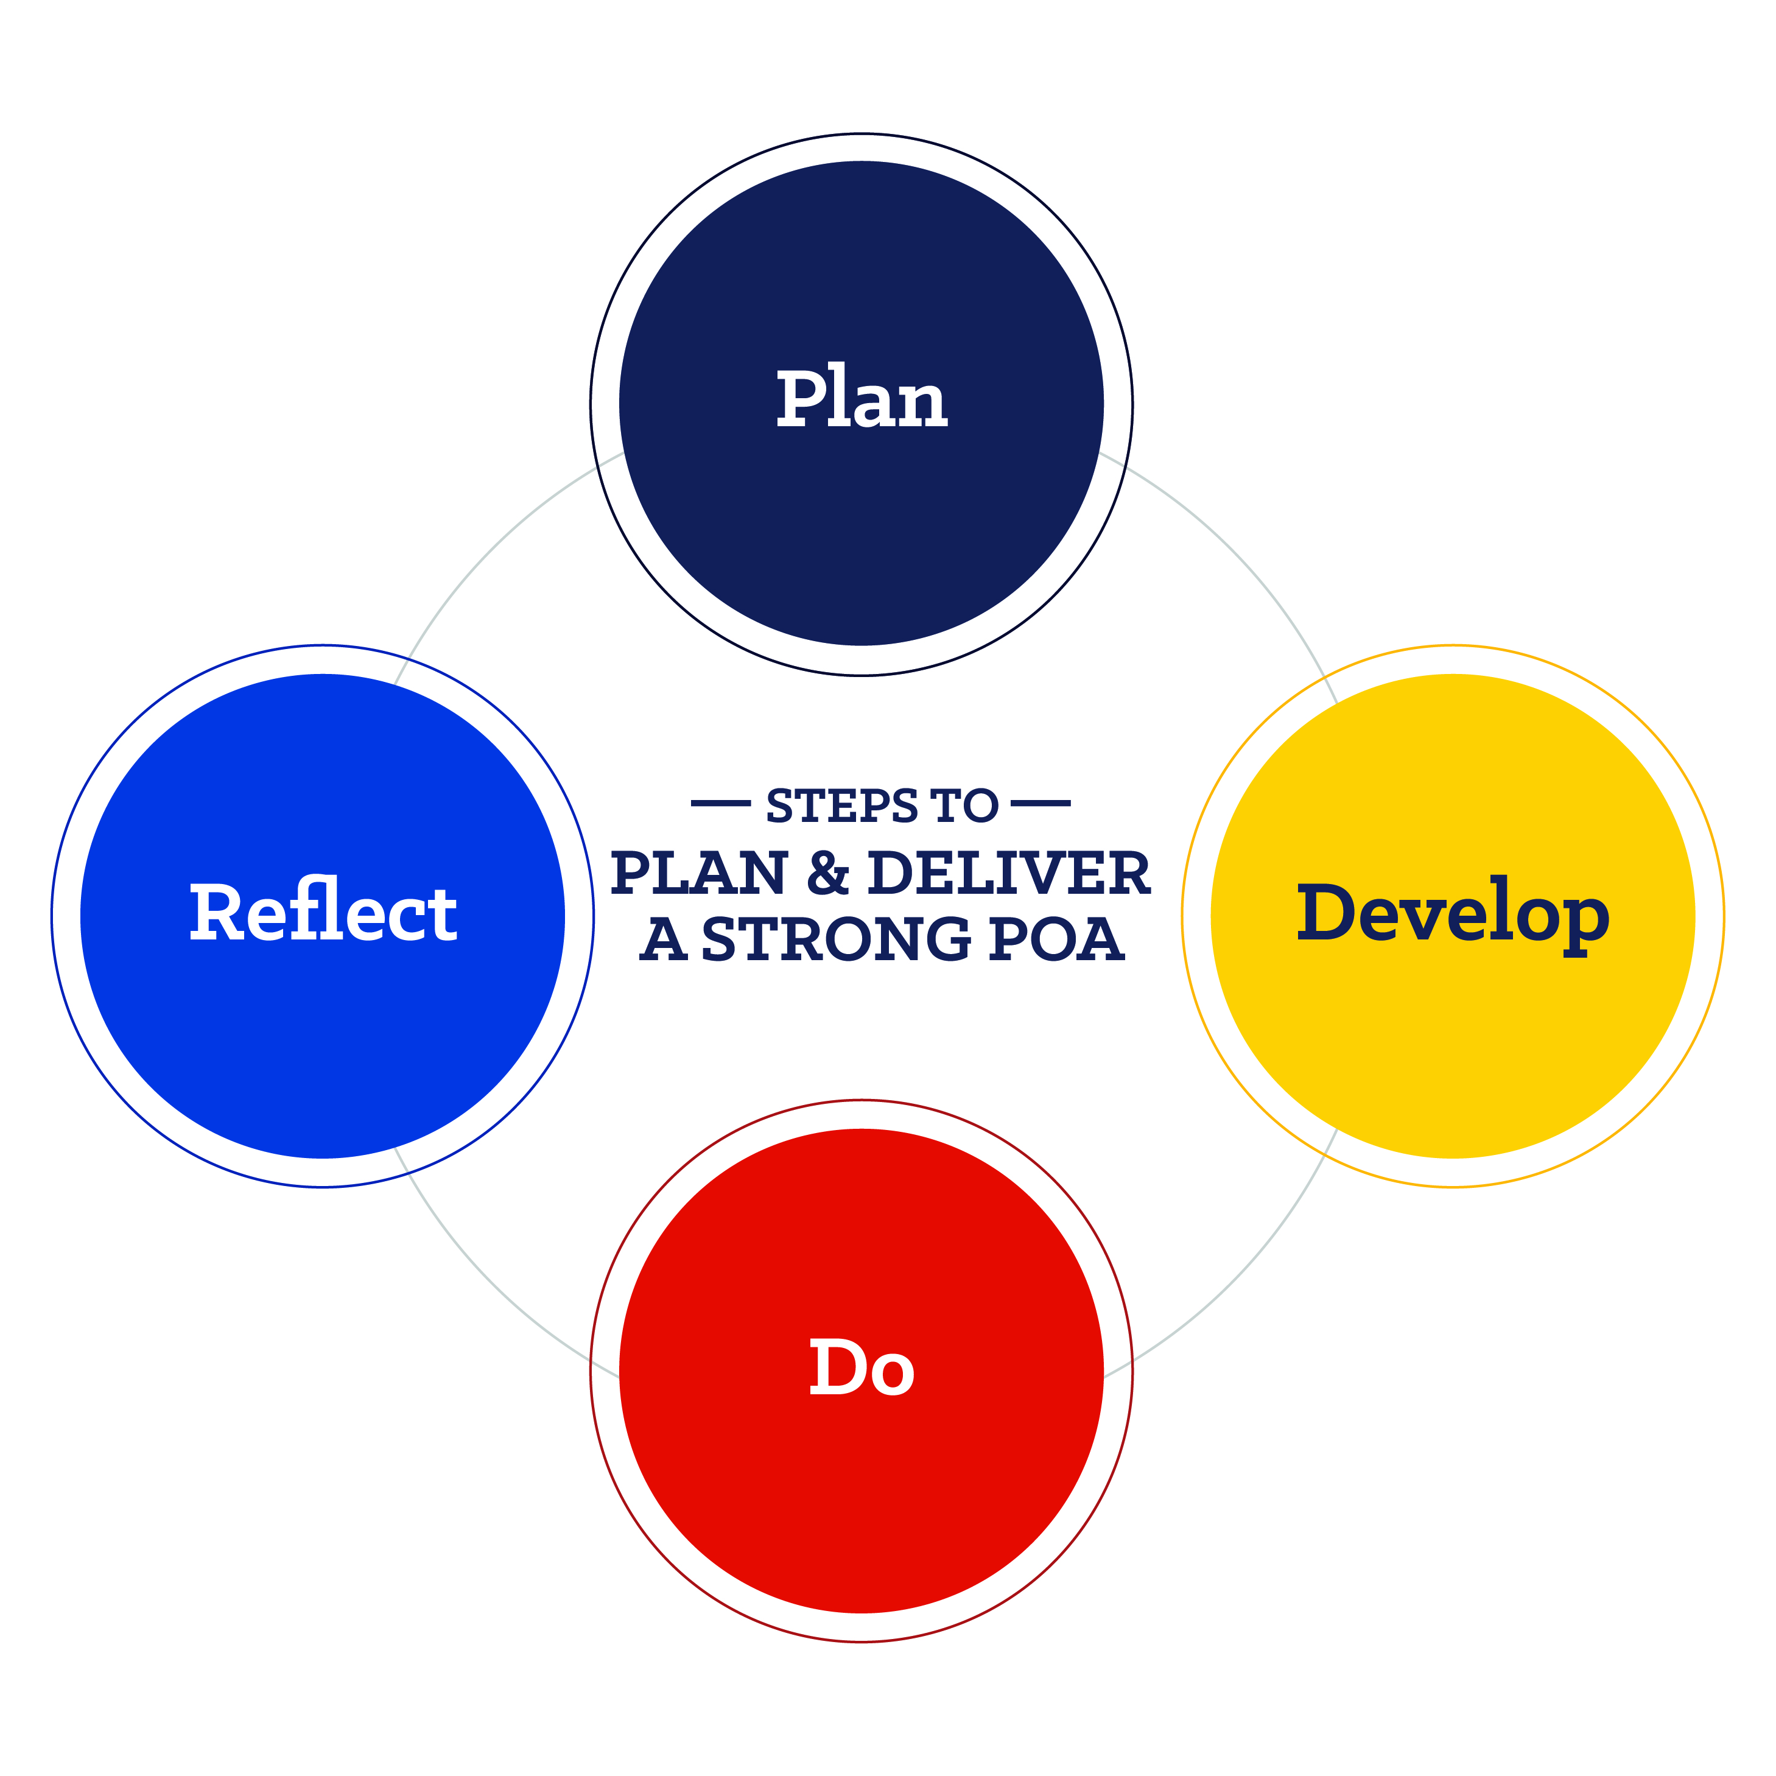
POA Planning
Learn more about the POA by visiting the POA resource guide.
The Program of Activities (POA) serves to define chapter goals, outline steps needed to meet those goals and act as a written guide to provide a calendar of events the chapter will follow in the year ahead.
Growing Leaders | Building Communities | Strengthening Agriculture
Leadership Committee  Chair:  Activities: | Environmental Committee  Chair:  Activities: | Support Group Committee  Chair:  Activities:
Healthy Lifestyle Committee  Chair:  Activities: | Human Resources Committee  Chair:  Activities: | Chapter Recruitment Committee  Chair:  Activities:
Scholarship Committee  Chair:  Activities: | Citizenship Committee  Chair:  Activities: | Safety Committee  Chair:  Activities:
Personal Growth Committee  Chair:  Activities: | Stakeholder Engagement Committee  Chair:  Activities: | Agricultural Advocacy Committee  Chair:  Activities:
Career Success Committee  Chair:  Activities: | Economic Development Committee  Chair:  Activities: | Agricultural Literacy Committee  Chair:  Activities:
For more information on Program of Activities development, visit FFA.org/POA.


Program of Activities: Form 1
Division:
Quality Standard:
Name of Committee:
Committee Purpose:
Committee Members:
Committee Chairperson(s):

Activity | Goal(s)
Activity Name:
Target Completion Date:
Estimated Income:
Estimated Expenses:
Chapter Action:

Activity | Goal(s)
Activity Name:
Target Completion Date:
Estimated Income:
Estimated Expenses:
Chapter Action:

Activity | Goal(s)
Activity Name:
Target Completion Date:
Estimated Income:
Estimated Expenses:
Chapter Action:

Activity | Goal(s)
Activity Name:
Target Completion Date:
Estimated Income:
Estimated Expenses:
Chapter Action:

For more information on Program of Activities development, review the POA Resource Guide.

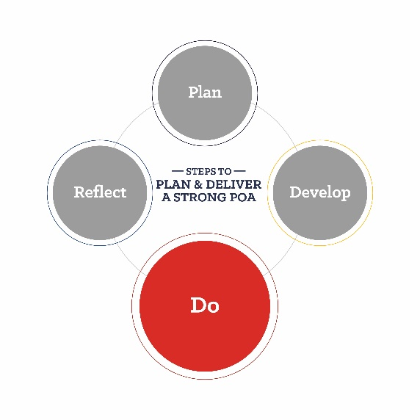
Program of Activities: Form 2
Directions: Complete one of these forms for each activity the chapter is conducting.

Division:
Quality Standard:
Committee:
Activity:
Committee Members Responsible:

Goals | Steps | Target Date | Expenses | Income | Results/Notes

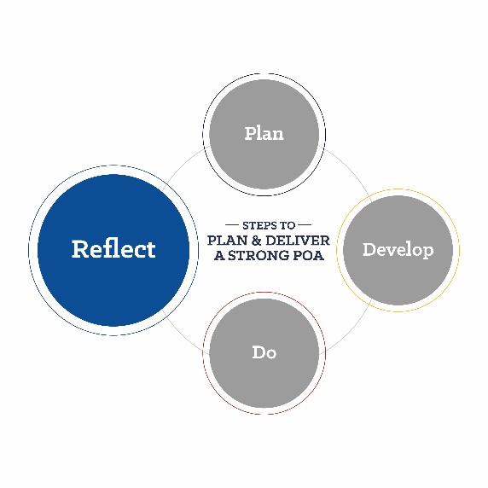
Program of Activities: Form 3
Directions: Complete one of these forms for each activity the chapter is conducting.
Date of Committee Meeting:
Division:
Quality Standard:
Committee:
Committee Members Present:

Action(s) Taken | Committee Member(s) Responsible

Comments:
________________________________________________________________________________________________________________________________________________________________________________________________________________________________________________________________________________________________________________________________________________________________________________________________________________________________________________________________________________________________________________________________________________________________________________________________________________________________________________________________________________________________________________________________________________________________________________________________________________________________________________________________________________________________________________________________________________________________________________________________________________________________________________________________________________________________________________________________________________________________________________________________________________________________________________________________________________________________________________________________________________________________________
Submitted by: ______________________________________________________________ ______________________
(committee chairperson) (date)
For more information on Program of Activities development, review the POA Resource Guide.


Program of Activities: Form 4
Directions: Complete one of these forms for each activity the chapter is conducting.

Division:
Quality Standard:
Committee:
Activity:
Completion Date:

Financial Impact
Estimated Expenses |  |  | Estimated Income
Actual Expenses |  |  | Actual Income
Expense Variance |  |  | Income Variance | Title

Accomplishments:

Recommendations:

Submitted by: ______________________________________________________________ ______________________
(committee chairperson) (date)
For more information on Program of Activities development, review the POA Resource Guide.

Team-Building Activities
- Mission Impossible: Teams work together to retrieve an object (e.g., a stuffed animal) from a designated “danger zone” without touching the floor, using only provided materials like ropes and boards.
- Bridge Build: Teams construct a bridge using limited supplies (e.g., straws, tape, paper) that can support the weight of small objects or toys.
- Minefield: One team member is blindfolded and must navigate through a “minefield” (marked obstacles) with verbal guidance from teammates who can see.
- Pipeline: Teams construct a pipeline using PVC pipes or similar materials to transport a ball or small object from one point to another without dropping it.
- Leaderless Initiative: Assign a task (e.g., building a structure with blocks) and rotate leadership roles within the team without designated leaders, encouraging shared responsibility and decision-making.
- Crossing the River: Teams must strategize and use limited resources to cross a simulated “river” (marked area) safely, demonstrating problem-solving and resource-management skills.



Section 5: Media, Promotion and Advocacy
The included resources will help you share your FFA chapter’s story throughout the community.
- Tell the FFA Story
  - This resource can better help officers tell your school and community about FFA.
- Social Media Tool Kit
  - Prepare students for properly posting on social media with the help of this kit.
- Social Media Post Examples
  - Utilize these examples to prepare students for properly posting on social media.
- News Release Template
  - This template can better prepare students to write articles for the newspaper.
- Public Service Announcement Scripts
  - Use these scripts to prepare students to speak publicly about FFA.
- Morning Announcement Script
  - Better prepare students for speaking on the announcements through this sample script.
- Planning for Advocacy
- Prepare students to advocate for agriculture and FFA through the support of this resource.

Strengthen Agriculture by Telling the FFA Story!
How can I tell the story of FFA and my chapter? Here are some ideas to help with promotion throughout the community.


Speak on the radio or have the radio station come to an FFA event at your school.

Utilize social media to share fun facts about agriculture or FFA and to talk about the activities your chapter will do during the year.

Share stories of how FFA has positively impacted individual members in your local newspaper.
Interview an FFA Alumni or Supporter member. Put together a video of several interviews to show what FFA has meant to alumni or why they support FFA.

Create and place “FFA Supporter” signs in the windows of partnering businesses. (Yard signs are a great option also!)
Work with local billboard agencies and secure space for an FFA chapter billboard. Ask them if they will donate the space for a month or so. (Some towns have old movie theatre sign space to rent too!)
Have students share their SAE projects in an SAE spotlight each week or month in your local newspaper or on your local radio station.
Write an editorial for your local newspapers. Highlight the many opportunities FFA has to offer.
Work with local newspapers and radio and TV stations to highlight the activities of the chapter and FFA members. Don’t forget about your school newspaper and announcements.

Develop an FFA chapter supplement for the local paper or for the school newsletter. Make it electronic and post it on the websites.

Provide FFA facts for your local media and school newspaper.
Send in ad slicks to area businesses for possible placement in newsletters, magazines, etc. Work with your local newspaper for donated ad space.

Take food or treats to the morning radio/TV stations. (Ex. cookies, candy, cupcakes, etc.)
Hold an open house for the community. Show off your classrooms, facilities and other special chapter areas. You could also do this at an off-site location and not necessarily a farm.
Strengthen Agriculture by Telling the FFA Story!
Now that you are a chapter officer, it is your role to tell the world about FFA! Voices spreading the FFA message across social media elevates awareness of FFA, and that’s where you come in. Your chapter’s story is important in helping others learn who we are, what we do and the diversity of FFA across the country. Use the guide below to help you plan for social media posts throughout the year.
Pick one or two social platforms to concentrate on. Don’t spread yourself too thin. It’s better to be in one place with great stories than everywhere with mediocre stories.
Which social platforms will you concentrate on?
- _______________________________
- _______________________________



Social platform 1: __________________________________

1.

2.
Social platform 2: _________________________________

1.

2.
Before your FFA activities or events, plan your posts. You can even write some of them ahead of time. Planning ahead will save time during the year. Just leave some room for spontaneity. In the boxes below, choose an event or activity you want to highlight, and compose two posts for each social platform you selected above.

Use this space to brainstorm a list of photos and videos that could be used. Don’t have any that will work? Brainstorm pictures and videos that can be taken!
In your posts, use the highest-quality photos and videos you have access to. These tell the best stories and generate the most engagement.

If someone is being vulgar, bullying or posting unrelated comments on your posts, hide them. It’s good practice to have user guidelines on your page in the About section. Ours is on the National FFA website: FFA.org/social-media-user-policy/.
Compose some guidelines that you could include to help avoid vulgarity, bullying or posting of unrelated comments.




MOST importantly, every member and every chapter have an important FFA story.
Don’t be afraid to share yours — we know it will be interesting!

SOCIAL MEDIA

TOOLKIT

TIPS and TRICKS
Consistent Branding and Voice: Maintain a consistent brand identity across all your social media channels.
Create Engaging Content: Mix your content formats, including images, videos and infographics.
Be Authentic and Transparent: Share behind-the-scenes glimpses of your chapter, showcase your team members and highlight activities.
Regularly Engage with Your Audience: Encourage interaction through likes, comments, shares and reposts.


BEST PRACTICES
Define Your Audience:
Tailor your content and engagement strategies according to your audience’s preferences and behaviors.
Exciting News:
Remember to post about exciting news, events or awards received. Every win is important!

Consistency Is Key:
The sweet spot for posting static posts is one to three per week between 11 a.m. and 3 p.m.
Hashtag Tips:
Use 25 to 30 branded hashtags to reach new audiences.
This is how users search.
POST PRACTICES

Posting to Your Grid:
One to three times per week

Stories:
At least three times per day

Engaging:
15 minutes a day

Reels + TikToks:
At least one per month

Caption:

EXAMPLE

🌟🚜 Exciting News Alert! 🚜🌟

Our local FFA chapter is bursting with excitement as we announce some incredible news! 🎉
Stay tuned as we unveil how our passionate members are making waves in the community and beyond. From groundbreaking projects to empowering initiatives, we can’t wait to share the journey with you! 🌱

Hashtags:
#FFA #NationalFFA #FFAlove #FFAmily #FFAProud #FFA23 #Agriculture #Leadership #foreverblue #bluejackets #bluejacket #ffasupporters #futurefarmersofamerica #futurefarmers #ffanational #ffacommunity #nonprofit #supportag #futureofagriculture #agriculture #agtech #agricultureadvocacy #agadvocacy #agknowledge




FFA BRAND
GUIDELINES

- Essential color selection
- Appropriate uses of
typography
- Proper use of the lettermark
and emblem
- Link to brand guidelines:
FFA.org/media-center/
FFA WEBSITE & SOCIAL MEDIA

ORGANIZATION WEBSITE

FFA.org

NATIONAL FFA FACEBOOK
National FFA Organization

NATIONAL FFA INSTAGRAM
@nationalffa

NATIONAL FFA LINKEDIN
National FFA Organization

NATIONAL FFA X (TWITTER)
@NationalFFA

NATIONAL FFA SNAPCHAT
nationalffa

NATIONAL FFA TIKTOK
@nationalffaorg
Social Media Post Examples
Sample Facebook Posts
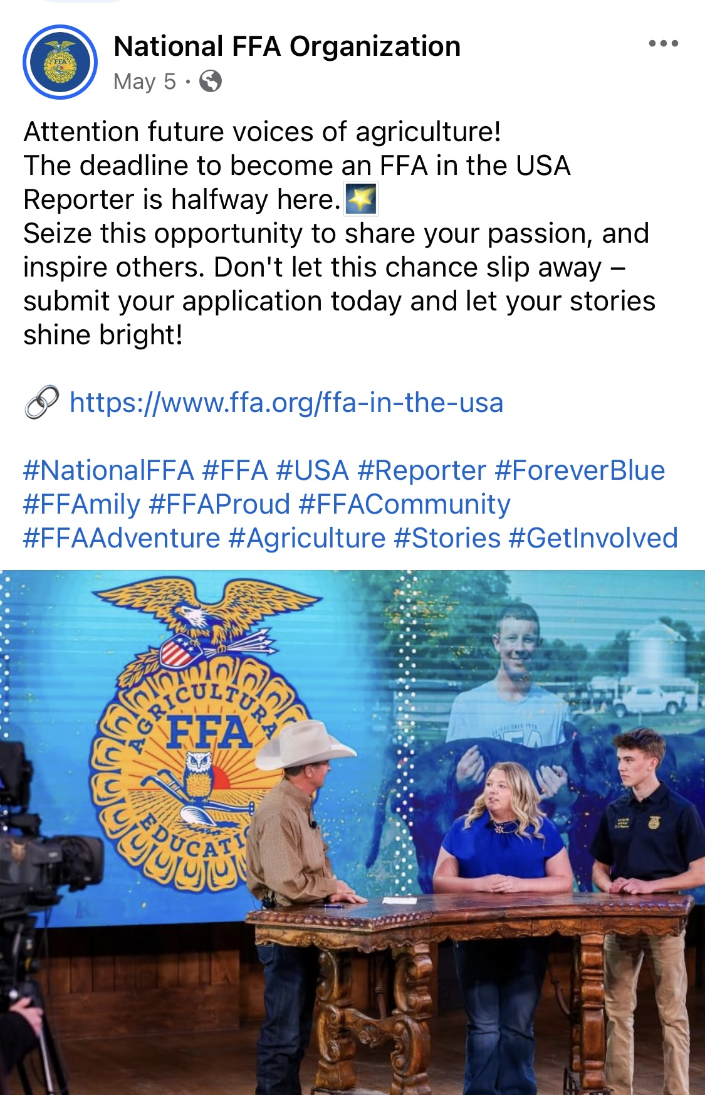
Sample Instagram Posts
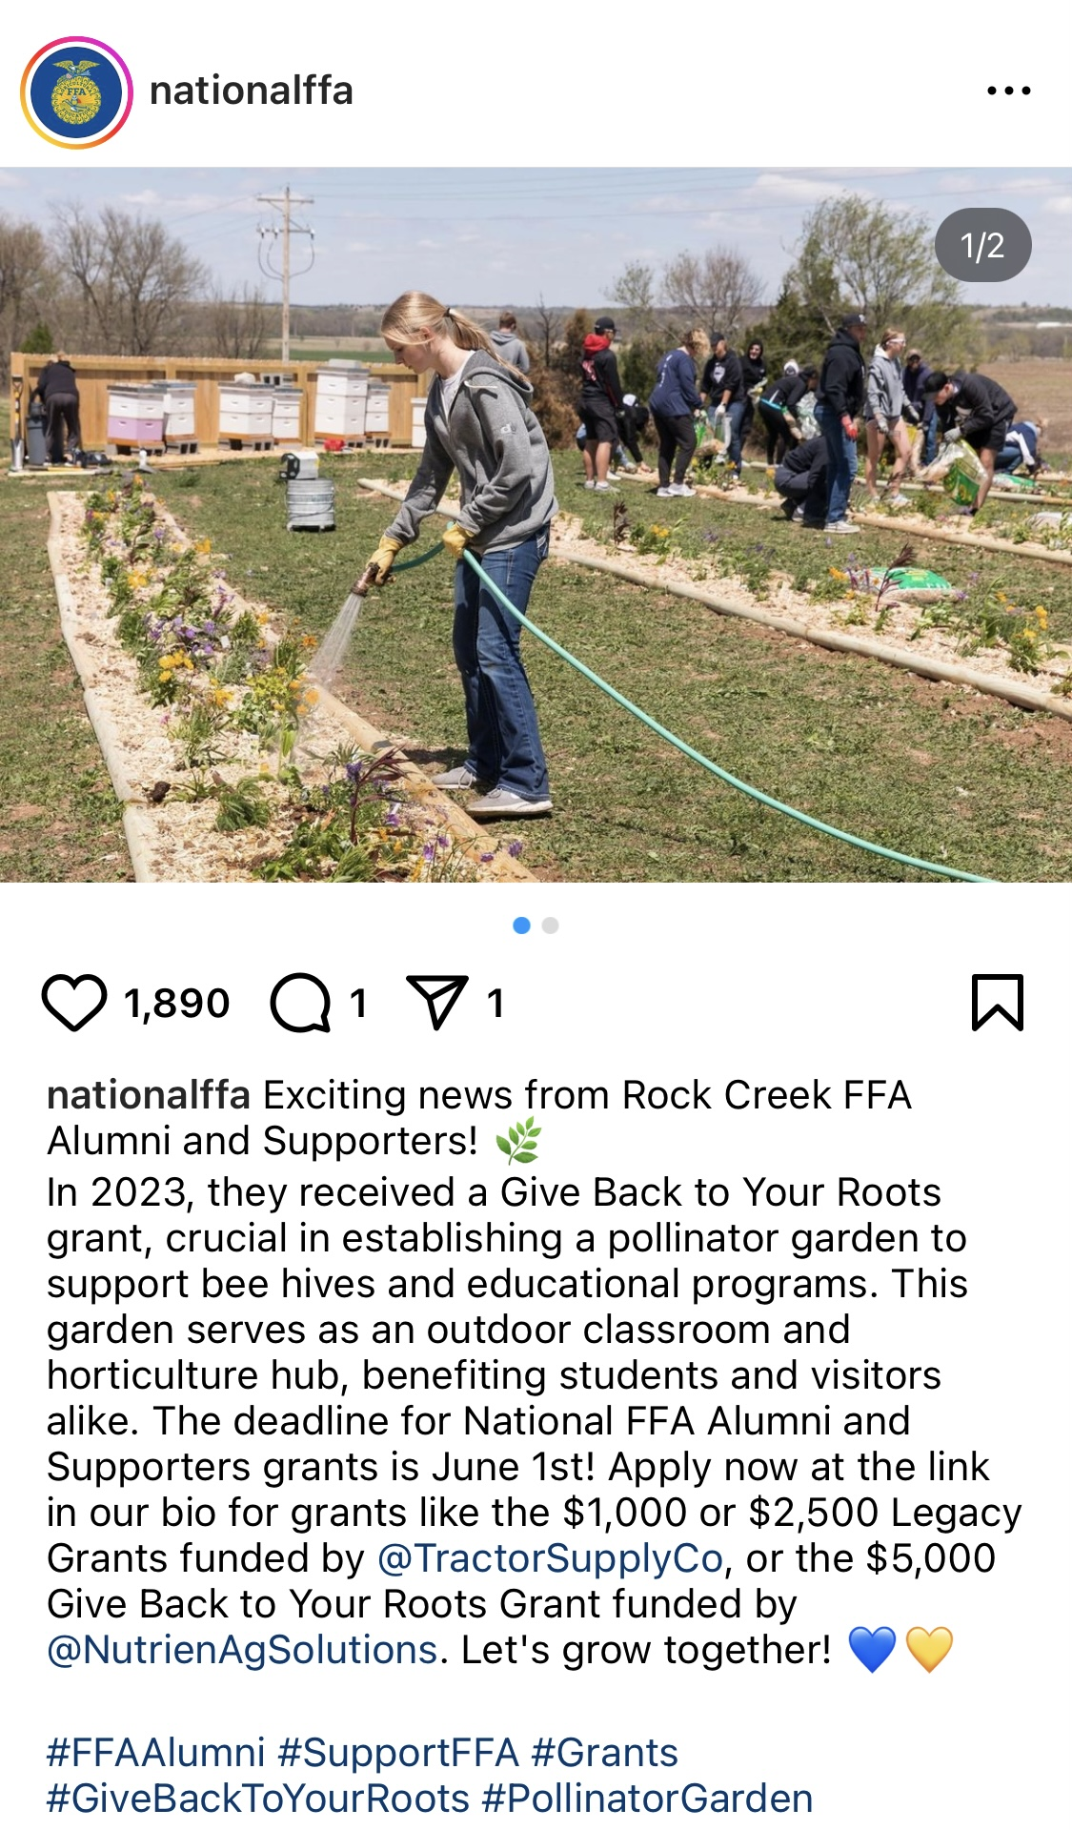
News Release Template
CONTACT
John Doe
Title/Position
Organization Name
jdoe@email.org
123-456-7890
(Enter Name of Chapter) Elects New Chapter Officer Team

(Day, date, year) — The (enter name of chapter) in (enter city, state), elected a new chapter officer team. They will lead the chapter for the next year.

The following students were elected to chapter office: (Enter names of students and their positions).

Today, FFA provides the next generation of leaders who will change the world. As the top school-based youth leadership development organization in the nation, FFA helps young people meet new agricultural challenges by developing their unique talents and exploring their interests in a broad range of career pathways. FFA members are our future leaders, our future food suppliers, our future innovators and more!

Whether it is through (Enter chapter activities conducted throughout the year), the chapter officer team is making an impact on the school and community and plays a huge role in the development of agriculture’s future leaders and advocating for importance of agricultural education and the FFA.

The National FFA Organization is a school-based national youth leadership development organization of more than 1,027,273 student members as part of 9,235 local FFA chapters in all 50 states, Puerto Rico and the U.S. Virgin Islands.
# # #
About National FFA Organization
The National FFA Organization is a school-based national youth leadership development organization of more than 1,027,273 student members as part of 9,235 local FFA chapters in all 50 states, Puerto Rico and the U.S. Virgin Islands. The FFA mission is to make a positive difference in the lives of students by developing their potential for premier leadership, personal growth and career success through agricultural education. For more, visit the National FFA Organization online at FFA.org and on Facebook and X.

About National FFA Foundation
The National FFA Foundation builds partnerships with industry, education, government, other foundations and individuals to secure financial resources that recognize FFA member achievements, develop student leaders and support the future of agricultural education. Governed by a 19-member board of trustees composed of educators, business leaders, individual donors and FFA alumni, the foundation is a separately registered nonprofit organization. About 82 percent of every dollar received by the foundation supports FFA members and agricultural education opportunities. For more, visit FFA.org/Give.

Find more examples here.

Public Service Announcement Scripts
PSA: 30-Second Radio
Ag Education Day at (Local School Name)
(Insert Dates)

Hello, it’s (name) from the (chapter name) FFA Chapter. We’re excited to announce Ag Education Day at (Local School Name) on (date)! Students, parents and community members are invited to explore agriculture through interactive workshops, live demonstrations and hands-on activities. From learning about sustainable farming to discovering the science behind crop production, it’s a day packed with fun and education. Join us in celebrating the importance of agriculture in our lives. Visit (social media page) to learn more and RSVP for this enriching event. See you there!
PSA: 30-Second Radio
Spring Plant Sale Fundraiser
(Insert Dates)

Hey everyone! I’m (name) from the (chapter name) FFA Chapter. Get ready to sprout some support for our community and agricultural education! Join us (dates) for our annual Spring Plant Sale Fundraiser. Whether you’re planting a garden or decorating your home, our wide selection of flowers, vegetables and herbs has something for everyone. Your purchase helps fund our chapter’s activities, scholarships and leadership development programs. Visit us at (location) or check out (social media page) for more details. Let’s grow together!

Use the space below to write your own example PSA.

Morning Announcement for School Scripts
- Good morning (insert school name)! This week is National FFA Week, a time in which to celebrate and learn about agriculture and FFA. Did you know that the National FFA Organization has more than 1,027,273 members in all 50 states, Puerto Rico and the U.S. Virgin Islands? As our FFA chapter celebrates agriculture and FFA this week, we want everyone to get involved here at school! This week we will have (list any important events, dress-up days, etc.). During this week, we hope to see each of you learn and engage with us to help celebrate! Talk to an officer or our agriculture teacher (insert agriculture teacher name) about how to join FFA.

- Good morning (insert school name)! As we embark on selecting new officers to lead our FFA chapter, it’s important to recognize that these individuals will play a pivotal role in shaping the future of agriculture here at (insert school name)! The new officers will be ambassadors of innovation, dedication and community spirit, tasked with inspiring their peers and fostering a passion for agriculture. They will embody the values of leadership, teamwork and commitment, driving initiatives that benefit our school and local community. We encourage all eligible members to consider applying for these influential roles and look forward to seeing the positive impact our new officers will make. Together, let’s continue to grow and thrive in the spirit of FFA!

- We are thrilled to announce an exciting upcoming FFA activity that promises to be both educational and enjoyable for all participants. On (Date), our chapter will be hosting (Name of Activity/Event), aimed at (briefly describe the purpose or goal of the activity). This event is a fantastic opportunity for our FFA members to deepen their understanding of (relevant topic or theme) and to collaborate with peers who share a passion for agriculture.
During (Name of Activity/Event), participants will engage in (list key activities or highlights of the event). It’s a chance to learn new skills, network with industry professionals and strengthen our community ties through shared experiences. Whether you’re interested in (specific aspect of agriculture or FFA) or simply want to expand your knowledge, this event promises something for everyone.
We encourage all FFA members to mark their calendars and join us for (Name of Activity/Event). Stay tuned for more details on how to participate and make the most out of this enriching opportunity. Let’s make this upcoming event a memorable success together!

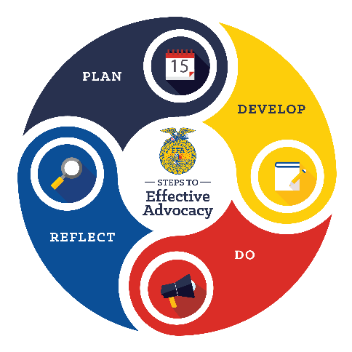
Planning for Advocacy
Advocating is an important and essential role needed in agriculture.
The Agricultural Literacy and Advocacy Model consists of four steps: plan, develop, do and reflect. This model can be used to complete advocacy experiences with different audiences, including those encountered during the year: elected officials, peers, community members and elementary students.

As your chapter plans activities, encourage students to plan an advocacy activity. With each potential audience, think about the following steps.

- Plan: Establish the overall question you want to investigate in this step. Each guiding question below will help determine the main question.
  - Define your issue.
What is the challenge we are facing?
Example: Idea that brown cows give chocolate milk
What is the vital information we need to know, and where can we find it?
  - Analyze.
Example: What age group has the greatest misunderstanding?

  - Understand the audience.
Who are we trying to influence?
Example: Elementary children aged K-3rd grade

- Develop: Now that you have analyzed the situation and identified the target audience, it’s time to develop materials, messages and resources. The following questions help guide you.
  - Write objectives.
What do we want to accomplish?
Example: Educate students about agriculture.

  - Identify SMART goals.
How are we going to accomplish this goal?
Example: We will increase knowledge about agriculture for 20 elementary school students. We will do this by hosting an ag day. This will be accomplished in one month.

  - Determine key messages.
What are our important talking points for our defined audience?
Example: Agriculture is present in all areas of our lives.

  - Develop a plan.
What are the steps we need to take to achieve our objectives?
Example: Identify school, animals and a lesson

- Do: Once students have successfully planned and developed resources, it’s time to take action. What are the next steps? Collaborate, execute and raise awareness! Use the following guiding questions to assist in the activity completion.
  - Collaborate.
How can we partner with others to strengthen our advocacy efforts?
Example: Find area experts that can provide animals or lessons.
How are we using what we know?
  - Execute.
Example: What did we learn in our agriculture classes that we can share?

  - Raise awareness.
How do we promote our advocacy efforts and gain support?
Example: Reach out to the newspaper to highlight the activity.

- Reflect: Once the activity is over, it’s time to reflect on what happened and what can be changed and/or improved. Use these questions to reflect on what you just accomplished.
What information can we collect that will demonstrate impact?
  - Monitor.
Example: What are the students’ perceptions before and after our activity?
How well did we achieve our objectives?
  - Review.
Example: Share how you met, exceeded or did not meet your expectations during this event.
What changes can we make to improve?
  - Adapt.
Example: Change lesson we provided to be more relatable for age.
Section 6: Prepare Your Officer Team for the Year Ahead
The included resources will help you set up your officer team for success in the year ahead.
- Time Management Activity
  - Guide students to manage their time effectively with the help of this activity.
- Planning Expectations
  - Better prepare students for planning out meetings and FFA activities with these expectations.
- How to Properly Run a Meeting
  - Use this resource to prepare students to properly run an FFA meeting.
- Example Agendas
  - These example agendas will help prepare students to create meeting agendas throughout the year.
- Example Meeting Minutes
  - Utilize these example minutes to prepare students to properly take minutes during a meeting.
- Parliamentary Procedure
  - Prepare students to efficiently run a meeting with the assistance of this resource.
- Facilitation Tips and Tricks
  - Equip students for facilitating workshops throughout the year by implementing these tips and tricks.
- Thank-You Note Writing
  - Instruct students to write thank-you notes throughout the year with this activity.
- Writing a Proper Email
  - Instruct students to write professional emails with the assistance of this resource.
- Making a Professional Phone Call
  - Use this resource to prepare students to make professional phone calls.
- Post Officer Retreat Reflection
  - This resource allows officers to reflect on their officer retreat experiences.

Time Management Activity
Instructions: FFA officers are often involved in activities outside of FFA. Many of these activities are productive and good to be involved in. However, sometimes it is easy to fall into the trap of being over committed by being involved in too many things or becoming so focused on one area that other areas of your life suffer.

- The following is a list of activities that may require your focus. Ask yourself, “Do I focus on any of these so much that it has a negative effect on other areas of my life?” Circle the ones where you may tend to be “over focused.”
  - Friends
  - Sports
  - School work
  - Boyfriend/Girlfriend
  - Part-time job
  - FFA
  - Other organizations
  - Other:

- Choose at least two of the areas listed above and list a problem that each might create by placing too much focus on them.

Area: Problem:
Area: Problem:

- Making Tough Choices: Read the following scenarios and circle which response you would choose. Be ready to explain why you made that choice. There is no right or wrong answer.

  - You are involved in sports, and practice takes place right after school for three hours a night. The officer team needs to plan a recruitment activity for junior high students. Everyone can get together at 7:00 p.m. on Monday night; however, your chorus instructor has slotted you to practice your solo for the district music contest at this same time, and he has no other time slots available. The music contest is on Tuesday. Your choices:
    - Tell your fellow officers you cannot attend the meeting.
    - Tell your music instructor you cannot practice that night.
    - Other options? (Explain if you have another option.)

Why did you make this choice?

  - You work after school from 4:00 p.m. until 8:00 p.m. on Mondays and Thursdays. Tuesday night is usually open for you. The second Tuesday of each month are FFA meetings beginning at 7:00 p.m. You are serving as secretary. On Tuesday afternoon of the meeting, your boss calls you and asks you to work a shift for another employee. You will have to work until 8:00 p.m. Your choices:
    - Tell the boss you have a prior commitment to the FFA meeting.
    - Tell your fellow officers you can’t be at the meeting.
    - Other options? (Explain if you have another option.)

Why did you make this choice?

- As an FFA officer, FFA should be one of your priorities. However, it is possible for several important priorities to conflict, placing you in the position of making a tough choice. It is possible that focus on each of your priorities may shift from time to time depending on the situation. Discuss with the other team members the following:
  - As a group, come up with two examples when switching your focus from FFA to other activities would be appropriate.
    - Example 1:

    - Example 2:

  - As a group, come up with two examples when switching your focus from FFA to other activities would not be appropriate.
    - Example 1:

    - Example 2:

Congratulations on Your Promotion to Schedule Manager!

Introduction: As someone in a leadership position, you need to learn how to manage your chosen activities in the 24-hour time period you have.

- Using the guide below, analyze where your time is spent during the weekday.

Activity | Amount of Time Spent
- Going to school
- School-related activities (sports, music, drama, FFA etc.)
- Part-time job
- Friends (count time spent with persons other than at school)
- Visiting on phone or computer with friends
- Time spent with family
- Time spent alone (listening to music, reading, thinking)
- Watching TV, playing computer games, etc.
- Sleeping
- Recreation
- Other:
Total (must equal exactly 24 hours):

- Do you see any activities where you are not spending your time productively? If so, list the number of the activity in the space provided below, and write down how much time you could save in that area.

Activity Amount of time I could save:

Activity Amount of time I could save:

Activity Amount of time I could save:

Total Time Saved:

- Where Could I Benefit Most? Using the information from Parts A and B, choose an activity that you feel you might need to spend more time developing. The amount of time available comes from the Total Time Saved in Part B and cannot exceed that amount. Also, list the benefit you would gain by spending more time in that activity.
Activity Amount I would increase my time spent in this area:
Benefit of spending this extra time:

Activity Amount I would increase my time spent in this area:
Benefit of spending this extra time:

Activity Amount I would increase my time spent in this area:
Benefit of spending this extra time

Total (Must equal exact amount of time saved in part B):

FFA Activity Planning Checklist
*Initial next to the task once it is completed.

Before Planning
- Identify Purpose and Goals:
  - Define the objective and goals of the activity (e.g., educational, community service, leadership development).
- Select Activity Type:
  - Choose an activity type that aligns with the identified purpose (e.g., workshop, field trip, competition).

Planning Phase
- Form Planning Committee:
  - Recruit members or officers to form a planning committee.
  - Assign roles and responsibilities (logistics, promotion, materials preparation).
- Develop Budget:
  - Estimate costs (materials, transportation, venue).
  - Secure funding through chapter funds, sponsorships or fundraising.
- Plan Logistics:
  - Determine logistics (equipment, facilities, permits).
  - Arrange resources (guest speakers, workshop materials).
- Create Agenda or Program:
  - Outline a detailed agenda or program.
  - Include key components (welcome, sessions, breaks, closing).

Preparing for the Activity
- Promote and Communicate:
  - Develop a promotion plan (social media, posters, email).
  - Communicate details to members, advisors and potential participants.
- Conduct Rehearsals:
  - Schedule preparatory meetings or rehearsals.
  - Ensure everyone understands their roles.

Day of the Activity
- Set Up Early:
  - Arrive early to set up equipment and materials.
  - Address any last-minute issues or adjustments.
- Execute the Plan:
  - Facilitate the agenda as planned.
  - Ensure activities run smoothly and participants are engaged.

After the Activity
- Evaluate and Follow-up:
  - Gather feedback from participants and advisors.
  - Assess the success of the activity based on goals.
  - Document lessons learned and areas for improvement.
- Express Gratitude:
  - Send thank-you notes or emails to participants, volunteers and sponsors.

Additional Tips
- Stay Organized: Keep track of deadlines, budgets and communication.
- Delegate Tasks: Distribute responsibilities to committee members effectively.
- Stay Flexible: Be prepared to adapt plans based on feedback or unforeseen circumstances.
- Celebrate Success: Recognize achievements and contributions of everyone involved.

FFA Activity Planning
Activity Name:
*Initial next to the task once it is completed.

Before Planning
- Purpose and Goals of Activity: ______________________________
  - Define the objective and goals of the activity (e.g., educational, community service, leadership development).
- Activity Type: _________________________
  - Choose an activity type that aligns with the identified purpose (e.g., workshop, field trip, competition).

Planning Phase
- Planning Committee Members:

- Committee Member Roles and Responsibilities (logistics, promotion, materials preparation):

- Budget:
  - Estimate Costs (materials, transportation, venue):

  - Funding Source:

- Plan Logistics:
  - Logistics and resources needed:

- Create Agenda or Program:
  - Outline agenda for event.

Preparing for the Activity
- Promotion and Communication Plan:

- Date and Time of Rehearsals:

Day of the Activity
- Individuals Responsible for Set Up:

- Individuals Responsible for Execution of Event:

- Individuals Responsible for Tear Down:

After the Activity:
- Individuals Responsible for Evaluation:

- Individuals Responsible for Thank-You Notes:

How to Properly Plan and Run a Meeting
Introduction: Even with the best goals, challenges with your chapter meetings will arise. Below is a list of challenges commonly faced and some suggestions on how to handle them. Write the name of the individual responsible for each task next to the bullet point.

1. Getting Members to Meetings
- Set up a point system that awards points for every meeting attended and give out a High Point award at your annual banquet.
- Set your meetings on the same day of every month (Ex. First Tuesday of every month at 7:30 a.m.). This helps students to remember meetings.
- Place an announcement in the school bulletin two days in advance of meetings.
- Create a set of FFA meeting posters at the beginning of the year, take them to your school library to have them laminated so you can write on them with an erasable marker. Have a place for meeting date, time and location. Place these around school two days in advance of the meeting. Place one on the outside of the agricultural education room door, above water fountains and wherever students congregate in the halls.
- Run meetings efficiently so they don’t drag on and cause them to be an experience of “drudgery and boredom.”
- Door Prizes (Ex. Draw for a box of donuts, a gift certificate to a local restaurant or store, etc.). Keep this simple and within your budget.
- Plan recreation activities after meetings (if they are held at a time when recreation is possible). Examples:
  - Volleyball or basketball
  - Ice skating
  - Movie and popcorn
  - Scavenger hunt
Special Note: If your meeting times will not allow for recreation, be sure to plan several fun, recreational activities during the year. Keeping it fun keeps them coming back.

2. Getting Members to Show Up on Time
- Door prizes again: Only members showing up on time are entered for door prizes.
- For morning meetings, provide brownies, donuts, etc. for the first 24 members to arrive.
- Award lesser points to those who come late.
3. Encouraging Members (other than officers) to Move Motions
- Bring a bag of candy and toss a piece of candy to those who move legitimate motions. (Legitimate motions are the key!)
- Enter names of chapter members moving motions for a drawing for a special prize at the annual banquet.
4. Maintaining Order
- Start with using parliamentary procedure and having organized meetings. This will take care of much of the problem.
- Assign students who are not paying attention to cleanup detail after the meeting.

Introduction: An organized meeting has a set order of business. To help your team keep the meeting organized, the following is the proper order of business according to Robert’s Rules of Order.

Order of Business
      - Opening Ceremony (Special Note: Helps set a professional business tone for the meeting)
      - Minutes From the Previous Meeting
      - Officers Reports (Ex. Treasurer’s report)
- Standing Committee Reports (Ex. Program of Activity Committees)
- Special Committee Reports (Ex. Land laboratory committee, banquet committee, etc.)
- Special Orders (Ex. Guest speaker, educational video, etc.)
- Unfinished Business (Business left over from previous meeting)
- New Business
- Degree and Installation Ceremonies (Ex. Greenhand and Chapter Degrees)
- Closing Ceremony
- Recreation


Note: Items 1, 9 and 10 are special to FFA. Not every organization has opening and closing ceremonies or degree installation.

Example Agenda
FFA Chapter
September Meeting

- Opening Ceremonies
- Minutes From the August Meeting
- Officer Reports
  - Treasurer's Report
  - Reporter’s Report
- Standing Committee Reports
  - Personal Growth Committee
  - Career Success Committee
  - Stakeholder Engagement Committee
- Special Committee Reports
  - Fundraising Committee
  - Banquet Committee
- Special Orders
- Unfinished Business
  - County Fair
  - National Convention
  - Officer Training
  - Fruit Sales
  - Eighth-Grade Orientation
- New Business
  - Pizza Sales
  - Homecoming Float
  - Football Tailgate
  - Fall Leadership Conference
- Degree and Installation Ceremonies
  - Greenhand Degree Ceremony
- Closing Ceremony
- Recreation
  - Root Beer Floats
  - Dodgeball in the Gym

Example Meeting Minutes
Meeting Minutes

FFA Chapter
High School, Ag. Ed. Room
Date:

Members Present

- Total Members: 29

Call to Order: 7:08 p.m.

Minutes: Student A moved to approve secretary’s minutes as read, seconded by Student B. Motion adopted, minutes approved.

Officer Reports

- Reporter: six social media posts
- Treasurer: Current Balance is $_____. Barb Dwire moved to approve treasurer’s report, seconded by Billy Bob. Motion adopted; minutes approved.

Committee Reports
- Ag Advocacy: Guest Speakers
They have come up with a list of potential speakers, and they will decide and ask people soon.
- Personal Growth: Etiquette Meal
They are going do to it during the November meeting.
- Citizenship: Tie Blankets
Planning on doing it during the December meeting, haven’t decided which charity to donate to
- Environmental: Bird Feeders
Has a plan of action, just waiting to begin work
- Career Success: Career Fair
Planning on doing in during FFA week in February. They are planning on reaching out to Mr. Cook soon.
- Ag. Literacy: Ag. Facts/Interviews
They are looking for ag facts to post weekly.

Unfinished Business:
Discussed Fall Leadership Conferences as well as church services
Discussed the community service project

New Business:
Jim Bob moved to host Donkey Basketball as an additional fundraiser, seconded by Jane Doe. Barb Dwire moved to refer the motion to a committee of five appointed by the chair given the power to act, seconded by Student C. Motion to refer approved. Committee is made up of Breanna, Nikki, William, Missy and Mitchell.

Kristi moved to conduct a 50-50 raffle at home varsity sporting events, seconded by Riston. Christine moved to refer this motion to a committee of five given the power to act, seconded by Colbey. Motion to refer approved. Committee is made up of Brian, Jory, Amanda, Jodee and Lane.

Jenny moved that the chapter conduct their annual fundraiser, seconded by Iris. Daniel moved to refer this motion to a committee of five given the power to act, seconded by Erik. Motion to refer approved. Committee is made up of Cheyenne, Ashley, Misty, Trevor and Darin.

Ben moved that the FFA Chapter Livestock Evaluation team(s) participate in the NILE and that the chapter pay the registration fee and hotel, seconded by Shawn. Motion adopted.

Next Meeting Date: October 23 at 6:00 p.m.

Adjournment: 7:53 p.m.

_______________________________ _____/_____/______
FFA Secretary Date

_______________________________ _____/_____/_______
FFA President Date

Parliamentary Procedure
Introduction: Running an effective meeting is about more than organization, proper procedure and covering items. It’s about image as well. As an officer team, it is your responsibility to develop an image of professionalism and productiveness at your meetings. Knowing basic parliamentary procedure is the first step.

- Introducing Motions
  - When introducing most motions, a member should follow these steps.
    - Rise and address the presiding officer by saying, “Mr./Mdm. President or President (Last Name)” or “Mr./Mdm. Chairperson or Chairperson (Last Name).
    - When recognized by presiding officer, the member begins with “I move that …” or “I move to …”

- Basic Motions Every Officer Needs to Know

Motion | Method of Presentation | Second Required | Debatable | Amendable | Type of Vote
Main  Purpose: Introduces an item of business for discussion | “I move that our chapter conduct an awards banquet.” | Yes | Yes | Yes | Majority
Amendment (Note: An amendable motion can only carry two amendments.)  Purpose: Modifies a motion by addition, substitution or deletion | “I move to amend the motion by adding on April 12th at 7:00 p.m.” | Yes | Yes | Yes | Majority
Refer to Committee  Purpose: Takes an item of business from the floor and assigns it to a committee to gather further information and report back | “I move to refer this item of business to a committee of three appointed by the president with instructions to report back at our next meeting.” | Yes | Yes | Yes | Majority
Postpone Definitely  Purpose: Postpones item of business to a set time and/or date | “I move to postpone this item until our January meeting.” | Yes | Yes | Yes | Majority
Extend or Limit Debate  Purpose: Places controls on the amount of debate on a pending question | “I move to limit debate to  two more speakers, one pro and one con,” or “I move to extend debate for  15 minutes.” | Yes | No | Yes | Two-thirds

Motion | Method of Presentation | Second Required | Debatable | Amendable | Type of Vote
Lay on the Table  Purpose: Lays pending question aside when something of immediate importance has arisen | “I move to lay this motion on the table.” | Yes | No | No | Majority
Take From the Table  Purpose: Brings back a motion that was previously tabled | “I move to take from the table the motion to have fruit sales as a fundraiser.” | Yes | No | No | Majority
Division of the Assembly  Purpose: Forces a counted vote if result of a voice vote is in doubt | “I call for division of the assembly.” | No | No | No | None
Point of Order  Purpose: Used when a member believes there has been an error in procedure | Member: “I rise to a point of order.”  Chair responds: “State your point.”  Member: “Discussion is out of order since there was no second on the motion.” | No | No | No | Chair Rules
Recess  Purpose: Provide a short intermission in meetings | “I move to recess for 10 minutes to allow for the counting of ballots.” | Yes | No | Yes | Majority
Question of Privilege  Purpose: Raises question relating to rights or comfort of members and requires immediate attention | Member: “I rise to a Question of Privilege.”  Chair responds: “State your question.”  Member: “It is very warm.” “May we turn up the air conditioning?”  Chair: Denies or approves  request | No | No | No | Chair Rules
Adjourn  Purpose: Brings the meeting to a close | “I move to adjourn the meeting.” | Yes | No | No | Majority

Note: These are basic parliamentary motions that will cover most meetings. However, there are more motions not listed here. For further information, consult Robert’s Rules of Order Newly Revised, 12th Edition.

Facilitation Tips and Tricks
1. Know Your Audience
- Example 1: When leading a workshop on FFA leadership roles, start by discussing the different officer positions available in FFA chapters and how each role contributes to chapter success.
- Example 2: For a workshop on FFA competitive events, assess members’ familiarity with various competitions like livestock judging, agricultural sales and public speaking to tailor the discussion to their interests.
- Example 3: In a workshop on FFA scholarships, understand members’ academic and extracurricular achievements to provide personalized guidance on scholarship application strategies relevant to their strengths.
2. Plan Thoroughly
- Example 1: Organize an agenda for a workshop on maximizing FFA opportunities that includes sessions on state and national FFA conventions, leadership conferences and career development workshops offered through FFA.
- Example 2: Prepare a detailed timeline for a workshop on preparing for FFA competitions, outlining practice schedules, coaching sessions and mock competitions to simulate real-world scenarios.
- Example 3: Create a structured outline for a workshop on FFA career pathways, covering agricultural education, agribusiness management and agricultural sciences, with guest speakers from each field.
3. Start With an Icebreaker
- Example 1: Begin a workshop on FFA community service projects by having members share their most memorable experiences volunteering in their communities through FFA initiatives.
- Example 2: Kick off a workshop on FFA leadership development by having members introduce themselves and share their goals for advancing their leadership skills within their FFA chapters.
- Example 3: Start a workshop on FFA advocacy by asking members to discuss agricultural issues they are passionate about and how they believe FFA can play a role in addressing these issues.
4. Be Confident and Enthusiastic
- Example: Start a workshop on FFA leadership skills by inspiring members with stories of past FFA leaders who have made significant contributions to their communities and industries.
5. Encourage Participation
- Example 1: During a workshop on FFA public speaking, encourage members to practice delivering speeches on agricultural topics and provide constructive feedback to each other.
- Example 2: Facilitate a discussion on FFA teamwork by encouraging members to share their experiences working together on FFA projects and identifying strategies for improving collaboration.
- Example 3: Lead a brainstorming session on FFA chapter activities by inviting members to suggest new ideas for community service projects, fundraising events and educational workshops.
6. Use Varied Teaching Techniques
- Example 1: In a workshop on FFA leadership styles, incorporate interactive role-playing exercises where members simulate different leadership scenarios commonly encountered in FFA chapters.
- Example 2: Organize a hands-on workshop on FFA agricultural technology by providing members with opportunities to explore and experiment with the latest farming technologies and equipment.
- Example 3: Facilitate a workshop on FFA parliamentary procedure by guiding members through mock meetings where they practice conducting business according to FFA guidelines.
7. Manage Time Effectively
- Set specific time limits for each segment of a workshop to ensure thorough coverage of all desired components.
8. Listen Actively
- Example 1: During a workshop on FFA leadership development, actively listen to members’ goals and aspirations for serving in leadership roles within their chapters and provide personalized guidance on achieving these goals.
- Example 2: Engage in meaningful conversations with members during a workshop on FFA career pathways, listening attentively to their interests in agricultural fields such as agribusiness, agronomy and animal sciences.
- Example 3: Solicit feedback from members on their experiences with FFA competitive events during a workshop, listening carefully to their suggestions for improving event preparation and support.
9. Facilitate Constructive Discussions
- Example 1: Lead a workshop on FFA agricultural advocacy by guiding members in discussing current agricultural issues affecting their communities and brainstorming advocacy strategies to raise awareness and promote solutions.
- Example 2: Facilitate a debate on FFA sustainability practices by encouraging members to explore different perspectives on sustainable agriculture and collaborate on developing practical solutions for implementing eco-friendly practices within their chapters.
- Example 3: Organize a roundtable discussion on FFA chapter development, inviting members to share their ideas and experiences in enhancing chapter activities, membership engagement and community outreach efforts.
10. Provide Clear Instructions
- Create instructions beforehand and practice them with a peer to ensure they are clear.
11. Be Adaptable
- Create a plan but be okay if everything does not go according to plan.
12. Summarize Key Points
- Example 1: Conclude a workshop on FFA leadership development by summarizing key leadership principles and encouraging members to apply these principles in their daily interactions within their chapters and communities.
- Example 2: Recap essential strategies for succeeding in FFA competitive events at the end of a workshop, emphasizing the importance of preparation, teamwork and effective communication in achieving competitive goals.
- Example 3: Summarize key insights gained from a workshop on FFA career pathways, highlighting diverse career options in agriculture and encouraging members to explore their interests further through FFA programs and resources.

13. Solicit Feedback
- Example 1: Collect feedback from members on their experiences with FFA leadership workshops, seeking input on workshop content, activities and suggestions for future leadership development opportunities.
- Example 2: Distribute evaluation forms to participants of a workshop on FFA advocacy, asking for feedback on the effectiveness of advocacy strategies discussed and recommendations for enhancing advocacy efforts within FFA chapters.
- Example 3: Gather input from members on their learning outcomes from a workshop on FFA scholarship applications, including suggestions for additional resources or workshops to support their scholarship-seeking efforts in the future.
14. Reflect and Learn
- Example 1: Reflect on the success of a workshop on FFA career pathways, identifying strengths in engaging members with diverse career interests and areas for improvement in providing more personalized career guidance.
- Example 2: Evaluate the impact of a workshop on FFA community service projects by reviewing feedback from members and assessing the effectiveness of project planning strategies and community engagement initiatives discussed.

- Example 3: Assess your facilitation of a workshop on FFA competitive events by reflecting on members’ performance improvements and identifying opportunities to enhance coaching support and event preparation in future workshops.

FFA Workshop Planning Template
Workshop Title: [Enter workshop title here.]
Date and Time: [Specify date and time.]
Location: [Specify venue or online platform.]
Objective: [State the objective or goals of the workshop.]
Target Audience: [Specify who the workshop is intended for, e.g., FFA members, specific grade levels, etc.]

Agenda:
1. Introduction
- Welcome and Introductions
- Icebreaker Activity: [Briefly describe icebreaker activity.]
2. Session 1: [Topic]
- Time: [Specify start and end time.]
- Objective: [State the objective of this session.]
- Activities:
  - Activity 1: [Describe the activity.]
  - Activity 2: [Describe the activity.]
- Materials Needed: [List any materials or resources required.]
3. Session 2: [Topic]
- Time: [Specify start and end time.]
- Objective: [State the objective of this session.]
- Activities:
  - Activity 1: [Describe the activity.]
  - Activity 2: [Describe the activity.]
- Materials Needed: [List any materials or resources required.]
4. Session 3: [Topic]
- Time: [Specify start and end time.]
- Objective: [State the objective of this session.]
- Activities:
  - Activity 1: [Describe the activity.]
  - Activity 2: [Describe the activity.]
- Materials Needed: [List any materials or resources required.]
5. Wrap-up and Reflection
- Summary of Key Points Discussed
- Q&A Session
- Feedback Collection: [How will you collect feedback?]
6. Next Steps
- Action Items: [List any actions or follow-ups needed.]
- Closing Remarks
7. Evaluation
- Overall Evaluation of Workshop Success
- Suggestions for Improvement

Materials Needed
- [List of materials, handouts or equipment required for each session.]

Notes
- [Additional notes or considerations for facilitators]

Thank-You Note Writing
The Necessities of a GREAT Thank You Note
***Create a draft directly on this worksheet, then copy to your card.***
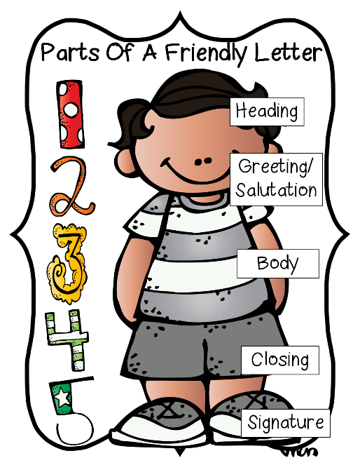
1. Greeting Don’t forget to make sure you’re using the correct form and spelling of the person’s name.
Be Specific!
- Dear Aunt Sharon,
- Dear Mr. Ed Myers,
________________________________

2. Express your thanks. Begin with the two most important words: Thank you. Avoid, “I’m writing to let you know …” Express the specific reason for thanking them.
- Thank you so much for …
Be Sincere!
- It made my day when I opened …
- I’m so grateful you were there when …
____________________________________________________________________________________________________________________________________________________________________________

3. Add specific details. Tell them how you plan to use or display their gift. It shows them you really appreciate the thought that went into it. You can also describe how you’ll spend a monetary gift.
- Here’s a picture of me with my new briefcase. I look so professional!
Be Informative!
- I can’t wait to use the birthday money you sent to decorate my dorm room.
- The going-away party meant so much to me. Having all my friends and family in one place was something I’ll never forget.
____________________________________________________________________________________________________________________________________________________________________________
4. Look ahead. Mention the next time you might see them, or just let them know you’re thinking of them.
- We look forward to seeing you next month at Lucy’s party.
Be Enthusiastic!
- I’ll always think of you when I use the new briefcase you gave me.

____________________________________________________________________________________________________________________________________________________________________________
5. Restate your thanks. Add details to thank them in a different way.
- Again, thank you for your generosity. I’m so excited about college. I’ll let you know all about it when I get settled.
- We felt so blessed that you made the trip to be with us on our wedding day. We can’t wait to see you again soon!
____________________________________________________________________________________________________________________________________________________________________________
6. End with your regards. “Sincerely” is a safe standby, but for closer relationships, you might choose a warmer option.
- With love,
- Many thanks,
- Yours truly,
________________________________

EXAMPLE

Dear Mr. Jacob Haagen,

Thank you so much for your partnership during the recent ACES Leadership Conference. Because of your generosity, over 1,500 FFA members have experienced a life-changing weekend! We were able to learn many leadership and career-readiness skills such as time management, public speaking and teamwork. These attributes will be very valuable as we proceed to college and the workforce.
FFA has opened my eyes to a vast array of careers in the agriculture industry. I’m so thankful for my own personal growth and look forward to the day I can work for a company like AgChoice Farm Credit! Again, thank you so much for your support of this conference and FFA.


Sincerely,
Sarah Sparks
FFA Chapter

Writing a Proper Email
The Necessities of a Professional Email
***Create a draft directly on this worksheet, then copy to your email.***
1. Greeting Don’t forget to make sure you’re using the correct form and spelling of the person’s name.
Be Friendly!
- Dear Ms. Johnson,
- Dear Mr. Ed Myers,
________________________________

2. Opening Establishes a polite and friendly tone.
- I hope this email finds you well.
Be Sincere!
- I trust this email finds you well.
- I hope you are doing well.
____________________________________________________________________________________________________________________________________________________________________________
3. Introduction Introduce yourself and your role within the FFA chapter.
- My name is Emily Davis, the FFA chapter president at Jefferson High School.
Be Concise!

____________________________________________________________________________________________________________________________________________________________________________
4. Connection/Context Establish a connection to the recipient’s organization and show genuine interest.
- As a prominent agricultural business in our community, we greatly admire [Business Name]’s commitment to supporting education and youth development.
Be Genuine!

____________________________________________________________________________________________________________________________________________________________________________
5. State Your Purpose. Clearly state why you are writing the email and provide context.
- I am reaching out to you to request a donation in support of our upcoming FFA activities, including [briefly mention specific activities or events].
____________________________________________________________________________________________________________________________________________________________________________
6. Provide Details. Specify what the donation will be used for and how it will benefit the FFA chapter.
- Your generous donation will directly support our efforts to provide educational resources, leadership development opportunities and hands-on agricultural experiences to our members.
____________________________________________________________________________________________________________________________________________________________________________
7. Closing Request Politely ask for their consideration and specify any additional information they may need.
- We would be grateful for any contribution you can make to help us achieve our goals. Please let us know if you need any further information from us.
____________________________________________________________________________________________________________________________________________________________________________
8. End with your regards. Choose an appropriate closing remark.
- Thank you for considering our request.
- We appreciate your support.
- Looking forward to hearing from you soon.
________________________________

EXAMPLE

Subject: Request for Donation to Support Jefferson High School FFA
Dear Mr. John Smith,
I hope this email finds you well.
My name is Emily Davis, and I am the president of the FFA chapter at Jefferson High School. As a prominent agricultural business in our community, we greatly admire Smith Farms’ dedication to fostering education and supporting youth development.
I am reaching out to you to request a donation in support of our upcoming FFA activities, including leadership conferences, agricultural education events and community service projects. Your generous contribution will directly support our efforts to provide valuable educational experiences and opportunities for personal growth to our members.
We would be grateful for any contribution you can make to help us achieve our goals. Please let us know if you need any further information from us.
Thank you for considering our request. We appreciate your support and look forward to the possibility of partnering with Smith Farms.
Sincerely,
Emily Davis
President, Jefferson High School FFA



Making a Professional Phone Call

Step-by-Step Guide to Making a Professional Phone Call
1. Prepare Beforehand
- Know Your Purpose: Clearly understand why you are making the call (e.g., inquire about a job opening, ask questions about a college program).
- Have Information Ready: Gather any necessary information such as your resume, transcript or questions you want to ask.
2. Choose a Suitable Time
- Aim to make your call during regular business hours unless specified otherwise.
- Avoid calling during busy times (e.g., lunch hour) to increase the likelihood of reaching the person you want to speak with.
3. Dialing the Number
- Make sure you have the correct phone number.
- If calling a business or office, find the main contact number rather than a personal number unless directed otherwise.
4. Introduction
- When the call is answered, introduce yourself clearly and politely.
- Example: “Hello, my name is [Your Name]. I’m calling to [state your purpose briefly].”
5. Be Polite and Courteous
- Use respectful language and speak clearly.
- Listen actively and patiently to the person on the other end.
6. State Your Purpose
- Clearly explain why you are calling.
- Example: “I’m calling to inquire about internship opportunities at your company.”
7. Ask Questions
- Have a list of questions ready to ask.
- Write down key points or answers provided during the call for future reference.
- Example questions: “Could you tell me more about the application process?” or “What are the next steps after submitting my resume?”
8. Take Notes
- Jot down important details, such as names, contact information or additional instructions.
- This will help you follow up or remember key points from the conversation.
9. Thank Them
- Before ending the call, thank the person for their time and assistance.
- Example: “Thank you for answering my questions. I appreciate your time.”
10. Follow Up if Necessary
- If you need to send additional information or follow up on something discussed during the call, ask for the best way to do so.
- Confirm any next steps or actions required on your part.
11. End the Call Professionally
- Politely say goodbye and end the call.
- Example: “Thank you again for your help. Have a great day.”
12. Reflect on the Call
- Take a moment to reflect on the call and what you learned from it.
- Consider what went well and if there are areas you can improve for future calls.
13. Follow Through
- If you promised to follow up with any information or actions, make sure to do so promptly.
- This shows professionalism and reliability.

Let’s Practice!

Write a script below for a phone call to a local business to request that they sponsor an award at the FFA banquet. When done, practice the phone call with another officer.

Post Officer Retreat Reflection
Directions: Reflect on your experiences during the officer retreat by completing the activities below.
- Five-minute free write: Use the space below to share your thoughts and feelings about your retreat experience.

- Choose one word that represents your officer retreat experience and create an acrostic poem using your chosen word.
Example:
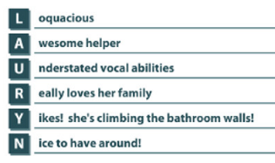

- What is one thing from your officer retreat experience that you can apply in your personal life and in school?
School
Personal

- What was your most interesting discovery during this experience?

