Edit of
FFA Official Dress

Historical Official Dress Items
In the late 1960s and early 1970s, all FFA members wore the same necktie, fashioned after the traditional male necktie. But by the mid 1970s, the FFA Supply Service began selling a dress scarf as official dress for female members. On this mannequin, we have the “Standing FFA” scarf, which is the earliest version of the scarf offered for young women. This scarf required a gold ring to tie it together around the neck. Eventually, the FFA Supply Service offered the “Waterfall” scarf that we know today; it is dressier and does not require a gold ring, which often got lost.
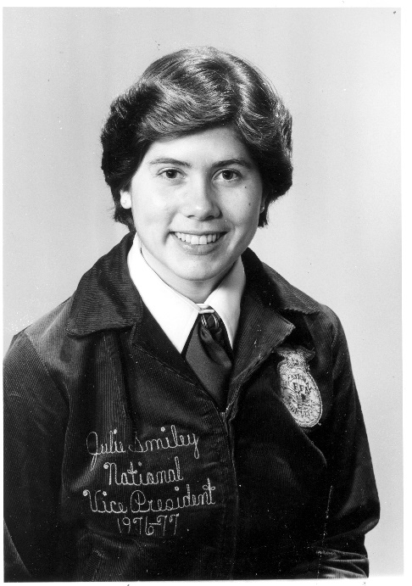
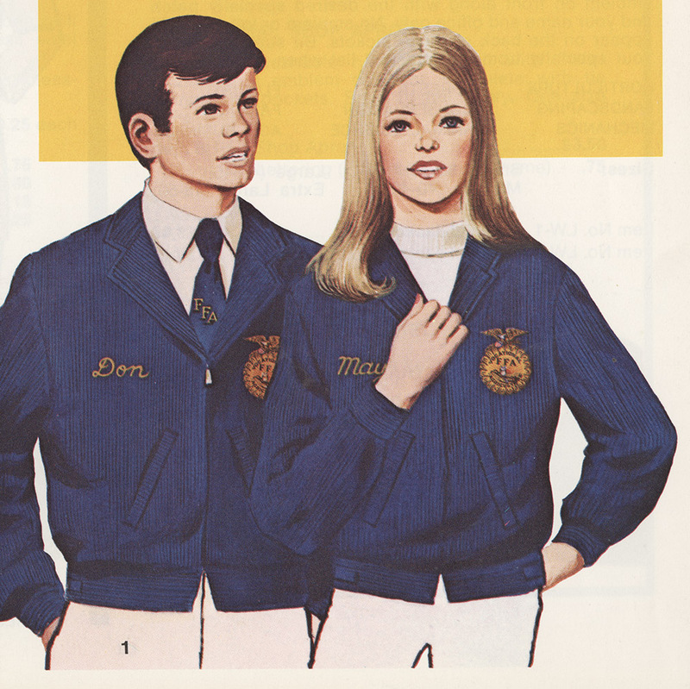
In addition to the scarf on the mannequin, we also have a shadow box displaying iconic historical pieces of official dress. Included in this shadow box are the blue bolo tie, wide yellow tie, wide blue tie, a tie bar, a tie tack, an alumni tie tack and a 1953 silver anniversary button. The earliest FFA ties were made from linen and were sold in royal blue with the letters FFA screen printed in a contrasting yellow. Later, a similar tie was produced in yellow with contrasting blue letters. During the 1950s and 1960s, the FFA Supply Service offered the cord of western-style bolo ties in three colors: blue, yellow and red.

Above left: Julie Smiley, the first woman elected to a National Officer position in 1976, is wearing a scarf like the one on display. Above right: When the female FFA jacket was first introduced in the supply catalog, it was shown paired with an FFA-branded sleeveless mock-neck sweater shell. Photo is from the 1972-73 FFA Supply Service catalog.
Special thank you to David Laatsch, retired agriculture teacher in Wisconsin, for contributing items, stories and facts for this display.

