FFA on Screen

Celebrating 20 years of Napoleon Dynamite
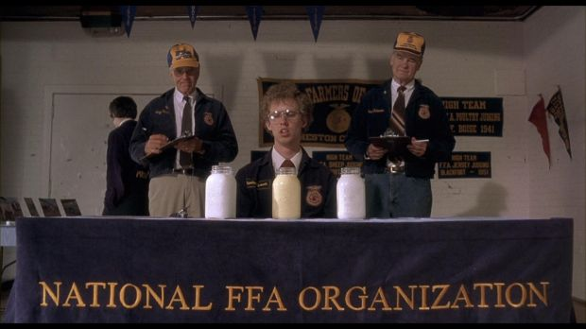
Twenty years ago, in 2004, former FFA member Jared Hess released his first full-length feature film, Napoleon Dynamite. This film captured the hearts of FFA members and agriculture teachers across the nation and continues to do so. Napoleon Dynamite showcases the life of a listless and alienated teenager who decides to help his new friend win the class presidency in their small western high school, while he must also deal with his bizarre family life at home. During the film, there are a few scenes that show Napoleon and his friend, Pedro, as members of their FFA chapter. One of the most iconic FFA scenes shows Napoleon competing in the milk quality CDE and tasting milk. For twenty years, FFA fans have referenced the movie and love the screen time that FFA received.
Other Notable Movies With FFA
The Green Hand (1940)
Charlotte’s Web (2006)
Deep in the Heart (2012)
Where the Fast Lane Ends (2017)
Silo (2019)
Walk. Ride. Rodeo. (2019)
Special thank you to North Carolina FFA for the use of the Napoleon Dynamite statue.

