FFA Chapter Sweetheart Items

Sweetheart Necklace and Compact
During the time of the FFA Chapter Sweetheart, the National FFA Supply Service noticed a need for more than just the sweetheart jacket for ladies. The National FFA Supply Service started offering accessories including necklaces, bracelets, rings, compacts and brooches.

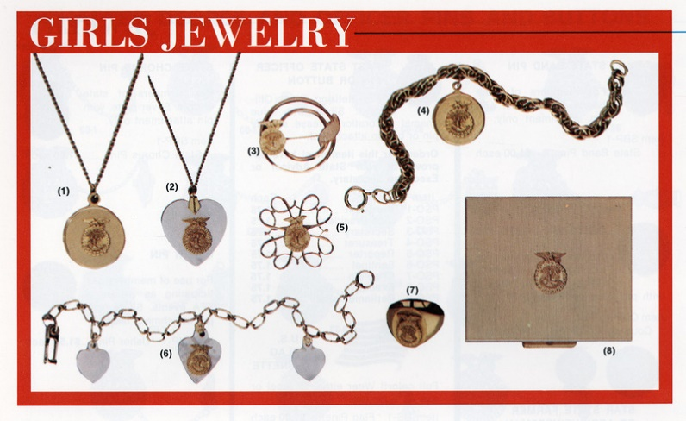
The FFA Sweetheart necklace and compact on display belonged to Carol Lu Lutz from the Manatee High School FFA Chapter in Florida. Please see the news article content and image below to learn more.

“Carol Lu Lutz was proudly named Manatee High School FFA Chapter Sweetheart on Thursday, Dec. 1, 1960, by FFA Chapter president Wayne Stokes. The crowning ceremony was held during the chapter’s formal dance.
Carol Lu, a high school senior, was selected from a group of three finalists. Besides the coveted tiara, she was also presented with an FFA Sweetheart necklace and compact. She will represent the chapter at numerous events, including the county fair and other school activities.
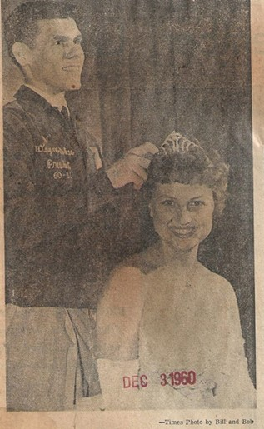
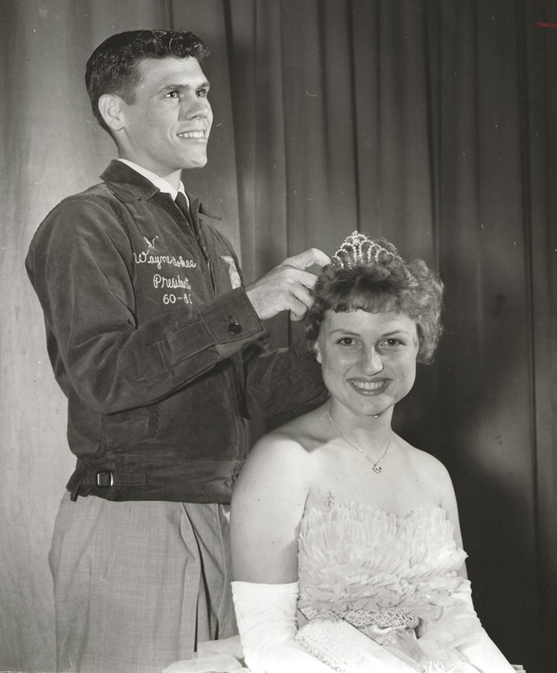
Located on the Gulf side of Florida, between Sarasota and Tampa, Manatee High School is the oldest public high school in Bradenton, Fla., opening in 1897. It is operated by the Manatee County School District.
Originally known as Bradentown High School, the school merged with Palmetto High School in 1947 and was renamed Manatee County High School. The schools split again in 1959, with the school getting the name Manatee High School.”

Special thank you to David Laatsch, retired agriculture teacher in Wisconsin, for contributing items, stories and facts for this display.
Page from the 1960-61 National FFA Supply Service Catalog
