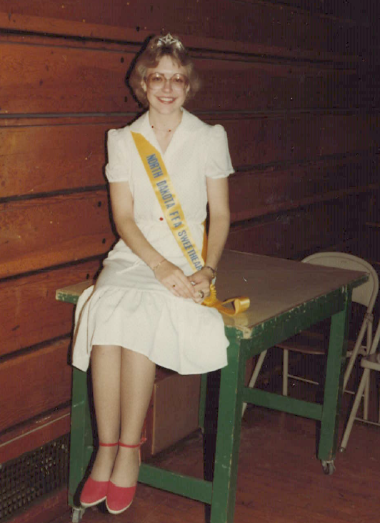
FFA Sweetheart Tiara
The FFA Sweetheart tiara that is on display has been provided by Lynelle Bachmeier from North Dakota. Lynelle was in the Kindred FFA Chapter in Kindred, N.D. On October 22, 1981, Lynelle was crowned as the District 5 Sweetheart at the District Leadership Conference in Wahpeton, N.D.
Lynelle went to the North Dakota State FFA Banquet and competed in the state sweetheart contest in June 1982, held at North Dakota State University. She was escorted onto the stage by Dave Torgerson. The eight contestants representing the eight districts in North Dakota were judged on looks, personality and a speech given to a panel of judges. On June 10, 1982, Lynelle’s hard work paid off, and she was crowned the North Dakota FFA State Sweetheart. She reigned for a year as the state sweetheart.
One of her most cherished memories was competing in the American Royal Pageant in Kansas City, Missouri (November 1982.) There were 18 contestants representing different states. The week-long selection process included interviews, luncheons, a horse show and the National FFA Convention. During the National FFA Convention, the contestants were escorted onto the stage by their state presidents, and they introduced themselves to the 50,000 FFA members, advisors and guests present. At the end of this contest, Lynelle was awarded third runner-up.
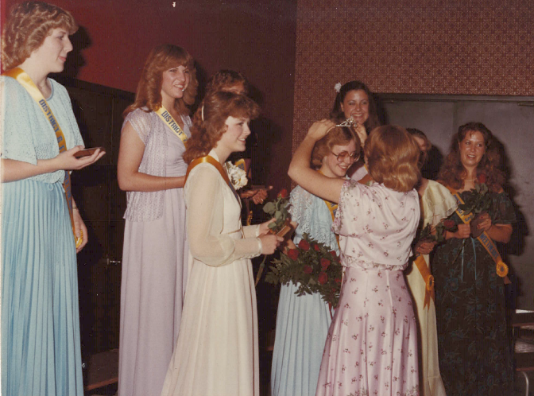
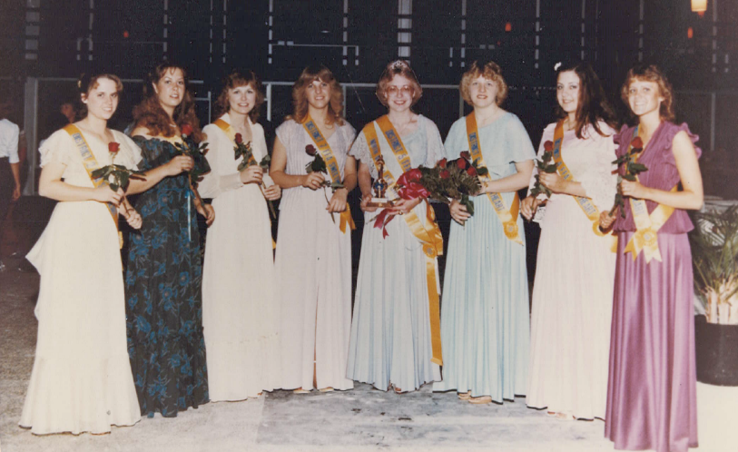
Lynelle had a busy and wonderful year as the North Dakota FFA State Sweetheart. She really enjoyed representing her state FFA association in this manner. In June 1983, during the State FFA Banquet in Fargo, N.D., she gave a retiring address and crowned the new sweetheart.

